

Practice Number: 5200296

|  |  |  |
| --- | --- | --- |
| Instructions for  Participants | **03 Nov 2022**  **03-2022** | |
| These are the clinical scenarios and response form for the NHLS Parasitology Stool PT Scheme. Detailed instructions can be found in the new Instruction Booklet for all NHLS Proficiency Testing Schemes. | | **NHLS Proficiency Testing Scheme – Parasitology Stool** |



# **NHLS Stool Parasites PT Scheme 0322**

**SURVEY RESPONSE FORM 0218**

**PTS LAB NO: ________ LABORATORY NAME: _________________________________**

|  |  |  |  |
| --- | --- | --- | --- |
| **CHALLENGE:** | **ANSWER CODE/S:** | **CLINICAL HISTORY:** | **INSTRUCTIONS:** |
| **PS11/22**  Stool/urine concentrate |  | Patient complaining loose stools, abdominal pain, and flatulence | Vortex/mix the specimen well. Make a few wet preparations and examine the slide for parasites using 10x and 40x objectives. |
|  |
|  |
| **PS12/22**  Stool/urine concentrate |  | Patient complaining loose stools, abdominal cramps | Vortex/mix the specimen well. Make a few wet preparations and examine the slide for parasites using 10x and 40x objectives. |
|  |
|  |
| **PS13/22**  Stool/urine concentrate |  | Patient complaining of abdominal pain and loss of loss of appetite | Vortex/mix the specimen well. Make a few wet preparations and examine the slide for parasites using 10x and 40x objectives. |
|  |
|  |
| **PS14/22**  Stool/urine concentrate |  | Patient complaining of abdominal pain, constipation | Vortex/mix the specimen well. Make a few wet preparations and examine the slide for parasites using 10x and 40x objectives. |
|  |
|  |
| **PS15/22**  Stool smear |  | Patient complaining of headache, fever, malaise, abdominal pain, vomiting, dehydration | You have been provided with a paper challenge containing an image of a ZN stain from stool. Please identify the parasite (s) present (page 3). |
|  |
| Stain used: |

**Paper challenge: Bonus sample**

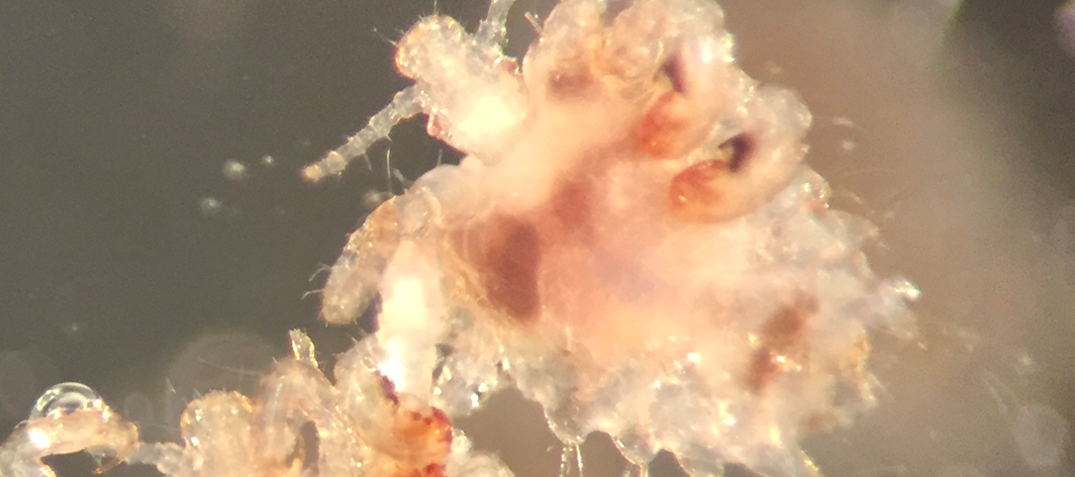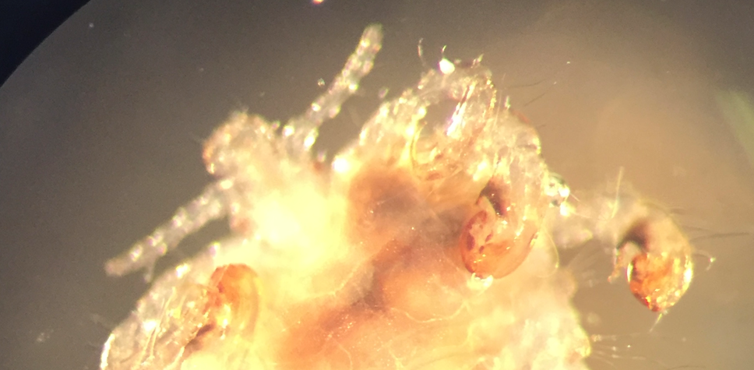

**PS16/22**

**Clinical scenario**:  Organisms found on eyelashes of a patient received for identification

**IMPORTANT INFORMATION**

* Please read the **instruction booklet** sent in the last survey for detailed instructions.
* Codes for completion of the response form can be found in the **instruction booklet** (page 4).
* The closing date for Survey 03 2022 is the **25 November 2022.**
* Submit results and queries to **parapts@nhls.ac.za** or 086 225 2460.

**NHLS PARASITOLOGY PTS ANSWER CODES**

|  |  |  |  |
| --- | --- | --- | --- |
| 00 | Noparasite(s) seen | 28 | *Schistosoma japonicum/mekongi* eggs |
| 01 | *Ascaris lumbricoides* eggs | 29 | *Strongyloides stercoralis* larvae |
| 02 | *Balantidium coli* | 30 | *Taenia* species eggs |
| 03 | *Blastocystis hominis* | 31 | *Trichostrongylus* species eggs |
| 04 | *Chilomastix mesnili* | 32 | *Trichuris trichiura* eggs |
| 05 | *Cryptosporidium* species oocysts | 33 | Other (specify parasite & stage) |
| 06 | *Cyclospora cayetanensis* oocysts | 34 | *Babesia* species |
| 07 | *Dientamoeba fragilis* | 35 | *Leishmania* species |
| 08 | *Diphyllobothrium* species eggs | 36 | Microfilaria (e) observed |
| 09 | *Endolimax nana* | 37 | *Loa loa* microfilariae |
| 10 | *Entamoeba coli* | 38 | *Mansonella perstans* microfilariae |
| 11 | *Entamoeba histolytica/E. Dispar* | 39 | *Onchocerca volvulus* microfilariae |
| 12 | *Entamoeba hartmanni* | 40 | *Wuchereria bancrofti* microfilariae |
| 13 | *Entamoeba polecki* | 41 | *Plasmodium* species |
| 14 | *Enterobius vermicularis* eggs | 42 | *Plasmodium* species, not *P. falciparum* |
| 15 | *Fasciola hepatica/ Fasciolopsis buski* eggs | 43 | Relapsing malaria species |
| 16 | *Giardia lamblia* | 44 | *Plasmodium falciparum* |
| 17 | *Clonorchis/Opisthorchis /Heterophyes/Metagonimus* eggs | 45 | *Plasmodium malariae* |
| 18 | Hookworm eggs | 46 | *Plasmodium ovale* |
| 19 | *Hymenolepis diminuta* eggs | 47 | *Plasmodium vivax* |
| 20 | *Hymenolepis* *nana* eggs | 48 | *Pneumocystis jirovecii* |
| 21 | *Iodamoeba bütschlii* | 49 | *Toxoplasma gondii* |
| 22 | *Cystoisospora (Isospora) belli* oocysts | 50 | *Trypanosoma* species |
| 23 | *Paragonimus westermani* eggs | 51 | *Trypanosoma gambiense* or *rhodesiense* |
| 24 | *Pentatrichomonas (Trichomonas) hominis* | 52 | *Trypanosoma cruzi* |
| 25 | *Sarcocystis* species oocysts/sporocysts | 53 | Hydatid hooklets / protoscoleces/Echinococcus granulosus |
| 26 | *Schistosoma haematobium* eggs |  |  |
| 27 | *Schistosoma mansoni* eggs |  |  |

**TEACHING SERIES**

**Differentiation between *Entamoeba histolytica* and *Entamoeba coli***

This teaching series focuses mainly on two commonly encountered *Entamoeba* species, *Entamoeba histolytica* and *Entamoeba coli*. The focus is on the two because *E. coli* can easily be confused with the pathogenic *E. histolytica* and correct speciation is important for appropriate management of patients.

Cysts of *E. histolytica / dispar* are 12-15 µm in diameter and contain 4 nuclei in a mature cyst while an immature cyst can have 1-3 nuclei. Karyosome is centrally located and chromatoid bodies are usually present in young cysts as elongated bars with bluntly rounded ends. 1The trophozoites may range from 10-60 µm and exhibit progressive (sometimes explosive) motility with extrusion of hyaline, finger-like pseudopodia when viewed by direct wet preparation from fresh stool.2

Cysts of *Entamoeba coli* are usually spherical, but may be elongated, and measure 10 to 35 µm.  Mature cysts typically have 8 nuclei but may have as many as 16 or more. Karyosomes may be compact or diffuse, and are usually eccentrically located and chromatoid bodies when present are usually splinter like with pointed ends. 1 The trophozoites of *E. coli* usually range from 20-25 µm and typically extrude short, blunt pseudopodia with non-directional movement. 2

It is important for microscopists to remember that although *E. coli* is generally larger and has more nuclei than *E. histolytica*, the size and numbers of nuclei in the two species can overlap depending on the maturity of the cysts and more than one cyst should be examined before deciding on the species.

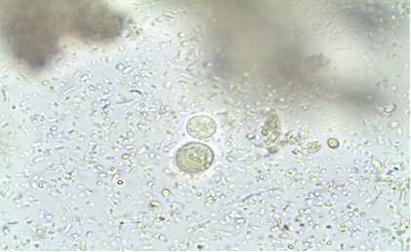

*Entamoeba coli*

*Entamoeba histolytica*

**Figure 1**: Figure 1. Micrograph showing size difference between *E. coli* & *E. histolytica*

**Morphological comparisons**

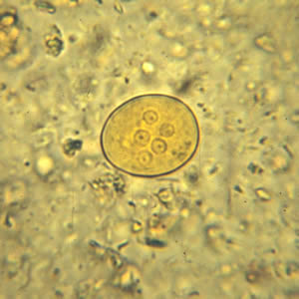***Entamoeba coli Entamoeba histolytica***

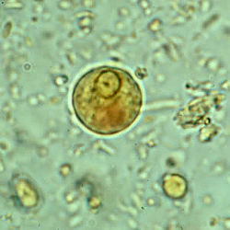

>4nuclei with eccentric karyosome 1 nuclei with central karyosome

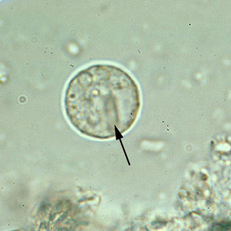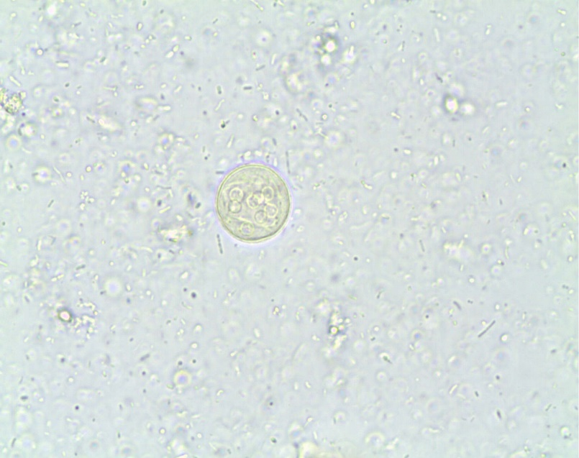

Chromatoid bars with splinter like bars Chromatoid bars with bluntly rounded ends

**References**

1. <https://www.cdc.gov/parasites/clonorchis/index.html>

2. Ash LR & Orihel TC. (1997). ***Atlas of Human Parasitology***, 4th Ed. ASCP Press, Chicago.

3. <https://www.cdc.gov/dpdx/clonorchiasis/index.html>

4. Parasitology Reference Laboratory Image Library