STANDARD OPERATING PROCEDURE

Title: Participant Information Chemical Pathology PT scheme

Document number: QASC0008

Version number: 24

(Changes from previous version highlighted)

Written by: BP Mofokeng

Checked by: PTS Managers

Approved by: P. Dabula

Active date: 10-08-2022

Date of next review | Date reviewed | Reviewed by | Action
10-08-2024

Date withdrawn: ……………...

Table of Contents

- Introduction 3

- Purpose 3

- Scope 3

- Responsibility 3

- Laboratory QA number form 4

- Participant Handbook 5

- Master Copy and PT material Preparation Information 17

- Introduction

The Chemical Pathology Proficiency Testing schemes provide information detailing the handling, processing and submission of samples for the schemes provided.

- Purpose

To provide information and instructions to participants in the Chemical Pathology Proficiency Schemes.

- Scope

This document covers general information about the Chemical Pathology schemes offered. It also provides sample preparation instructions per scheme as well as result interpretation aids.

- Responsibility

It is the responsibility of the Proficiency Scheme Manager/s to prepare the information to participants that are published online.

To all NHLS PT Scheme Participants,

Please note that your QC laboratory number is ____________________________

Laboratory Name: __________________________________________________________

Use this number when filling in your result sheet and with any other QA correspondence.

If you have any queries you may contact:

Proficiency testing scheme-general | Contact person | Email address
Chemical pathology | Bongiwe Mofokeng | chempath@nhls.ac.za
Therapeutic Drug Monitoring | Mahlatse Maleka | chempath@nhls.ac.za
Flow cytometry-CD4 | Mahlatse Maleka | cd4pts@nhls.ac.za
Cardiac | Zazi Molebatsi | chempath@nhls.ac.za
D-Dimer, Coagulation | Zazi Molebatsi | haempts@nhls.ac.za
Endocrine | Esther Tsheola | chempath@nhls.ac.za
Haematology | Bongiwe Mofokeng | haempts@nhls.ac.za
Blood gas | Thokozile Zulu | chempath@nhls.ac.za

National Health Laboratory Service
Chemical Pathology Proficiency Testing Schemes
Participant  Handbook | 20XX/XX
This is a detailed documented participant’s instruction for NHLS Chemical Pathology Proficiency Schemes participants. All relevant information regarding this proficiency testing scheme is contained in this document which must be acknowledged prior to processing the proficiency testing scheme samples. |  | Chemical Pathology Schemes
General Chemical Pathology Proficiency Testing Information

Introduction

Welcome to the NHLS Chemical Pathology Proficiency Testing Schemes. We hope that your participation will be beneficial to your laboratory. Please read the information provided. Important dates for shipment and return of results are indicated.

Instructions for recording and reporting of results

Participants will receive a master copy result submission sheet, of which copies must be made in order to submit results.

The participant’s unique participant code number must be included.
The survey number and trial number must be included. *
The instrument name must be included. *
*Please note: If the above is not included on the results sheet, the provider takes no responsibility for incorrect information reflected on the reports.

Results must be written as per blocks provided on the result sheet. Results would not be analysed if not submitted as per result sheet (i.e. write the results as per blocks provided.) See below for examples.

Example | Correct |  |  |  | Incorrect
Glucose - 18.6 mmol/l | 1 | 8 | , | 6 | 18,6 |  | ,
Example | Correct |  |  |  | Incorrect
Chloride – 114 mmol/l | 1 | 1 | 4 |  |  |  | 114

Results to be reported in the units on the form, if your laboratory use different units please convert and report in the units on the result sheet. Results to be submitted during the submission period

Results to be submitted via email to chempath@nhls.ac.za. Results not to be faxed anymore.

General Chemistry - Web entry

Web address http://pts.nhls.ac.za/

General Chemistry results online via the web entry, no results sheets to be emailed to the result mailbox.

For access and user manuals please contact the Chemical Pathology PT scheme manager.
Contact IT helpdesk to reset passwords at (+27)11 386 6125 or helpdesk6@nhls.ac.za
When requesting a password reset please indicate clearly in the subject line the following “Chemistry Proficiency Testing Scheme password reset “
Clearly indicate the laboratory QA number.

Method of evaluation

The Chemical Pathology PTS has the following methods of evaluation.

1. Consensus of the mean (Chauvenet’s Criterion)

Participant results are compared to consensus mean that uses Chauvenet’s Criterion to eliminate outliers. The following schemes are evaluated according to this method.

Chemistry
CRP

2. Defined target

The defined target schemes use traceable reference material and the allowable limits are calculated using Rhodes acceptable limits (www.datainovarionsicos acceptable limit criteria). The following PT schemes are evaluated according to this method.

Therapeutic Drugs
Endocrinology
Blood gas
Cardiac

Direct Qualitative analysis

The Qualitative BhCG results are compared to the expected results and reported as Acceptable or Not-acceptable

Laboratory performance report

The results which have been sent by the participating laboratories are analysed and documented in a report.
The report includes the following:
- Results of survey number, trial number and sample number.
- A summary table of statistics that includes: reported value (laboratory submitted result), aggregate group mean value (method mean), SD, %CV and SDI (z-score).
- A W indicates a result more than 3SD (z-score)
- A * indicates a result of more than 2SD (z-score)/results outside of the acceptable limit.

Reports are send out before the next survey is due (+- 4 weeks post submission)

Acceptable criteria

The z-score indicates the laboratories performance in relation to the group mean. The z-score must be applied in the same manner as the QC rules in your laboratory. See acceptable z-score criteria below:

- Z-score < 2 – acceptable result
- Z-score >2 but <3 – questionable result (monitor results)
- Z-score >3 – unacceptable result (needs immediate action)

Defined target interpretation- the result must be within the acceptable limits defined on the report. Bias – indicate the participant results distance from the target value.

Calculations used for Chemical Pathology Schemes

Z-score
The z-score shows how well your result compares with the peer group mean. It is expressed in units as a ratio of the difference between your lab mean and the pool mean to the standard deviation of the pool mean.

Z-score= Your Lab Result –GroupMean
SD of Group Mean

%Bias
The % Bias indicates your result in relation to the target result express as a percentage.

%bias = (X-target value)/Target value *100

Communication procedures

Participants are able to contact NHLS Chemical Pathology Proficiency Schemes managers to discuss any issues related to the scheme.

Scheme manager | email address | Scheme names
Bongiwe Mofokeng | Bongiwe.moyake@nhls.ac.za | General Chemistry, CRP and BhCG
Esther Tsheola | Esther.tsheola@nhls.ac.za | Endocrine
Mahlatse Maleka | Mahlatse.maleka@nhls.ac.za | Therapeutic Drug Monitoring
Thokozile Zulu | Thokozile.zule@nhls.ac.za | Blood gas
Zazi Molebatsi | Zazi.molebatsi@nhls.ac.za | Cardiac

Physical address:
1 Modderfontein Road
Sandringham
NHLS
2192

Postal address:
Private Bag X8
Sandringham
NHLS
2131

Chemical Pathology Due Dates 2022-2023

PT Scheme | Apr | May | Jun | Jul | Aug | Sep | Oct | Nov | Dec | Jan | Feb | Mar
General Chemistry | Sample 1 | Sample 2 | Sample 3 | Sample 4 | Sample 5 | Sample 6 | Sample 7 | Sample 8 | Sample 9 | Sample 10 | Sample 11 | Sample 12
Blood Gas | Sample 1 |  | Sample 2 |  | Sample 3 |  | Sample 4 |  | Sample 5 |  | Sample 6
TDM |  | Sample 1 |  | Sample 2 |  | Sample 3 |  | Sample 4 |  | Sample 5 |  | Sample 6
Endocrine |  | Sample 1 |  | Sample 2 |  | Sample 3 |  | Sample 4 |  | Sample 5 |  | Sample 6
BhCG |  | Sample 1 |  |  | Sample 2 |  |  | Sample 3 |  |  | Sample 4
CRP |  |  |  | Sample 1 |  |  | Sample 2 |  |  | Sample3 |  | Sample 4
Cardiac |  | Sample 1 |  | Sample 2 |  | Sample 3 |  | Sample 4 |  | Sample 5 |  | Sample 6
Submission Dates | 29/04/2022 | 27/05/2022 | 24/06/2022 | 29/07/2022 | 26/08/2022 | 23/09/2022 | 28/10/2022 | 25/11/2022 | 16/12/2022 | 27/01/2023 | 24/02/2022 | 31/03/2022

National Health Laboratory Service
Chemical Pathology Proficiency Testing Schemes

REPLACEMENT SAMPLES

PT Scheme (e.g. Cardiac/Blood gas etc) |  |  |  | Trial number
Laboratory  name: |  |  |  |  | Code number:
Date |  |  | Name (Please print) |  |  | Signature
 |  |  |  |  |  | Complete where relevant
PTS received damaged
PTS sample received incomplete, e.g., missing sample
Other

Please complete a copy of this master copy and return by fax or email to NHLS Chemical Pathology Proficiency Scheme Manager. A replacement sample/s will be sent to your laboratory, if this form is received by the PTS manager within 5 working days from date of receipt of shipment.

Email: chempath@nhls.ac.za

Acknowledgement of receipt
QA NUMBER:

RECEIVED BY: ____________________________

DATE RECEIVED ________________

SIGNATURE: __________________________________

Fax completed form within 5 working days of samples receipt to email chempath@nhls.ac.za

 | Participate | Not participate | Received  Y/N
General Chemistry

CRP

Blood gas

TDM
Endocrinology
Cardiac
Please note: Qualitative BhCG samples are send in the month it is due with the Haematology shipment

Email : chempath@nhls.ac.za

National Health Laboratory Service
Chemical Pathology Proficiency Testing Schemes

Laboratory Information

Laboratory QA number
Laboratory Manager
Laboratory Manager Email address
Laboratory telephone number
Physical address

Email: chempath@nhls.ac.za

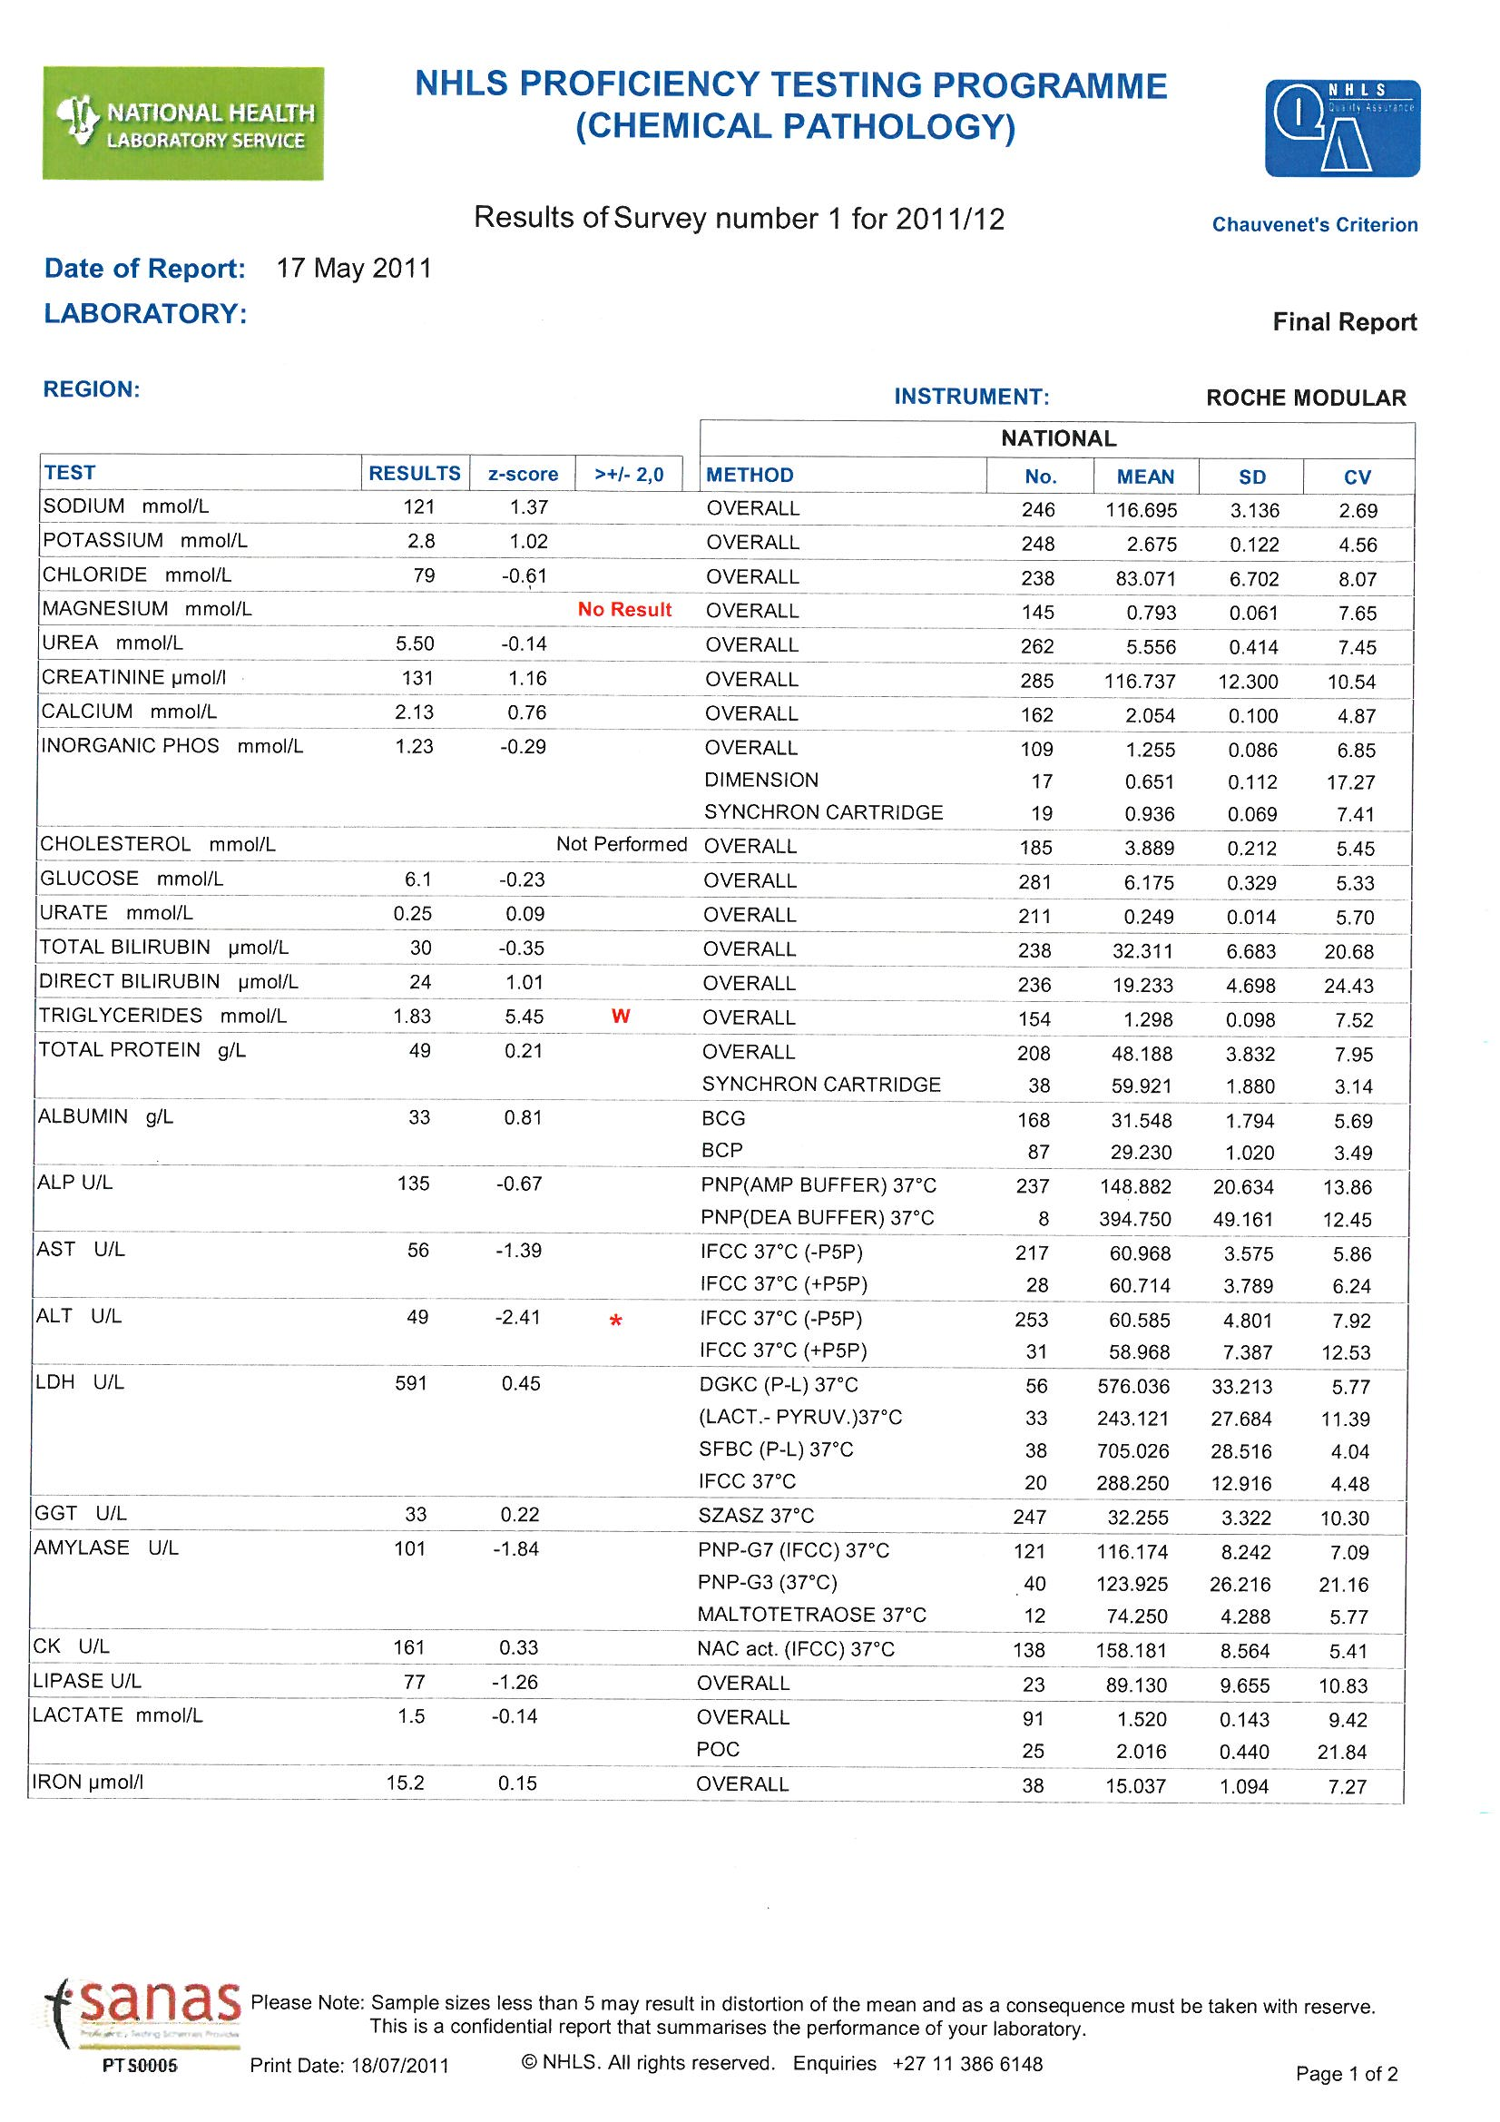
Your Result
OUT OF LIMITS FLAG
WILD

Your Performance Score
Score

Lab not registered to perform this test
Registered to perform this test, but no result submitted.
Number in Group
Target
Value
Methods used

SD
& CV of
Results

Your instrument
OUT OF LIMITS FLAG
>SD

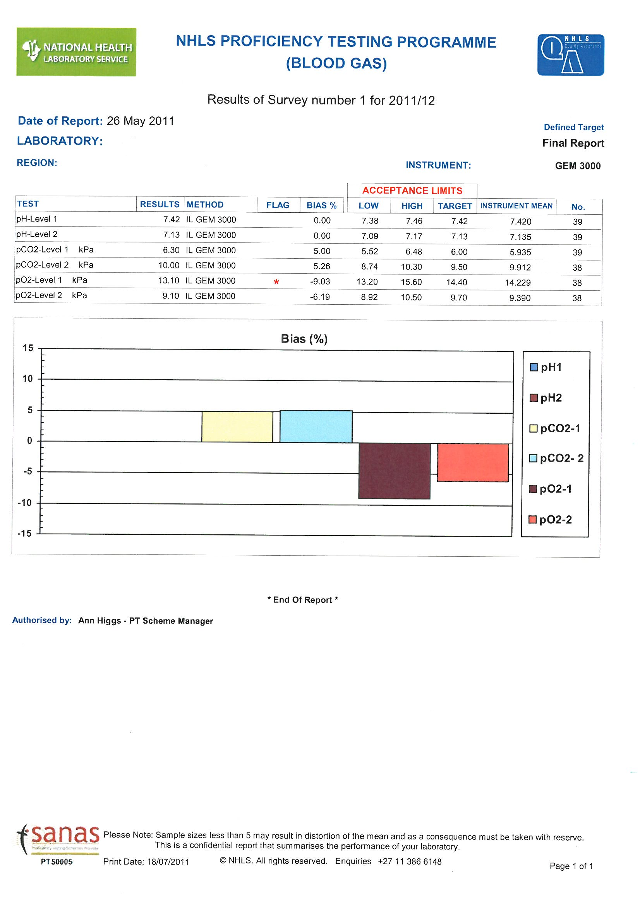
Your Result
Your method

Out of limits flag
Your Performance
Target
Value
Mean of results of your instrument

Your instrument
Performance graph of all results for this survey.
Number in Group

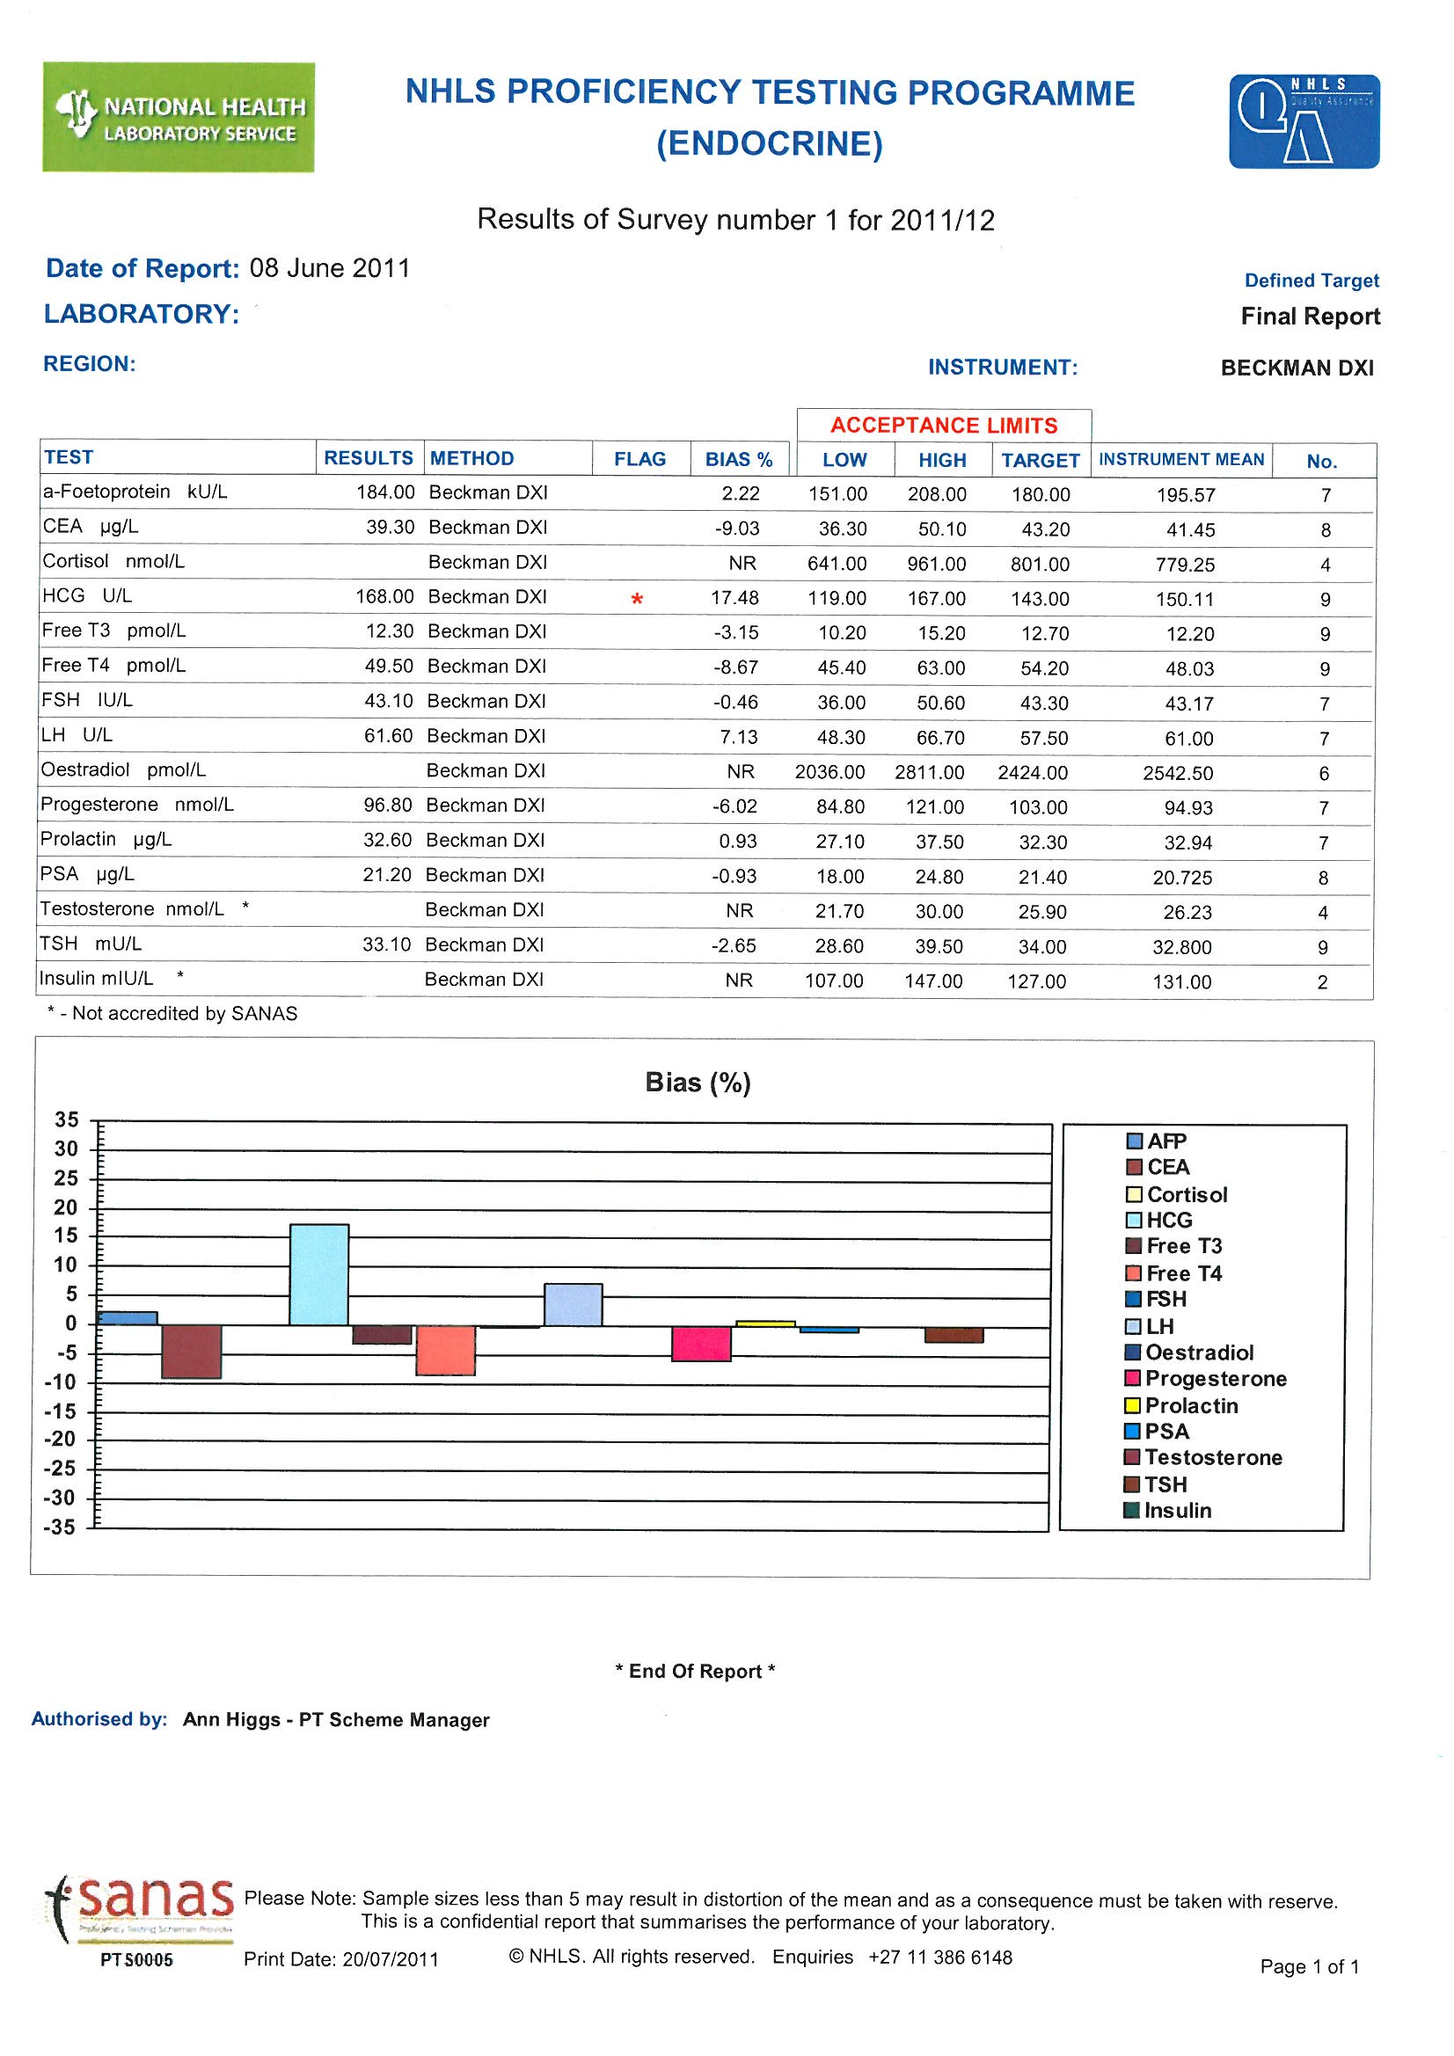
Mean of results in method group

Your result
Method used
Lower and upper limits of your method group
Your
Performance
Score

Target
Value
Number
in
Group
OUT
OF LIMITS
FLAG
Performance graph of all results for this survey.
Your instrument
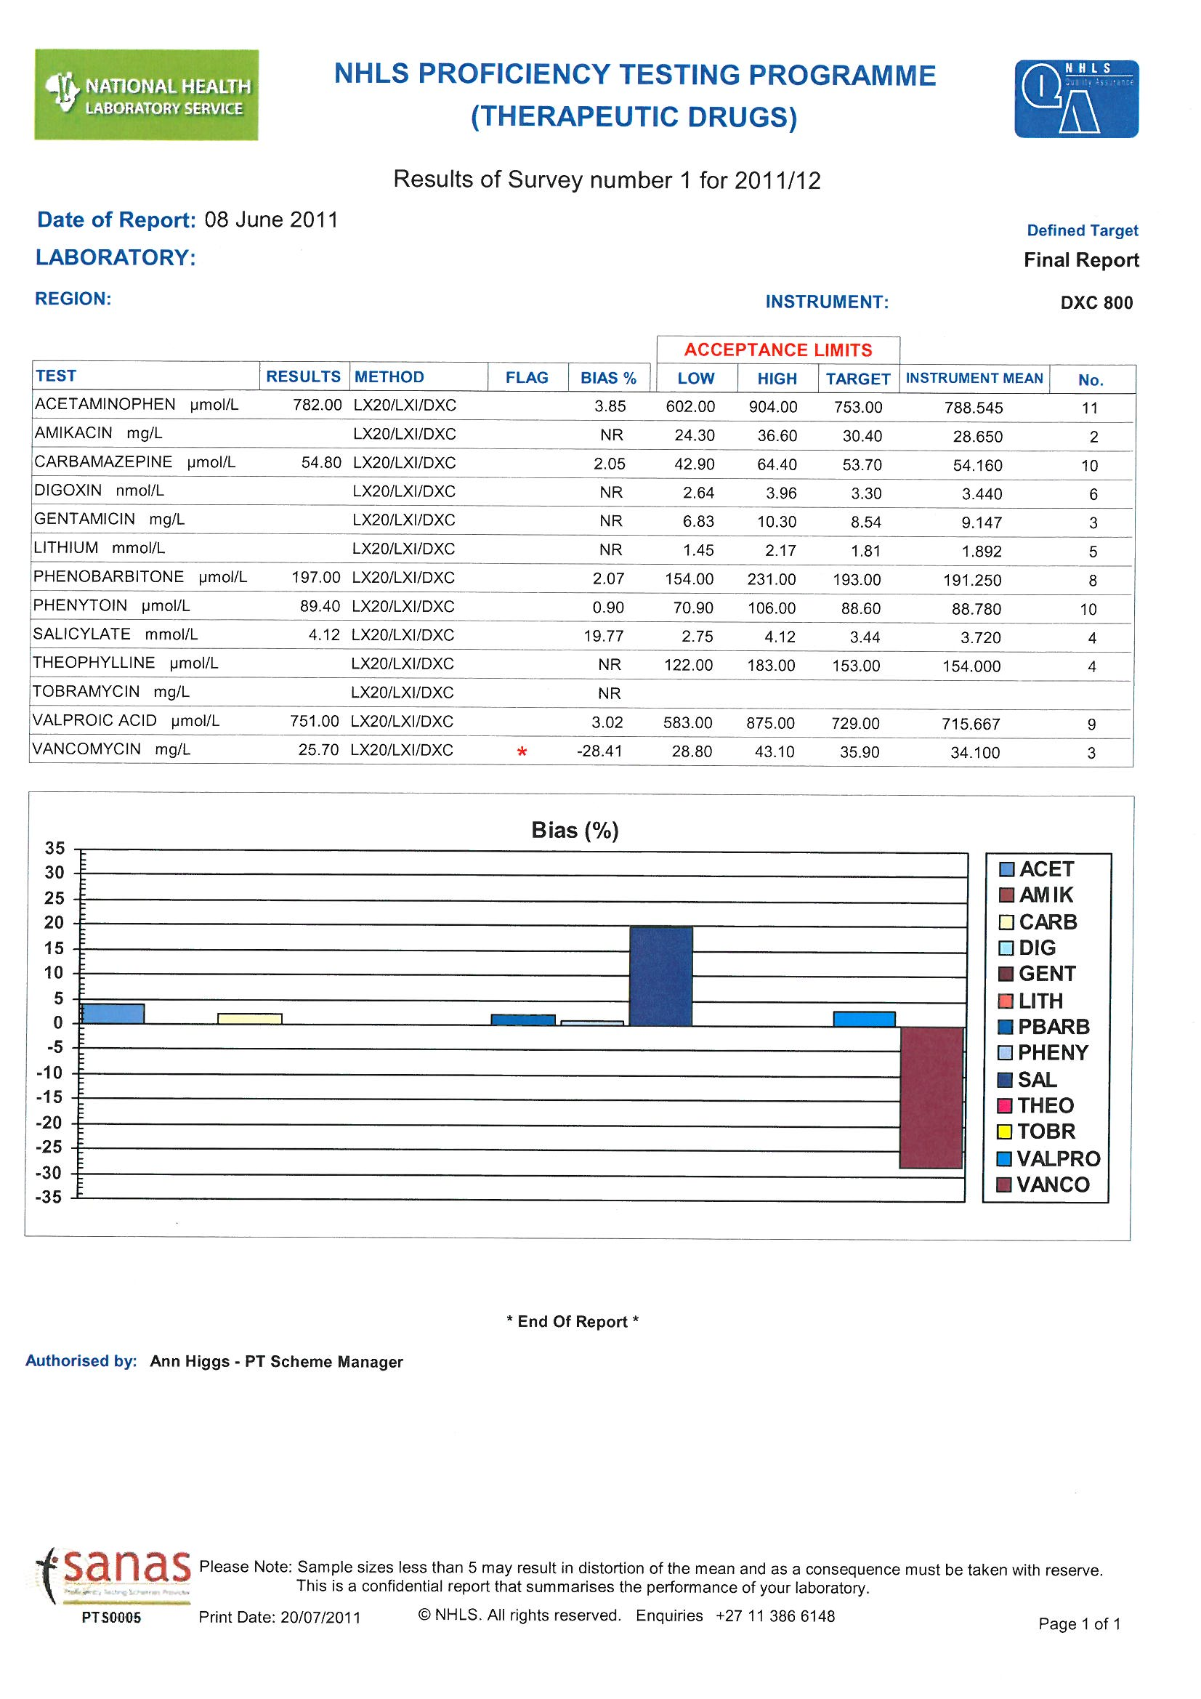
Mean of results in method group

Your
Result
Methods
Used
OUT
OF LIMITS
FLAG
Lower and upper limits of your method group
Target
Value
Number
in
Group
Your
Performance
Score

Performance graph of all results for this survey.
Your instrument

National Health Laboratory Service
Chemical Pathology Proficiency Testing Schemes
Master Copy and PT material Preparation Information | 20XX/XX
This is a detailed documented participant’s instruction for NHLS Chemical Pathology Proficiency Schemes participants. All relevant information regarding this proficiency testing scheme is contained in this document which must be acknowledged prior to processing the proficiency testing scheme samples. |  | Chemical Pathology Schemes

NHLS CHEMICAL PATHOLOGY
PROFICIENCY TESTING SCHEME
INSTRUCTIONS TO PARTICIPANTS

MATERIALS SUPPLIED
Twelve vials of lyophilised serum labelled 1-12 (Store at 2-8°C)
One result form – PLEASE MAKE COPIES OF THE RESULT FORM. One method questionnaire.

Please note: The above dates are the final dates for acceptance of results but you may return results before this date.
Please fill in the method questionnaire immediately and return within 5 days of receipt of samples by fax or email to the QA department. After analysing the samples enter your results on the website http://pts.nhls.ac.za (do not send result sheets to QA if results were entered on web) or complete a result sheet each month and return the sheet by email to chempath@nhls.ac.za .

ANALYSIS
1. The sample is to be used in accordance with the directions accompanying the assay procedure being used.
2. Each sample must be analyzed at the appropriate time, preferably some time before the final date for receipt of results. It serves no useful purpose to analyse all twelve samples simultaneously or to perform multiple analyses of each parameter to derive a mean result. Results will only be analysed in the month that it is due, no results will be kept by QA when send in the incorrect month.
3. Please ascertain that your laboratory is classified under the correct method for enzyme assays. If any methods change during the year indicate the changes in the spaces provided on the result sheet.

For in vitro diagnostic use only

CAUTION: Human source material was used in the manufacture of this product. Each donor unit used was tested for and found to be non-reactive for HBsAg, HIV-1, HIV-2 and HCV. Because no test method can offer complete assurance that products derived from human blood will not transmit infectious agents, it is recommended that this product be handled with the same precautions used for patient specimens. Dispose of any discarded material in accordance with your laboratory waste regulations.

RECONSTITUTION
1. Add exactly 5ml of distilled water at 15 - 25°C to the vial.
2. Replace the stopper in the vial and allow to stand for 30 minutes out of direct sunlight.
3. Swirl the contents until homogeneous, then remove sample for testing. Avoid formation of foam. Do not shake.
4. Keep material in the refrigerator up to the time of analysis. Prior to reuse, mix sample thoroughly.

STORAGE CONDITIONS
The samples are transported at ambient temperature.
Unopened material - The samples should be stored between 2 - 8°C and are stable for the period of the programme.

Reconstituted material – The samples are stable for 8 hours at 15 - 25°C or 7 days at 2 - 8°C and 28 days when frozen once at -20°C. Do not return any residual product to the original vial.

It is recommended that for Alk Phos the reconstituted serum is allowed to stand for 1 hour at 15 - 25°C before measurement. Total and Direct Bilirubin is stable for 4 days at 2 - 8°C when stored in the dark. Do not store at 15 - 25°C. Do not freeze; analysis should be done on the day of reconstitution.

LIMITATIONS OF PROCEDURES

Glucose, bilirubin and alkaline phosphatase should be analysed on the day of reconstitution.
The results obtained are dependent upon several factors. Erroneous results can occur from improper storage, reconstitution inaccuracies, inadequate mixing, and technical errors associated with the assay procedure. For more information, refer to the "Limitations of Procedure" section of the direction insert of the assay procedure being used. If there is visible evidence of microbial growth in a vial do not use that vial and request another vial from the QA Department.
Testing has been conducted to assure that this product is sufficiently homogeneous.

Completing the result sheet

- After analysing the samples complete a result sheet each month by filling in the Laboratory name, QA lab number, date, instrument used and the name of the person who did the assays as well as the results you obtained. Use the blocks provided for the results.
- Incomplete result sheets will result in a corrective action/no return.
- Please do not enter two numbers in a block, the correct number of blocks and decimal places are provided for each assay’s result.
- Please complete the method questionnaire form timeously and submit to QA via email, when changing instruments or for the addition or removal of analytes. Results cannot be entered if no method questionnaire is submitted.

Result submission

- All General Chemistry results to be captured online. Do not email result sheets to the Chempath mailbox. Please refer to the user manual for the web based result entry.

Replacement samples

Please complete the appropriate form when requesting a replacement sample

NHLS CHEMICAL PATHOLOGY METHODOLOGY QUESTIONNAIRE

LAB Name...............…………………................. LAB. QA Number……………..

Contact Person............………………………………….…. Tel Nº.................………...………………………….….

Fax Nº...................…………………….…….
Email address………………………………………………………..….
PLEASE FAX/EMAIL THE COMPLETED FORM TO: /chempath@nhls.ac.za WITHIN 5 DAYS OF RECEIPT.
INSTRUMENT/S………………………………………………………………..…
PLEASE TICK THE RELEVANT BOX FOR EACH ANALYTE
IT IS VERY IMPORTANT THAT YOU TICK THE “NOT DONE IN LAB” IF YOU DO NOT OFFER THAT TEST
 | METHOD/INSTRUMENT |  | Test done in your  laboratory  Please tick | Test NOT done in  Your laboratory  Please tick
Sodium
Potassium
Chloride
Magnesium
Urea
Creatinine
Calcium
I/Phosphate
Cholesterol
Glucose
Urate
Total Bilirubin
Direct Bilirubin
Triglycerides
HDL
Total Protein
Albumin | Bromcresol green
tick the correct box for your method | Bromcresol purple
Alk Phos | AMP Buffer
tick the correct box for your method | DEA Buffer
AST | IFCC without P₅P
tick the correct box for your method | IFCC with P₅P
ALT | IFCC without P₅P
tick the correct box for your method | IFCC with P₅P
LDH | IFCC (L-P)
tick the correct box for your method | SFBC
 | DGKC
 | Lactate to Pyruvate
γGT
Amylase | PNP-G7
tick the correct box for your method | PNP-G3
CK
Lipase | Colorimetric method
tick the correct box for your method | UV method
Lactate | Instrument name:
write your instrument name or tick the box | Accutrend POC
Iron
CO2
Lithium Pilot*
Transferrin | Write method

NHLS CHEMICAL PATHOLOGY PT SCHEME
RESULTS
Lab QA number
Sample number
Instrument name
Tech ID
Date analysed

Sodium |  |  |  |  |  |  | mmol/l
Potassium |  |  |  | , |  |  | mmol/l
Chloride |  |  |  |  |  |  | mmol/l
Magnesium |  |  |  | , |  |  | mmol/l
Urea |  |  |  | , |  |  | mmol/l
Creatinine |  |  |  |  |  |  | µmol/l
Calcium |  |  |  | , |  |  | mmol/l
I/Phosphate |  |  |  | , |  |  | mmol/l
Cholesterol |  |  |  | , |  |  | mmol/l
Glucose |  |  |  | , |  |  | mmol/l
Urate |  |  |  | , |  |  | mmol/l
T/Bilirubin |  |  |  |  |  |  | µmol/l
D/Bilirubin |  |  |  |  |  |  | µmol/l
Triglycerides |  |  |  | , |  |  | mmol/l
HDL |  |  |  | , |  |  | mmol/l
Total Protein |  |  |  |  |  |  | g/l
Albumin |  |  |  |  |  |  | g/l
Alk Phos 37°C |  |  |  |  |  |  | U/l
AST 37°C |  |  |  |  |  |  | U/l
ALT 37°C |  |  |  |  |  |  | U/l
LDH 37°C |  |  |  |  |  |  | U/l
γGT 37°C |  |  |  |  |  |  | U/l
Amylase 37°C |  |  |  |  |  |  | U/l
CK 37°C |  |  |  |  |  |  | U/l
Lipase 37°C |  |  |  |  |  |  | U/l
Lactate |  |  |  | , |  |  | mmol/l
Iron |  |  |  | , |  |  | µmol/
CO2 |  |  |  |  |  |  | mmol/l
Lithium Pilot * |  |  | , |  |  |  | mmol/l
HDL |  |  |  | , |  |  | mmol/l
Transferrin |  | , |  |  |  |  | g/l

NHLS
C-REACTIVE PROTEIN
PROFICIENCY TESTING SCHEME
INSTRUCTIONS TO PARTICIPANTS

MATERIALS SUPPLIED
Four vials of liquid serum labelled 1 to 4 (Store at 2-8°C)
One result form (please make copies of the result form).

RETURN DATES:

Please note: The above dates are the final dates for acceptance of results.
After analysing the samples complete a result sheet and return the sheet by email to chempath@nhls.ac.za .

ANALYSIS
1. The control is to be used in accordance with the directions accompanying the assay procedure being used.

For in vitro diagnostic use only
CAUTION: Human serum was used in the manufacture of this product. Each donor unit used was tested with licensed reagents and found to be non-reactive for HbsAg, HIV1/2 Antibody and HCV Antibody.
Because no test method can offer complete assurance that products derived from human blood will not transmit infectious agents, it is recommended that this product be handled with the same precautions used for patient specimens. Dispose of any discarded material in accordance with your laboratory waste regulations.

Samples are ready for use; no reconstitution is required.

LIMITATIONS OF PROCEDURES
The results obtained are dependent upon several factors. Erroneous results can occur from improper storage, reconstitution inaccuracies, inadequate mixing, and technical errors associated with the assay procedure. For more information, refer to the "Limitations of Procedure" section of the direction insert of the assay procedure being used. If there is visible evidence of microbial growth in a vial do not use that vial and request another vial from the QA Department.
Testing has been conducted to assure that this product is sufficiently homogeneous.

STORAGE CONDITIONS
The samples are transported at ambient temperature.
The samples should be stored between 2 - 8°C and. Protect from light and heat.

Completing the result sheet
- After analysing the samples complete a result sheet each month by filling in the Laboratory name, QA lab number, date, instrument used and the name of the person who did the assays as well as the results you obtained. Use the blocks provided for the results.
- Incomplete result sheets will result in a corrective action/no return.
- Please do not enter two numbers in a block, the correct number of blocks and decimal places are provided for each assay’s result.

Contact details
Tel: 011 386 6148 (Bongiwe Moyake)
Email: chempath@nhls.ac.za

O PARTICIPANTS

MATERIALS SUPPLIED
Six vials of lyophilized serum labeled 1-6. (Store at 2 - 8 °C)
One result form (please make copies of the result form).

Please note: The above dates are the final dates for acceptance of results.
After analysing the samples complete the result sheet and return the sheet by email to chempath@nhls.ac.za .

ANALYSIS
1. All constituents should be analysed on the day of reconstitution.
2. Each sample must be analysed at the appropriate time. It serves no useful purpose to analyze all six materials simultaneously or to perform multiple analyses of each parameter to derive a mean result. Results will only be analysed in the month that it is due, no results will be kept by QA when send in the incorrect month.

For in vitro diagnostic use
PRECAUTIONS
This serum is human based and has been tested for the presence of HIV-1/HIV-2 antibody, HBsAg, and HCV and was found to be non-reactive. This product may also contain other human source materials for which there are no approved tests. In accordance with good laboratory practice, all human source material should be considered potentially infectious and handled in the same manner as patient samples. Dispose of any discarded material in accordance with your laboratory waste regulations.

STORAGE CONDITIONS
The samples should be stored between 2 to 8°C and are stable for the period of the program.
The samples are shipped under ambient conditions.

RECONSTITUTION
- Open the vial carefully, avoiding any loss of material.
- Reconstitute with exactly 5 ml distilled or deionised water.
- Replace the rubber stopper and allow to stand for 15 minutes.
- Gently swirl gently contents to ensure that the contents are completely dissolved.
- Prior to use, mix the contents by inverting the vial, avoiding the formation of foam. Ensure that no lyophilized material remains unreconstituted.
- Allow the sample to reach room temperature before use (18 - 25°C). Replace the stopper promptly.
Reconstituted vials are stable for 7 days when stored tightly capped at 2 to 8°C and 4 weeks frozen at -20°C
Do not return residual product to the original vial to avoid contamination.

PROCEDURE
The sample is to be used in accordance with the directions accompanying the assay procedure being used. While following these directions, the control is to be treated in the same manner as a patient specimen.

LIMITATIONS OF PROCEDURES
The results obtained using the sample is dependent upon several factors. Erroneous results can occur from improper storage, reconstitution inaccuracies, inadequate mixing, and technical errors associated with the assay procedure. If there is visible evidence of microbial growth in a vial do not use that vial and request another vial from the QA Department.
Testing has been conducted to assure that this product is sufficiently homogeneous.

Completing the result sheet

- After analysing the samples complete a result sheet by filling in the Laboratory name, QA lab number, date, instrument used and the name of the person who did the assays as well as the results you obtained. Use the blocks provided for the results.
- Incomplete result sheets will result in a corrective action/no return.
- Please do not enter two numbers in a block and report your results in the 3 most significant digits only.
- Please report results in the units on the result form, if different units are used please use the conversion factors
- Please complete the form attached to indicate the tests your laboratory would be participating in
- Mark any method changes in the space provided.

NHLS THERAPEUTIC DRUG PT SCHEME
RESULTS

LAB QA No: __________________ SAMPLE NO: _________________

DATE: ________________ TECHNOLOGIST’S NAME: ___________________________

INSTRUMENT/S: ___________________________________

IF MORE THAN ONE INSTRUMENT IS USED PLEASE USE THE SPACE MARKED INSTRUMENT TO INDICATE WHICH ANALYTE WAS RUN ON WHICH INSTRUMENT

Results must be reported in the units stated and the blocks provided on this result sheet. No other units are accepted.

Please do not enter two numbers in a block, the correct number of blocks and decimal places are provided for each assay’s result.

** Please transcribe results from the laboratory report and not the instrument report.

TEST | RESULT |  |  |  |  |  |  | UNITS | INSTRUMENT
ACETAMINOPHEN |  |  |  |  |  |  |  | µmol/L
AMIKACIN |  |  |  |  |  |  |  | mg/L
CARBAMAZEPINE |  |  |  |  |  |  |  | µmol/L
DIGOXIN |  |  |  | , |  |  |  | nmol/L
GENTAMYCIN |  |  |  | , |  |  |  | µmol/L
PHENOBARBITONE |  |  |  |  |  |  |  | µmol/L
PHENYTOIN |  |  |  |  |  |  |  | µmol/L
SALICYLATE |  |  |  | , |  |  |  | mmol/L
THEOPHYLLINE |  |  |  |  |  |  |  | µmol/L
TOBRAMYCIN |  |  |  | , |  |  |  | µmol/L
VALPROATE |  |  |  |  |  |  |  | µmol/L
VANCOYMYCIN |  |  |  | , |  |  |  | µmol/L

Please send results to: chempath@nhls.ac.za
NHLS THERAPEUTIC DRUGS ANALYTE SELECTION

LAB. QA Number: ____________

Contact Person: _________________________ Email address: ________________________________

Tel Nº: _________________________ Fax Nº: ___________________________

INSTRUMENT/S: ___________________________________________

PLEAS FAX/EMAIL THE COMPLETED FORM TO: chempath@nhls/ac.za WITHIN 5 DAYS OF RECEIPT.

TEST | Method | Kit | Select if test performed (√)
ACETAMINOPHEN

AMIKACIN

CARBAMAZEPINE

DIGOXIN

GENTAMYCIN

PHENOBARBITONE

PHENYTOIN

SALICYLATE

THEOPHYLLINE

TOBRAMYCIN

VALPROATE

VANCOYMYCIN

NHLS
ENDOCRINOLOGY
PROFICIENCY TESTING SCHEME
INSTRUCTIONS TO PARTICIPANTS

MATERIALS SUPPLIED
Six vials of lyophilized serum labeled 1-6. (Store at 2 - 8 °C)
One result form (please make copies of the result form).

Please note: The above dates are the final dates for acceptance of results.
After analyzing the samples complete the result sheet and return the sheet by email to chempath@nhls.ac.za .
.

ANALYSIS
- All constituents should be analysed on the day of reconstitution.
- Each sample must be analysed at the appropriate time. It serves no useful purpose to analyze all six materials simultaneously or to perform multiple analyses of each parameter to derive a mean result.
- The sample, tightly capped will be stable for 20 days if frozen once and stored at -10 to -20°C.

For in vitro diagnostic use
PRECAUTIONS
This serum is human based and has been tested for the presence of HIV-1/HIV-2 antibody, HBsAg, and HCV and was found to be non-reactive. This product may also contain other human source materials for which there are no approved tests. In accordance with good laboratory practice, all human source material should be considered potentially infectious and handled in the same manner as patient samples. Dispose of any discarded material in accordance with your laboratory waste regulations.

STORAGE CONDITIONS
The samples should be stored between 2 to 8°C and are stable for the period of the program.
The samples are shipped under ambient conditions.

RECONSTITUTION
- Open the vial carefully, avoiding any loss of material.
- Reconstitute with exactly 5 ml distilled water at +15°C to 25°C.
- Replace the rubber stopper and allow standing for 30 minutes.
- Gently swirl gently contents to ensure that the contents are completely dissolved.
- Prior to use, mix the contents by inverting the vial, avoiding the formation of foam. Ensure that no lyophilised material remains unreconstituted.

Reconstituted vials are stable for 7 days when stored tightly capped at 2 to 8°C and 4 weeks at -20°C.
Do not return residual product to the original vial to avoid contamination.

ROCEDURE
The sample is to be used in accordance with the directions accompanying the assay procedure being used. While following these directions, the control is to be treated in the same manner as a patient specimen.

LIMITATIONS OF PROCEDURES
The results obtained using the samples are dependent upon several factors. Erroneous results can occur from improper storage, reconstitution inaccuracies, inadequate mixing, and technical errors associated with the assay procedure. If there is visible evidence of microbial growth in a vial do not use that vial and request another vial from the QA Department.
Testing has been conducted to assure that this product is sufficiently homogeneous

Completing the result sheet

- After analysing the samples complete a result sheet by filling in the Laboratory name, QA lab number, date, instrument used and the name of the person who did the assays as well as the results you obtained. Use the blocks provided for the results.
- Incomplete result sheets will result in a corrective action/no return.
- Please do not enter two numbers in a block. Please report results in the units on the result form, if different units are used please use the conversion factors.
- Please complete the form attached to indicate the tests your laboratory would be participating in
- Mark any method changes in the space provided

NHLS ENDOCRINE ANALYTE SELECTION
LAB. QA Number: ____________

Contact Person: _____________________

Email address: __________________________________

Tel Nº: _________________________ Fax Nº: ___________________________

INSTRUMENT/S: __________________________________________

PLEASE FAX/EMAIL THE COMPLETED FORM TO: chempath@nhls.ac.za WITHIN 5 DAYS OF RECEIPT
TEST | Method | Kit | Select if test performed (√)
α-Foetoprotein

CEA

Cortisol

HCG

Free T3

Free T4

FSH

LH

Oestradiol

Progesterone

Prolactin

PSA

Testosterone

TSH

Insulin

Ferritin* (Pilot)

NHLS ENDOCRINE PT SCHEME
RESULTS

Lab QA number
Survey number
Kit name
Tech ID
Date analysed

PLEASE FILL IN THE INSTUMENT NEXT TO EACH RESULT IF MORE THAN ONE INSTRUMENT IS USED
Results must be reported in the units stated on this result sheet. No other units are accepted
Please do not enter two numbers in a block, the correct number of blocks and decimal places are provided for each assay’s result. ** Please transcribe results from the laboratory report and not the instrument report.

TEST | RESULT |  |  |  |  |  |  | UNITS | INSTRUMENT
α-Foetoprotein |  |  |  | , |  |  |  | µg/L
CEA |  |  |  | , |  |  |  | μg/l
Cortisol |  |  |  |  |  |  |  | nmol/L
HCG |  |  |  |  |  |  |  | IU/L
Free T3 |  |  |  | , |  |  |  | pmol/L
Free T4 |  |  |  | , |  |  |  | pmol/L
FSH |  |  |  | , |  |  |  | IU/L
LH |  |  |  | , |  |  |  | IU/L
Oestradiol |  |  |  |  |  |  |  | pmol/L
Progesterone |  |  |  | , |  |  |  | nmol/L
Prolactin |  |  |  | , |  |  |  | μg/L
PSA |  |  |  | , |  |  |  | μg/L
Testosterone |  |  |  | , |  |  |  | nmol/L
TSH |  |  |  | , |  |  |  | mIU/L
Insulin |  |  |  | , |  |  |  | mIU/L
Ferritin* (Pilot) |  |  |  |  |  |  |  | μg/L
NHLS
CARDIAC
PROFICIENCY TESTING SCHEME
INSTRUCTIONS TO PARTICIPANTS

MATERIALS SUPPLIED
Six vials of lyophilised serum labelled 1 to 6 (Store at 2-8°C)
One result sheet, please make copies

Please note: The above dates are the final dates for acceptance of results.
After analyzing the samples complete a result sheet and return the sheet by email to chempath@nhls.ac.za .

ANALYSIS
1. The control is to be used in accordance with the directions accompanying the assay procedure being used.
For in vitro diagnostic use only
CAUTION: Human source material from which this product has been derived has been tested at donor level for HIV-1, HIV-2, HBsAg and HCV antibodies and found to be NON REACTIVE. However, it is recommended that this product be handled with the same precautions used for patient specimens. Dispose of any discarded material in accordance with your laboratory waste regulations.

RECONSTITUTION
Carefully reconstitute each vial of lyophilised serum with exactly 1ml of redistilled water at 15 to 25°C. Close bottle and allow to stand for 30 minutes before use. Ensure contents are completely dissolved by swirling gently. Avoid formation of foam. Do not shake.

STORAGE CONDITIONS
Unreconstituted material - the samples should be stored between 2 - 8°C. Protect from light.
Reconstituted material – the samples are stable for 5 days at 2 - 8°C and 4 weeks at -20°C if kept capped in original container and free from contamination.
Troponin I is stable for 2 weeks at -20°C if kept capped in original container and free from contamination.

LIMITATIONS OF PROCEDURES
The results obtained are dependent upon several factors. Erroneous results can occur from improper storage, reconstitution inaccuracies, inadequate mixing, and technical errors associated with the assay procedure. For more information, refer to the "Limitations of Procedure" section of the direction insert of the assay procedure being used. If there is visible evidence of microbial growth in a vial do not use that vial and request another vial from the QA Department.
Testing has been conducted to assure that this product is sufficiently homogeneous.
This program does not assess CK MB Activity

Completing the result sheet

- After analyzing the samples complete a result sheet each month by filling in the Laboratory name, QA lab number, date, instrument used and the name of the person who did the assays as well as the results you obtained. Use the blocks provided for the results.
- Incomplete result sheets will result in a corrective action/no return.
- Please do not enter two numbers in a block, the correct number of blocks and decimal places are provided for each assay’s result.

NHLS CARDIAC PT SCHEME
RESULTS

LAB QA No: _____

SAMPLE NO: ______

DATE: ________________

TECHNOLOGIST’S NAME: ___________________________

INSTRUMENT: ___________________________________

Please do not enter two numbers in a block, the correct number of blocks and decimal places are provided for each assay’s result.
TEST | RESULT |  |  |  |  |  |  | UNITS
CK-MB Mass |  |  |  | , |  |  |  | µg/L
Troponin I |  |  |  |  |  |  |  | ng/L
Troponin T (Quantitative) |  |  |  |  |  |  |  | ng/L

Troponin T h232 | Select correct the correct result
<50 ng/l
50-100 ng/l
100-2000 ng/l( write actual result)
>2000 ng/l

Troponin T semi-quantitative

Please send results to: chempath@nhls.ac.za

NHLS
BLOOD GAS
PROFICIENCY TESTING SCHEME
INSTRUCTIONS TO PARTICIPANTS

MATERIALS SUPPLIED
Twelve ampoules of aqueous control material labelled 1A- 6B. (Store at 2 - 25°C)
One result sheet, please make copies

Please note: The above dates are the final dates for acceptance of results.
After analysing the samples complete the result sheet and return the sheet by email to chempath@nhls.ac.za .

ANALYSIS
Two ampoules are analysed for each cycle e.g. 1A and 1B.
N.B. Allow a minimum of four hours for the sample to reach room temperature before analysing.
Before sampling, hold the ampoule between the thumb and forefinger and shake for 10 seconds to completely mix the contents, and then gently tap so that any fluid trapped in the top of the ampoule is forced down.
To open, place the ampoule in a piece of paper towel between thumb and forefinger to prevent injury from broken glass, snap open and immediately introduce into the instrument.
The material must be analysed in the same way as patient samples and run in accordance with protocol for the instrument in use.

- Direct aspiration: Aspirate the contents directly from the opened ampoule as per instrument protocol.
- Syringe transfer:
- To prime the syringe fill with a small volume (0.2 –0.3ml) of control.
- Remove the syringe from the ampoule, carefully debubble and discard most of the solution leaving the syringe “dead space” filled with control. Do not return any discarded material to the ampoule.
- Aspirate the desired volume with the syringe.
- Expel one or two drops through the needle.
- Remove the needle and immediately inject the sample into the instrument.

STORAGE CONDITIONS
Material - The controls should be stored between 2 to 25°C and are stable for the period of the survey.
The samples are shipped under ambient conditions.

PROCEDURE
The control is to be used in accordance with the directions accompanying the assay procedure being used. While following these directions, the control is to be treated in the same manner as a patient specimen.

LIMITATIONS OF PROCEDURES
The results obtained using the control is dependent upon several factors. Erroneous results can occur from improper storage, reconstitution inaccuracies, inadequate mixing, and technical errors associated with the assay procedure. For more information, refer to the "Limitations of Procedure" section of the direction insert of the assay procedure being used. If there is visible evidence of microbial growth in a vial do not use that vial and request another vial from the QA Department.

DISPOSAL
Dispose of used vials in a glass disposal container in accordance with your laboratory waste regulations.

Completing the result sheet

- After analyzing the samples complete a result sheet by filling in the Laboratory name, QA lab number, date, instrument used and the name of the person who did the assays as well as the results you obtained. Use the blocks provided for the results.
- Incomplete result sheets will result in a corrective action/no return.
- Please do not enter two numbers in a block. Ascertain that your laboratory is reporting the results in the units required.

NHLS BLOOD GAS PT SCHEME
RESULTS

LAB QA No: ______

SAMPLE NO: _________________

DATE: ________________

NAME: ___________________________

INSTRUMENT: _________________________________

Please do not enter two numbers in a block, the correct number of blocks and decimal places are provided for each assay’s result.

TEST RESULT UNITS INSTRUMENT CHANGES
pH(A) |  |  | . |  |  | pH
pH(B) |  |  | . |  |  | pH
pCO₂(A) |  |  | . |  |  | kPa
pCO₂(B) |  |  | . |  |  | kPa
pO₂(A) |  |  | . |  |  | kPa
pO₂(B) |  |  | . |  |  | kPa

NB: Please notify us of any changes in instruments in the column provided. Please ensure results are written clearly on the form.

Please send results to: chempath@nhls.ac.za

NHLS
Qualitative BhCG
INSTRUCTIONS TO PARTICIPANTS

MATERIALS SUPPLIED

Two vials of liquid urine (Store at 2-8°C)
One result form.

RETURN DATES:

Please note: The above date is the final date for acceptance of results.
After analysing the samples complete a result sheet and return the sheet by email to chempath@nhls.ac.za .

ANALYSIS
1. The control is to be used in accordance with the directions accompanying the assay procedure being used.

For in vitro diagnostic use only

CAUTION: Human source material, from which this product has been derived, has been tested at donor level for Human Immunodeficiency Virus (HIV1, HIV 2) antibody, Hepatitis B Surface Antigen (HbsAg) , and Hepatitis C Virus (HCV) antibody and found to be non-reactive. FDA approved methods have been used to conduct these tests. However, since no method can offer complete assurance as to the absence of infectious agents, this material and all patient samples should be handled as though capable of transmitting infectious diseases. Dispose of any discarded material in accordance with your laboratory waste regulations.

Samples are ready for use; no reconstitution is required.

LIMITATIONS OF PROCEDURES
The results obtained are dependent upon several factors. Erroneous results can occur from improper storage, reconstitution inaccuracies, inadequate mixing, and technical errors associated with the assay procedure. For more information, refer to the "Limitations of Procedure" section of the direction insert of the assay procedure being used. If there is visible evidence of microbial growth in a vial do not use that vial and request another vial from the QA Department.
Testing has been conducted to assure that this product is sufficiently homogeneous.

STORAGE CONDITIONS
The samples are transported at ambient temperature. Once received store at 2-8°C.
Completing the result sheet

- After analysis, complete a result sheet by filling in the Laboratory name, QA lab number, date, instrument used and the name of the person who did the assays as well as the results you obtained. Use the blocks provided for the results.

Contact details

Tel: 011 386 6148 (Bongiwe Moyake)
Email: bongiwe.moyake@nhls.ac.za

NHLS CHEMICAL PATHOLOGY PT SCHEME
Qualitative BhCG
RESULTS

Lab QA number
Survey number
Kit name
Tech ID
Date analysed

Please fill in the sample number in the space provided.

SAMPLE ID | Results tick
BhCG | Positive
BhCG | Negative

SAMPLE ID | Results  tick
BhCG | Positive
BhCG | Negative

Result submission: Email chempath@nhls.ac.za

Quick Guide: Interpretation of NHLS PTS reports (Chemistry/Endocrine)
KEY QUANTITATIVE/QUALITATIVE REPORTS
CONSENSUS MEAN REPORT
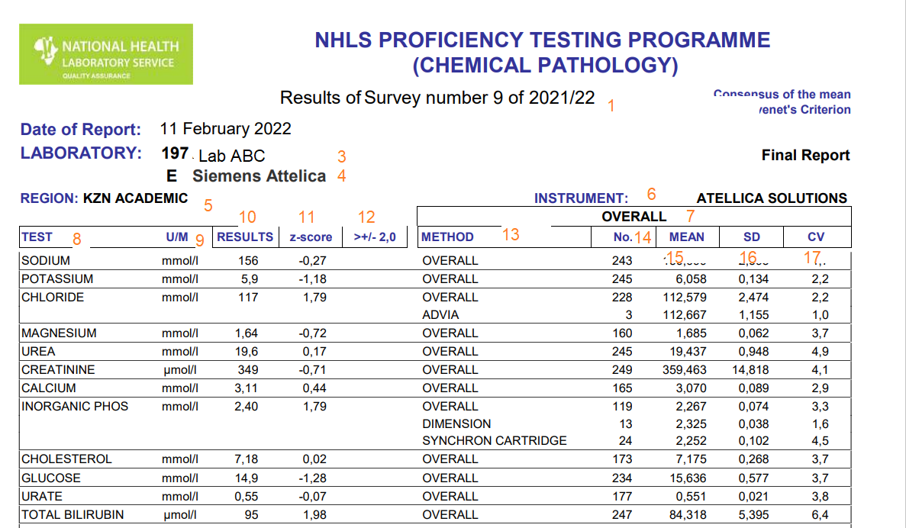
2
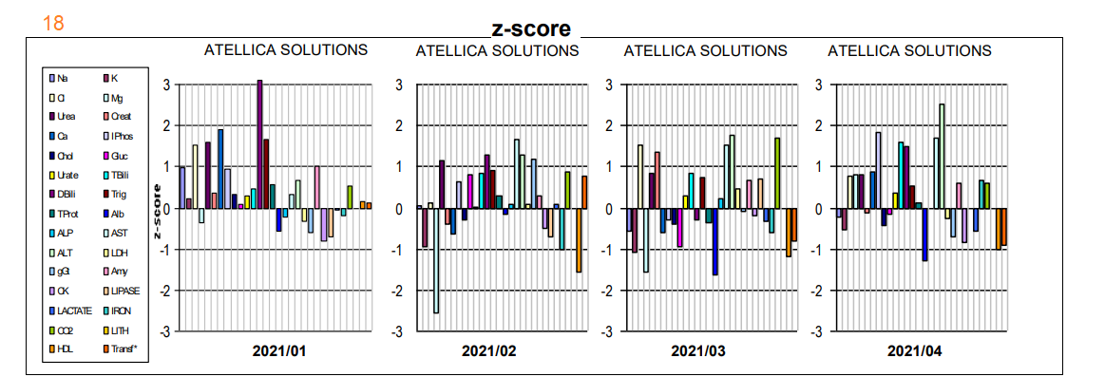

KEY
- Name of survey and survey number
- Indication of final report
3 and 4. Submitting lab name and analyser with serial number
5. NHLS business unit
6. Instrument name of submitting lab
7. Type of report Overall /Individual
Note for the for the individual (peer report) the analyser name will appear instead of the term overall. eg Atellica solutions
8. Analyte name
9. Units analyte /test reported in
10. Results as submitted by the participant lab
11. Z-score
12. Where lab results have a Z score of > 2 this column has a red asterix (*) flag, and results with a Z score > 3 will have a wild (W) flag
13. Method your lab is evaluated on where two methodologies exist for same analyser
14. Number of participants in a scheme
15. Mean of participant labs for this test and sample number
16. Standard deviation of all labs
17. Coefficient of variation (%) of all labs for this test on this sample
18. Histogram depicting z scores for all submitted samples of the participant lab for this survey (per test, per sample)

DEFINED TARGET REPORT
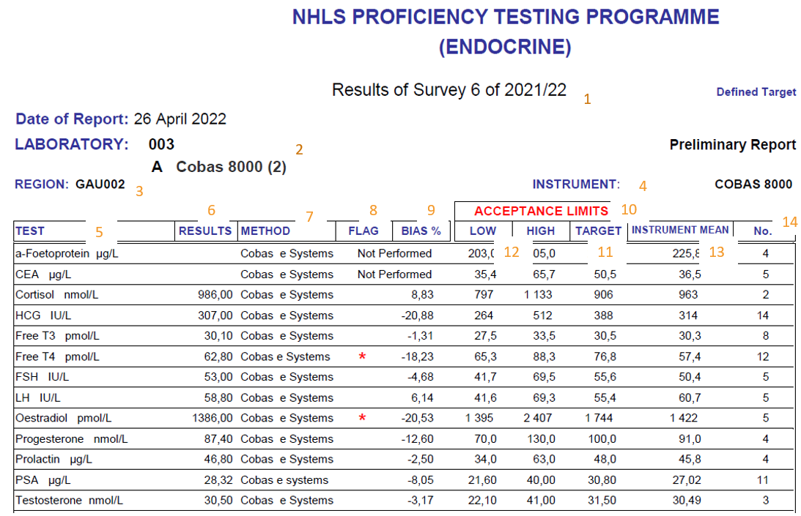

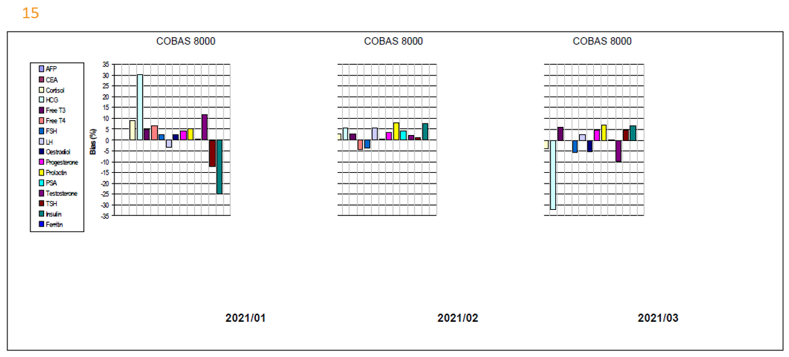

KEY
- Name of survey and survey number
- Submitting lab number and analyser
3. NHLS business unit
4. Instrument name of submitting lab
5. Analyte name and units analyte /test reported in
6. Results as submitted by the participant lab
7. Method used
8. Where lab results are out of acceptable limits this column has a red asterix (*) flag
9. Calculated percentage bias of lab results to target
10. Target acceptable limits that lab results are compared to
11. Target mean
12. Target lower and upper limits
13. Mean of the results in the same method group
14. Number of participants in a group
15. Histogram depicting % biases for all submitted samples of the participant lab for this survey (per test, per sample)

QUALITATIVE REPORT
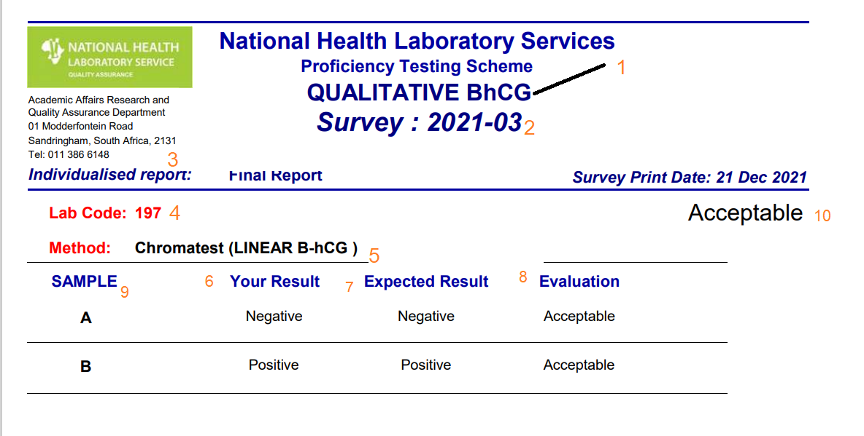
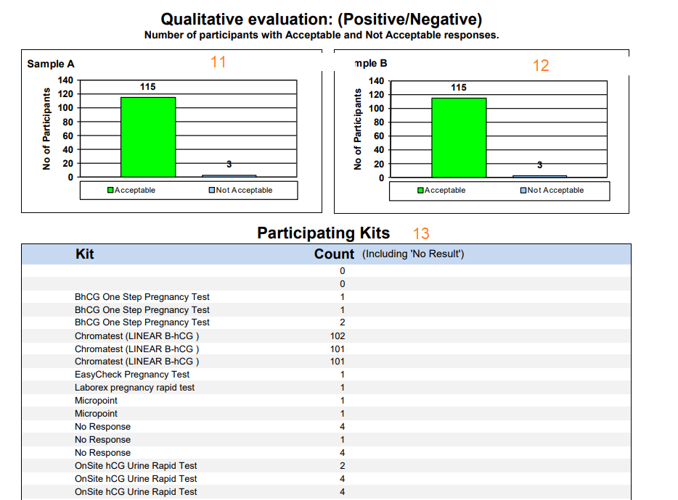

Note all reports will have the name of the PTS scheme manager that has authorized the report as well as the contact number for the NHLS PTS program

Key qualitative report
1 Name of survey scheme
2 Survey number
3 Type of report (individual/overall)
4. Lab code specific for the submitting lab (lab identification number)
5. Methodology for performing laboratory
6. The labs result/s that were submitted to the PTS
7. The target (expected) result
8. Acceptability or non-acceptability of the labs submitted results
9. Sample identification
10. Overall performance of lab
11. Histogram for sample A depicting number of participants in scheme with acceptable or non-acceptable results
12. Histogram for sample B depicting number of participants in scheme with acceptable or non-acceptable results
Histograms provide a frequency distribution of the results submitted by all participants
13. List of methods used for this PTS by other participant laboratories submitting their result
(note information on 11,12, 13 information is helpful when choosing what method or analyser to use in terms of number of peers and performance)

- What reports does the lab receive from NHLS PTS ?
i)Consensus mean report: (e.g. General chemistry)
The laboratory should receive two types of quantitative reports
- OVERALL: The first report reviews overall performance against the target mean as assigned by the supplier of the PTS material
- INDIVIDUAL: The second report reviews the performance of the laboratory against their peers performance
Peers are laboratories on the same NHLS PTS scheme that use the same analyser and test methodology as your laboratory

ii)Defined target report: (Endocrine and Therapeutic drug monitoring)
The laboratory should receive one report with instrument specific target values for the analytes tested.
- Which report should I base my lab performance on ?
Consensus mean report
The laboratory should review both the overall and the individual performance, and ideally performance should be acceptable for both.
Acceptable performance is considered to be where your z score is </=2.0 and your result falls within the acceptable range based on the target mean and SD provided on the report
If your lab results are not within acceptable limits for overall performance :
- Review your lab results for the particular survey samples against the individual performance – where your lab is reviewed against the relevant peers
- Results can be considered acceptable if you are within the acceptable limits for the individual ( peer group ) performance PROVIDED that the number of peer participants for that assay is greater than five (peer n > 6)
- If the number of peers in your group is < 6 the result cannot be fully evaluated
Defined target report:
Acceptable performance is considered to be where your lab result falls within the acceptable limits, based on the target values and ranges, provided on the report. (% bias should thus fall within the acceptable limits as defined by the PTS)
Where lab results are outside acceptable limits and if peer n=/>6
– lab values can be compared to the peer mean and percentage deviation from peer mean to determine acceptability
- When should troubleshooting be performed?

Troubleshooting and root cause analysis should be performed for the following instances ( but not limited to )
- The laboratory performance for a particular assay is out of acceptable limits for the overall and individual reports (peer) performance
- The laboratory performance for a particular assay is out of acceptable limits for overall performance and acceptable for individual report. but peer n < 6
- The laboratory performance for a particular assay is out of acceptable limits for defined target analytes
- Several assays are unacceptable for a particular scheme
It is also suggested that troubleshooting and RCA be performed for ongoing bias ( 3 or more consecutive results ) is noted for a particular assay even if within acceptable limits

- What is the Z score ?
The Z-score uses the mean result and SD to indicate the number of standard deviations a participant is away from the average result.
Lab Z score = Lab result - Mean (target) / SD

Other FAQs

- Where do I get information regarding sample preparation and handling?
This can be found on the NHLS intranet

- How do I access my lab reports ?
This is access either via : PTS portal/ results emailed to QAC/ posted to lab
if you have not received PTS within period specified below please contact the program manager

- How long does a report take to be issued by NHLS PTS?
It takes approximately 4-6 weeks

- What should the lab do if they are unable to submit results before closing date due to instrument downtime or reagent stock out ?
- Your lab will be marked as not evaluated for the test/s in question
- Once the analyser is back up / reagent available the sample should be analysed and acceptability evaluated using the relevant target as available on the report for that particular survey
- This should be documented in the laboratory

- How do I amend the results online once submitted?
The amended data should be emailed to Chempath mailbox.
- How do I add or remove an analytes?
The lab should complete the method questionnaire (QASC0008) and indicate from which survey the analytes should

Acknowledgement of Reading Form

My signature confirms that I have read and understood the content of this document and relevant kit insert (where applicable).

Name | Signature | Date

