National Health Laboratory Service
Proficiency Testing Schemes

Participants Instructions | 2022/2023
This is a detailed documented participants instructions for the following NHLS Proficiency Testing Scheme:  Automated Reticulocyte  All relevant information regarding these proficiency testing scheme is contained in the document that must be read prior to processing the proficiency testing scheme sample. |  | Automated Reticulocyte Count Pilot Study

NHLS Automated Reticulocyte Count Proficiency Testing Scheme

- General information
The NHLS Proficiency Testing Schemes are continually striving to provide participants with a comprehensive range of quality assessment schemes and to offer participants the opportunity to provide feedback on ways we can improve our content and service. We certainly appreciate that your time is valuable but your input does contribute to the ongoing development of all schemes.

This is a detailed documented participant instruction for NHLS Automated Reticulocyte Count Proficiency Testing Scheme participants. All relevant information regarding this proficiency testing scheme is contained in this document which must be read prior to processing the proficiency testing scheme sample.
Please read the information provided. The pilot study package should include the following items:
- One proficiency testing sample. (This material is transported at ambient (18°C-25°C) temperature and on arrival in your laboratory the material must be stored at 2°C-8°C until analysed. The whole blood material is ready for use once brought to ambient temperature). Process the stabilised human blood product as a quality control sample.
- Envelope containing participant’s instructions and result form.

IMPORTANT
Make sure you have the correct sample PRODUCT CODE for the type of haematology analyser used in your laboratory.

Instrument group | Product code
Sysmex | XE-RET
Advia | ADVIA RETIC PLUS
Coulter LH and DxH | RETIC-I Plus
Mindray | BC-RET

The NHLS Automated Reticulocyte Count PTS Pilot study issued stabilised whole blood in which participants are required to determine the percentage and absolute counts within the preparation. Participants are required to return the below results:
Provide printout from analyser with result sheet. Write code number on analyser printout.
Provide units of measure on the results table (e.g. x10¹²/l)
Give interpretation of results obtained.
Provide the laboratory tier your laboratory falls under.
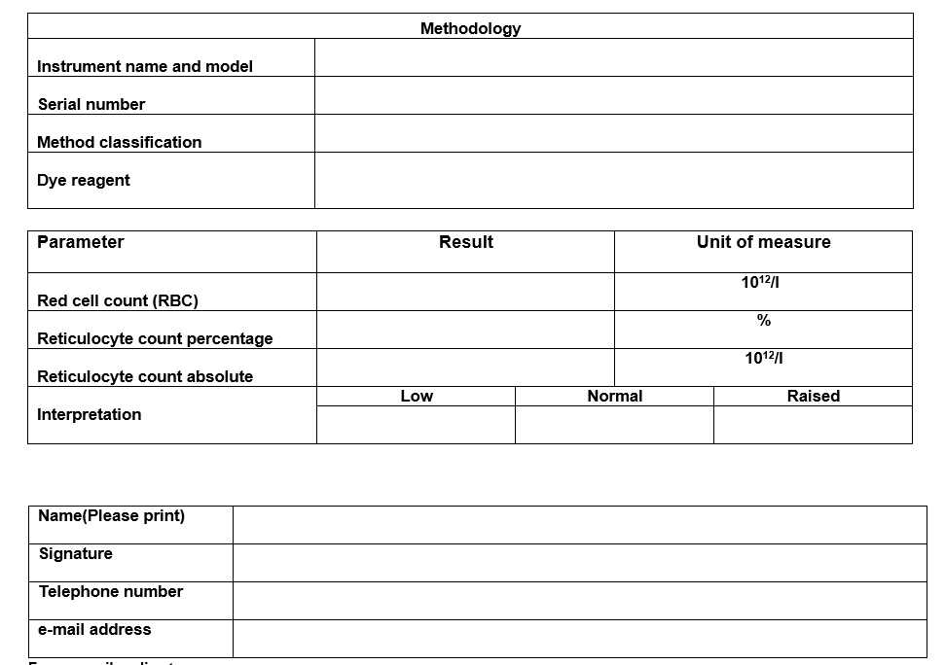

- Participation
Participation is open to all laboratories who offer Haematology full blood counts and reticulocyte counts that have been selected for the pilot study.

- Methodology
The laboratories are to use the haematology analyser method for their laboratory.
.
Methodology for the following user groups

- Coulter LH and DxH series
- Advia series
- Sysmex series
- Mindray series

B. Homogeneity and stability
The samples have been tested and found to be homogeneous and stable for this scheme.

C. Potential biohazardous material
Each donor unit used in the preparation of this material was tested by an FDA approved method for the presence of the antibodies to Human Immunodeficiency Virus (HIV-1, HIV-2) and Hepatitis C Virus (HCV) as well as the Hepatitis B surface antigen (HbsAg) and found to be negative (were not repeatedly reactive).
Because no test method can offer complete assurance that HIV, HCV, Hepatitis B Virus (HBV), or other infectious agents are absent, this reagent should be handled at the Biosafety Level 2 as recommended for any potentially infectious human serum or blood specimen. The laboratories should use good laboratory practice when handling this reagent.
D. Stability and storage
Store the tubes vertically in their original package at 2 to 8°C when not in use. DO NOT FREEZE.

E. Reconstitution
- No reconstitution required, the sample is stabilized whole blood.
- Remove the tube of blood from the refrigerator and allow to warm at room temperature (18 to 25°C) for 15 minutes before mixing.
- To mix, hold a tube horizontally between the palms of the hands. Do not pre-mix on a mechanical mixer.
- Roll the tube back and forth for 20 - 30 seconds; occasionally invert the tube. Mix vigorously, but do not shake.
- Continue to mix in this manner until the red cells are completely suspended. Tubes stored for a long time may require extra mixing,
- Gently invert the tube 8 - 10 times immediately before sampling.
- Return tube to the refrigerator within 30 minutes of use.

F. USER GROUPS

- COULTER LH Series and DxH instruments
Whole blood material compatible with Coulter LH series, DxH 600, 800, 900 instruments.
- Analyse the sample as instructed in the Quality Control section of the Operator's Manual for your instrument.
- This product should be sampled as QC material.

- ADVIA 2120i
Whole blood material compatible with Advia instruments.
- Analyse the sample as instructed in the Quality Control section of the Operator's Manual for your instrument.
- This product should be sampled as QC material.

- SYSMEX
Whole blood material compatible with Sysmex instruments.
- Analyse the sample as instructed in the Quality Control section of the Operator's Manual for your instrument.
- This product should be sampled as QC material.
- Sysmex XE/XT: Please report your impedance count for all parameters.

- MINDRAY
Whole blood material compatible with Mindray instruments.
- Analyse the sample as instructed in the Quality Control section of the Operator's Manual for your instrument.
- This product should be sampled as QC material.

Result sheet
- The participant’s laboratory name and unique participant code number (and sub code number/letter if registered more than one instrument) must be written in.
- The survey number must be written in.
- The instrument name and serial number must be written in.
- Information required from participants includes:
- Results absolute counts and lymphocyte percentages
- Units of measure
- Interpretation
- Printout of raw data
- Name, signature, telephone number and email address

G. Return of results
Fax or email replies to:
Thokozile Zulu-PTS manager
E-mail: cd4pts@nhls.ac.za / Fax: +27-11 - 386 0582

