Practice Number: 5200296

Instructions for  Participants | 05 May 2022  01-2022
These are the clinical scenarios and response form for the NHLS Parasitology Stool PT Scheme. Detailed instructions can be found in the new Instruction Booklet for all NHLS Proficiency Testing Schemes. |  | NHLS Proficiency Testing Scheme – Parasitology Stool

NHLS Stool Parasites PT Scheme 0122

SURVEY RESPONSE FORM 0218

PTS LAB NO: ________ LABORATORY NAME: _________________________________

CHALLENGE: | ANSWER CODE/S: | CLINICAL HISTORY: | INSTRUCTIONS:
PS01/22  Stool/urine concentrate |  | Patient complaining of loose stools and mild abdominal cramps | Vortex/mix the specimen well. Make a few wet preparations and examine the slide for parasites using 10x and 40x objectives.
PS02/22  Stool/urine concentrate |  | Patient complaining loose stools, abdominal pain, and flatulence | Vortex/mix the specimen well. Make a few wet preparations and examine the slide for parasites using 10x and 40x objectives.
PS03/22  Stool/urine concentrate |  | Patient complaining of diarrhoea that lasts for more than a few days | Vortex/mix the specimen well. Make a few wet preparations and examine the slide for parasites using 10x and 40x objectives.
PS04/22  Stool/urine concentrate |  | Patient complaining of abdominal pain, constipation and excess gas | Vortex/mix the specimen well. Make a few wet preparations and examine the slide for parasites using 10x and 40x objectives.
PS05/22  Stool smear |  | Patient complaining of headache, fever, malaise, abdominal pain, vomiting, dehydration | You are provided with a fixed stool smear; stain with an appropriate stain and examine the slide for parasites using the appropriate objective. Please do not return your slide.
 | Stain used:

IMPORTANT INFORMATION

- Please read the instruction booklet sent in the last survey for detailed instructions.
- Codes for completion of the response form can be found in the instruction booklet (page 4).
- The closing date for Survey 01 2022 is the 20 May 2022.
- Submit results and queries to parapts@nhls.ac.za or 086 225 2460.

TEACHING SERIES: Microscope use and care

NHLS PARASITOLOGY PTS ANSWER CODES

00 | No parasite(s) seen | 28 | Schistosoma japonicum/mekongi eggs
01 | Ascaris lumbricoides eggs | 29 | Strongyloides stercoralis larvae
02 | Balantidium coli | 30 | Taenia species eggs
03 | Blastocystis hominis | 31 | Trichostrongylus species eggs
04 | Chilomastix mesnili | 32 | Trichuris trichiura eggs
05 | Cryptosporidium species oocysts | 33 | Other (specify parasite & stage)
06 | Cyclospora cayetanensis oocysts | 34 | Babesia species
07 | Dientamoeba fragilis | 35 | Leishmania species
08 | Diphyllobothrium species eggs | 36 | Microfilaria (e) observed
09 | Endolimax nana | 37 | Loa loa microfilariae
10 | Entamoeba coli | 38 | Mansonella perstans microfilariae
11 | Entamoeba histolytica/E. Dispar | 39 | Onchocerca volvulus microfilariae
12 | Entamoeba hartmanni | 40 | Wuchereria bancrofti microfilariae
13 | Entamoeba polecki | 41 | Plasmodium species
14 | Enterobius vermicularis eggs | 42 | Plasmodium species, not P. falciparum
15 | Fasciola hepatica/ Fasciolopsis buski eggs | 43 | Relapsing malaria species
16 | Giardia lamblia | 44 | Plasmodium falciparum
17 | Clonorchis/Opisthorchis /Heterophyes/Metagonimus eggs | 45 | Plasmodium malariae
18 | Hookworm eggs | 46 | Plasmodium ovale
19 | Hymenolepis diminuta eggs | 47 | Plasmodium vivax
20 | Hymenolepis nana eggs | 48 | Pneumocystis jirovecii
21 | Iodamoeba bütschlii | 49 | Toxoplasma gondii
22 | Cystoisospora (Isospora) belli oocysts | 50 | Trypanosoma species
23 | Paragonimus westermani eggs | 51 | Trypanosoma gambiense or rhodesiense
24 | Pentatrichomonas (Trichomonas) hominis | 52 | Trypanosoma cruzi
25 | Sarcocystis species oocysts/sporocysts | 53 | Hydatid hooklets / protoscoleces
26 | Schistosoma haematobium eggs
27 | Schistosoma mansoni eggs

TEACHING SERIES
Clonorchis sinensis
Clonorchis sinensis, commonly known as the oriental or Chinese liver fluke, is a trematode belonging to the phylum platyhelminthes.¹ It is endemic to China, Korea, Taiwan, Hong Kong, Russia and Vietnam.² C. sinensis infects the liver, gallbladder and bile ducts in humans, and causes clonorchiasis.¹ Most clinical manifestations of clonorchiasis result from inflammation and obstruction of the biliary ducts. During the acute phase, abdominal pain, diarrhoea and nausea can occur. In longer infections, cholelithiasis, pancreatitis, and cholangiocarcinoma can develop, and this may be fatal.³
Eggs are ovoid and yellow-brown in colour. They have a fairly thick wall with a seated operculum a small knob on the abopercular end. They measure 27µm-35µm by 12µm-19µm.¹
C. sinensis eggs are often difficult to identify. It is important to note the size and the seated operculum. The knob at the abopercular end may not always be present or visible.¹ It is also important to note the geographic distribution of such parasites. C. sinensis is not a parasite found in Africa, and will only be found in travelers therefore patient histories should be considered if available.
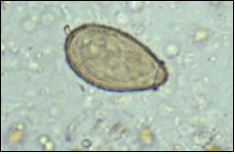
Figure 1: Micrograph showing C. sinensis egg ³ 40 X objective

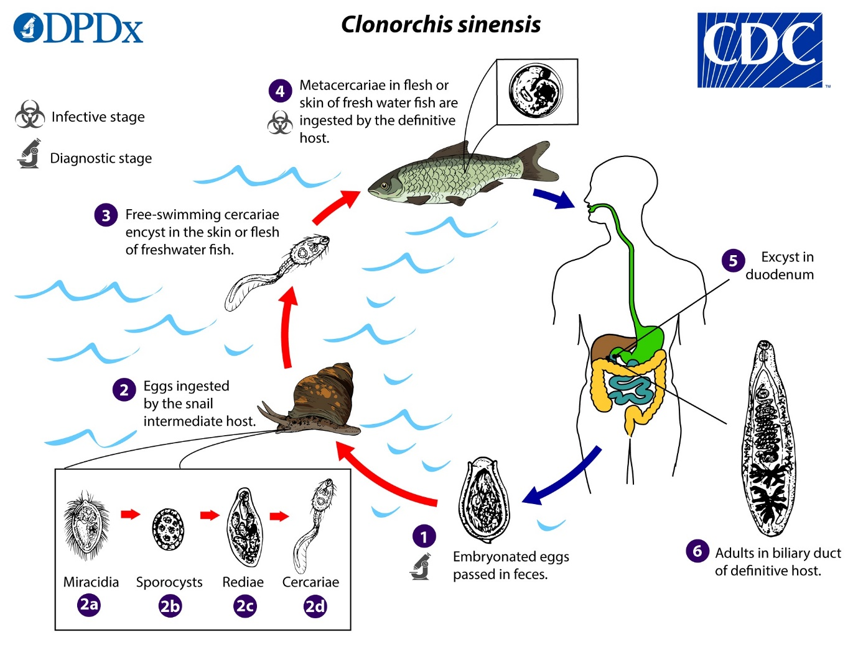
Figure 2: Life cycle of C. sinensis. ³
Clonorchis sinensis eggs are discharged in the biliary ducts and in the stool in an embryonated state . Eggs are ingested by a suitable snail intermediate host . Eggs release miracidia , which go through several developmental stages (sporocysts , rediae , and cercariae ). The cercariae are released from the snail and, after a short period of free-swimming time in water, they come in contact and penetrate the flesh of freshwater fish, where they encyst as metacercariae . Infection of humans occurs by ingestion of undercooked, salted, pickled, or smoked freshwater fish . After ingestion, the metacercariae excyst in the duodenum and ascend the biliary tract through the ampulla of Vater . Maturation takes approximately one month. The adult flukes (measuring 10 to 25 mm by 3 to 5 mm) reside in small and medium sized biliary ducts. ³

References
1. https://www.cdc.gov/parasites/clonorchis/index.html
2. Ash LR & Orihel TC. (1997). Atlas of Human Parasitology, 4th Ed. ASCP Press, Chicago.
3. https://www.cdc.gov/dpdx/clonorchiasis/index.html
4. Parasitology Reference Laboratory Image Library

