
NHLS PROFICIENCY TESTING SCHEME

NHLS Stool Parasites PTS

COMMENTARY FOR SURVEY 1 OF 2021

This commentary accompanies your individual report

IMPORTANT INFORMATION:
This PT Scheme is run by the Quality Assurance Department, National Health Laboratory Service.
Scheme Manager: Thokozile Zulu (responsible for authorisation of all reports).
Contact telephone number: +27(0)11 555-0582, Fax number: 086 225 2460
Postal address: National Health Laboratory Service, Quality Assurance, Private Bag X4, Sandringham, 2131, South Africa. Practice number: 5200296.
Physical address: Quality Assurance, NHLS, 1 Modderfontein Road, Sandringham, 2192, South Africa. E-mail: parapts@nhls.ac.za
An Advisory Group moderates our processes to ensure fairness.
Survey shipment date: 5 May 2021. Survey closing date: 28 May 2021
Please note the following:
- The posting/couriering of samples is subcontracted.
- Reports are confidential and may be used as seen fit by the participating laboratory.
- Homogeneity and stability testing of all samples have been done and participants can contact us for more information.

RETURNING OF RESULTS:
It is the responsibility of participants to ensure that their survey results have been received before the deadline. Within five working days of receiving any PTS evaluation reports, the participant may dispute the outcome by directing their appeal in writing to the Microbiology PT Scheme office. If you want the provisional results emailed to you, please send your email address to parapts@nhls.ac.za. Survey specimens should be kept as reference and teaching materials. Only return specimens to us when we request them, e.g. in order to assess stain quality. No late returns will be assessed. It is important that a laboratory sends out routine test results on time and with the correct details, such as patient’s name, laboratory’s name, sender’s details, etc. PTS surveys should be treated in the same way.

SCORING SYSTEM:

Score: | Result: | Definition: | Performance assessment:
4 | Completely correct result | A result accepted as the most correct and clinically relevant result. | Acceptable
3 | Almost completely correct result | A result not entirely correct but having little or no clinical impact; a deviation from what is considered the most clinically relevant result. | Acceptable
 | Separator | To divide the acceptable from unacceptable responses. | N/A
1 | A significantly incorrect result | A clinically relevant result that could lead to a minor diagnosis or treatment error. | Unacceptable
0 | Completely incorrect result | A clinically relevant result that could lead to a major diagnosis or treatment error. | Unacceptable
0 | No result | No result submitted by participant. | Unacceptable

SAMPLE PS01/21:

Participants were provided with a stool concentrate containing Giardia lamblia (16). 89% of the referee laboratories reported this, as well as 47.4% of participants. The average score was 1.9 out of 4 and the scoring system is explained in Table 1.

Table 1: Scoring system for PS01/21

Score | Result: | Identification: | Performance assessment:
4 | Completely correct result | Giardia lamblia (16) | Acceptable
3 | Almost completely correct result | Giardia lamblia (16)  PLUS a non-pathogen not present | Acceptable
 | Separator
1 | A significantly incorrect result | Giardia lamblia (16)  PLUS a pathogen not present | Unacceptable
0 | Completely incorrect result & no result received | Any other response OR  No result | Unacceptable

Giardia lamblia is a flagellate with a worldwide distribution, being more common in children than adults. It inhabits the small intestine and cysts are transmitted from one individual to another by water and food contaminated by faeces. The cysts are ovoid in shape and measure 8-19 μm in length, with a usual range of 11-14 μm. Mature cysts have four nuclei and are the infective stage for transmission of this disease. The use of iodine when examining stool concentrates is recommended, as this will stain the parasite’s nuclei and intracytoplasmic fibrils. Trophozoites are pear-shaped and measure about 12-15 µm in length. G. lamblia can cause chronic diarrhoea with malabsorption and weight loss. Giardiasis may be difficult to detect and multiple stool specimens or duodenal aspirates may be necessary. Metronidazole is the drug of choice for treatment.¹
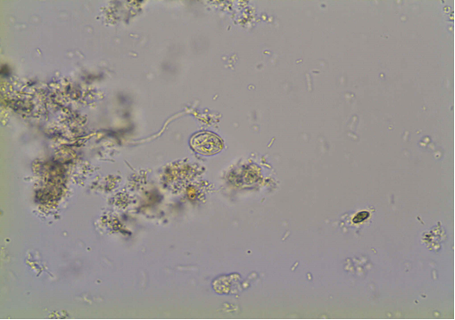
Giardia lamblia cyst

Figure 1: Micrograph of a Giardia lamblia cyst (40x objective) PS11/21

A
B

SAMPLE PS02/21:

Participants were provided with a stool concentrate containing no parasites (00).100% of referee laboratories reported this, well as 67.4% of participants. The average score was 2.7 out of 4 and the scoring system is explained in Table 2.

Table 2: Scoring system for PS12/21

Score | Result: | Identification: | Performance assessment:
4 | Completely correct result | No parasite(s) seen (00) | Acceptable
3 | Almost completely correct result | N/A | Acceptable
 | Separator
1 | A significantly incorrect result | N/A | Unacceptable
0 | Completely incorrect result & no result received | Any other response OR  No result | Unacceptable

SAMPLE PS03/20:

Participants were provided with a stool concentrate containing Ascaris lumbricoides (01). 88% of the referee laboratories reported this, as well as 52% of participants. The average score was 2.1 out of 4 and the scoring system is explained in Table 3.

Table 3: Scoring system for PS03/21

Score | Result: | Identification: | Performance assessment:
4 | Completely correct result | Ascaris lumbricoides (01) | Acceptable
3 | Almost completely correct result | Ascaris lumbricoides (01) PLUS a non-pathogen not present | Acceptable
 | Separator
1 | A significantly incorrect result | Ascaris lumbricoides (01) PLUS a pathogen not present | Unacceptable
0 | Completely incorrect result & no result received | Any other response OR  No result | Unacceptable

Infection with Ascaris lumbriciodes is a significant health problem throughout the world. Human infection is acquired through ingestion of embryonated eggs from contaminated soil. The large adult worms live in the small intestine. Both fertilised and unfertilised eggs are passed in stool, as well as occasional adult worms. Fertilised eggs are oval with a thick mammillated coat that is bile-stained a golden brown; they measure up to 75 μm long and 50 μm wide. In some instances the outer mammillated layer is absent and these eggs are termed decorticated. Unfertilised eggs are more elongated and are up to 90 μm long (Figure 2). Both fertile and infertile eggs were present in this sample. Pulmonary symptoms may be present during larval migration. Owing to the potential migration of adult worms to extraintestinal sites, all infections should be treated. Albendazole is the treatment of choice for this infection.^{1,2}

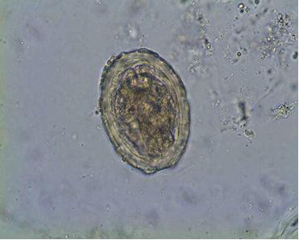

Ascaris lumbricoides egg
Figure 2: Micrograph showing Ascaris lumbricoides egg (40x objective) from PS03/21

SAMPLE PS04/21:

Participants were provided with a stool concentrate containing no parasites (00).100% of referee laboratories reported this, well as 71.1% of participants. The average score was 2.8 out of 4 and the scoring system is explained in Table 4

Table 4: Scoring system for PS04/21

Score | Result: | Identification: | Performance assessment:
4 | Completely correct result | No parasite(s) seen (00)  No assessed | Acceptable
3 | Almost completely correct result | N/A | Acceptable
 | Separator
1 | A significantly incorrect result | N/A | Unacceptable
0 | Completely incorrect result & no result received | Any other response OR  No result | Unacceptable

SAMPLE PS05/21:
A

Participants were provided with an unstained stool smear containing Cryptosporidium species oocysts (05). 84% of the referee laboratories reported this as well as 62.2% of participants.
The average score was 2.5 out of 4 and the scoring system is explained in Table 5.

Table 5: Scoring system for PS05/21

Score | Result: | Identification: | Performance assessment
4 | Completely correct result | Cryptosporidium species oocysts (05) | Acceptable
3 | Almost completely correct result | Cryptosporidium species oocysts (05)a non-pathogen not present | Acceptable
 | Separator
1 | A significantly incorrect result | Cryptosporidium species oocysts (05) PLUS a pathogen not present | Unacceptable
0 | Completely incorrect result & no result received | Any other response OR  No result | Unacceptable

In AIDS patients Cryptosporidium species can produce profuse, chronic diarrhoea that is very difficult to treat and potentially life-threatening. It causes self-limiting enteritis in immunocompetent individuals. The spherical, infectious oocysts are shed in faeces and are highly resistant to harsh environments and chemical agents. At least 3 stools should be examined before reporting a negative diagnosis. The greater the number of oocysts in a stool the more diarrhoeic the consistency and oocysts will be caught up in the mucus. Stools should be concentrated and smears made from the concentrated sediment. Cryptosporidium oocysts, stained with the modified Ziehl-Neelsen stain, often do not take up the stain uniformly, causing an uneven, variable staining effect. Some oocysts may not take up the stain at all and appear as clear shiny circles (ghost oocysts), particularly in resolving infections. Cryptosporidium oocysts measure 4-6µm in diameter and stain variably acid-fast from an intense red to dark pink (Figure 3) Mature oocysts contain 4 sporozoites and these may be visible as black dots. Misdiagnosis due to artefacts or yeasts can occur.^{1,2}

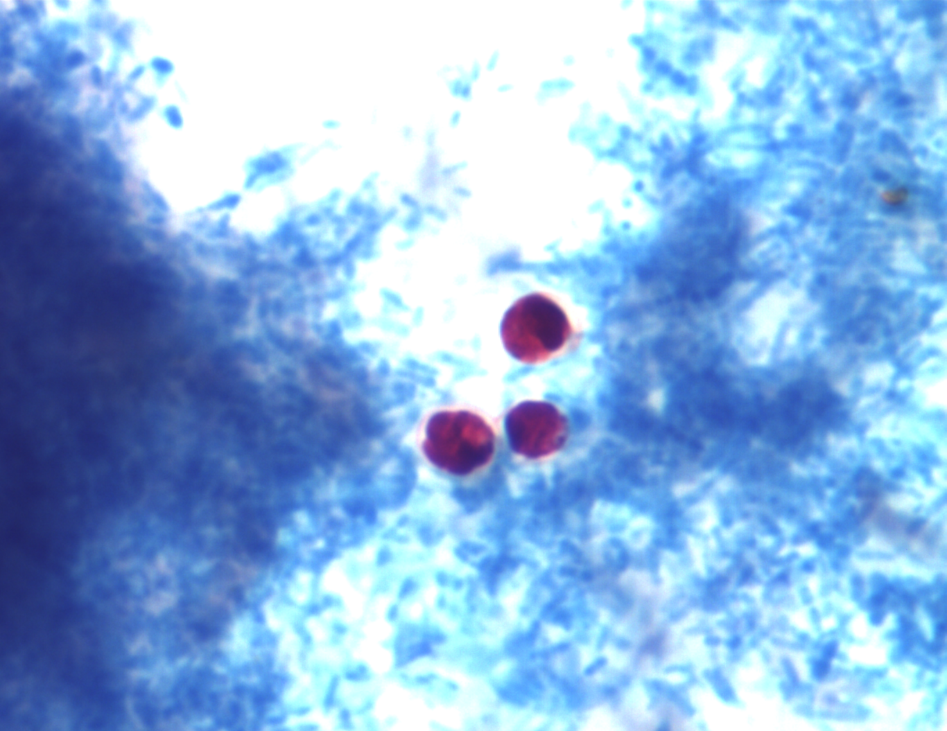
Cryptosporidium species oocysts

Figure 3: Cryptosporidium species oocysts
A

TOTAL SCORES FOR THIS SURVEY:
The total maximum score for this survey was 20 and (including the 31 non-returns) was 12.2 (58.5 %). There were 104 participants (excluding 31 non returns); 41 (39%) scored 100%, 67 (64%) scored 75% and above, and 68 (65%) scored below 75%.

COMMON ERRORS/ PROBLEMS

Please remember the following:

- Answer code 33 is reserved for parasites that are not on the NHLS Parasitology PTS answer code list.
- When answer code 33 is used, please specify the parasite and stage on the response form.
- It is very important for a laboratory to send out all routine test results on time and with the correct details, such as the patient’s name, laboratory’s name, sender’s details, etc., and PTS surveys should be treated in the same way.

The following were not assessed: 29 non-returns and 2 forms received with no PTS laboratory number.

REFERENCES:

- Ash LR & Orihel TC. (1997). Atlas of Human Parasitology, 4th Ed. ASCP Press, Chicago.
- Garcia LS. (2001). Diagnostic Medical Parasitology, 4th Ed. ASM Press, Washington, D.C.
- Jeffrey, HC & Leach, RM. (1975). Atlas of Medical Helminthology and Protozoology, 2nd Ed. Churchill Livingstone, London.
- Isaäcson M & Frean J. (2002). DTM&H notes, NICD NHLS.
- www.dpd.cdc.gov/dpdx
- www.wadsworth.org
- Brooke MM & Melvin DM. (1989). Morphology of diagnostic stages of parasites of humans, 2nd Ed. Public Health Service, CDC Atlanta, Georgia.
- http://phil.cdc.gov/phil/home.asp
End of report!!

