Practice Number: 5200296

Instructions for  Participants | 04 Aug 2021  02-2021
These are the clinical scenarios and response form for the NHLS Parasitology Stool PT Scheme. Detailed instructions can be found in the new Instruction Booklet for all NHLS Proficiency Testing Schemes. |  | NHLS Proficiency Testing Scheme – Parasitology Stool

NHLS Stool Parasites PT Scheme 0221

SURVEY RESPONSE FORM 0218

PTS LAB NO: ________ LABORATORY NAME: _________________________________

CHALLENGE: | ANSWER CODE/S: | CLINICAL HISTORY: | INSTRUCTIONS:
PS06/21  Stool/urine concentrate |  | Patient complaining of abdominal pain or tenderness | Vortex/mix the specimen well. Make a few wet preparations and examine the slide for parasites using 10x and 40x objectives.
PS07/21  Stool/urine concentrate |  | Patient complaining of gastritis, indigestion, dyspepsia. | Vortex/mix the specimen well. Make a few wet preparations and examine the slide for parasites using 10x and 40x objectives.
PS08/21  Stool/urine concentrate |  | Patient complaining with loose stools mild abdominal cramps. | Vortex/mix the specimen well. Make a few wet preparations and examine the slide for parasites using 10x and 40x objectives.
PS09/21  Stool/urine concentrate |  | Patient complaining of abdominal pain and lack of appetite | Vortex/mix the specimen well. Make a few wet preparations and examine the slide for parasites using 10x and 40x objectives.
PS010/21  Stool smear |  | Patient complaining of diarrhea, vomiting and dehydration | You are provided with a fixed stool smear; stain with an appropriate stain and examine the slide for parasites using the appropriate objective. Please do not return your slide.
 | Stain used:

NHLS PARASITOLOGY PTS ANSWER CODES

00 | No parasite(s) seen | 28 | Schistosoma japonicum/mekongi eggs
01 | Ascaris lumbricoides eggs | 29 | Strongyloides stercoralis larvae
02 | Balantidium coli | 30 | Taenia species eggs
03 | Blastocystis hominis | 31 | Trichostrongylus species eggs
04 | Chilomastix mesnili | 32 | Trichuris trichiura eggs
05 | Cryptosporidium species oocysts | 33 | Other (specify parasite & stage)
06 | Cyclospora cayetanensis oocysts | 34 | Babesia species
07 | Dientamoeba fragilis | 35 | Leishmania species
08 | Diphyllobothrium species eggs | 36 | Microfilaria (e) observed
09 | Endolimax nana | 37 | Loa loa microfilariae
10 | Entamoeba coli | 38 | Mansonella perstans microfilariae
11 | Entamoeba histolytica/E. Dispar | 39 | Onchocerca volvulus microfilariae
12 | Entamoeba hartmanni | 40 | Wuchereria bancrofti microfilariae
13 | Entamoeba polecki | 41 | Plasmodium species
14 | Enterobius vermicularis eggs | 42 | Plasmodium species, not P. falciparum
15 | Fasciola hepatica/ Fasciolopsis buski eggs | 43 | Relapsing malaria species
16 | Giardia lamblia | 44 | Plasmodium falciparum
17 | Clonorchis/Opisthorchis /Heterophyes/Metagonimus eggs | 45 | Plasmodium malariae
18 | Hookworm eggs | 46 | Plasmodium ovale
19 | Hymenolepis diminuta eggs | 47 | Plasmodium vivax
20 | Hymenolepis nana eggs | 48 | Pneumocystis jirovecii
21 | Iodamoeba bütschlii | 49 | Toxoplasma gondii
22 | Cystoisospora (Isospora) belli oocysts | 50 | Trypanosoma species
23 | Paragonimus westermani eggs | 51 | Trypanosoma gambiense or rhodesiense
24 | Pentatrichomonas (Trichomonas) hominis | 52 | Trypanosoma cruzi
25 | Sarcocystis species oocysts/sporocysts | 53 | Hydatid hooklets / protoscoleces
26 | Schistosoma haematobium eggs
27 | Schistosoma mansoni eggs

TEACHING SERIES- Relative sizes of helminth eggs
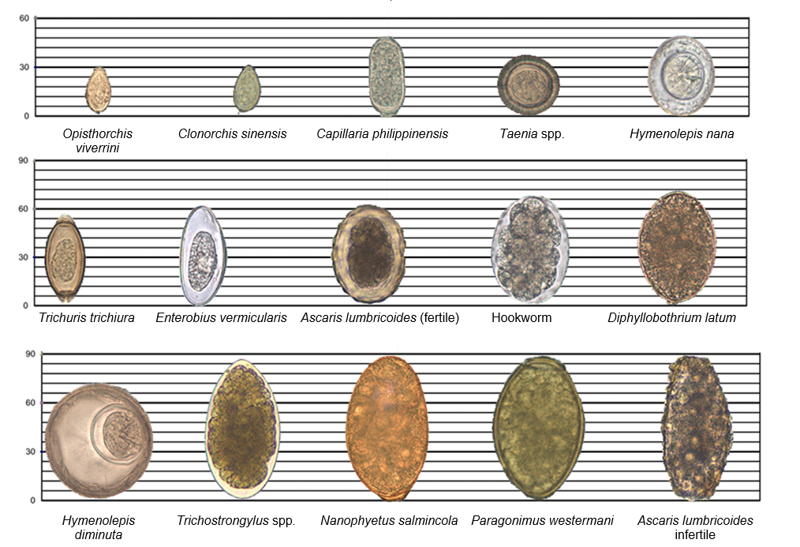
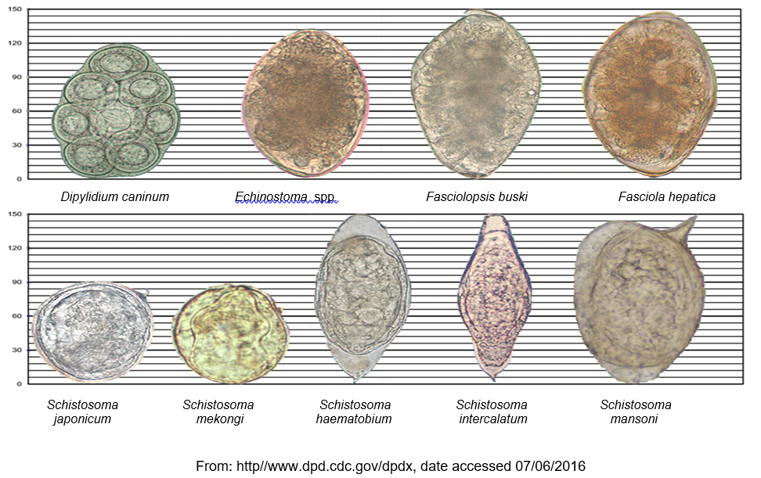

References
1. www.cdc.dpdx.co.za: Accessed: 10/06/2020
2. Ash LR & Orihel TC. (1997). Atlas of Human Parasitology, 4th Ed. ASCP Press, Chicago
3. https://www.msu.edu/course/zol/316/ameba.htm: Accessed: 10/06/2015
4. http://www.dpd.cdc.gov/dpdx/html/imagelibrary/Amebiasis_il.htm: Accessed: 10/06/2015
5. Parasitology Reference Laboratory Image Library
6. Ali, I.K.M. 2015. Intestinal amebae. Clinics in Laboratory Medicine 35 (2): 393-422.

