
Laboratory User Handbook
2019
Vision Statement:
“To render Efficient Patient Centred Services and Global Centre of Excellence for Innovative Laboratory Medicine”

STANDARD OPERATING PROCEDURE
Title: | National Health Laboratory Service (NHLS) User Handbook
Document number: | GPQ0064
Version number: | 2
Written by: | NHLS Handbook Technical Working Group (TWG)
Checked by:
Approved by: | Patience Dabula
Active date: 10-03-2020
Date of next review | Date reviewed | Reviewed by | Action
10-03-2021
Date withdrawn: …………………

TABLE OF CONTENTS
1.0 VISION OF THE NHLS 15
2.0 MISSION OF THE NHLS 15
3.0 QUALITY POLICY STATEMENT 15
4.0 CONFIDENTIALITY STATEMENT 16
5.0 INTRODUCTION 16
6.0 PROCEDURE FOR COMPLAINTS 16
7.0 CONTACT DETAILS AND HOURS OF OPERATION 19
8.0 PROCESS FLOW 55
9.0 REQUISITION FORM 59
10.0 SPECIMEN COLLECTION CONTAINERS 65
11.0 GENERAL SPECIMEN COLLECTION GUIDELINES 71
11.1 Patient identification 71
11.2 Completing the request form 72
11.3 Collecting the specimen 72
11.4 Labeling of primary specimen containers 72
11.5 Specimen rejection criteria 73
11.6 Specimen packaging 75
11.7 Specimen transport 75
11.8 Multiple specimens 75
12.0 SAFETY AND INFECTION CONTROL 79
12.1 Practise universal precautions 79
12.2 Body fluid exposure (e.g. needle stick, eye splash, etc.) 79
12.3 Protect the patient 79
13.0 BLOOD SAMPLE COLLECTION PROCEDURE 83
13.1 Venepuncture procedure 83
13.1.1 Order of draw 84
13.1.2 Venepuncture site selection 84
13.1.3 Procedure for vein selection 85
13.1.4 Performance of a venepuncture 85
13.2 Additional considerations 89
13.2.1 Tourniquet use 89
13.2.2 Preventing a haematoma 89
13.2.3 Preventing haemolysis 89
13.2.4 Preventing haemoconcentration 90
13.2.5 Using indwelling lines or catheters 90
13.3 Factors that may affect patient results 90
13.4 Troubleshooting guidelines 91
13.5 Performance of a finger prick 92
13.6 Blood collection from babies (heel prick) 94
14.0 ANATOMICAL PATHOLOGY 97
14.1 Routine histopathology 97
14.1.1 General 97
14.1.2 Frozen sections 97
14.1.3 Special biopsies 98
14.1.3.1 Muscle biopsy 98
14.1.3.2 Renal biopsy 98
14.1.3.3 Nerve biopsy 98
14.1.3.4 Skin biopsy 99
14.1.3.5 Biopsies for histochemistry in the case of patients with Hirschsprung disease 99
14.1.4 Post-mortem examination 99
14.1.5 Electron microscopy 100
14.1.6 Immunohistochemistry 100
14.1.7 Histology polymerase chain reaction (PCR) 100
14.1.8 Urgent specimens 100
14.2 Cytology 101
14.2.1 General 101
14.2.1.1 Labelling specimens and requisition forms 101
14.2.1.2 Special instructions 101
14.2.1.3 Fixation technique 101
14.2.2 Female genital tract (FGT) 102
14.2.2.1 Specimens include: 102
14.2.2.2 Sampling technique to yield adequate smears using conventional or liquid based cytology (LBC) method 102
14.2.2.2.1 Preparing the patient 102
14.2.2.3 Conventional method 103
14.2.2.3.1 Materials required 103
14.2.2.3.2 Collection technique 103
14.2.2.4 LBC method 104
14.2.2.4.1 Materials required 104
14.2.2.4.2 Collection technique 104
14.2.3 Non-gynaecological / General cytology 106
14.2.3.1 Respiratory system 106
14.2.3.1.1 Sputum 106
14.2.3.2 Fluids 107
14.2.3.2.1 CSF 107
14.2.3.4 Urogenital tract 108
14.2.3.5 The breast 108
14.2.4 Fine needle aspiration (FNA) 108
14.2.4.1 FNA collection procedure 109
14.2.4.2 Special investigations 112
14.2.4.3 Oral and maxillo-facial pathology 112
15.0 CHEMICAL PATHOLOGY 117
15.1 Sample types 117
15.1.2 Urine sample 117
15.1.2.1 Random urine samples 117
15.1.2.2 24-hour urine collection 117
15.1.3 Cerebrospinal fluid (CSF) 118
15.1.4 Fluids 118
15.1.5 Stool 118
15.1.6 Stones 118
15.1.7 Saliva 118
15.2 Special instructions 119
15.2.1 Unstable analytes 119
15.2.2 Fasting blood samples 119
15.2.3 Oral glucose tolerance test (OGTT) 119
15.2.4 Blood gas analysis 120
15.2.5 Aldosterone and renin 121
15.2.6 Urinary vanillyl mandelic acid (VMA), metanephrines and plasma cathecholamines 121
15.2.7 Urine 5-HIAA (5-hydroxy-indoleacetic acid) 122
15.2.8 Prolactin 122
15.2.9 Lactate 122
15.2.10 Porphyrins 123
15.2.11 Alpha-1 antitrypsin clearance 123
15.2.12 Aluminum serum and urine sample collection 123
16.0 HAEMATOLOGY 127
16.1 Specimen collection 127
16.1.1 General guidelines 127
16.1.2 Bone marrow 127
16.2 Immunophenotyping by Flow cytometry 128
17.0 CLINICAL MICROBIOLOGY AND INFECTIOUS DISEASES 131
17.1 General guidelines for specimen collection 131
17.1.1 Guidelines for proper specimen transport 133
17.1.2 Specimen containers 133
17.1.2.1 Swabs 133
17.1.2.2 Sterile screw-cap universal containers 134
17.1.2.3 Sterile Petri dishes / slides 134
17.1.2.4 Sterile tubes 134
17.1.2.5 Viral transport medium (VTM) 134
17.2 Blood cultures 134
17.2.1 General principles 134
17.2.2 Optimal number of blood cultures 135
17.2.3 Timing of blood culture collection 135
17.2.4 Volume of blood to be collected 136
17.2.5 Blood culture collection procedure 136
17.3 Cerebrospinal fluid (CSF) 140
17.4 Bone marrow 142
17.5 Sterile fluids and tissue specimens 142
17.6 Nasopharyngeal and respiratory tract specimens 143
17.6.1 Specimens for lower respiratory tract infections 143
17.6.1.1 Sputum specimens 143
17.6.2 Nasopharyngeal specimens 149
17.6.2.1 Throat swabs 149
17.6.2.2 Nasal swabs 149
17.6.2.3 Nasopharyngeal swabs 149
17.6.2.4 Nasopharyngeal aspirates 150
17.6.2.5 Unusual pharyngeal pathogens 150
17.6.2.5.1 Neisseria gonorrhoeae (gonococcal pharyngitis) 150
17.6.2.5.2 Bordetella pertussis (whooping cough) 150
17.6.2.5.3 Corynebacterium diphtheriae 151
17.7 Oral cultures 151
17.8 Ocular specimens 151
17.8.1 General considerations 151
17.8.2 Special considerations 152
17.9 Tissue biopsies, aspirates / swabs of abscesses and fluids 152
17.9.1 General principles 152
17.9.2 Tissue biopsies 153
17.9.3 Pus specimens 153
17.9.3.1 Aspirates 153
17.9.3.2 Deep lesions 154
17.9.3.3 Burn wounds 154
17.9.3.4 Pus swabs 154
17.9.4 Ulcers 154
17.9.5 Rectal biopsy 155
17.10 Stool specimens 155
17.10.1 General principles 155
17.10.2 Rectal swabs 155
17.10.3 Parasites 156
17.10.3.1 Cellotape preparation for pinworm (Enterobius vermicularis) 156
17.11 Urine specimens 157
17.11.1 General principles 157
17.11.2 Midstream or clean-catch specimen collection 157
17.11.2.1 Females 157
17.11.2.2 Males 158
17.11.3 Catheter specimens 158
17.11.3.1 Indwelling urinary catheter specimen collection 158
17.11.3.2 Straight / in-out catheter specimen collection 159
17.11.4 Parasites, dysmorphic cells and casts 159
17.11.5 Renal tuberculosis 160
17.12 Mycology specimens 160
17.12.1 Tissue specimens 160
17.12.2 Purulent exudates and fluids 160
17.12.3 Urine, stool and rectal swabs 161
17.12.4 Lower respiratory tract infections 161
17.12.5 Skin 161
17.12.6 Nails 161
17.12.7 Hair and scalp 161
17.12.8 Beta−D glucan Fungitell® assay 162
18.0 COMMUNICABLE AND REPORTABLE DISEASES 165
19.0 INFECTION CONTROL 171
19.1 Hemodialysis water 171
19.1.1 Test frequency and timing 171
19.1.1.1 Routine 171
19.1.1.2 Repeat 171
19.1.1.3 Ad hoc 171
19.1.1.4 Timing 171
19.1.2 Specimen collection, transport and storage 171
19.1.2.1 Dialysis water 171
19.1.2.1 Dialysate 171
19.1.2.2 Volume 172
19.1.2.3 Method 172
19.1.2.1 Transport and storage 172
19.2 Collection of water from hydrotherapy pools 172
19.3 Culture of continuous ambulatory peritoneal dialysis fluid 172
19.4 Culture of intravascular devices 173
19.4.1 Specimen collection 173
19.4.2 Long catheters 173
19.4.3 Short catheters 173
19.4.4 Specimen transport 173
19.5 Surveillance cultures for multidrug-resistant micro-organisms and as part of infection prevention and control strategies 173
19.5.1 Selective culture for fungi 173
19.5.2 Surveillance culture for vancomycin-resistant Enterococci (VRE), methicillin-resistant Staphylococcus aureus (MRSA) and carbapenem-resistant Enterobacteriaceae (CRE) 174
19.5.3 Selective bowel culture 174
19.6 Information and samples required to diagnose infusate-related sepsis 174
19.6.1 Required information 174
19.6.2 Specimens 175
19.6.3 Collection and sending of infusates 175
19.7 Polymerase chain reaction (PCR) detection of Bordetella pertussis in nasopharyngeal swabs and aspirates 175
19.8 PCR detection of toxigenic Clostridioides difficile in stool samples 176
19.9 Infection control tests 176
19.9.1 Clinical specimens 176
19.9.2 Specialized antibiotic susceptibility testing 176
19.9.3 Outbreak investigations 177
19.9.4 Public Health Microbiology 177
20.0 PUBLIC HEALTH 181
20.1 General guidelines for sample collection and transport 181
20.1.1 Clinical samples 181
20.1.2 Environmental, food and water samples 181
20.1.3 Proper sample transport 181
20.1.4 Sample containers 182
20.2 Samples (milk, food and water) 182
20.2.1 Collection of specimens to test food products, surfaces and utensils for the presence of food poisoning organisms 182
20.2.1.1 Food sampling 182
20.2.1.2 Clinical samples for food poisoning 183
20.2.1.3 Specimen collection and transport 184
20.3 Environmental swabs 185
20.3.1 Area to be swabbed 185
20.3.2 Method of swabbing 185
20.4 Collection of milk samples 186
20.5 Collection of domestic potable water samples 187
20.6 Collection of water samples for the culture of Salmonella spp. (including S. Typhi), Shigella spp., E. coli 0157 and Vibrio cholerae 187
20.6.1 Sample collection 187
20.6.2 Procedure for neutralising chlorine in water samples 188
20.7 Collection of water samples for Legionella culture (tested according to ISO 11731) 188
20.7.1 Sample containers 188
20.7.2 Sampling in the presence of Biocide 189
20.7.3 Sampling frequency 189
20.7.4 Sample volume 189
20.7.5 Transport to the laboratory 189
20.8 Available Public Health tests 190
21.0 VIROLOGY 195
21.1 General 195
21.2 Guide to appropriate specimen collection and transport 195
21.3 Viral hepatitis screening 198
21.4 HIV testing 199
21.5 Expanded Program on Immunisation (EPI)-related surveillance 202
21.5.1 Acute flaccid paralysis (AFP) surveillance 202
21.5.1.1 Case definition 202
21.5.1.2 Suspected AFP notification and testing protocol in brief 202
21.5.2 Measles (rash-based) surveillance 202
21.5.2.1 Case definition 202
21.5.2.2 Suspected measles notification and testing protocol in brief 202
21.6 Special viral pathogens 203
21.6.1 Suspected human rabies 203
21.6.1.1 Protocol for request of laboratory investigation of suspected human rabies cases 203
21.6.2 Suspected viral haemorrhagic fever (VHF) 205
21.6.2.1 Suspected VHF protocol in brief 205
21.6.2.2 The following five principles should be observed in the collection of all patient specimens 205
22.0 GENETIC TESTING: COLLECTION, TRANSPORT, AND PATIENT REFERRAL 209
22.1 Cytogenetics 209
22.1.1 Specimen types 209
22.1.2 Specimen collection 209
22.1.2.1 Peripheral blood 210
22.1.2.2 Amniotic fluid 210
22.1.2.3 Bone marrow aspirate 210
22.1.2.4 Chorionic villus samples (CVS), products of conception (POC), and skin 210
22.1.2.5 Specimens for FISH studies 211
22.1.3 Specimen transport 211
22.2 Molecular genetics 211
22.2.1 Specimen types 212
22.2.2 Specimen collection 212
22.2.2.1 Peripheral blood 212
22.2.2.2 Amniotic fluid 213
22.2.2.3 CVS and fresh tissue 213
22.2.2.4 Formalin-fixed paraffin-embedded (FFPE) tissue 213
22.2.2.5 Other sample types 214
22.2.2.6 Specimen transport 214
22.3 Referral of patients for genetic counselling and/or assessment by a medical geneticist 215
23.0 IMMUNOLOGY 219
23.1 General 219
23.2 Allergology – Testing for allergens (allergies) 219
23.3 Laboratory investigations for primary immunodeficiency diseases (PID) 219
23.3.1 Quick reference guide for tests, TrakCare codes and NHLS labs for PID testing 221
23.3.1.1 General screening tests 221
24.0 LIST OF TESTS OFFERED BY THE NHLS 225
25.0 RESULTS 313
26.0 TIME LIMITS FOR REQUESTING ADDITIONAL TESTS 313
27.0 REFERRAL OF SPECIMENS 314

LIST OF ABBREVIATIONS
5-HIAA 5-hydroxy-indoleacetic acid
ACD Acid citrate dextrose
ACE inhibitors Angiotensin-converting enzyme inhibitors
ACLA Anti-cardiolipin antibodies
AFB Acid-fast bacilli
AFP Acute flaccid paralysis
ALPS Auto-immune lymphoproliferative syndrome
ANA Antinuclear antibodies
ANCA Anti-neutrophil cytoplasmic antibodies
Anti HAV IgM Hepatitis A virus IgM antibodies
Anti HBc IgM Hepatitis B virus core IgM
Anti-HBs Hepatitis B virus surface antibodies
Anti-HCV Hepatitis C virus antibodies
APCR Activated Protein C resistance
ARV Antiretroviral therapy
AST Aspartate aminotransferase
BAL Bronch-alveola Lavage
BCG Bacille Calmette-Guérin
BDG Beta-D glucan
CCHF Crimean-Congo hemorrhagic fever
CCMT Comprehensive Care, Management and Treatment
CD Cluster of differentiation
CDC Centers for Disease Control and Prevention
CHB Chris Hani Baragwanath
CJM Charles Johnson Memorial
CK Creatine kinase
cm Centimeter
CMJ Charlotte Maxeke Johannesburg
CMV Cytomegalovirus
COSH Church of Scotland
CRE Carbapenem-resistant Enterobacteriaceae
CSF Cerebrospinal Fluid
CT Computerised Tomograph
CVID Common variable immune deficiency
CVS Chorionic villus sampling
DBS Dried blood spot
DGM Dr George Mukhari
DM Diabetes Mellitus
DNA Deoxyribonucleic acid
DOH Department of Health
DPL DNA Profiling Laboratory
DST Drug Susceptibility Testing
EBV Epstein-Barr virus

EDTA Ethylenediaminetetraacetic acid
eGK Electronic gate keeping
EHP Environmental Health Practitioner
ELISA Enzyme-linked immunosorbent assay
EPI Exocrine Pancreatic Insufficiency
EPID Epidemiological Identification
ESR Erythrocyte sedimentation rate
FBC Full blood count
FFPE Formalin-fixed paraffin embedded
FGT Female Genital Tract
Fig. Figure
FISH Fluorescence in situ hybridization
FNA Fine needle aspiration
g grams
GISA Glycopeptide -Intermediate S. aureus
HAART Highly active antiretroviral therapy
HAV Hepatitis A virus
HBcAg Hepatitis B core antigen
HBsAg Hepatitis B surface antigen
HBeAg Hepatitis B virus e-antigen
HBeAb Hepatitis B virus e-antibody
HCV Hepatitis C virus
H&E Haematoxylin and Eosin
hGISA Heterogenously Glycopeptide -Intermediate S. aureus
HHV-8 Human herpesvirus-8
HIV Human immunodeficiency virus
HLA Human leukocyte antigen
HPV Human papillomavirus
Hrs Hours
HSV Herpes simplex viruses
ID Identity document
Ig Immunoglobulin
IgG Immunoglobulin G
IMF Immunofluorescence
INR International Normalising Ratio
IT Information Technology
IV Intravenous
JHB Johannesburg
K₂EDTA Dipotassium ethylenediaminetetraacetic acid
KG Kilogram
LAD Lamina-associated domain
LBC Liquid based cytology
LDH Lactate dehydrogenase
MAOIs Monoamine oxidase inhibitors
MC&S Microscopy, Culture and Sensitivity
MDR Multi Drug Resistant
MERS-CoV Middle East respiratory syndrome coronavirus
MIC Minimum Inhibitory Concentration
MIN Minutes
mL Milliliter
mm Millimeter
mm² Millimeter squared
MLPA Multiplex ligation-dependent probe amplification
MPV Mean Platelet Volume
MRN Medical Record Number
MRSA Methicillin-resistant Staphylococcus aureus
MSI Microsatellite instability
MTB Mycobacterium tuberculosis
N Normal
Na₂EDTA Disodium ethylenediaminetetraacetic acid
NaOH Sodium hydroxide
NCR National Cancer Registry
NHLS National Health Laboratory Service
NICD National Institute for Communicable Diseases
NIOH National Institute for Occupational Health
NK Natural killer
OGTT Oral glucose tolerance test
PAS Periodic Acid-Shift
PCR Polymerase chain reaction
PCV Packed cell volume
PH Public holidays
PHC Primary Health Care
PID Primary immunodeficiency diseases
PJP Pneumocystis jiroveci pneumonia
POC Point of care
PPT Plasma preparation tube
PTT Partial Thromboplastin Time
PTS Proficiency Testing Scheme
PUO Pyrexia of Unknown Origin
QF – PCR Quantitative Fluorescence Polymerase Chain Reaction
QMS Quality management system
RBC Red Blood Cell
RL Regal-Lowe
RSV Respiratory syncytial virus
SA South Africa
SARS-CoV Severe acute respiratory syndrome-related coronavirus
Sec Seconds
SG 1 Serotype Group 1
STI Sexually Transmitted Infections
SMS Short message service

SOP Standard operating procedure
SPUR Serious, persistent, unusual, recurrent
SST Serum separator tube
T Tumor
TAD Tshwane Academic Division
TAT Turnaround time
TB Tuberculosis
VHF Viral haemorrhagic fever
VMA Vanillyl mandelic acid
VTM Viral transport medium
VRE Vancomycin-resistant enterococci
WBC White blood cell
WHO World Health Organisation
XDR Extemsively Drug Resistant

SECTIONS 1.0 – 6.0
1.0VISION OF THE NHLS
2.0MISSION OF THE NHLS
3.0QUALITY POLICY STATEMENT
4.0CONFIDENTIALITY STATEMENT
5.0INTRODUCTION
6.0PROCEDURE FOR COMPLAINTS

1.0 VISION OF THE NHLS
To render efficient patient centred services and global centre of excellence for innovative laboratory medicine.

2.0 MISSION OF THE NHLS
To provide quality, affordable and sustainable health laboratory services through an intergrated network of laboratories, the provision of training for health science education and the execution of innovative and relevant research with focus on patient care.

3.0 QUALITY POLICY STATEMENT As per POLQ0001v11
The management and staff of the NHLS laboratories and departments aspire to realise our vision of providing a quality, affordable and sustainable health laboratory and related public health service by fostering and sustaining a laboratory culture that supports a deep commitment to quality, continuous improvement and good professional practice. We do this by:
- Maintaining a Quality Management System (QMS) that continually improves the effectiveness of the service to our customers and ensuring that this is applied throughout the NHLS.
- Our QMS is compliant with the requirements of the following:
  - ISO 15189 for Medical laboratories
  - ISO/IEC 17025 for testing and calibration laboratories
  - ISO/IEC 9001 for production and support service departments
  - ISO/IEC 17043 for proficiency testing scheme providers
  - ISO 13485 for manufacturing of medical devices
  - ISO/IEC 22870 for point of care testing
  - Other regulatory authorities
- Requiring that all laboratory staff comply with the QMS and provide training and support for them to do so.
- Requiring that the quality objectives that improve the QMS are set and reviewed by top management.
- Supporting teaching and research to promote the adoption and application of innovative technology.
- Ensuring professional behaviour and ethical standards of business conduct, and
- Ensuring that all staff within the organisation is aware of this quality policy.
Our laboratories and departments are committed to providing services in laboratory health and related public health service that are responsive to the needs of our customers and meet their expectations. The full scope of testing and services is documented and available to our customers.

The NHLS goals and objectives are set out in the NHLS strategic plan. These and the quality policy are reviewed regularly for continued effectiveness and best practise within the public health service.

4.0 CONFIDENTIALITY STATEMENT
The NHLS and its users/clients are responsible for maintaining confidentiality of patient information. The NHLS ensures protection of personal information by ensuring that all employees are aware that patient information is confidential. There is a standard operating procedure (SOP) GPQ0061 on confidentiality that all employees are expected to comply with. Access to electronic information is managed through a formal registration process and password-protected access. Therefore, laboratory employees and registered healthcare workers are allocated appropriate access levels depending on their scope of work and/or responsibilities.

5.0 INTRODUCTION
This booklet serves as a guide to the services offered by the NHLS. Please contact the laboratory if any additional information is required. Table 7-1 on pages 19−51 shows the contact numbers for laboratories and their hours of operation.
The NHLS is divided into six areas, the National Institute for Communicable Diseases (NICD) and the National Institute for Occupational Health (NIOH).
The six areas are:
- Eastern Cape
- Free State and North West
- Gauteng
- KwaZulu-Natal
- Limpopo and Mpumalanga
- Western and Northern Cape

6.0 PROCEDURE FOR COMPLAINTS
If you have any complaints about our service, please contact your local laboratory at the numbers provided in Table 7-1 on pages 19 - 51. The laboratory has a complaints procedure number GPQ0059 to follow and address your concern.

SECTION 7.0
CONTACT DETAILS AND HOURS OF OPERATION

ACT DETAILS AND HOURS OF OPERATION

7.0 CONTACT DETAILS AND HOURS OF OPERATION
Table 7-1: Laboratory contact numbers and hours of operation per province and institution.
EASTERN CAPE PROVINCE
AREA / BUSINESS MANAGER |  | TELEPHONE | MOBILE |  | FAX
AREA MANAGER |  | (043) 700 8702 | (082) 893 6875 |  | (086) 535 6519
BUSINESS MANAGERS
Alfred Nzo & Joe Gqabi |  | (039) 727 4007 | (082) 899 2351 |  | (039) 727 4218
Buffalo City & Amathole |  | (043) 701 6004 | (082) 737 7290 |  | (086) 555 1186
Nelson Mandela Academic |  | (047) 502 4922 / 4189 | (082) 317 8393 |  | (047) 502 4051
Nelson Mandela Bay & Sarah Baartman |  | (041) 395 6158 | (082) 809 5287 |  | (041) 395 6147
OR Tambo & Chris Hani |  | (047) 531 1407 / 1312 | (082) 872 9986 |  | (047) 531 1407
LAB NAME | TELEPHONE | AFTER-HOURS / MOBILE | WEEKDAY HOURS | SATURDAY HOURS |  | CALL-OUT
Andries Vosloo (Somerset East) | (042) 243 1465 | (076) 793 9745 | 08h00 – 17h00 |  |  | ON CALL
Aliwal-North | (051) 634 2398 | (079) 893 0966 | 08h00 – 17h00 |  |  | ON CALL
All Saints | (047) 548 6001 | (082) 803 8808 | 08h00 – 20h00 | 08h00 – 12h00 |  | ON CALL
Bambisana | (039) 253 7524 | (082) 899 2399 | 08h00 – 17h00
Bisho | (040) 635 0579 / 0582 | (082) 899 2403 | 08h00 – 19h00
Butterworth | (047) 491 8690 | (078) 671 8384 | 24 hrs | 08h00 – 12h00 |  | ON CALL
Cala | (047) 877 0357 / 0037 | (082) 882 9963 | 08h00 – 18h00
Canzibe | (047) 568 8576 | (082) 804 0204 | 08h00 – 20h00 |  |  | ON CALL
Cecilia Makiwane | (043) 708 2218 / 2477 | (082) 906 0081 | 24 hrs
EASTERN CAPE PROVINCE
LAB NAME | TELEPHONE | AFTER-HOURS / MOBILE | WEEKDAY HOURS | SATURDAY HOURS |  | CALL-OUT
Cofimvaba | (047) 874 8020 / 0095 | (072) 628 9818 | 08h00 – 20h00 | 08h00 – 12h00 |  | ON CALL
Cradock | (048) 881 4343 | (082) 329 6448 | 08h00 – 18h00 |  |  | ON CALL
Dora Nginza | (041) 464 4655 / 1065 | (041) 464 4655 / 1065 | 24 hrs
Dr Malizo Mpehle | (047) 542 8881 / 90 | (082) 802 0236 | 08h00 – 17h00 |  |  | ON CALL
Empilisweni | (051) 611 0061 | (082) 899 2361 | 08h00 – 17h00
Frere (East London) | (043) 701 6021 /  (043) 743 3000 | (082) 737 7290 | 24 hrs
Frontier (Queenstown) | (045) 839 4483 / 838 1916 | (082) 807 2639 | 24 hrs
Glen Grey | (047) 878 0121 | (082) 897 1607 | 08h00 – 18h00
Greenville | (039) 251 3267 /  (064) 870 2743 | (064) 870 2743 | 08h00 – 17h00
Hewu | (040) 841 0036 | (082) 899 2422 | 08h00 – 17h00
Holy Cross | (039) 253 7542 / 7082 | (082) 870 3506 | 08h00 – 18h00 |  |  | ON CALL
Humansdorp | (042) 200 4255 | (082) 803 1626 | 08h00 – 17h00 |  |  | ON CALL
Isilimela | (047) 564 0009 | (078) 816 3940 | 08h00 – 17h00
Livingstone – Lab Support Services | (041) 453 3816 | (041) 453 3816 | 24 hrs
Livingstone – Chemical Pathology | (041) 405 2226 | (041) 405 2226 | 24 hrs
Livingstone – Haematology | (041) 405 2229 | (041) 405 2229 | 24 hrs
Madwaleni | (047) 577 8812 / 8801 | (079) 510 5618 | 08h00 – 17h00 |  |  | ON CALL
EASTERN CAPE PROVINCE
LAB NAME | TELEPHONE | AFTER-HOURS / MOBILE | WEEKDAY HOURS | SATURDAY HOURS |  | CALL-OUT
Madzikane KaZulu Memorial | (039) 255 1653 / 0628 | (082) 899 2297 | 08h00 – 17h00 |  |  | ON CALL
Maluti | (039) 256 0547 |  | 08h00 – 17h00
Midlands (Graaff – Reinet) | (049) 892 5195 | (082) 807 0485 | 08h00 – 17h00 |  |  | ON CALL
Mount Ayliff | (039) 254 0951 | (082) 872 5834 | 08h00 – 19h00 |  |  | ON CALL
Nelson Mandela Academic – Lab Support Services | (047) 502 4878 |  | 24 hrs
Nelson Mandela Academic – Chemical Pathology | (047) 502 4895 |  | 24 hrs
Nelson Mandela Academic – Cytology | (047) 502 4894 |  | 08h00 – 17h00
Nelson Mandela Academic – Haematology | (047) 502 4889 / 4896 |  | 24 hrs
Nelson Mandela Academic – Histology | (047) 502 4877 / 4879 |  | 08h00 – 17h00
Nelson Mandela Academic – Microbiology | (047) 502 4919 |  | 24 hrs
Nelson Mandela Academic – Tuberculosis (TB) | (047) 502 4954 / 4957 |  | 24 hrs
EASTERN CAPE PROVINCE
LAB NAME | TELEPHONE | AFTER-HOURS / MOBILE | WEEKDAY HOURS | SATURDAY HOURS |  | CALL-OUT
Nelson Mandela Academic – Virology and Serology | 047) 502 4953 / 4893 |  | 24 hrs
Nessie Knight | (047) 553 6104 |  | 08h00 – 17h00
Port Elizabeth Provincial (P2) | (041) 392 3372 | Refer to Livingstone | 08h00 – 17h00
Port Elizabeth Main Branch – Lab Support Services | (041) 395 6111 | Refer to Livingstone (weekends and public holidays) | 24 hrs | 07h00 – 12h00 |  | 07h00 – 11h00 Sundays
Port Elizabeth Main Branch – Microbiology (Bacteriology) | (041) 395 6111 |  | 07h00 – 17h30 | 07h00 – 13h00 |  | 08h00 – 12h00 Sundays
Port Elizabeth Main Branch – Microbiology (TB) | (041) 395 6109 / 6171 / 6172 / 6132 |  | 24 hrs | 08h00 – 13h00
Port Elizabeth Main Branch – Serology | (041) 395 6111 |  | 07h30 – 17h00 | 08h00 – 12h00
Port Elizabeth Main Branch – Virology | (041) 395 6111 |  | 07h30 – 17h00 | 08h00 – 12h00 |  | 08h00 – 10h00 Sundays
Port Elizabeth Main Branch – Anatomical Pathology (Cytology) | (041) 395 6111 |  | 07h45 – 16h30 | 08h00 – 12h00 |  | ON CALL
Port Elizabeth Main Branch – Anatomical Pathology (Histology) | (041) 395 6111 |  | 08h00 – 17h00 |  |  | ON CALL
EASTERN CAPE PROVINCE
LAB NAME | TELEPHONE | AFTER-HOURS / MOBILE | WEEKDAY HOURS | SATURDAY HOURS |  | CALL-OUT
Port Alfred | (046) 624 1047 | (082) 902 6435 | 08h00 – 17h00 |  |  | ON CALL
Qumbu | (047) 553 8013 | (082) 872 9242 | 08h00 – 17h00
Settler’s (Grahamstown) | (046) 622 5066 | (082) 807 0481 | 08h00 – 19h00 |  |  | ON CALL
SS Gida | (040) 658 0083 / 0039 | (072) 910 2324 | 08h00 –18h00
St Barnabas | (047) 568 7766 / 7769 | (082) 803 8984 | 08h00 – 20h00 |  |  | ON CALL
St Elizabeth | (039) 253 1238 | (082) 899 2399 | 24 hrs |  |  | ON CALL
St Patrick’s | (039) 251 0288 | (082) 899 2264 | 24 hrs |  |  | ON CALL
Tafalofefe | (047) 498 6012 | (082) 327 2270 | 08h00 – 17h00 | 08h00 – 12h00
Taylor Bequest (Matatiele) | (039) 737 4714 | (082) 604 1324 | 08h00 – 19h00 |  |  | ON CALL
Taylor Bequest / Mount Fletcher | (039) 257 0528 | (072) 910 0747 | 08h00 – 19h00 |  |  | ON CALL
Uitenhage | (041) 961 0682 / 966 2020 | (082) 807 2640 | 24 hrs
Victoria | (040) 653 2715 | (082) 899 2241 | 08h00 – 18h00
Willowvale | (047) 499 1204 | (072) 629 5529 | 08h00 – 19h00
Zitulele | (047) 575 9550 / 9551 / 0055 | (072) 628 9820 | 08h00 – 20h00 | 08h00 – 12h00 |  | ON CALL

FREE STATE PROVINCE
AREA / BUSINESS MANAGER |  | TELEPHONE | MOBILE |  | FAX
AREA MANAGER |  | (011) 489 9170 | (082) 603 2577
BUSINESS MANAGERS
Free State |  | (051) 405 9348 | (082) 908 4449
Universitas |  | (051) 405 0500 | (082) 804 1701
LAB NAME | TELEPHONE | AFTER-HOURS / MOBILE | WEEKDAY HOURS | SATURDAY HOURS |  | CALL-OUT
3 Military | (051) 402 1859 | (051) 405 3025 / 3931  (Universitas) | 08h00 – 17h00
Bethlehem | (058) 303 5586 | (082) 801 8279 /  (083) 566 5469 | 08h00 – 20h00 | 08h00 – 12h00 |  | ON CALL
Boitumelo (Kroonstad) | (056) 212 2169 | (082) 801 8279 /  (082) 806 7619 | 08h00 – 20h00 | 08h00 – 12h00 |  | ON CALL
Bongani (Welkom) | (057) 396 6200 | (057) 396 6200 /  (082) 807 7843 | 24 hrs
Botshabelo | (051) 534 1610 | (082) 809 5520 /  (083) 782 8987 | 08h00 – 17h00 | 08h00 – 12h00 |  | ON CALL
Fezi Ngubentombi (Sasolburg) | (016) 973 3837 |  | 08h00 – 17h00
Manapo | (058) 713 1700 | (082) 907 4181 /  (072) 136 0652 | 08h00 – 17h00 | 08h00 – 12h00 |  | ON CALL
National District | (051) 405 2552 / 2438 | (051) 405 3025 / 3931  (Universitas) | 08h00 – 17h00 | 08h00 – 12h00
Pelonomi | (051) 405 9340 | (051) 405 9343 /  (071) 670 3459 | 24 hrs
FREE STATE PROVINCE
LAB NAME | TELEPHONE | AFTER-HOURS / MOBILE | WEEKDAY HOURS | SATURDAY HOURS |  | CALL-OUT
Universitas – Lab Support Services | (051) 405 3035 | (051) 405 3025 | 24 hrs
Universitas – Chemical Pathology | (051) 405 2931 | (051) 405 2931 | 24 hrs
Universitas – Cytology | (051) 405 3044 |  | 08h00 – 17h00
Universitas – Haematology | (051) 405 3887 | (051) 405 3887 | 24 hrs
Universitas – Histology | (051) 405 3051 |  | 08h00 – 17h00
Universitas – Human Genetics | (051) 405 3047 |  | 08h00 – 17h00
Universitas – INR Clinic | (051) 405 3072 |  | 07h00 – 16h00
Universitas – Microbiolgy | (051) 405 3077 / 3078 | (051) 405 3025 / 3931 | 08h00 – 17h00 | 07h30 – 12h00 |  | ON CALL
Universitas – Virology | (051) 405 3162 | (051) 405 3025 / 3931 | 08h00 – 17h00

GAUTENG PROVINCE
AREA / BUSINESS MANAGER |  | TELEPHONE | MOBILE |  | FAX
AREA MANAGER |  | (011) 489 9650 | (082) 605 9756 |  | (086) 662 4894
BUSINESS MANAGERS
Charlotte Maxeke Johannesburg (CMJ) (JHB) |  | (011) 480 8418 /  (011) 489 8538 | (071) 670 3389
Chris Hani Baragwanath (CHB) |  | (011) 489 8792 | (082) 872 9969
Dr George Mukhari (DGM) |  | (012) 521 4282 | (082) 905 7016
Ekurhuleni and Tshwane |  | (011) 489 9154 / 9284 | (082) 941 5672
Johannesburg, Sedibeng and West Rand |  | (011) 489 9153
Tshwane Academic Division (TAD) |  | (012) 319 2177 / 2617 | (082) 884 5262
LAB NAME | TELEPHONE | AFTER-HOURS / MOBILE | WEEKDAY HOURS | SATURDAY HOURS |  | CALL-OUT
Bertha Gxowa | (011) 873 0000 | (072) 616 8936 | 08h00 – 19h00 | 10h00 – 14h00
Bheki Mlangeni | (011) 933 5454 | (072) 146 5723 /  (072) 223 3154 | 08h00 – 17h00 | 08h00 – 12h00
Braamfontein – Lab Support Services | (011) 489 9053 | (079) 699 0962 | 24 hrs | 08h00 – 12h00
Braamfontein – TB | (011) 489 9355 | (072) 616 8982 | 24 hrs
Braamfontein – Cytology | (011) 489 9400 |  | 08h00 – 16h30 | 08h00 – 12h00
Braamfontein – Immunology | (011) 489 9412 |  | 08h00 – 17h00

GAUTENG PROVINCE
LAB NAME | TELEPHONE | AFTER-HOURS / MOBILE | WEEKDAY HOURS | SATURDAY HOURS | CALL-OUT
Braamfontein – Genetics Clinical & Counselling Section | (011) 489 9223 | Medical Geneticist:  (082) 659 7138  Genetic Counsellor:  (078) 080 8841 | 08h00 – 16h30 | No operation
Braamfontein – Genetics Lab Manager | (011) 489 9286 |  | 09h00 – 17h00 | No operation
Braamfontein – Genetic Ancestry Testing Lab | (011) 489 9237 |  | 08h00 – 16h30 | No operation
Braamfontein – Genetics Aneuploidy Testing | (011) 489 9238 |  | 08h00 – 16h30 | No operation
Braamfontein – Genetics Biochemistry | (011) 489 9220 |  | 08h00 – 16h30 | No operation
Braamfontein – Genetics DNA Profiling Laboratory (DPL) (paternity testing) | (011) 489 9470 / 9471 |  | 08h00 – 16h30 | No operation
Braamfontein – Molecular Genetics | (011) 489 9217 / 9498 |  | 08h00 – 16h30 | No operation
Braamfontein – Cytogenetics | (011) 489 9231 / 9232 / 9229 |  | 08h00 – 16h30 | No operation
Carletonville | (018) 788 6258 | (072) 616 8955 | 24 hrs | 08h00 – 12h00
Chris Hani Baragwanath – Lab Support Services | (011) 489 8791 | (083) 299 9246 | 24 hrs
Chris Hani Baragwanath – Histology | (011) 489 8711 | (082) 908 1611 | 08h00 – 16h30 | 08h00 – 12h00
GAUTENG PROVINCE
LAB NAME | TELEPHONE | AFTER-HOURS / MOBILE | WEEKDAY HOURS | SATURDAY HOURS | CALL-OUT
Chris Hani Baragwanath – Chemical Pathology | (011) 489 8781 | (084) 781 0584 | 24 hrs
Chris Hani Baragwanath – Haematology | (011) 489 8749 | (072) 370 1552 /  (082) 878 5214 | 24 hrs
Chris Hani Baragwanath – Microbiology | (011) 489 8740 | (082) 807 4966 | 24 hrs
Chris Hani Baragwanath – Satellite Lab | (011) 489 8770 | (072) 146 5723 /  (072) 223 3154 | 24 hrs
Chris Hani Baragwanath – STAT Lab | (011) 933 9736 |  | 24 hrs
Charlote Maxeke JHB – Lab Support Services | (011) 489 8403 | (082) 656 6117 | 24 hrs
Charlote Maxeke JHB – Anatomical Pathology | (011) 489 8463 | (082) 328 7432 | 08h00 – 16h30 | 08h00 – 12h00
Charlote Maxeke JHB – Chemical Pathology | (011) 489 8453 | (082) 904 3319 | 24 hrs
Charlote Maxeke JHB – Cytogenetics | (011) 489 8596 |  | 08h00 – 17h00
Charlote Maxeke JHB – Flow Cytometry | (011) 489 8409 |  | 24 hrs
Charlote Maxeke JHB – Haematology | (011) 489 8554 / 8547 / 8809 / 8804 | (082) 801 2732 | 24 hrs
Charlote Maxeke JHB – Infection Control / Public Health | (011) 489 8578 | (071) 681 5732 | 08h00 – 17h00 | 08h00 – 12h00
GAUTENG PROVINCE
LAB NAME | TELEPHONE | AFTER-HOURS / MOBILE | WEEKDAY HOURS | SATURDAY HOURS | CALL-OUT
Charlote Maxeke JHB – Microbiology | (011) 489 8425 | (082) 807 4966 | 24 hrs
Charlote Maxeke JHB – Virology | (011) 489 8517 / 8594 | (082) 329 2914 | 07h00 – 18h00 | 08h00 – 12h00
Dr George Mukhari – Lab Support Services | (012) 521 3048 | (082) 888 5347 | 24 hrs
Dr George Mukhari – Anatomical pathology | (012) 521 5850 | (082) 884 9106 | 07h00 – 17h00
Dr George Mukhari – Chemical Pathology | (012) 521 4062 | (082) 671 7532 | 24 hrs
Dr George Mukhari – Cytogenetics | (012) 521 4070 | (083) 499 9389 | 08h00 – 17h00
Dr George Mukhari – Haematology | (012) 521 5807 | (082) 671 7847 | 24 hrs
Dr George Mukhari – Microbiology | (012) 521 4790 | (082) 671 7768 | 24 hrs
Dr George Mukhari – Virology | (012) 521 4217 | (082) 671 7665 | 08h00 – 18h00 | 08h00 – 17h00
Edenvale | (011) 882 4000 | (079) 510 5591 | 07h00 – 18h00 | 08h00 – 12h00
Far East Rand | (011) 813 2136 | (072) 620 1391 | 08h00 – 22h00 | 08h00 – 13h00 | ON CALL
Helen Joseph | (011) 489 0402 / 0403 / 0405 | (079) 510 5604 | 24 hrs
Jubilee | (012) 717 9300 | (082) 901 1809
Kalafong | (012) 318 6838 | (082) 908 8895 | 24 hrs
GAUTENG PROVINCE
LAB NAME | TELEPHONE | AFTER-HOURS / MOBILE | WEEKDAY HOURS | SATURDAY HOURS | CALL-OUT
Kopanong | (016) 428 2601 / 7170 / 7106 | (082) 657 6921 | 07h00 – 19h00 | 09h00 – 18h00 07h00 – 19h00
Leratong | (011) 410 6340 | (072) 616 8961 | 24 hrs
Mamelodi | (012) 801 1405 | (082) 808 5809 | 08h00 – 19h00
Odi | (012) 725 7800 | (082) 901 5909 | 08h00 – 00h00 | 07h00 – 12h00
Pholosong | (011) 812 5080 | (082) 808 5906 | 08h00 – 19h00 | 09h00 – 14h00
Rahima Moosa | (011) 470 9060 /  (011) 489 0405 | (079) 510 5604 | 07h00 – 16h30
Sebokeng | (016) 988 1438 | (083) 631 5742 | 24 hrs
South Rand | (011) 681 2068 | (082) 628 0625 | 08h00 – 17h00 | 08h00 – 12h00
Steve Biko (TAD) – Lab Support Services | (012) 354 1132 / 2115 / 1579 / 3849 | (082) 803 4520 | 24 hrs
Steve Biko (TAD) – Anatomical Pathology | (012) 319 2153 | (082) 374 9729 | 08h00 – 17h00
Steve Biko (TAD) – Chemical Pathology | (012) 354 3871 | (072) 352 3138 | 24 hrs
Steve Biko (TAD) – Haematology | (012) 354 3854 | (082) 948 8559 | 24 hrs
Steve Biko (TAD) – Immunology | (012) 319 2120 / 2124 | (082) 906 7706 /  (076) 590 0890 | 08h00 – 17h00;  Transplant Unit only – 24 hrs | Transplant Unit only – 24 hrs
Steve Biko (TAD) – Microbiology | (012) 319 2134 | (083) 417 7435 | 24 hrs
GAUTENG PROVINCE
LAB NAME | TELEPHONE | AFTER-HOURS / MOBILE | WEEKDAY HOURS | SATURDAY HOURS | CALL-OUT
Steve Biko (TAD) – Virology | (012) 319 2350 | (076) 219 4979 | 24 hrs
Tambo Memorial | (011) 917 9605 | (072) 616 8965 | 24 hrs
Tembisa | (011) 920 1126 | (072) 623 4727 | 24 hrs
Thelle Mogoerane | (011) 909 1241 | (072) 622 8559 | 24 hrs
Yusuf Dadoo | (011) 660 7388 / 7389 | (082) 886 5972 | 08h00 – 19h00 | 08h00 – 12h00 | ON CALL

KZN PROVINCE
AREA / BUSINESS MANAGER |  | TELEPHONE | MOBILE |  | FAX
AREA MANAGER |  | (031) 327 6718 / 6736 | (083) 468 0552 |  | (086) 774 7405
BUSINESS MANAGERS
Academic Complex |  | (031) 240 2809 | (082) 561 9993
Ethekwini |  | (031) 327 6701 | (082) 324 4564
Harry Gwala – Ugu |  | (031) 327 6715 | (082) 817 6867 /  (079) 519 1223
Lembe – Thungulu |  | (031) 327 6761 | (083) 557 9628
Maju – Mzinyathi |  | (034) 312 6338 | (082) 902 7165
Mkhanya – Zulu |  | (031) 327 6701 | (083) 375 3223
Mngungundlovu – Thukela |  | (033) 342 6170 | (082) 676 4804
LAB NAME | TELEPHONE | AFTER-HOURS / MOBILE | WEEKDAY HOURS | SATURDAY HOURS |  | CALL-OUT
Addington | (031) 327 2463 | (076) 776 7171 | 24 hrs
Appelsbosch | (032) 294 8006 | (076) 860 0002 | 07h00 – 00h00 | ON CALL |  | ON CALL
Benedictine | (035) 831 3279 | (082) 402 4091 | 24 hrs
Bethesda | (035) 595 1161 | (067) 221 5844 | 24 hrs
Catherine Booth | (035) 331 9200 | (071) 874 7701 | 08h00 – 18h00 | ON CALL |  | ON CALL
Ceza | (035) 832 0346 | (076) 567 5026 | 08h00 – 17h00 | ON CALL |  | ON CALL
Charles Johnson Memorial (CJM) | (034) 271 0665 | (083) 773 4888 | 24 hrs | ON CALL
Christ The King | (039) 834 7522 | (072) 589 5068 | 08h00 – 18h00 | 08h00 – 16h00 |  | ON CALL

KZN PROVINCE
LAB NAME | TELEPHONE | AFTER-HOURS / MOBILE | WEEKDAY HOURS | SATURDAY HOURS | CALL-OUT
Church of Scotland (COSH) | (033) 493 0968 | (082) 741 7148 | 24 hrs | ON CALL | ON CALL
Dundee | (034) 212 1052 | (076) 537 9759 | 24 hrs | ON CALL | ON CALL
Edendale | (033) 395 4220 | (084) 410 0681 | 24 hrs
eDumbe | (034) 995 1441 |  | 08h00 – 18h00 | ON CALL
Ekhombe | (035) 834 8055 | (073) 358 1529 | 08h00 – 18h00 | 08h00 – 18h00 | ON CALL
Emmaus | (036) 488 1570 | (082) 803 5370 | 07h30 – 23h00 | ON CALL | ON CALL
Eshowe | (035) 473 4500 | (072) 472 3823 | 07h00 – 17h00 | 08h00 – 20h00
Estcourt | (036) 342 7035 | (076) 691 9892 | 07h00 – 00h00 | ON CALL | ON CALL
General Justice Cetshwayo Gizenga Mpanza (Stanger) | (032) 552 2553 | (083) 663 5930 | 24 hrs
Greys | (033) 345 2070 | (082) 559 7007 | 24 hrs
Greytown | (033) 413 9427 | (082) 850 0885 | 07h00 – 22h00 | ON CALL | ON CALL
Hlabisa | (035) 838 1387 | (073) 529 8913 | 24 hrs | ON CALL
Inkosi Albert Luthuli – Anatomical Pathology | (031) 240 2724 | (083) 560 1324 | 24 hrs
Inkosi Albert Luthuli – Chemical Pathology | (031) 240 2570 | (073) 492 1892 | 24 hrs
Inkosi Albert Luthuli – Cytology | (031) 240 2627 | (083) 959 9780 | 24 hrs |  | ON CALL

KZN PROVINCE
LAB NAME | TELEPHONE | AFTER-HOURS / MOBILE | WEEKDAY HOURS | SATURDAY HOURS | CALL-OUT
Inkosi Albert Luthuli – Haematology | (031) 240 2682 | (083) 404 6550 | 24 hrs
Inkosi Albert Luthuli – Microbiology | (031) 240 2769 | (083) 384 4848 | 24 hrs
Inkosi Albert Luthuli - Virology | (031) 240 2599/2600 | (031) 240 1000 | 24 hrs
Itshelejuba | (034) 413 2542 |  | 24 hrs | ON CALL | ON CALL
King Edward VIII – Lab  Support Services | (031) 205 6812 | (083) 696 1996 | 24 hrs
King Edward VIII – Chemical Pathology | (031) 205 6810 | (073) 339 4470 | 24 hrs
King Edward VIII – Haematology | (031) 205 6564 | (073) 488 7147 | 24 hrs
King Edward VIII – Microbiology | (031) 360 3189 | (076) 157 3034 | 24 hrs
King Dinizulu | (031) 242 6077 | (083) 603 4792 /  (060) 318 5374 | 24 hrs
Kokstad | (039) 797 8147 | (073) 337 6068 | 08h00 – 18h00 | 08h00 – 16h00 | ON CALL
KwaMashu Community Health Centre | (031) 503 2700 | (082) 567 3815 | 08h00 – 20h00
KwaMagwaza (St Mary’s) | (035) 450 8231 | (064) 751 1639 | 08h00 – 21h00 | ON CALL | ON CALL
Ladysmith | (036) 637 2111 ext 427 | (083) 646 8405 | 24 hrs
KZN PROVINCE
LAB NAME | TELEPHONE | AFTER-HOURS / MOBILE | WEEKDAY HOURS | SATURDAY HOURS | CALL-OUT
Madadeni | (034) 328 8124 | (083) 982 2502 | 24 hrs
Mahatma Gandhi Memorial | (031) 539 6290 | (082) 923 0910 | 24 hrs
Manguzi | (035) 592 0209 | (073) 877 2335 | 24 hrs | ON CALL | ON CALL
Mbongolwane | (035) 476 6242 | (083) 344 8158 | 08h00 – 17h00 | ON CALL | ON CALL
Montebello | (033) 506 0203 | (071) 636 5107 | 08h00 – 20h00 | ON CALL | ON CALL
Mosvold | (035) 591 0205 | (082) 427 5419 | 24 hrs | ON CALL | ON CALL
Mseleni | (035) 574 1004 | (083) 744 9235 | 24 hrs | ON CALL | ON CALL
Murchison | (039) 687 7950 | (083) 743 2629 | 24 hrs | ON CALL | ON CALL
Newcastle | (034) 328 0054 | (078) 142 3335 | 24 hrs | ON CALL | ON CALL
Ngwelezane | (035) 794 2941 | (084) 444 2570 | 24 hrs
Nkandla | (035) 833 5042 | (079) 971 6719 | 08h00 – 20h00 | 08h00 – 20h00 | ON CALL
Nkonjeni | (035) 873 0107 | (078) 023 0824 | 24 hrs | ON CALL
Northdale | (033) 397 0210 | (082) 803 5370 | 24 hrs
Osindisweni | (032) 541 9200 | (083) 524 7561 | 08h00 – 16h30 | ON CALL | ON CALL
Port Shepstone | (039) 688 6114 | (071) 839 2526 | 24 hrs
Prince Mshiyeni Memorial | (031) 907 8334 | (083) 473 2545 | 24 hrs
Public Health | (031) 327 6743 | (083) 231 3684 | 07h30 – 16h00 | 07h30 – 10h00
Queen Nandi (Empangeni) | (035) 907 7000 | (082) 315 5806 | 24 hrs
KZN PROVINCE
LAB NAME | TELEPHONE | AFTER-HOURS / MOBILE | WEEKDAY HOURS | SATURDAY HOURS | CALL-OUT
RK Khan | (031) 459 6296 | (083) 475 4330 | 24 hrs
Rietvlei | (039) 260 0017 | (078) 362 6378 | 08h00 – 18h00 | 08h00 – 16h00 | ON CALL
Scottburgh | (039) 976 1180 | (076) 896 3832 | 24 hrs | ON CALL | ON CALL
St Andrews | (039) 433 1955 | (076) 897 3157 | 08h00 – 18h00 | 08h00 – 16h00 | ON CALL
St Apollinaris | (039) 833 9010 | (072) 589 5068 | 08h00 – 18h00 | 08h00 – 16h00 | ON CALL
Umphumulo | (032) 481 4100 | (073) 587 3285 | 07h30 – 18h00 | ON CALL | ON CALL
Untunjambili | (033) 444 0818 | (079) 879 9557 | 08h00 – 18h00 | ON CALL | ON CALL
Vryheid | (034) 989 5346 | (079) 191 2267 | 24 hrs
Wentworth | (031) 460 5054 | (078) 003 4503 | 24 hrs

LIMPOPO PROVINCE
AREA / BUSINESS MANAGER |  | TELEPHONE | MOBILE |  | FAX
AREA MANAGER |  | (087) 985 0342 /  (315) 296 3780 | (082) 904 4416 |  | (086) 620 3431
BUSINESS MANAGERS
Capricon |  | (015) 296 3781 / 3910 | (083) 429 5504 |  | (015) 296 4647 / 4557
Sekhukhune and Waterberg |  | (015) 296 3781 / 3910 | (083) 429 5504 /  (082) 616 1906 |  | (015) 296 4647 / 4557
Vhembe Mopani |  | (015) 296 0653 / 3780 | (082) 887 9039 |  | (015) 296 4647 / 4557
LAB NAME | TELEPHONE | AFTER-HOURS / MOBILE | WEEKDAY HOURS | SATURDAY HOURS |  | CALL-OUT
Bela-Bela (Warmbaths) | (014) 736 2374 | (082) 801 8267 | 08h00 – 17h00 | 08h00 – 12h00 |  | ON CALL
Botlokwa | (015) 527 8030 | (082) 908 4476 | 08h00 – 17h00 |  |  | ON CALL
CN Phatudi | (015) 355 4935 | (082) 907 5191 | 08h00 – 17h00 | 08h00 – 12h00 |  | ON CALL
Dilokong | (013) 214 8310 | (082) 809 1317 | 08h00 – 17h00 | 08h00 – 12h00 |  | ON CALL
Donald Fraser | (015) 963 6369 | (082) 906 8802 | 08h00 – 19h00 | 08h00 – 12h00 |  | ON CALL
Elim | (015) 556 3250 | (082 906 8774 | 08h00 – 17h00 | 08h00 – 12h00 |  | ON CALL
Ellisras | (014) 763 2254 | (082) 801 8266 | 08h00 – 17h00 | 08h00 – 12h00 |  | ON CALL
George Masebe | (015) 425 0055 | (082) 908 4439 | 08h00 – 17h00 | 08h00 – 12h00 |  | ON CALL
Groblersdal | (013) 262 5245 | (082) 881 9670 /  (082) 801 2731 | 08h00 – 17h00 | 08h00 – 12h00 |  | ON CALL
Helen Franz | (015) 505 0102 | (082) 809 5971 | 08h00 – 17h00 | 08h00 – 12h00 |  | ON CALL
Jane Furse | (013) 265 9514 | (082) 880 0887 | 08h00 – 17h00 | 08h00 – 12h00 |  | ON CALL
Kgapane | (015) 328 3811 | (082) 909 3201 | 08h00 – 17h00 | 08h00 – 12h00 |  | ON CALL
LIMPOPO PROVINCE
LAB NAME | TELEPHONE | AFTER-HOURS / MOBILE | WEEKDAY HOURS | SATURDAY HOURS |  | CALL-OUT
Knobel | (015) 221 1634 | (083) 630 5793 | 08h00 – 17h00 | 08h00 – 12h00 |  | ON CALL
Lebowakgomo | (015) 632 5347 | (082) 802 4294 | 08h00 – 17h00 | 08h00 – 12h00 |  | ON CALL
Letaba | (015) 303 83333 | (082) 908 4463 | 24 hrs
Louis Trichardt | (015) 516 6880 | (082) 806 6927 | 08h00 – 17h00 | 08h00 – 12h00 |  | ON CALL
Malamulele | (015) 851 0068 | (082) 907 5190 | 08h00 – 17h00 | 08h00 – 12h00 |  | ON CALL
Mankweng | (015) 267 6530 | (082) 908 4472 | 24hrs
Maphutha Malatjie (Namakgale) | (015) 769 1379 | (082) 809 5972 | 08h00 – 17h00 | 08h00 – 12h00 |  | ON CALL
Matlala | (013) 264 5109 | (083) 633 6879 | 08h00 – 17h00 | 08h00 – 12h00 |  | ON CALL
Mecklenburg | (015) 619 0435 | (082) 908 4778 | 08h00 – 17h00 | 08h00 – 12h00 |  | ON CALL
Mokopane | (015) 483 4077 / 4336 | (082) 809 1316 | 08h00 – 19h00 | 08h00 – 12h00 |  | ON CALL
Musina | (015) 534 0151 | (082) 201 2620 | 08h00 – 17h00 | 08h00 – 12h00 |  | ON CALL
Nkhensani (Giyani) | (015) 812 1360/3661 | (082) 807 5677 | 08h00 – 17h00 | 08h00 – 12h00 |  | ON CALL
Nylstroom | (014) 717 4435 | (082) 801 8265 | 08h00 – 17h00 | 08h00 – 12h00 |  | ON CALL
Philadelphia | (013) 983 0358 / 0142 | (082) 880 9112 | 08h00 – 18h00 | 08h00 – 12h00 |  | ON CALL
Pietersburg (Polokwane) | (015) 297 1099 / 1100 / 1101 | (082) 801 8262 | 24 hrs
Potgietersrus | (015) 491 2370 | (082) 803 2920 | 08h00 – 17h00 | 08h00 – 12h00 |  | ON CALL
Sekororo | (015) 383 0123 / 9426 | (082) 909 3231 | 08h00 – 17h00 | 08h00 – 12h00 |  | ON CALL
Seshego | (015) 223 6519 | (082) 801 9108 | 08h00 – 17h00 | 08h00 – 12h00 |  | ON CALL
Siloam | (015) 973 0453 | (082) 806 6896 | 08h00 – 17h00 | 08h00 – 12h00 |  | ON CALL
LIMPOPO PROVINCE
LAB NAME | TELEPHONE | AFTER-HOURS / MOBILE | WEEKDAY HOURS | SATURDAY HOURS |  | CALL-OUT
St Ritas | (082) 906 8745 | (082) 906 8745 | 08h00 – 17h00 | 08h00 – 12h00 |  | ON CALL
Thabazimbi | (014) 777 2174 | (082) 907 6904 | 08h00 – 17h00 | 08h00 – 12h00 |  | ON CALL
Tshilidzini | (015) 964 2238 | (082) 908 7225 | 24 hrs |  |  | ON CALL
Van Velden (Tzaneen) | (082) 801 1829 | (082) 801 1829 | 08h00 – 17h00 | 08h00 – 12h00 |  | ON CALL
Witpoort | (014) 769 0197 | (083) 680 0141 | 08h00 – 17h00 |  |  | ON CALL
Zebediela | (015) 662 1198 | (082) 802 0836 | 08h00 – 17h00 | 08h00 – 12h00 |  | ON CALL

MPUMALANGA PROVINCE
AREA / BUSINESS MANAGER |  | TELEPHONE | MOBILE |  | FAX
AREA MANAGER |  | (087) 985 0342 / 3 | (082) 904 4416 |  | (086) 620 3431
BUSINESS MANAGERS
Ehlanzeni |  | (013) 752 2052 / 2053 | (082) 615 1548 |  | (013) 752 2104
Gert Sibande and Nkangala |  | (013) 755 3662 | (079) 519 1248 |  | (013) 752 2104
LAB NAME | TELEPHONE | AFTER-HOURS / MOBILE | WEEKDAY HOURS | SATURDAY HOURS |  | CALL-OUT
Amajuba (Volksrust) | (017) 735 1994 | (079) 519 1248 | 08h00 – 17h00
Barberton | (013) 712 2763 | (082) 807 2629 | 08h00 – 17h00 | 10h00 – 14h00 |  | ON CALL
Bethal | (017) 647 2533 | (079) 519 1248 | 08h00 – 17h00
Delmas | (013) 665 1059 | (082) 894 7570 | 08h00 – 17h00 | ON CALL |  | ON CALL
Embhuleni | (017) 883 1504 | (082) 882 4679 | 08h00 – 17h00 | 08h00 – 12h00 |  | ON CALL
Ermelo | (017) 811 3305 | (082) 499 0912 | 24 hrs
Evander | (017) 632 2075 | (082) 807 7198 | 08h00 – 17h00 | 08h00 – 12h00 |  | ON CALL
Kwa Mhlanga | (013) 947 9169 | (072) 044 4354 | 08h00 – 17h00 | 08h00 – 12h00 |  | ON CALL
Lydenburg | (013) 235 4487 | (082) 808 2862 | 07h30 – 16h00
Mapulaneng | (013) 799 0202 | (082) 804 9956 | 08h00 – 17h00 | ON CALL |  | ON CALL
Matikwana | (013) 708 7010 | (083) 629 8574 | 08h00 – 17h00 | ON CALL |  | ON CALL
Middelburg | (013) 282 5443 | (082) 807 7360 | 24 hrs | 08h00 – 12h00 |  | ON CALL
Mmamethlake | (012) 721 3867 | (082) 900 2157 | 08h00 – 19h00 | 10h00 – 14h00 |  | ON CALL
Piet Retief | (017) 824 1314 | (082) 809 2088 | 08h00 – 17h00 | 08h00 – 12h00 |  | ON CALL
Rob Ferreira (Nelspruit) | (013) 741 1014 | (082) 808 2862 | 24 hrs

MPUMALANGA PROVINCE
LAB NAME | TELEPHONE | AFTER-HOURS / MOBILE | WEEKDAY HOURS | SATURDAY HOURS | CALL-OUT
Shongwe | (013) 781 0632 | (083) 645 9094 | 08h00 – 17h00 | 08h00 – 12h00 | ON CALL
Standerton | (017) 712 4011 | (082) 807 8939 | 08h00 – 17h00 | ON CALL | ON CALL
Themba | (013) 796 0236 | (082) 808 2842 | 24 hrs
Tintswalo | (013) 795 5151 | (082) 881 1671 | 08h00 – 17h00 | ON CALL | ON CALL
Tonga | (013) 780 3621 | (082) 908 5213 | 08h00 – 17h00 | 08h00 – 12h00 | ON CALL
Witbank | (013) 656 6646 | (082) 807 6941 | 24 hrs

NATIONAL INSTITUTE FOR COMMUNICABLE DISEASES (NICD)
 |  | TELEPHONE | MOBILE |  | FAX
DIRECTOR |  | (011) 386 6137
LAB NAME | TELEPHONE | AFTER-HOURS / MOBILE | WEEKDAY HOURS | SATURDAY HOURS |  | CALL-OUT
Centre for Emerging and Zoonotic Diseases Clinical Advice Hotline | (082) 883 9920
Centre for Enteric Diseases | (011) 386 6235 /  (011) 555 0348
Centre for Enteric Diseases – Bacteriology | (011) 555 0334 / 0360
Centre for Enteric Diseases – Virology | (011) 555 0370
Centre for Opportunistic, Tropical and Hospital Infections | (011) 555 0304 /  (011) 555 0311
Centre for Respiratory  Diseases and Meningitis | (011) 555 0488 /  (011) 386 6373
Centre for Sexually Transmitted Infections (STI) | (011) 555 0461
Centre for Tuberculosis | (011) 885 5321 /  (011) 885 5315
Centre for Vaccines and  Immunology | (011) 386 6330
Electron Microscope  Laboratory | (011) 386 6424 /  (011) 386 6376
NATIONAL INSTITUTE FOR COMMUNICABLE DISEASES (NICD)
LAB NAME | TELEPHONE | AFTER-HOURS / MOBILE | WEEKDAY HOURS | SATURDAY HOURS |  | CALL-OUT
Public Health, Surveillance and Response | (011) 386 6337 /  (011) 555 0392 /  (011) 555 0542 /  (011) 555 0541 | (082) 807 6770 /  (082) 940 4780 /  (079) 871 7278 /  (082) 607 4591 |  |  |  | 24/7 Doctor on call Outbreak Hotline

NATIONAL INSTITUTE FOR OCCUPATIONAL HEALTH (NIOH)
 |  | TELEPHONE | MOBILE |  | FAX
DIRECTOR |  | (011) 712 6413
LAB NAME | TELEPHONE | AFTER-HOURS / MOBILE | WEEKDAY HOURS | SATURDAY HOURS |  | CALL-OUT
Analytical Services Section | (011) 712 6535 / 6440 |  | 08h00 – 16h00
Biobank | (011) 712 6507 |  | 08h00 – 16h00
Epidemiology Section | (011) 712 6436 |  | 08h00 – 16h00
Human Immunodeficiency Virus (HIV) / TB Department | (011) 712 6516 |  | 08h00 – 16h00
Information Technology (IT) Department | (011) 712 6512 |  | 08h00 – 16h00
Information Services (Library) | (011) 712 6557 |  | 08h00 – 16h00
Occupational Hygiene | (011) 712 6500 |  | 08h00 – 16h00
Immunology / Microbiology | (011) 712 6475 |  | 08h00 – 16h00
Occupational Medicine | (011) 712 6462 |  | 08h00 – 16h00
Toxicology | (011) 712 6428 |  | 08h00 – 16h00
Pathology | (011) 712 6597 |  | 08h00 – 16h00

NORTH WEST PROVINCE
AREA / BUSINESS MANAGER |  | TELEPHONE | MOBILE |  | FAX
AREA MANAGER |  | (011) 489 9170 | (082) 603 2577
BUSINESS MANAGER |  | (082) 881 1313 | (018) 293 3512
LAB NAME | TELEPHONE | AFTER-HOURS / MOBILE | WEEKDAY HOURS | SATURDAY HOURS |  | CALL-OUT
Brits | (012) 252 0483 | (082) 887 2192 | 07h30 – 18h00 | 08h00 – 12h00 |  | ON CALL
Ganyesa | (053) 998 3666 | (082) 803 8825 /  (073) 546 8963 | 08h00 – 17h00
Gelukspan | (018) 336 1153 | (083) 941 1334 /  (073) 223 0629 | 08h00 – 17h00 | 08h00 – 12h00 |  | ON CALL
Job Shimankana Tabane (Rustenburg) | (014) 592 2792 / 594 1803 | (082) 804 3043 | 24 hrs
Joe Morolong (Vryburg) | (053) 927 2001 | (082) 803 8825 | 24 hrs
Klerksdorp | (018) 465 4772 | (072) 460 8746 | 08h00 – 17h00
Lehurutshe | (018) 363 4148 | (082) 882 5251 | 08h00 – 22h00 | 08h00 – 12h00 |  | ON CALL
Mafikeng | (018) 383 3936 | (082) 882 5284 | 24 hrs
Moses Kotane | (014) 556 3992 | (082) 803 4792 | 07h00 – 19h00 | 08h00 – 12h00 |  | ON CALL
Potchefstroom | (018) 297 5525 | (083) 654 3661 | 24 hrs
Taung | (053) 994 1030 | (083) 292 6115 | 08h00 – 17h00 | 08h00 – 12h00 |  | ON CALL
Thusong | (018) 338 1612 | (073) 257 6258 /  (082) 882 5284 | 08h00 – 17h00
Tshepong | (018) 465 4088 | (072) 460 8746 | 24 hrs
Tshepong TB Lab | (018) 465 7860 | (072) 460 8746 | 24 hrs
Wolmaranstad | (018) 596 1708 | (083) 653 5065 | 08h00 – 16h00

NORTHERN CAPE PROVINCE
AREA / BUSINESS MANAGER |  | TELEPHONE | MOBILE |  | FAX
AREA MANAGER |  | (021) 417 9377 | (082) 322 0950
BUSINESS MANAGER |  | (053) 831 3969 | (082) 889 8974
LAB NAME | TELEPHONE | AFTER-HOURS / MOBILE | WEEKDAY HOURS | SATURDAY HOURS |  | CALL-OUT
Central Karoo (De Aar) | (053) 631 0669 / 0189 / 0190 | (082) 809 5859 | 08h00 – 18h00 |  |  | ON CALL
Dr Harry Surtie (Upington) | (054) 339 0950 /  (054) 332 9139 / 9140 / 9141 | (082) 804 9887 | 24 hrs | 08h00 – 13h00 23h00 – 08h00
Dr Izak van Niekerk (Springbok) | (027) 712 1169 / 1099 | (082) 807 3566 | 08h00 – 19h00 |  |  | ON CALL
Robert Mangaliso Sobukwe (Kimberley Lab Support Services) | (053) 833 1641 / 831 2895 | (053) 833 1641 / 831 2895 | 24 hrs
Robert Mangaliso Sobukwe (Kimberley) Chemical Pathology | (053) 802 2172 | (053) 802 2172 | 24 hrs
Robert Mangaliso Sobukwe (Kimberley) Haematology | (053) 802 2167 | (053) 802 2167 | 24 hrs
Robert Mangaliso Sobukwe (Kimberley) Histology | (053) 802 2169 |  | 08h00 – 17h00
Robert Mangaliso Sobukwe (Kimberley) Microbiology | (053) 802 2166 | (053) 802 2166 | 24 hrs | 07h00 – 14h00 & 19h00 – 07h00
Robert Mangaliso Sobukwe (Kimberley) TB | (053) 802 2168 | (053) 802 2168 | 24 hrs | 10h30 – 16h30 & 19h00 – 07h00
Tshwaragano | (053) 774 0647 / 0011 | (082) 803 9149 | 08h00 – 23h00 |  |  | ON CALL

WESTERN CAPE PROVINCE
AREA / BUSINESS MANAGER |  |  |  | TELEPHONE |  | MOBILE |  |  | FAX
AREA MANAGER |  |  |  | (021) 417 9377 |  | (082) 322 0950
BUSINESS MANAGER
Groote Schuur & Red Cross Children’s Hospital |  |  |  | (021) 404 5294 |  | (082) 748 9406
Tygerberg |  |  |  | (021) 938 4259 |  | (082) 808 7554
Western Cape |  |  |  | (021) 417 9374 |  | (082) 880 9878
LAB NAME |  | TELEPHONE |  | AFTER-HOURS / MOBILE |  | WEEKDAY HOURS |  | SATURDAY HOURS |  | CALL-OUT
Beaufort West |  | (023) 415 1447 |  | (082) 809 5322 |  | 08h00 – 17h00 |  | ON CALL |  | ON CALL
George |  | (044) 874 2022 |  | (082) 809 5274 |  | 24 hrs
Greenpoint – Lab Support Services |  | (021) 417 9300 / 9368 |  | (021) 417 9300 / 9368 |  | 24 hrs
Greenpoint – Haematology |  | (021) 417 9341 / 9342 |  | (021) 417 9341 / 9342 |  | 24 hrs
Greenpoint – Chemical Pathology |  | (021) 417 9330 / 9301 |  | (021) 417 9335 |  | 24 hrs
Greenpoint – TB |  | (021) 417 9360 / 9361 |  | (021) 417 9360 / 9361 |  | 24 hrs
Greenpoint – STAT lab at New Somerset Hospital |  | (021) 402 6375 |  | (021) 402 6375 |  | 24 hrs
Greenpoint – Public Health |  | (021) 417 9354 / 9355 |  |  |  | 08h00 – 17h00
Groote Schuur – Anatomical Pathology (Cytology) |  | (021) 404 6252 / 3515 |  | (072) 620 6537  (Registrar on call) |  | 08h00 – 17h00
WESTERN CAPE PROVINCE
LAB NAME |  | TELEPHONE |  | AFTER-HOURS / MOBILE |  | WEEKDAY HOURS |  | SATURDAY HOURS |  | CALL-OUT
Groote Schuur – Anatomical Pathology (Histology) |  | (021) 404 3000 |  | (072) 620 6537  (Registrar on call) |  | 08h00 – 17h00
Groote Schuur –  Chemical Pathology |  | (021) 404 4129 / 4135 |  | (072) 620 8419  (Registrar on call) |  | 24 hrs
Groote Schuur – Inherited Metabolic Diseases |  | (021) 404 4449 /  (021) 650 1630 |  |  |  | 08h00 – 17h00
Groote Schuur – Haematology |  | (021) 404 4129 |  | (082) 879 6378  (Registrar on call) |  | 24 hrs
Groote Schuur – Haematology (Molecular) |  | (021) 404 4129 / 4449 |  |  |  | 08h00 – 17h00
Groote Schuur – Virology |  | (021) 404 4129 |  | (021) 404 4129 to obtain Registrar on call number |  | 08h00 – 17h00 |  |  |  | ON CALL
Groote Schuur – Microbiology |  | (021) 404 5298 / 5301 |  | (082) 907 5282  (Registrar on call) |  | 08h00 – 20h00
Groote Schuur – Tissue  Immunology |  | (021) 404 4502 |  | (021) 404 4129 to obtain on-call number |  | 08h00 – 17h00 |  |  |  | ON CALL
Groote Schuur – Immunology |  | (021) 404 4129 / 4537 |  | (021) 404 4129 |  | 08h00 – 17h00
Groote Schuur – Human  Genetics (Cytogenetics) |  | (021) 404 4509 |  | (021) 404 4129 |  | 08h00 – 17h00
Groote Schuur – Human  Genetics (Molecular) |  | (021) 404 4550 |  | (021) 404 4129 |  | 08h00 – 17h00
WESTERN CAPE PROVINCE
LAB NAME | TELEPHONE |  | AFTER-HOURS / MOBILE |  | WEEKDAY HOURS |  | SATURDAY HOURS |  |  |  | CALL-OUT
Helderberg (Somerset  West) | (021) 852 3623 |  | (082) 809 5662 |  | 08h00 – 17h00
Hermanus | (028) 312 5275 |  | (082) 328 1592 |  | 07h30 – 17h30 |  | 10h00 – 14h00 (Incl Sun & PH)
Karl Bremer | (021) 949 6141 |  | (021) 949 6141 /  (021) 918 1471 / 1470 / (079) 511 7076 |  | 08h00 – 00h00 |  | 08h00 – 14h00 (Incl Sun & PH)
Khayelitsha | (021) 361 0038 / 0075 |  | (021) 361 0038 / 0075 |  | 24 hrs
Knysna | (044) 382 0991 |  | (082) 809 5274 |  | 08h00 – 17h00
Mitchells Plain | (021) 371 7921 |  | (082) 605 9756 |  | 24 hrs
Mosselbay | (044) 690 3745 |  |  |  | 08h00 – 17h00 |  | 13h00 – 17h00
Oudtshoorn | (044) 279 1104 |  | (082) 809 5989 |  | 08h00 – 17h00 |  | 09h00 – 13h00 |  |  |  | ON CALL
Oudtshoorn | (044) 279 1104 |  | (082) 809 5989 |  | 08h00 – 17h00 |  | 09h00 – 13h00 |  |  |  | ON CALL
Paarl | (021) 860 2719 / 2720 / 2721 |  | (082) 807 5626 |  | 24 hrs
Red Cross – Anatomical  Pathology | (021) 658 5209 |  | (072) 622 6672 (Pathologist on call) |  | 07h00 – 17h00
Red Cross – Chemical  Pathology | (021) 658 5224 / 5226 |  |  |  | 24 hrs
Red Cross – Haematology | (021) 658 5203 / 5204 |  |  |  | 24 hrs
Tygerberg – Results | (021) 938-4330 / 4904 / 4931 |  | (021) 938 4934 |  | 24 hrs
WESTERN CAPE PROVINCE
LAB NAME | TELEPHONE |  | AFTER-HOURS / MOBILE |  | WEEKDAY HOURS |  | SATURDAY HOURS |  |  |  | CALL-OUT
Tygerberg – Lab Support | (021) 938 4934 |  | (021) 938 4934 |  | 24 hrs
Tygerberg – Anatomical Pathology (Histology) | (021) 938 4036  (Routine) |  | Radio room: (021) 938 6666 |  | 07h30 – 17h00 |  | 08h00 – 12h00 |  |  |  | ON CALL
Tygerberg – Anatomical Pathology (Cytology) | (021) 938 4040 / 4202 |  | (021) 938 4911  Radio room: (021) 938 6666 |  | 07h30 – 16h00 |  | Call hospital and ask for Cytopathologist  on call |  |  |  | ON CALL
Tygerberg – Chemical Pathology | (021) 938 4904 / 4931 / 4330 |  | (021) 938 4904 / 4931 / 4934 |  | 24 hrs
Tygerberg – Haematology (Routine) | (021) 938 5867 / 5750 |  | (021) 938 5750 / 5867  Radio room: (021) 938 6666 |  | 24 hrs
Tygerberg – Haematology (Blood grouping) | (021) 938 6081 / 6082 |  | (021) 938 5750 / 5867  Radio room: (021) 938 6666 |  | 24 hrs
Tygerberg – Haematology (Bone marrow) | (021) 938 4122 |  | (021) 938 5750 / 5867  Radio room: (021) 938 6666 |  | 24 hrs
Tygerberg – Haematology  (Coagulation) | (021) 938 4615 |  | (021) 938 5750 / 5867  Radio room: (021) 938 6666
Tygerberg – Microbiology | (021) 938 4006 / 4007 / 4026 |  | (076) 134 6592  Radio room: (021) 938 6666 |  | 07h00 – 16h00  16h00 – 00h00 (1 Med Tech on duty) |  | 07h30 – 13h00  13h00 – 00h00 (1 Med Tech on duty) |  |  |  | 00h00 – 07h30

WESTERN CAPE PROVINCE
LAB NAME | TELEPHONE | AFTER-HOURS / MOBILE | WEEKDAY HOURS | SATURDAY HOURS | CALL-OUT
Tygerberg – Immunology | (021) 938 4018 / 4001 | (021) 938 4001 ext. 5278  Radio room: (021) 938 6666 | 08h00 – 17h00 | 08h00 – 13h00
Tygerberg – Virology | (021) 938 9557 | Radio room: (021) 938 6666  (Request registrar / pathologist on call) | 07h00 – 16h00 | 07h30 – 12h00 | ON CALL
Tygerberg – Genetics (Molecular) | (021) 938 9089 / 9164 | Answering service | 06h00 – 15h00
Vredendal | (027) 213 3924 | (083) 625 6310 | 08h00 – 17h00 |  | ON CALL
Vredendal | (027) 213 3924 | (083) 625 6310 | 08h00 – 17h00 |  | ON CALL
West Coast District  (Vredenburg) | (022) 713 4468 / 4467 | (083) 631 5738 | 08h00 – 17h00 |  | ON CALL
Worcester | (023) 348 1401 / 1407 | (083) 925 4350 | 24 hrs

SECTION 8.0
PROCESS FLOW

8.0 PROCESS FLOW
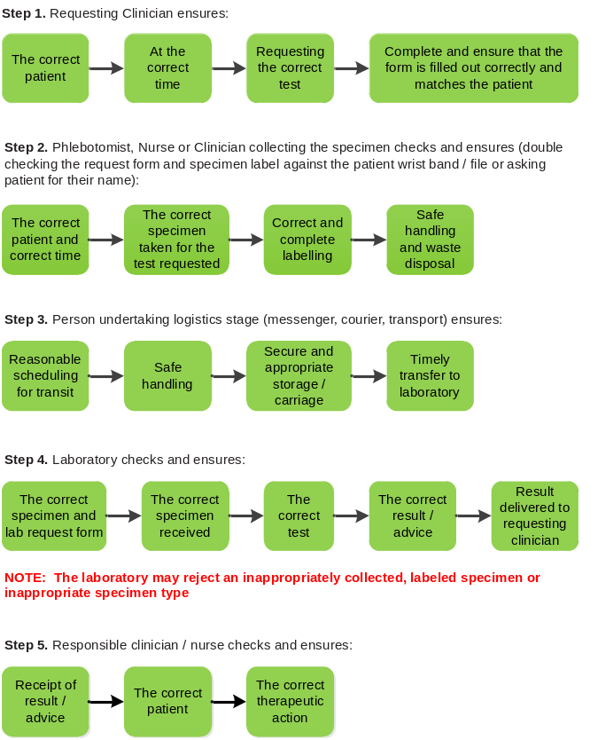

SECTION 9.0
COMPLETION OF REQUISITION FORMS

9.0 REQUISITION FORM
NHLS provides request forms to be completed for all specimens.
Forms have unique barcode numbers and therefore, should not be photocopied.
Please complete the appropriate form in full so that the laboratory will be able to process specimens correctly.
The following information is essential for sample processing:
- Patient name/surname, sex, age/date of birth, hospital or clinic number and identity document (ID) number/passport number: To ensure that the laboratory data is matched to the correct patient and that appropriate age and sex adjusted reference intervals are supplied.
- Patient’s location (hospital ward/clinic): To ensure that the laboratory reports are sent to the appropriate location. Please use the official names of the facilities and avoid using abbreviations.
- Collection date and time: Gives indication of the time interval between collection and receipt/processing of the specimen.
- The doctors/sisters full name and contact details: So that he/she can be contacted if need arises.
- Electronic Gate Keeping (eGK): please provide the approval code if required.
- The name of the person collecting the specimens: Information is needed if the person collecting the specimens is not the same as the one in above.
- The investigation required: So that the correct test can be done.
- Type of specimen including collection site (where necessary): For Microbiology, be specific on the type of specimens e.g. sputum, gastric aspirate, type of urine as well as type of swab, NOT Pus swab.
- Clinical diagnosis/information of the patient: Assist with correct processing of the specimen and with interpretation of the result. For certain tests detailed clinical information is mandatory.
Babies’ specimens
In cases where the specimen belongs to a baby, clearly state that this is the baby’s sample. In the event of multiple births, please indicate clearly if the sample is from e.g. Twin A or Twin B, etc. Use the baby’s own folder number.
SHOULD YOU REQUIRE SPECIMENS TO BE TREATED URGENT, PLEASE INDICATE “URGENT” OR “STAT” ON THE FORM.

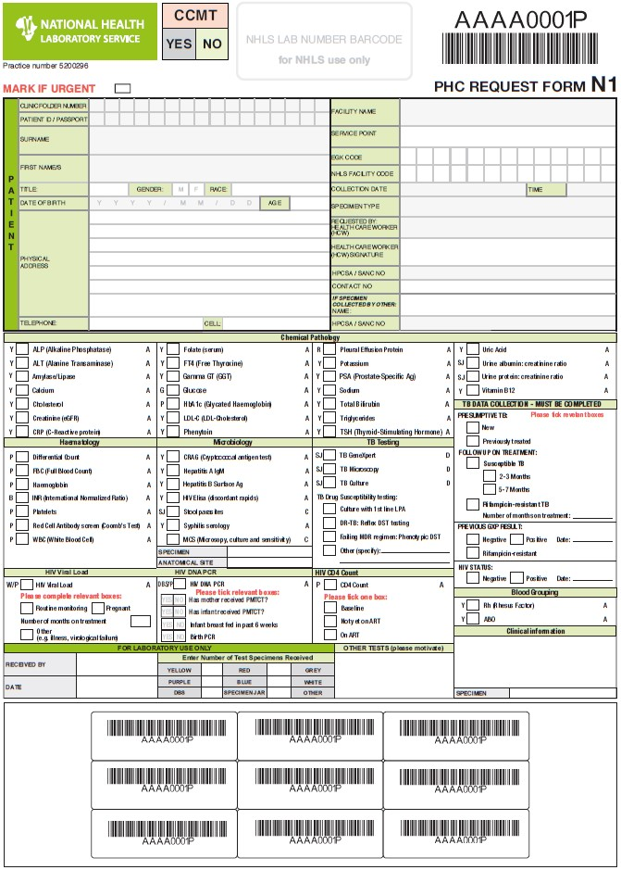

Fig. 9-1: Primary Health Care (PHC) request form N1

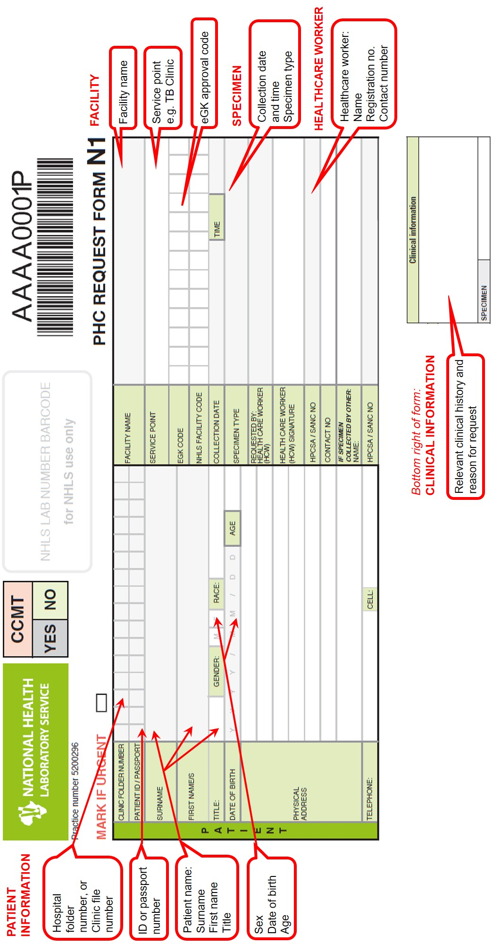
Fig. 9-2: Close-up view of PHC request form N1
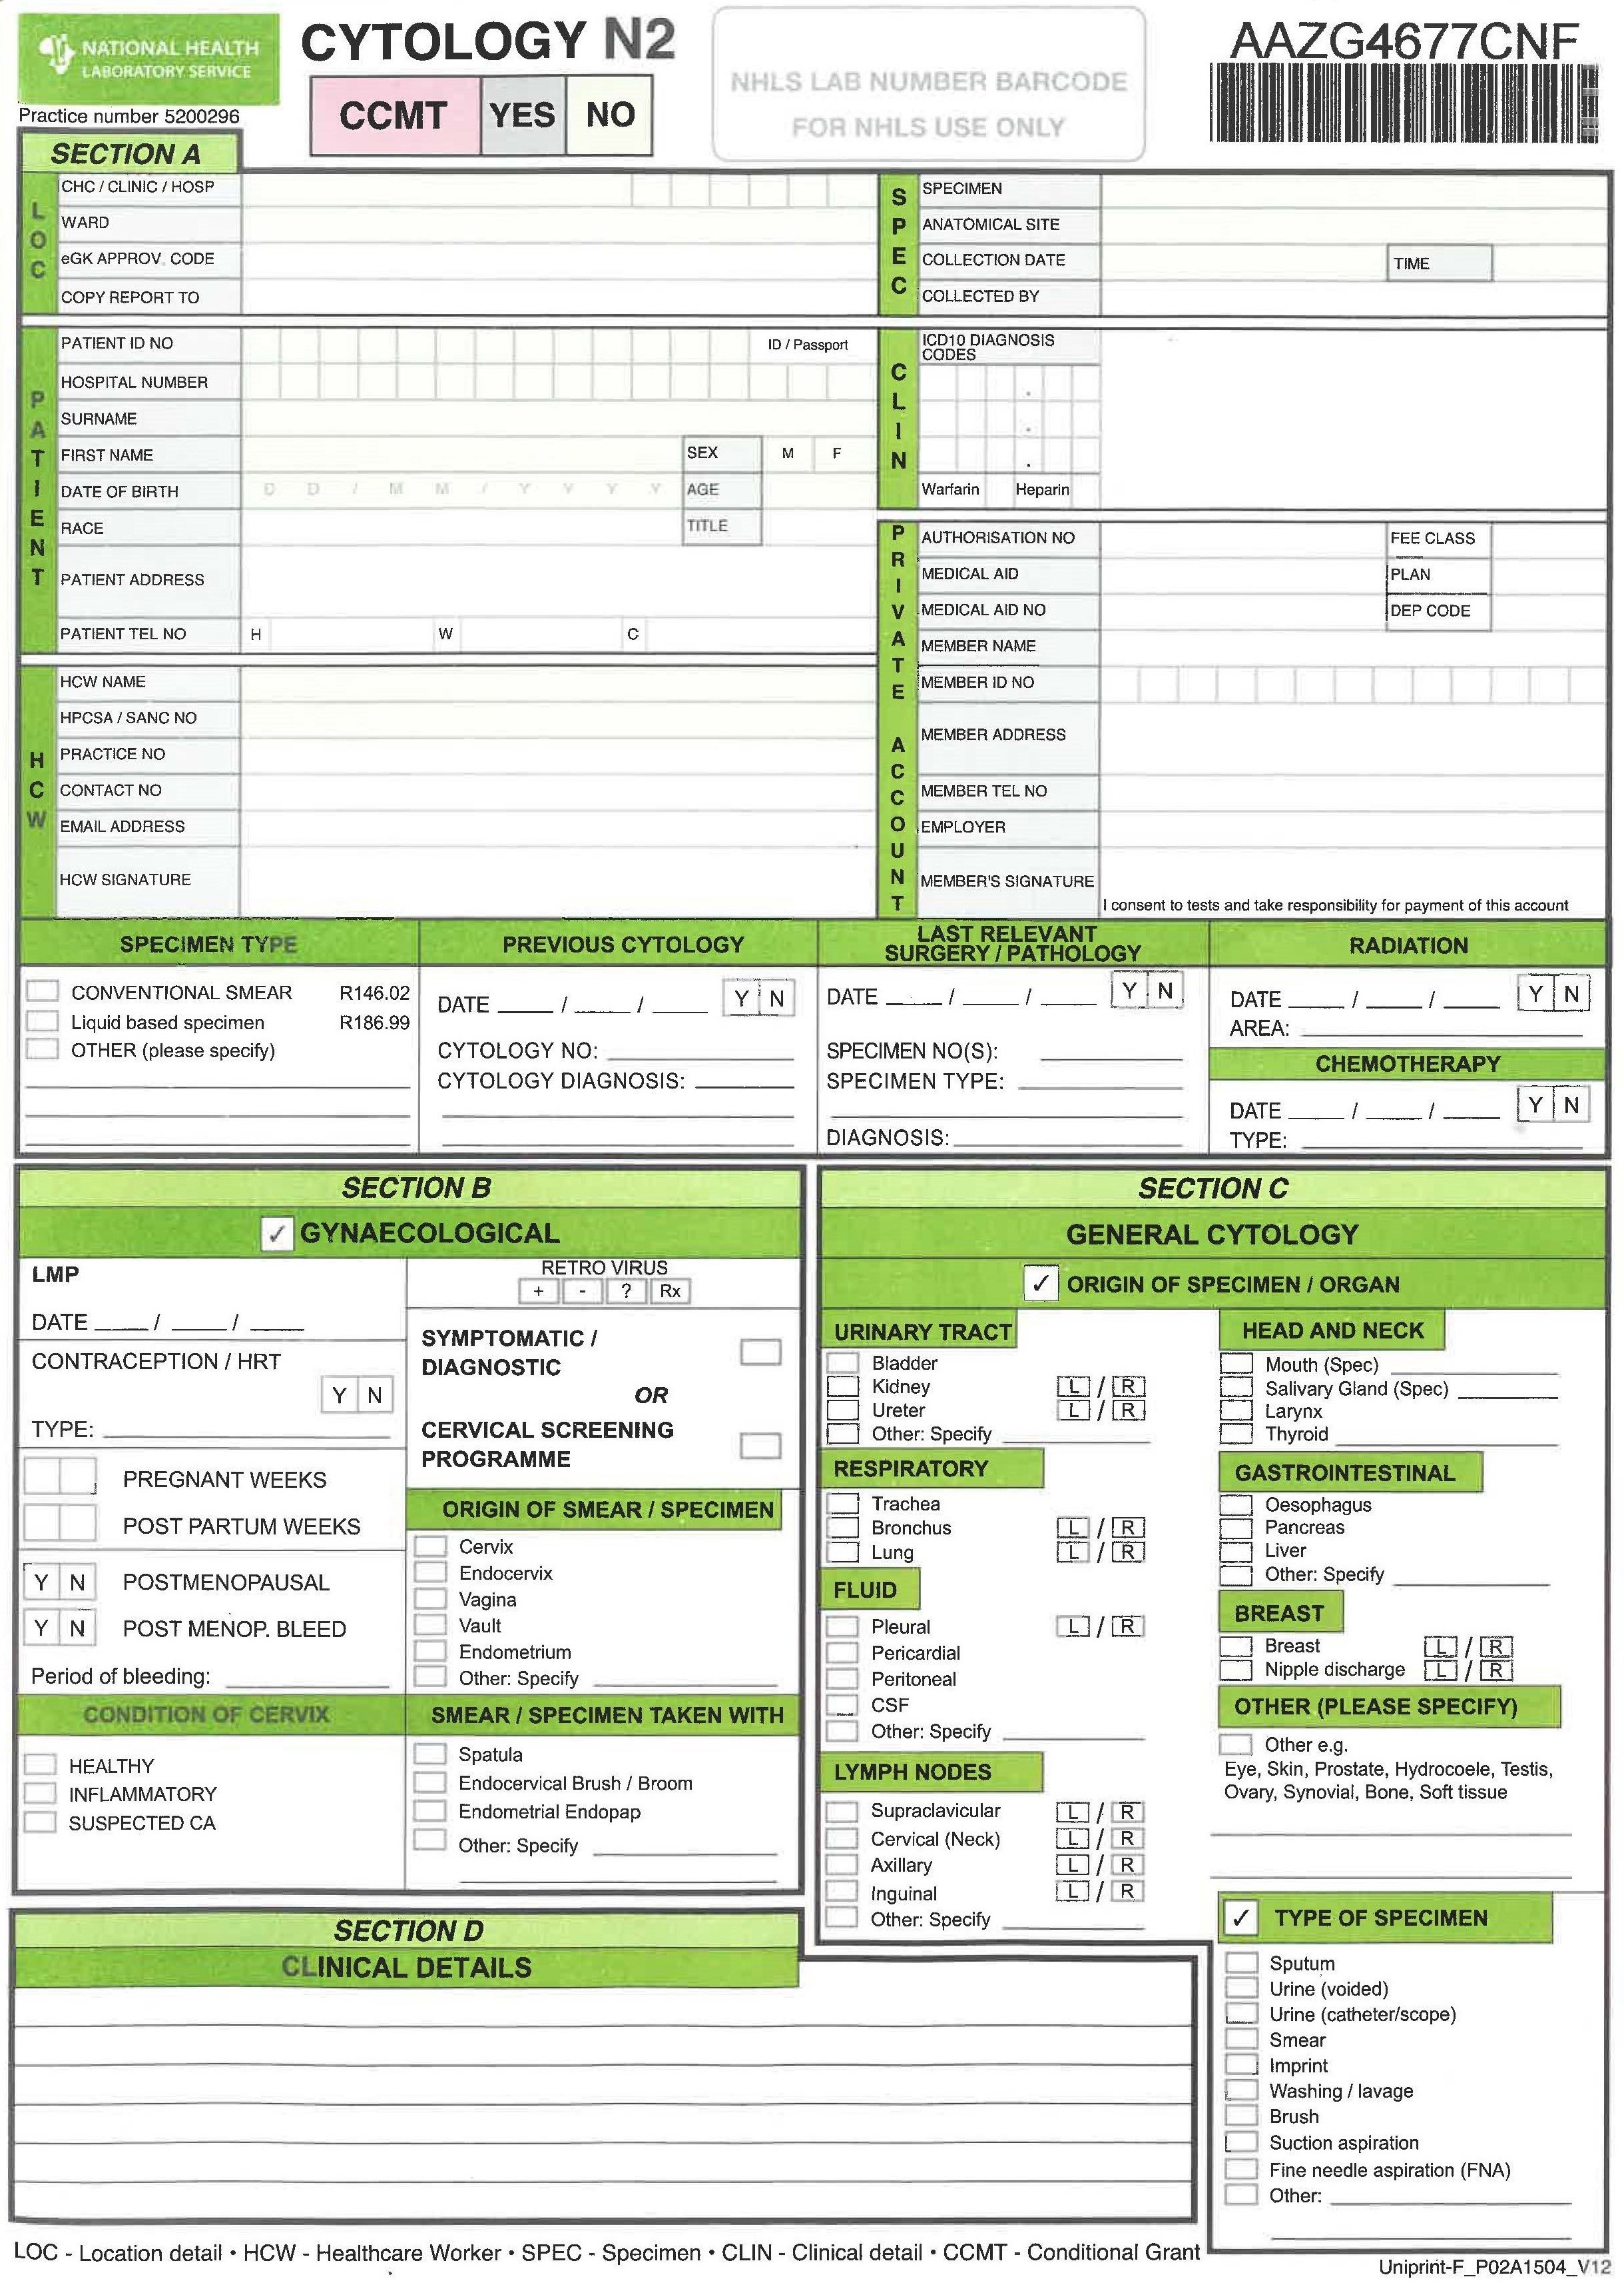
Fig. 9-3: Cytology N2 request form

SECTION 10.0
SPECIMEN COLLECTION
CONTAINERS

10.0 SPECIMEN COLLECTION CONTAINERS
The NHLS will provide selected specimen collection material on request. Examples of materials provided are shown in Figs. 10-1 to 10-8 below. Please contact your local laboratory and inform them which materials you require, the contact details are in Table 7-1 on pages 19−51. Please use the guidelines in Table 20-1 on pages 181 so that the correct container can be used. Guidelines for specimen collection are provided in Section 11 from page 71 onwards. Please follow them to ensure that the laboratory provides you with reliable results.
Examples of materials for specimen collection
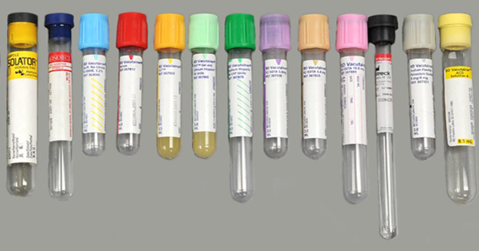
Fig. 10-1. Blood collection tubes in order of draw
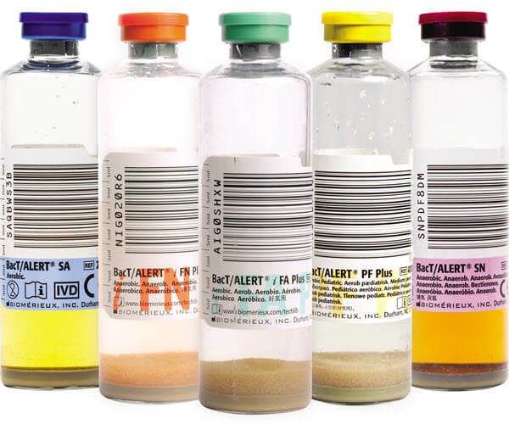 |  | 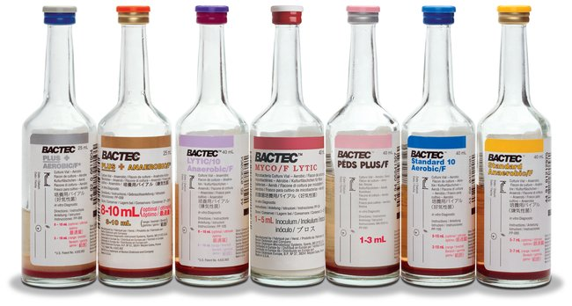
Fig. 10-2. Blood culture bottles
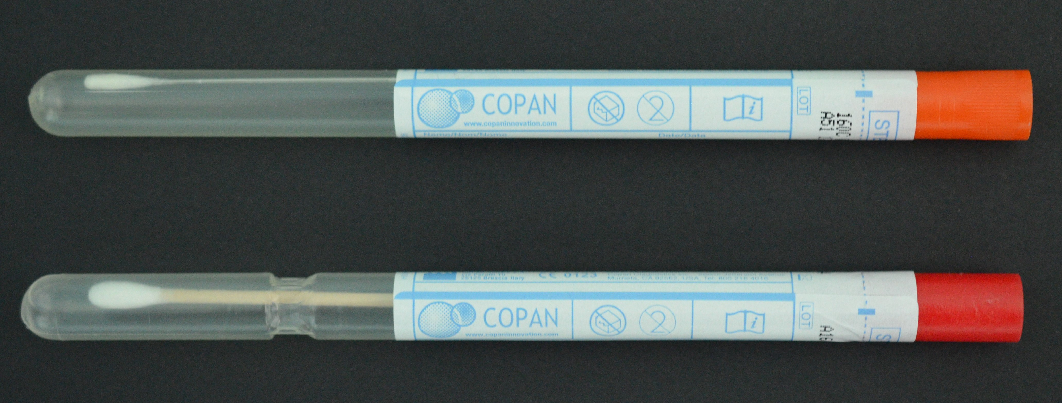
Fig. 10-3. Swabs without transport medium
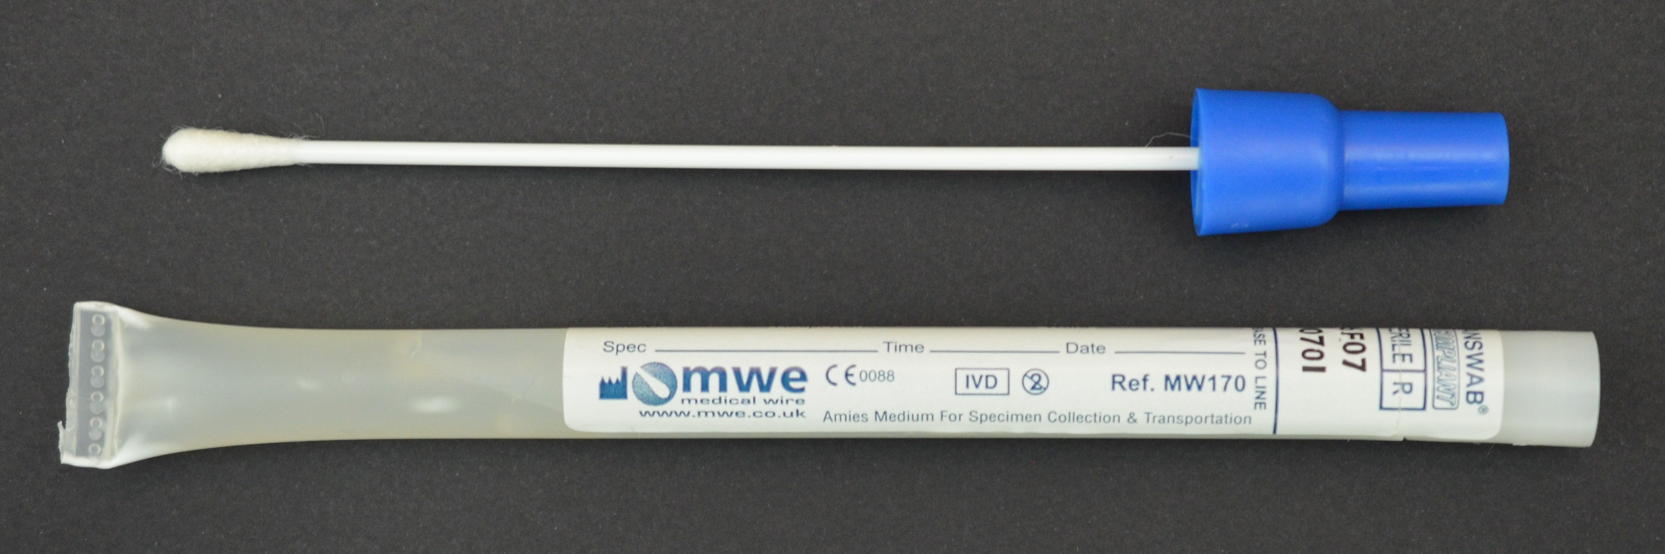
Fig. 10-4. Swab with transport medium
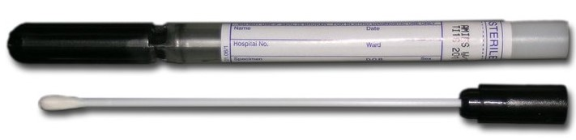
Fig. 10-5. Swab with Amies transport medium and charcoal
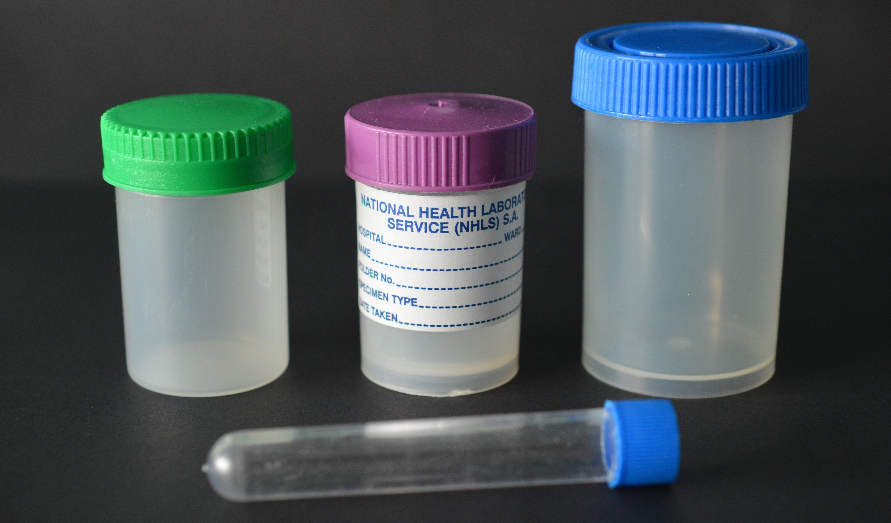
Fig. 10-6. Sterile universal containers
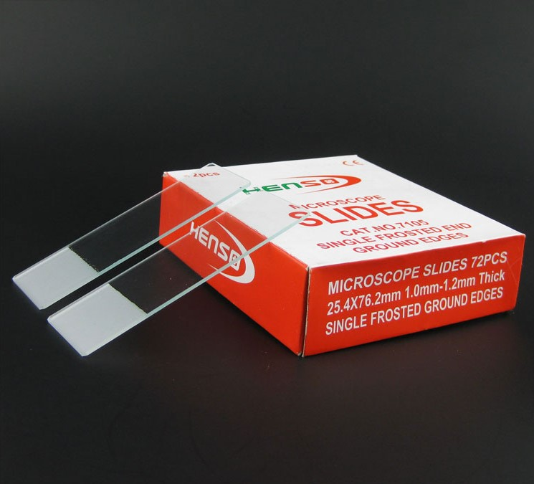 | 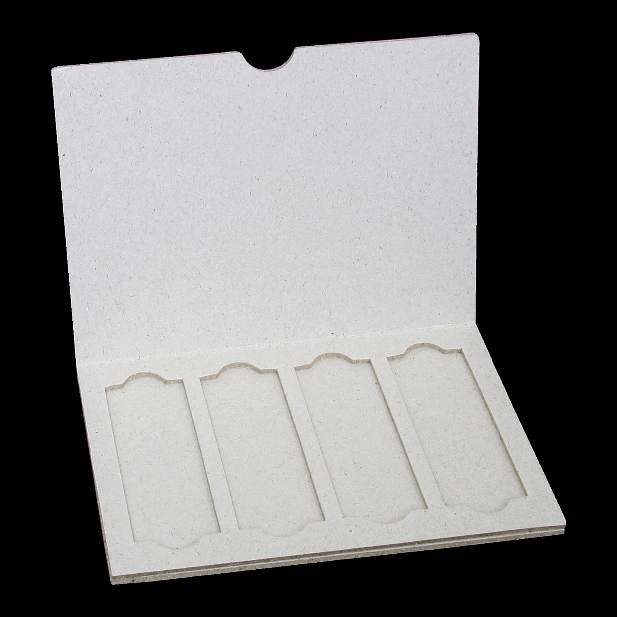 |  | 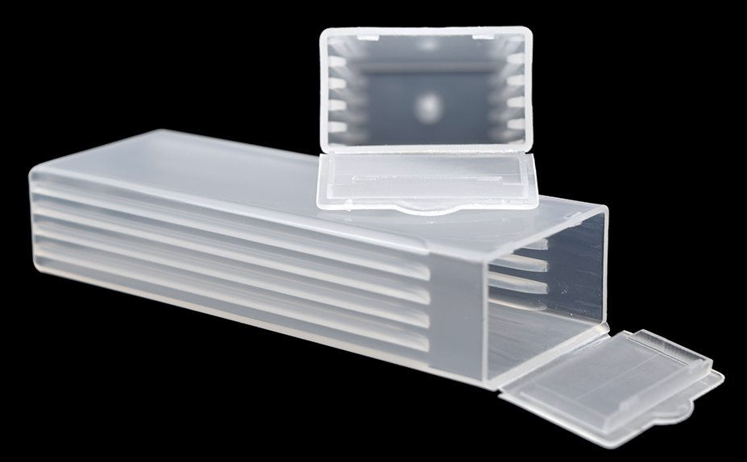
Fig. 10-7. Slides and slide mailer / container
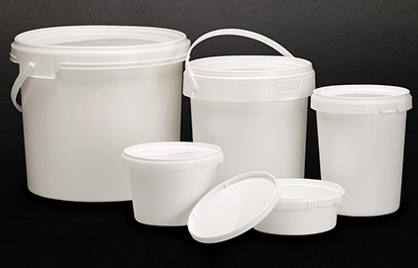
Fig. 10-8. Histology specimen containers

SECTION 11.0
GENERAL SPECIMEN COLLECTION
GUIDELINES

11.0 GENERAL SPECIMEN COLLECTION GUIDELINES
Several essential steps are required for successful sample collection:
- Identify the patient.
- Assess the patient’s general physical condition (e.g. hydration, nutrition, stress).
- Complete the request form, including requested tests, patient information, and confirm the need for any special requirements.
- Prepare the necessary equipment and the patient.
- Collect the sample in the appropriate specimen container at the required volume and with appropriate mixing if required.
- Discard all collection material into appropriate waste containers.
- Label the collection container with a patient ID label or handwritten information at the patient’s side.
- Assess the need for specimen re-collection and/or possible rejection.
- Recognise complications associated with the collection procedure and manage accordingly.
- Promptly send the specimens with the request form to the laboratory.

11.1 Patient identification
Verbal identification
- Greet the patient and identify yourself.
- Ask the patient to state his/her full name. Always ask patients to state their names. Never ask, “Are you John Smith?” (Remember that many patients have a tendency to say yes to anything in the outpatient setting).
- Ask the patient’s date of birth and ask them to spell their names if you want to query the patient’s identity.
Verifying identification
Examination of any of the following should follow verbal identification:
- Identity book.
- Wrist band: All information on the wristband should match the details provided on the request form.
NOTE: A wristband lying on the bedside table may NOT be used for identification.
- Ankle band: Used for paediatric patients and newborns
- Hospital/clinic card/book.
- Hospital card/book: Should be inspected to confirm the patient’s name, hospital number and date of birth.

NOTE: Bed Number – A bed number on the request form cannot be used to identify ward patients.

11.2 Completing the request form
Complete the test request form as described in Section 9 on page 59.

11.3 Collecting the specimen
Specimens should be collected according to the guidelines set out in the appropriate sections in this manual. Any specimens that require invasive sampling techniques should be conducted with the appropriate clinical consultation. Please do not transfer specimens from one collection container to another as this may lead to the mixing of additives or preservatives.

11.4 Labeling of primary specimen containers
- Please ensure that samples are properly labeled with adequate information to ensure that the specimen is traceable to the patient and the accompanying request form.
- Clearly label the specimen container with the patient’s name, file number and label all specimens with one of the peel-off pre-printed barcoded labels from the requisition form.
INSTRUCTIONS TO COMPLETE THIS FORM
- When completing the form, ensure that writing is legible, and all ticks are placed clearly in the tick boxes.
- Please label all specimens with one of the peel-off pre-printed labels, in addition to the patient identification label.
- Use the correct specimen tubes, according to the specimen key next to each test.
- If TB or CCMT tests are requested, the Data Collection questions must be completed.
 | Specimen Key
APPLY BAR CODE LENGHTWISE DO NOT WRAP AROUND | Yellow (or red) with gel | Y
APPLY BAR CODE LENGHTWISE DO NOT WRAP AROUND | Red without gel | R
APPLY BAR CODE LENGHTWISE DO NOT WRAP AROUND | Green (heparin) | G
APPLY BAR CODE LENGHTWISE DO NOT WRAP AROUND | Grey (fluoride) | Grey
APPLY BAR CODE LENGHTWISE DO NOT WRAP AROUND | Purple (EDTA) | P
APPLY BAR CODE LENGHTWISE DO NOT WRAP AROUND | Blue (citrate) | B
APPLY BAR CODE LENGHTWISE DO NOT WRAP AROUND | Black (citrate) | BL
APPLY BAR CODE LENGHTWISE DO NOT WRAP AROUND | White (Plasma Preparation Tube) | W
All slides and smears must be marked with the patient’s details on frosted ends with a pencil or bar coded sticker.
NOTE: Please ensure that the sticker does not cover the entire container, as the laboratory staff must be able to inspect the contents of the container.

11.5 Specimen rejection criteria
Please ensure that all the specimens are collected and transported correctly. This will allow proper diagnostic testing to be done by the laboratory.
The following are examples of specimens that are unacceptable for testing:
- Unlabeled or improperly labeled specimens
- Specimens received in leaking, cracked or broken containers
- Specimens not appropriate for a particular test
- Specimens with obvious (visually, apparent) contamination
- Expired tubes or other collection devices / containers
- Incorrect temperature and/or packaging of specimen
- Stability of the analyte in the specimen has been exceeded (specimen is too old upon receipt)
- Incomplete request forms
- Inadequate volume over / underfilling of specimen container (see Figs. 11-1 to 11-3 on the next page)
- Incorrect specimen container or tube
- Request form not included with the specimen
- Insufficient clinical information for certain tests e.g. Genetics
- Specimen not included with the request form
- Specimen identification is missing or incorrect or does not correlate with the information on request form
- eGK, as per Department of Health (DOH) rules.
- Specimen haemolysed for certain tests.
- Specimen clotted for certain tests.
Specimens may also be rejected if the specific conditions for that particular test listed in Table 24-1 on page 226 are not met.
Exceptions to rejection of samples may be made for critical samples e.g. Cerebrospinal fluid (CSF), tissue, after consultation with the responsible health care worker.

Examples of inadequate volume or overfilling of tubes:

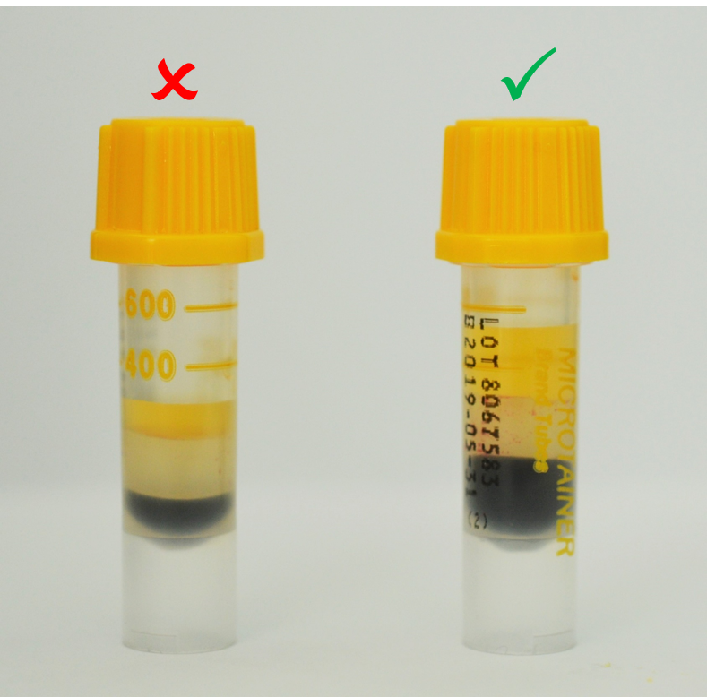 |  | 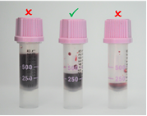
Fig. 11-1. Mini collect /  Paediatric clotted (yellow top)  tubes – Insufficient / underfilled  and sufficient |  | Fig. 11-2. Mini collect/Paediatric Ethylenediaminetetraacetic acid (EDTA) (purple top) tubes – overfilled, sufficient and insufficient / underfilled
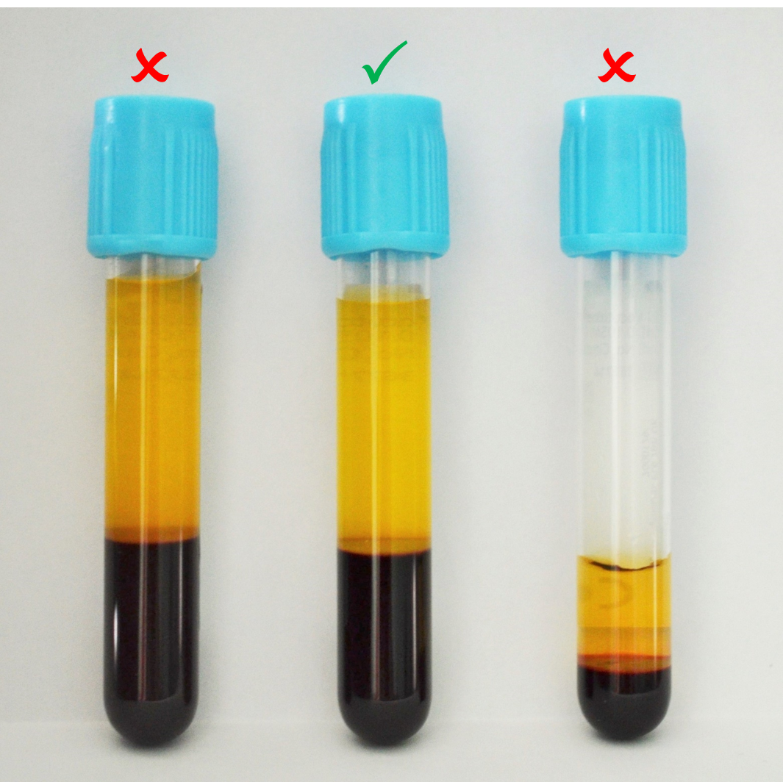
Fig. 11-3. Adult sodium citrate (blue top) tubes for coagulation studies – overfilled, sufficient and insufficient / underfilled

11.6 Specimen packaging
- Always use sealable plastic bags with a separate pouch for the laboratory request form.
- The specimen must be placed in the sealed bag and the form in the outer pouch of the bag. More than one specimen from the same patient can be placed in one bag, but ONLY from that same patient.
- Ensure that all specimens are properly sealed to avoid leaking in transit.
NOTE: Do not staple the plastic bags.
- A red biohazard sticker or label must be used on all specimens from patients suffering from or suspected of having infectious diseases that may put laboratory staff at risk e.g. Viral Haemorrhagic Fever (VHF). Please contact the laboratory BEFORE specimen collection in order to establish the correct procedure.

11.7 Specimen transport
Arrangements have been made with different facilities for specimen transport to the laboratory. Ensure that the specimens are transported in the conditions as described in Table 24-1 on page 226 under the specific test requested. All specimens are to be placed in the containers at the central collection point. These are then taken to the laboratories by different methods depending on the arrangements with the facility:
  - Delivered by hospital staff members.
  - Collected by NHLS messengers and delivered to the laboratory following a specific schedule.
  - Collected by drivers either employed by the NHLS or a courier company contracted by the NHLS and delivered to the laboratory following a specific schedule.

11.8 Multiple specimens
Please submit a separate specimen for tests that are processed in different sections of the laboratory, for example Cluster of Differentiation (CD)4 and HIV viral load testing require separate specimens. Failure to do this may lead to any of the following:
- Delay in results as some tests may have to wait for others to be completed before being done.
- Possibility of errors due to aliquoting.
- Possibility of inadequate specimen volume preventing all the requested tests to be done thus delaying patient management when another specimen must be sent at a later stage.
Always send a separate sample for HIV tests to avoid possible false-positive

results due to cross contamination in the laboratory.

SECTION 12.0
SAFETY AND INFECTION CONTROL

12.0 SAFETY AND INFECTION CONTROL
Due to contact with sick patients and their specimens, it is important to follow safety and infection control procedures. Always follow the hand hygiene approach described in Fig. 12.1 on the next page.
PROTECT YOURSELF

12.1 Practise universal precautions
  - Wear gloves and protective gear when handling blood/body fluids.
  - Change gloves after each patient contact.
  - Wash hands frequently or use antiseptic, after each patient.
  - Dispose of all items in the appropriate waste containers.
  - Dispose of needles in a sharps container immediately upon removal from the patient’s vein. Do not bend, break, or recap needles to avoid accidental needle puncture or splashing of contents.
  - Clean up any blood spills or any other potentially infectious specimens with a suitable disinfectant (please refer to your local facility’s document).

12.2 Body fluid exposure (e.g. needle stick, eye splash, etc.)
- Remain calm.
- Remove your gloves and dispose all contaminated materials in the appropriate waste container.
- Rinse the affected area under running water.
- Record the patient’s name and ID number.
- Follow your institution’s injury on duty guidelines regarding further treatment and follow-up.

12.3 Protect the patient
- Place blood collection equipment away from patients, especially children and psychiatric patients.
- When wearing gloves, change them between patients and wash or disinfect your hands frequently.
- For point of care devices, clean as per manufacturer’s instruction.

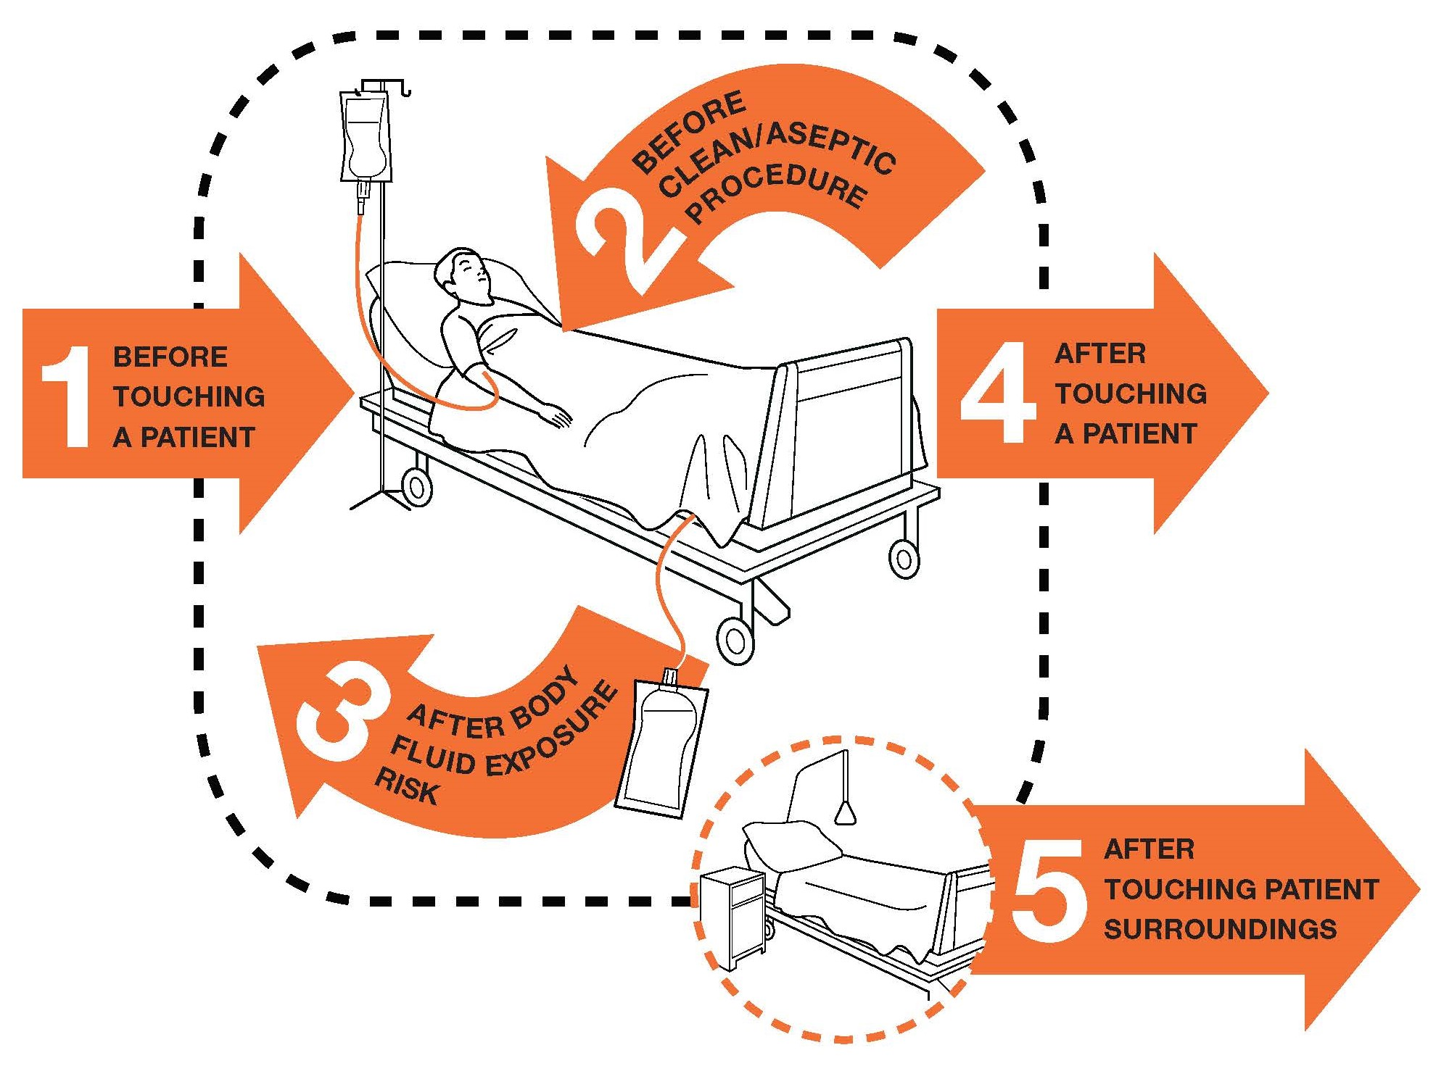

Fig. 12-1: The “5 Moments for Hand Hygiene” approach
SECTION 13.0
BLOOD SAMPLE COLLECTION PROCEDURE

13.0 BLOOD SAMPLE COLLECTION PROCEDURE
The procedure below is to be followed for collection of specimens where blood has to be collected for testing in all disciplines of the laboratory, e.g. Chemical Pathology, Haematology, Immunology, Microbiology, Serology and Virology. For blood culture collection procedure, refer to Section 17.2.5 on page 142.

Please follow the guidelines given in Table 24-1 from page 226 on the type of tube to be used and the instructions to follow for each test.

Before drawing blood for an HIV screening test, counseling should be done by the relevant Health Care Practitioner. Counseling records are kept in the patient’s file.

13.1 Venepuncture procedure
The venepuncture procedure is complex, requiring both knowledge and skill to perform. Each phlebotomist generally establishes a routine that is comfortable for her or him. Several essential steps are required for every successful collection procedure:
  - Identify the patient.
  - Assess the patient’s physical general condition (e.g. hydration, nutrition, stress).
  - Check the request form for requested tests, patient information and any special requirements.
  - Prepare the equipment, the patient and the puncture site.
  - Perform the venepuncture.
  - Collect the sample in the appropriate tube to the required filling level following the correct order of draw and invert the tubes 6−8 times.
  - Label the collection tubes with patient identity, and request form bar code label at the bedside or in the drawing area in the presence of the patient.
  - Assess the adequacy and suitability of the samples prior to sending to the laboratory.
  - Recognise complications associated with the phlebotomy procedure and manage accordingly.
  - Promptly send the specimens with the request form to the laboratory.

13.1.1 Order of draw
Blood collection tubes must be drawn in a specific order to avoid cross-contamination of additives between tubes. The recommended order of draw is as follows:
First draw | Blood culture bottles (refer to Section 17.2.5 on page 142)
Second draw* | Coagulation tube / sodium citrate (blue top) tube
Third draw | Clotted tube (red or yellow top) & non-additive tube (clear top)
Last draw | Additive tubes in this order:  - Heparin (dark green top)  - EDTA (purple top)  - Plasma preparation tube (PPT) (pearl top)  - Acid citrate dextrose (ACD) (pale yellow)  - Fluoride oxalate (grey top)
*When using a butterfly device (winged collection system), first draw a sample to discard in a beige/tan top tube then proceed to draw a blue top tube.
NOTE: Tubes with additives must be thoroughly mixed (by gentle inversion and not shaking). Erroneous test results may be obtained when the blood is not thoroughly mixed with the additive, especially tests for Haematology. Overzealous mixing also results in haemolysis. Certain tests cannot be performed accurately in the presence of haemolysis.
WARNING: Do not pour contents from one tube into another as this will cause cross contamination of additives, which may cause erroneous test results.
Please refer to Table 13-1 on page 87 for more information.

13.1.2 Venepuncture site selection
  - Although the larger and fuller median cubital and cephalic veins of the arm are used most frequently, wrist and hand veins are also acceptable for venepuncture. If other sites are needed, they should be done with clinical consultation.
  - Certain areas are to be avoided when choosing a site:
    - Extensive scars from burns and surgery: It is difficult to puncture the scar tissue and obtain a specimen.
    - The upper extremity on the side of a previous mastectomy: Test results may be affected because of lymphoedema.
    - Haematoma: May cause erroneous test results. If another site is not available, collect the specimen distal to the haematoma.

    - Intravenous therapy (IV) / blood transfusions: Fluid may dilute the specimen, so collect from the opposite arm if possible.
    - Otherwise, satisfactory samples may be drawn below the IV by following these procedures:
- Turn off the IV for at least 2 min before venepuncture.
- Apply the tourniquet below the IV site. Select a vein other than the one with the IV.
- Perform the venepuncture. Draw 5 mL of blood and discard before drawing the specimen tubes for testing.
- Cannula / fistula / heparin lock: Hospitals have special policies regarding these devices. In general, blood should not be drawn from an arm with a fistula or cannula without consulting the attending physician.
- Oedematous extremities: Tissue fluid accumulation may alter test results.

13.1.3 Procedure for vein selection
  - Palpate and trace the path of veins with the index finger. Arteries that pulsate are most elastic and have a thick wall. Thrombosed veins lack resilience, feel cord-like and roll easily.
  - If superficial veins are not readily apparent, gently tap the site with the index and second finger, apply a warm, damp washcloth to the site for 5 min, or lower the extremity over the bedside to allow the veins to fill.

13.1.4 Performance of a venepuncture
  - Also see Fig. 13-1 on page 88 for a quick guide to the performance of a venepuncture.
  - Approach the patient in a friendly, calm manner. Provide for their comfort as much as possible, and gain the patient’s co-operation.
  - Identify the patient correctly (as per Section 11.1 on page 71).
  - Practice universal infection control precautions as described under Safety and Infection Control (Section 12 on page 79).
  - Properly fill out the appropriate request form as described in Section 9 on page XX, indicating the test(s) ordered.
  - Verify the patient’s condition. Fasting, dietary restrictions, medications, timing, and medical treatment are all of concern and should be noted on the laboratory request form.
  - Position the patient. The patient should sit in a chair, lie down or sit up in bed.

- Carefully hyperextend the patient’s arm.
- Apply the tourniquet 7.5−10 cm above the selected puncture site. Do not place too tightly or leave on for more than 2 min.
- The patient should make a fist without pumping the hand.
  - Select the venepuncture site.
  - Prepare the patient’s arm using an alcohol wipe. Cleanse in a circular fashion, beginning at the site and working outward. Allow to air dry.
  - Hold the patient’s arm firmly using your thumb to draw the skin taut and anchor the vein. The needle should form a 15 to 30-degree angle with the surface of the arm. Swiftly insert the needle through the skin and into the lumen of the vein. Avoid excessive trauma and probing.
  - As soon as the blood flows into the first tube, release the tourniquet.
  - Remove the needle from the patient’s arm using a swift backward motion.
  - Press down on the gauze once the needle is out of the arm, applying adequate pressure to avoid the formation of a haematoma.
  - Dispose of needle in the sharps container WITHOUT RECAPPING.
  - Dispose of contaminated materials/supplies in the designated waste containers.
  - Have the patient hold a small gauze pad over the puncture site for a couple of minutes to stop the bleeding. Cover the puncture site with sterile gauze, held in place with an elastic plaster.
  - Mix and label all appropriate tubes at the patient bedside. Label the tubes with the appropriate patient information as described in Section 11.4 on page 72.
  - Send specimens to the laboratory immediately.

NOTE: Special handling requirements: Some specimens need to be immediately transported to the laboratory under special conditions, e.g. ammonia and serum osmolality on ice and cryoglobulins at 37°C (the specimen tube is best transported under the axilla to maintain temperature). Refer to the complete test list in Table 24-1 on page 226 for full details of other analytes which may require special transport conditions.

Table 13-1: Order of draw and appropriate sample tubes with examples of tests
Collection tube |  | Additive | Tests | Special instructions
Blood culture bottles |  |  | Culture | Refer to Section 17.2.4 for volume of blood to be collected, and Figs. 17-2 & 17-3 for Blood culture collection procedure
Blue Top | 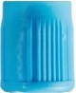 | Sodium Citrate | Coagulation tests e.g. INR, Partial Thromboplastin Time (PTT), fibrinogen & D-dimer | Full draw required  (Volume stated on tube – Adult tube: 3.2 mL; Paediatric tube: 1.8 mL OR 0.9 mL)  Invert gently 3−4 times
Red Top | 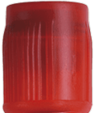 | Clot activator, silicon coated | Selected tests only, e.g. Meth (see Table 24-1 on page 226) | Cannot be used for CSF  specimens  Invert 5 times after sampling
Yellow Top | 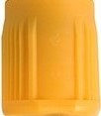 | Serum Separating Tube (SST) – clot activator & gel | Most clinical chemistry, serology, immunology & toxicology | Invert 5 times after sampling to ensure mixing of clot activator & blood
OR
OR | 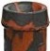 | Serum Separating Tube (SST) – clot activator & gel | Most clinical chemistry, serology, immunology & toxicology
Red & gray Top
Green Top | 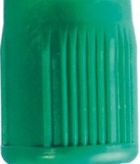 | Sodium or lithium heparin (light green with gel) | Certain tests e.g. traditional cytogenetic studies & flow cytometry | Invert 8 times after sampling to ensure mixing of anticoagulant with blood to prevent clotting
Purple / Lavender  Top | 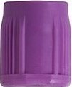 | Dipotassium ethylenediaminetetraacetic acid (K₂EDTA) | Certain haematology, clinical chemistry, molecular genetic studies, toxicology & virology | Invert 8 times after sampling to ensure mixing of anticoagulant with blood to prevent clotting
Pearl / White Top | 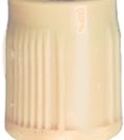 | Plasma preparation tube (PPT) – K₂EDTA with gel | HIV viral load | Invert 8 times after sampling to ensure mixing of anticoagulant with blood to prevent clotting
Black Top | 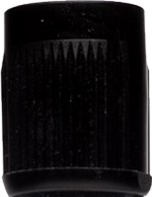 | Sodium citrate  (buffered) | Erythrocyte sedimentation rate (ESR) | Full draw required  Invert 8 times after sampling to ensure mixing of additives with blood
Grey Top | 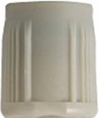 | Sodium fluoride & potassium oxalate or Disodium ethylenediaminetetraacetic acid (Na₂EDTA) | Glucose & lactate | Full draw required  Invert 8 times after sampling to ensure mixing of additives with blood
Light yellow Top | 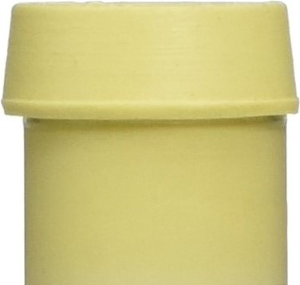 | Citrate Dextrose | Tissue typing, cross match | Invert 4 times
PLEASE NOTE: The colour of the collection tube top may vary slightly between different manufacturers. Select the collection tubes according to the desired additive.
QUICK GUIDE TO PERFORMANCE OF A VENEPUNCTURE
Always use universal safety precautions
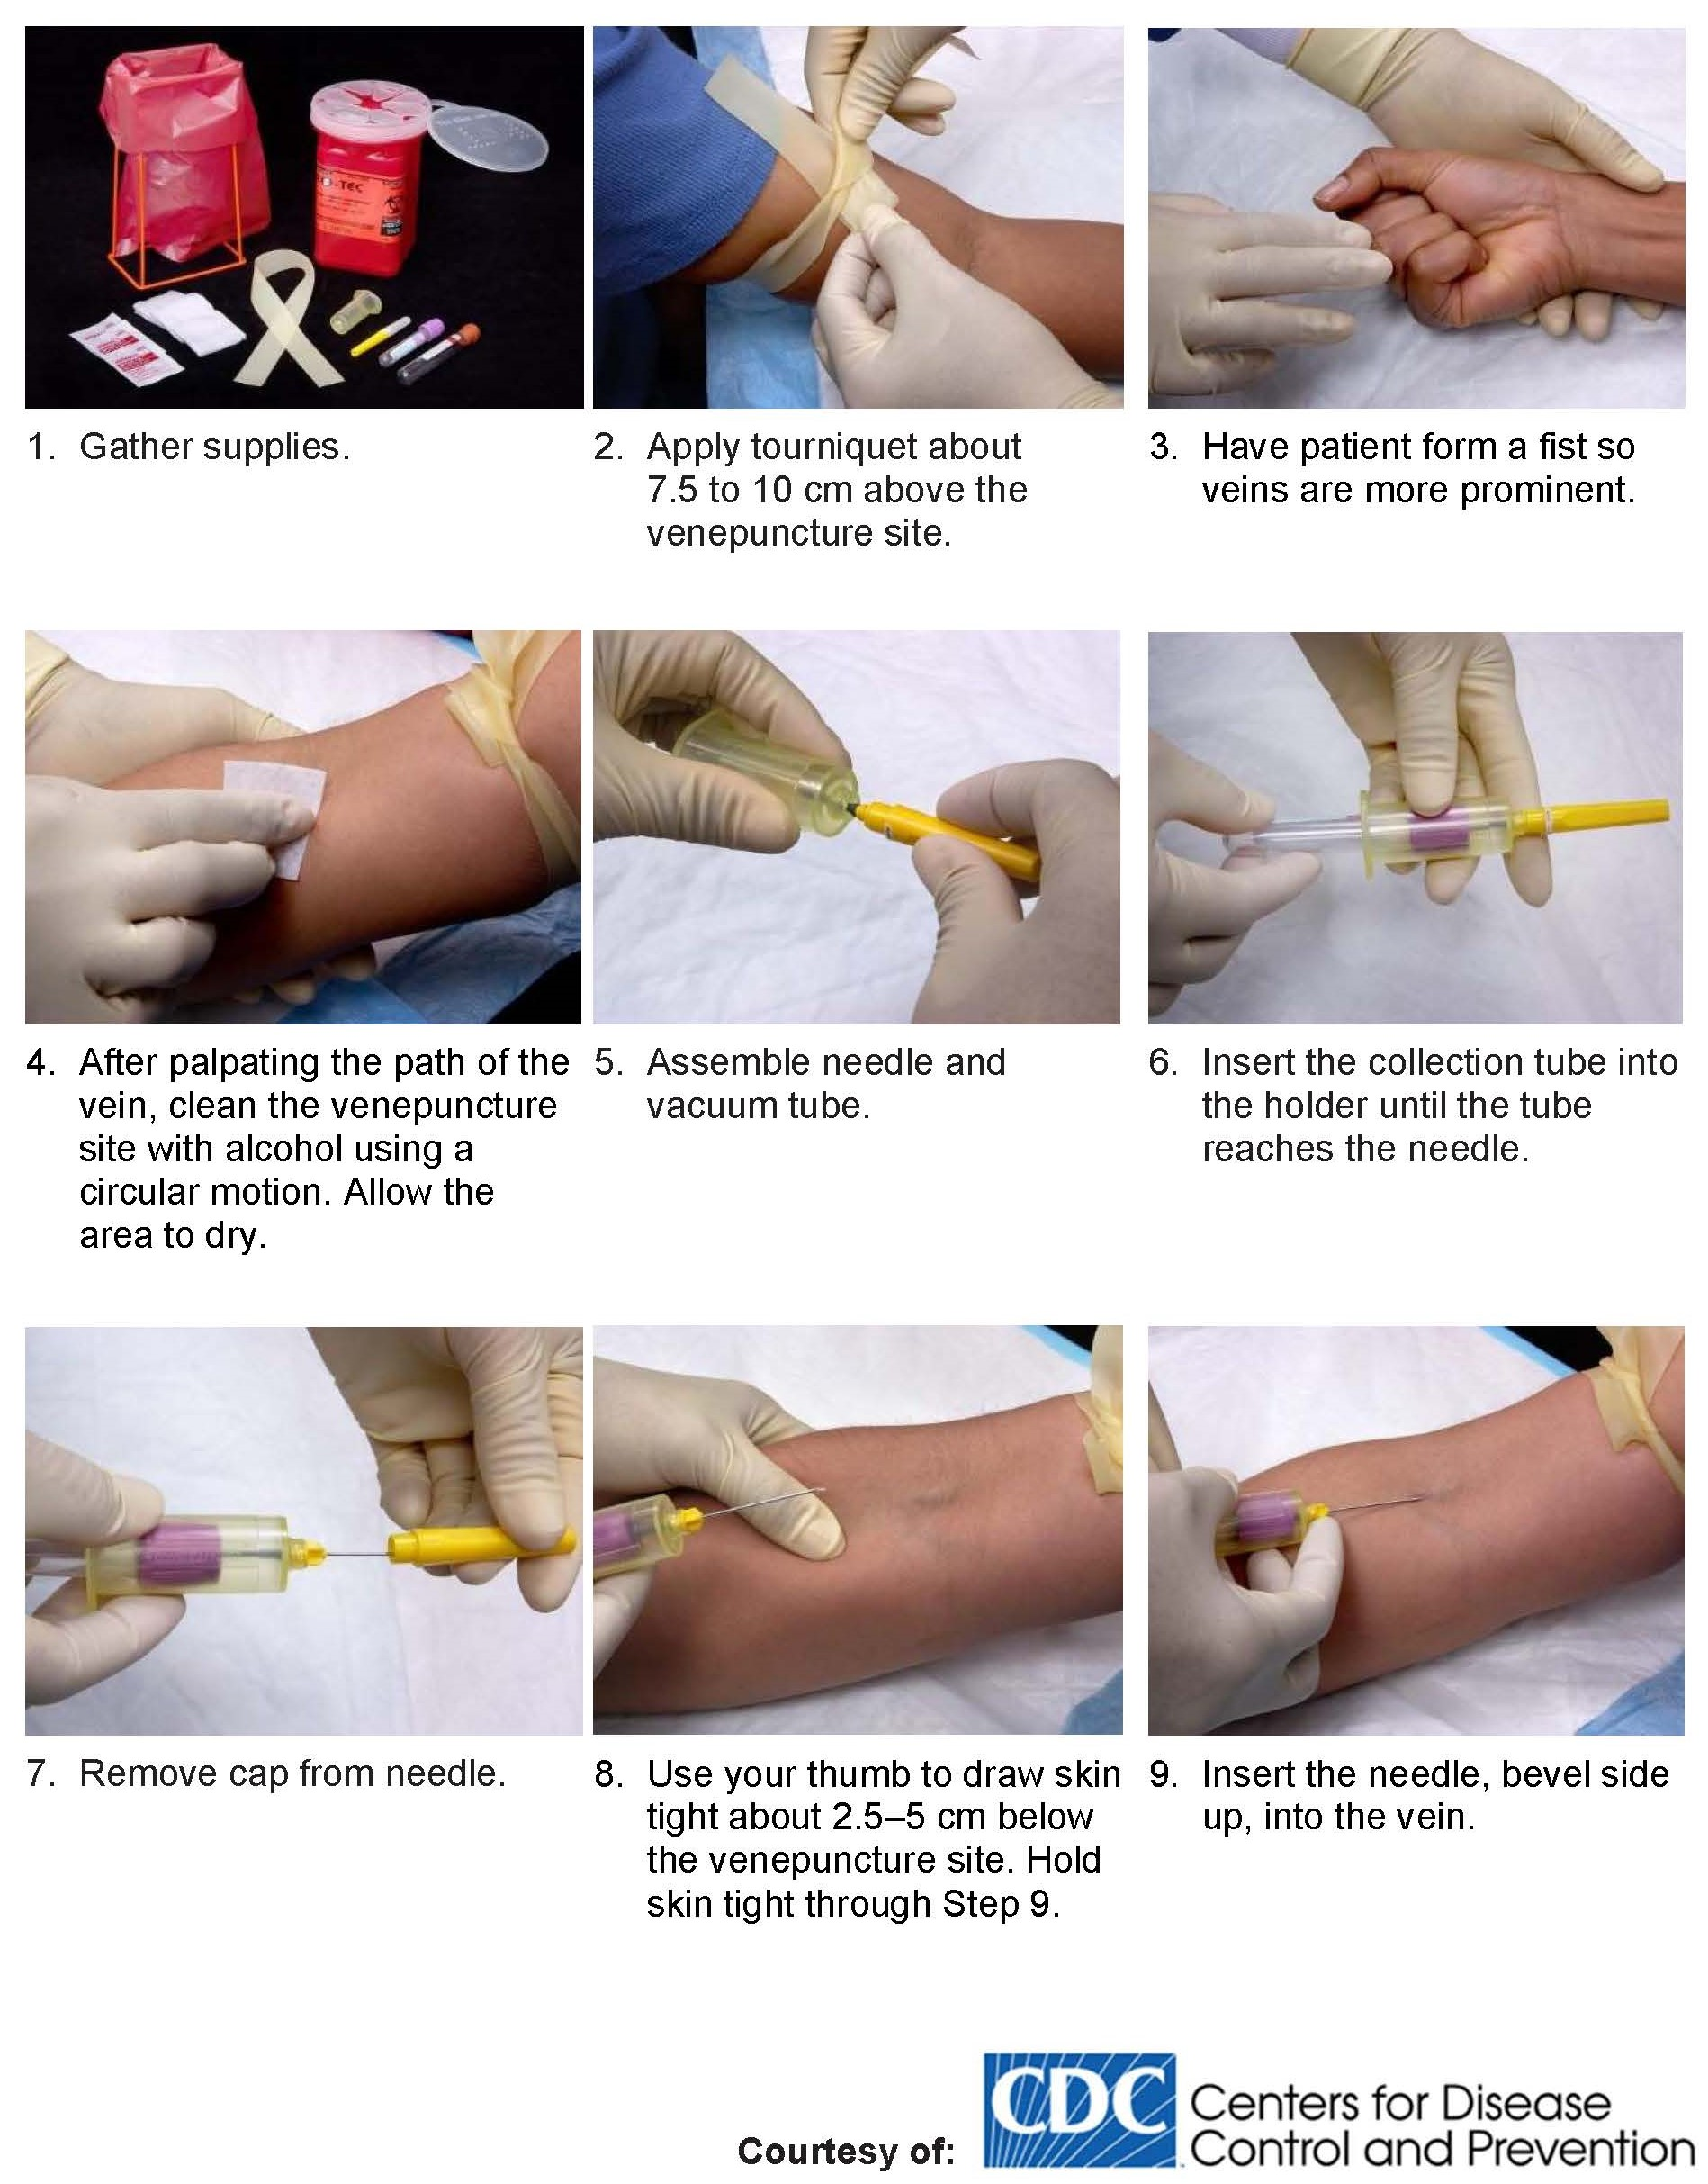
Fig. 13-1: A quick guide to performance of a venepuncture.

13.2 Additional considerations

13.2.1 Tourniquet use
    - The primary effect is haemoconcentration of elements that are not filterable (i.e. proteins). The hydrostatic pressure causes some water and filterable elements to leave the extracellular space.
    - Affects packed cell volume (PCV) and other cellular elements.
    - The following serum chemistry tests can be affected by tourniquet use which should, therefore, be minimised:
    - Calcium
    - Lactate
    - Potassium
    - Total protein
    - Iron
    - Cholesterol
    - Triglycerides
    - Bilirubin
    - Aspartate aminotransferase.

13.2.2 Preventing a haematoma
- Use the major superficial veins.
- Make sure the needle fully penetrates the uppermost wall of the vein, otherwise blood may leak into the surrounding soft tissue.
- Remove the tourniquet before removing the needle.
- Apply pressure to the venipuncture site after sample collection.

13.2.3 Preventing haemolysis
- The use of a vacuum tube system (e.g. vacutainer or vacuette) to draw blood is recommended.
- Allow the venipuncture site to air dry, to allow the alcohol to evaporate.
- Use appropriate needle gauge (bore) size for the age of the patient.
- Avoid drawing blood from a haematoma.
- If using a needle and syringe, avoid pulling or pushing the plunger forcefully.
- Invert tubes with anticoagulant additives gently 5−10 times.
- Avoid a probing, traumatic venipuncture.

13.2.4 Preventing haemoconcentration
An increased concentration of larger molecules and formed elements in the blood may be due to several factors:
Prolonged tourniquet application (no more than 2 min).
- Massaging, squeezing, or probing a venipuncture site.
- Sclerosed or occluded veins.

13.2.5 Using indwelling lines or catheters
- Potential source of test error due to contaminaton by catheter fluid.
- Most lines are flushed with a solution of heparin to reduce the risk of thrombosis. Discard a sample at least three times the volume of the line before a specimen is obtained for analysis.

13.3 Factors that may affect patient results
  - Therapeutic drug monitoring: Different pharmacological agents have different patterns of administration, body distribution, metabolism, and elimination that affect the drug concentration as measured in the blood. Many drugs will have “peak” and “trough” levels that vary according to dosage levels and intervals. Check for timing instructions in Table 24-1 on page 226 for drawing the appropriate samples. Timing of phlebotomy relative to drug dosing must be stated on the request form.
  - Effects of exercise: Muscular activity has both transient and longer lasting effects. Creatine kinase (CK), aspartate aminotransferase (AST), lactate dehydrogenase (LDH), troponin, lactate and platelet count may be affected.
  - Stress: May cause transient elevation in white blood cells (WBCs) and elevated adrenal hormone values (cortisol and catecholamines). Anxiety that results in hyperventilation may cause acid-base imbalances.
  - Diurnal rhythms: Diurnal rhythms are body fluid and analyte fluctuations during the day, e.g. serum cortisol levels are highest early in the morning but are decreased in the afternoon. Serum iron levels tend to drop during the day. You must check the timing of these variations for the desired collection point.
  - Posture: Postural changes (supine to sitting, etc.) are known to influence laboratory results of some analytes. Certain larger molecules are not filterable into the tissue; therefore, they are more concentrated in the blood. Enzymes, proteins, lipids, iron and calcium are significantly increased with changes in position.

  - Other physiological factors: Age, sex, menstrual cycle and pregnancy have an influence on some laboratory results. Normal reference ranges are often noted according to age and sex, and therefore it is crucial to supply this information on the request form.
  - Technical factors:
  - Tourniquet application (for certain analytes)
  - Incorrect collection tube selection
  - Toppling between different collection tubes
  - Incorrect order of the draw
  - Incorrect sample volume
  - Delay in analysis (refer to Table 24-1 on page 226 for individual analyte details)
  - Incorrect transport conditions (refer to Table 24-1 on page 226 for individual analyte details).

13.4 Troubleshooting guidelines
  - If an incomplete collection or no blood is obtained:
- Change the position of the needle. Move it forward (it may not be in the lumen of the vein) or move it backward (it may have penetrated too far).
- Adjust the angle (the bevel may be against the vein wall).
- Loosen the tourniquet. It may be obstructing blood flow.
- Try another tube. There may be no vacuum in the one being used.
- Re-anchor the vein. Veins sometimes roll away from the point of the needle and puncture site.
  - If the blood stops flowing into the tube:
- The vein may have collapsed – re-secure the tourniquet to increase venous filling. If this is not successful, remove the needle, take care of the puncture site, and redraw from a new site.
- The needle may have pulled out of the vein when switching tubes. Hold equipment firmly and place fingers against patient’s arm, using the flange for leverage when withdrawing and inserting tubes.
  - Problems other than an incomplete collection:
- A haematoma forms under the skin adjacent to the puncture site; release the tourniquet immediately and withdraw the needle. Apply firm pressure and redraw from a new site.
- The blood is bright red (arterial) rather than dark red (venous). Apply firm pressure to the puncture site for more than 5 min.

13.5 Performance of a finger prick
  - See Fig. 13-2 on page 93 for a quick guide to performance of a finger prick.
  - Follow the procedure as outlined above for greeting and identifying the patient. As always properly fill out the appropriate request form, indicating the test(s) ordered.
  - Verify the patient’s condition. Fasting, dietary restrictions, medications, timing, and medical treatment are all of concern and should be noted on the laboratory request form.
  - Practise universal infection control precautions as described in Section 12.1 on page 79. Position the patient. The patient should sit in a chair, lie down or sit up in bed.
  - The best locations for performing a fingerprick are the 3rd and 4th fingers of the non-dominant hand. Do not use the tip of the finger or the centre of the finger. Avoid the side of the finger where there is less soft tissue, where vessels and nerves are located, and where the bone is closer to the surface. The 2nd (index) finger tends to have thicker, callused skin. The 5th finger tends to have less soft tissue overlying the bone. Avoid puncturing a finger that is cold or cyanotic, swollen, scarred, or covered with a rash.
  - Clean skin with an alcohol wipe and allow to dry.
  - Using a sterile lancet, make a skin puncture just off the centre of the finger pad. The puncture should be made perpendicular to the ridges of the fingerprint so that the drop of blood does not run down the ridges.
  - Wipe away the first drop of blood, which tends to contain excess tissue fluid.
  - Collect drops of blood into the collection device by gently massaging the finger. Avoid excessive pressure that may squeeze tissue fluid into the drop of blood.
  - Cap, rotate and invert the collection device to mix the blood collected.
  - Have the patient hold a small gauze pad over the puncture site for a couple of minutes to stop the bleeding.
  - Dispose of contaminated materials/supplies in designated waste containers.
  - Label all tubes with the appropriate information at the patient’s bedside. Label the tubes with the patient’s name and hospital/clinic number.
  - Send specimens to the laboratory immediately.
QUICK GUIDE TO PERFORMANCE OF A FINGER PRICK
Always use universal safety precautions
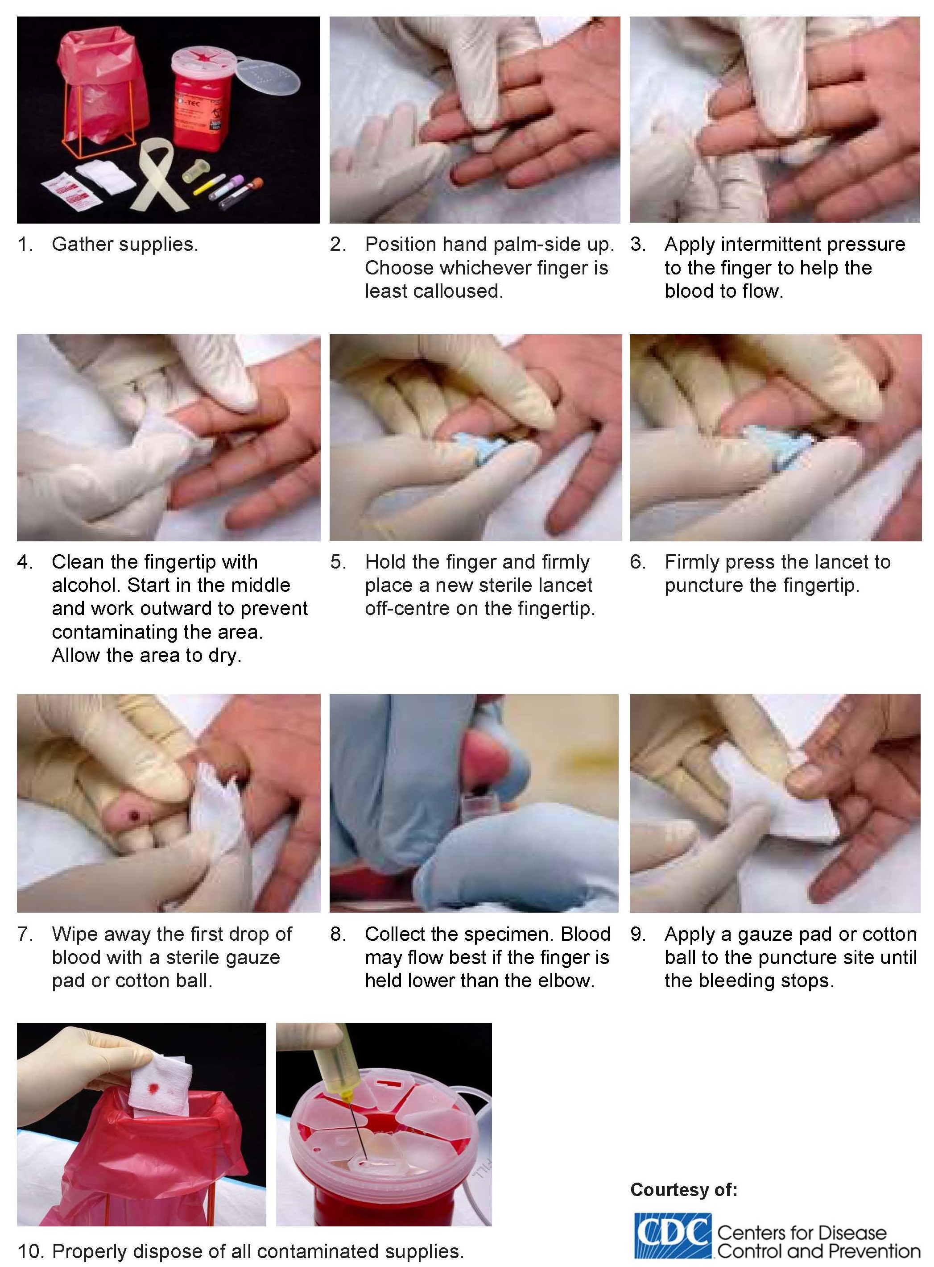
Fig. 13-2: A quick guide to performance of a finger prick.

13.6 Blood collection from babies (heel prick)
  - In most circumstances, the recommended location for blood collection on a newborn baby or infant is the heel.
  - Gently pre-warm the infant’s heel to obtain capillary blood.
  - Clean the site to be punctured with an alcohol wipe. Dry the cleaned area with a dry cotton swab. Hold the baby’s foot firmly to avoid sudden movement.
  - Using a sterile blood lancet, puncture the side of the heel. Do not use the central portion of the heel because you might injure the underlying bone, which is close to the skin surface. Do not use a previous puncture site. Make the cut across the heelprint lines so that a drop of blood can well up and not run down.
  - Wipe away the first drop of blood with a piece of clean, dry cotton. Since newborns do not often bleed immediately, use gentle pressure to produce a rounded drop of blood. Do not use excessive pressure or heavy massaging because the blood may become diluted with tissue fluid.
  - Fill the capillary tube(s) or micro collection device(s) as needed following the recommended order of draw (see Section 13.1.1 on page 84).
  - When finished, elevate the heel, place a piece of clean, dry cotton on the puncture site, and hold it in place until the bleeding has stopped.
  - Be sure to dispose of the lancet in the appropriate sharps container. Dispose of contaminated materials in appropriate waste containers. Remove your gloves, dispose appropriately and wash your hands.
  - Label all tubes with the appropriate information at the patient’s side.
  - Send specimens to the laboratory immediately.

SECTION 14.0
ANATOMICAL PATHOLOGY

14.0 ANATOMICAL PATHOLOGY

14.1 Routine histopathology

14.1.1 General
  - The Anatomical Pathology Department offers a comprehensive tissue diagnostic service. All specimens must be submitted in 10% neutral buffered formalin. The ratio of formalin to tissue should be 10:1 volume.
  - URGENT specimens should be marked accordingly to allow for priority processing.
  - Specimens from patients with potential biohazards (e.g. HIV, Hepatitis B, Hepatitis C) should be labeled appropriately.
  - All specimens should be submitted with full patient demographic details including the surname of the patient, the first name of the patient, the hospital number of the patient, the age and sex of the patient as well as the referring clinician’s name, practitioner number, location, and if possible, a contact phone number. In addition, all specimens should be submitted with as much detailed clinical information as possible. This expedites diagnosis.

14.1.2 Frozen sections
- All routine frozen sections as well as emergency, frozen sections must be arranged with the pathologist on emergency duty who will ensure that the emergency team is ready to receive the specimen(s).
- Frozen sections must be booked by contacting the administrative office.
- The administrative clerk will require details such as patient name, hospital number, site of biopsy, requesting clinician and expected date and time of arrival of the frozen biopsy to record the booking.
- All prior biopsy numbers must also be provided and it is advisable to book at least one day in advance.
- The consulting pathologist must be contacted for the clinical discussion.
  - If the clinical grounds for a frozen section are altered or the frozen section is cancelled, this must be conveyed to the pathologist office.
  - The tissue for frozen section must NOT be submitted in a fixative.

14.1.3 Special biopsies

14.1.3.1 Muscle biopsy
  - Diagnostic appraisal of muscle biopsies requires 3 specimens, one each for light microscopy, enzyme studies and electron microscopy.
  - All muscle biopsies must be submitted on cardboard on stretch and NONE of these must be immersed in saline.
  - All light microscopy specimens must be submitted in 10% buffered formalin.
  - For enzyme studies, specimens must be wrapped in saline-moistened gauze and placed in an appropriately sized container which must be transported on wet ice.
  - For electron microscopy, the specimen must be submitted in 2.5% glutaraldehyde fixative (see Table 14-1 on the next page). The expiry date of glutaraldehyde is indicated on the container.
  - The fixatives (formalin and gluteraldehyde) may be obtained by contacting the laboratory.

14.1.3.2 Renal biopsy
  - Diagnostic appraisal of renal biopsies requires 3 specimens, one each for light microscopy, immunofluorescence (IMF) and electron microscopy.
  - NONE of these are submitted immersed in saline.
  - All light microscopy specimens must be submitted in 10% buffered formalin or corrosive formalin (mercuric chloride + formaldehyde).
  - For IMF, specimens must be submitted in Michel’s/IMF transport medium (pH 7.2) and for electron microscopy, specimens must be submitted in 2.5% gluteraldehyde fixative (see Table 14-1 on next page).
  - The fixatives (10% buffered formalin, gluteraldehyde and IMF medium) may be obtained by contacting the laboratory.

14.1.3.3 Nerve biopsy
  - Diagnostic appraisal of nerve biopsies requires 2 specimens, one each for light microscopy and electron microscopy.
  - Nerve biopsies must be submitted on cardboard on stretch.
  - The specimen for light microscopy must be submitted in 10% buffered formalin and the specimen for electron microscopy must be submitted in 2.5% gluteraldehyde fixative (see Table 14-1 on next page).

14.1.3.4 Skin biopsy
  - Diagnostic appraisal of a skin biopsy most often requires a single specimen for light microscopy submitted in 10% buffered formalin.
  - Should IMF be required, an additional specimen in Michel’s medium must be submitted (see Table 14-1 below).
  - Michel’s medium must be kept at room temperature and has a shelf life of 6 months from the date indicated on the container.

14.1.3.5 Biopsies for histochemistry in the case of patients with Hirschsprung disease
Obtain tissue by suction of rectal biopsy or full thickness of rectal biopsy. Put on a gauze to avoid folding of the strip of tissue and immediately fixing in 10% buffered formalin.
Table 14-1. Fixatives for special biopsies
Special biopsy | Light microscopy | Electron  microscopy | Immuno-fluorescence | Enzyme  histology
Muscle | 10% buffered formalin | 2.5% gluteraldehyde | − | Saline-moistened gauze
Nerve | 10% buffered formalin | 2.5% gluteraldehyde | − | −
Renal | 10% buffered formalin or corrosive formalin (mercuric chloride + formaldehyde) | 2.5% gluteraldehyde | Michel’s / IMF transport medium | −
Skin | 10% buffered formalin | − | Michel’s transport medium | −

14.1.4 Post-mortem examination
All potential autopsies should be discussed with the pathologist in charge of the autopsy service. Autopsies on persons who died of unnatural causes must be performed by a Government Pathologist and will thus be referred to the Government mortuary for autopsy.

14.1.5 Electron microscopy
Specimens specifically intended for electron microscopy should be submitted in glutaraldehyde fixative. Containers are available directly from the laboratory on request. Tissue to be submitted must be no more than 1 x 1 x 1 cm cubes.

14.1.6 Immunohistochemistry
The laboratory does a range of more than 200 immunohistochemical stains used for diagnostic as well as for prognostic purposes. Oestrogen receptor and progesterone receptor stains, as well as proliferation markers and diagnostic markers such as Cerb B2 are stocked. Although the use of these is usually at the discretion of the pathologist, they can be performed upon request.

14.1.7 Histology polymerase chain reaction (PCR)
We offer Polymerase Chain Reaction (PCR) testing for B-cell and T-cell gene rearrangement, Real time detection of Mycobacterium tuberculosis, synovial sarcoma, parvovirus and human herpesvirus 8 (HHV-8), nested PCR detection of Bartonella, microsatellite instability studies, Epstein-Barr virus (EBV) and human papilloma virus (HPV). These can be performed on request. Please contact the PCR laboratory.

14.1.8 Urgent specimens
Small biopsies, submitted urgently before 12h00, can be processed rapidly on request with a 4−5 hrs turnaround time, and a result can be given within 5 hrs; however, this is not recommended as a routine as the morphology is not well preserved.

14.2 Cytology

14.2.1 General

14.2.1.1 Labelling specimens and requisition forms
  - All slides, vials and specimen bottles should be labeled with the name of the patient and a unique ID (Medical Record number (MRN) or birthdate).
  - A completely filled-out requisition form (i.e. Cytology N2 request form – see page 62) should accompany the specimen, with full demographic details, nature of specimen, clinical history including retrovirus information, relevant previous investigations or treatment, histology and cytology reference numbers.
Please note that the laboratory is legally entitled to return specimens that do not have these details legibly supplied

14.2.1.2 Special instructions
  - Urgent cases should be discussed with the cytology laboratory, as these will only be done by prior arrangement. Please refer to Table 7-1 on pages 19−51 for the relevant contact numbers.
  - Where more than one investigation (e.g. microbiology, chemistry and cytology) is to be done on one specimen, please submit a separate specimen for cytology where possible.
  - Slides/smears prepared by the clinician, e.g. Pap smears or gastric brushings should be fixed promptly and correctly (refer to Section 14.2.1.3 below for Fixation technique).

14.2.1.3 Fixation technique
  - Proper fixation is necessary and important to ensure clear nuclear detail. Air-dried specimens cause distortion, loss of cytoplasmic density that cannot be coloured properly and loss of clear nuclear detail.
  - When preparing a slide e.g. Pap smear or bronchial / esophageal / gastric brushings, the smear should be smeared in one direction with one motion.
  - All prepared smears should be fixed immediately using cytological fixative. Liquid based cytology (LBC) samples are fixed with the liquid in the vial – do not add additional fixative.
  - Check expiry date.

14.2.2 Female genital tract (FGT)

14.2.2.1 Specimens include:
- Cervical
- Vaginal
- Vault
- Vulva
- Endocervical
- Endometrial smear.

14.2.2.2 Sampling technique to yield adequate smears using conventional or LBC method

14.2.2.2.1 Preparing the patient
- Sampling of cervix is paramount for specimen adequacy. Cells from this area (in particular the squamo-columnar junction) are often the first to show pathologic changes.
- Have a good light source.
- Before inserting the speculum lubricate with saline or water – avoid the use of lubricant jelly.
- Remove excessive discharge, blood or mucus from the cervix using a dabbing motion – do not wipe.
- How to visualise the cervical os when not seen:
- First, establish if the patient does not have a history of hysterectomy.
- If the patient had a hysterectomy, the smear should be treated as a vault smear.
- To enable visualising the cervix you may ask the patient to cough, push, or bear colon or put a pillow or a rolled towel under the pelvic area at the back.
- Rotate the speculum up/down/sideways to locate the cervix until the cervical os is visualised.
- For obese patients/patients with excess vaginal tissue walls that obscure the vaginal pathway, cut the tip of a male condom, roll it over the speculum and re-insert into the vaginal canal.

14.2.2.3 Conventional method
Figures 14-1, 14.2 and 14.3 are material required for collection for conventional method of testing.

14.2.2.3.1 Materials required
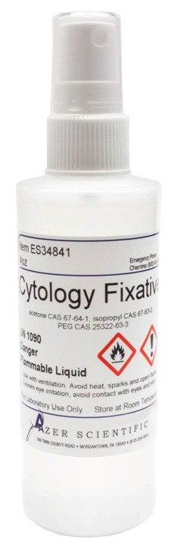 | Cytological fixative | 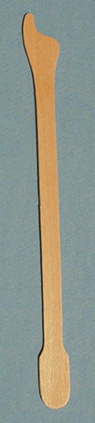 | 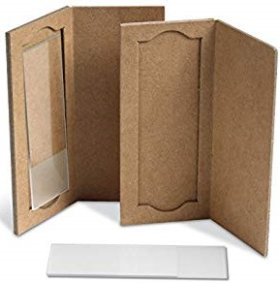
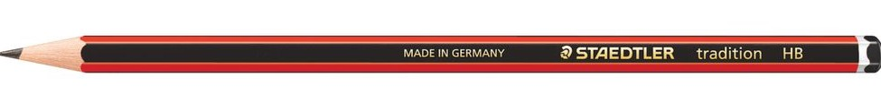 | Pencil
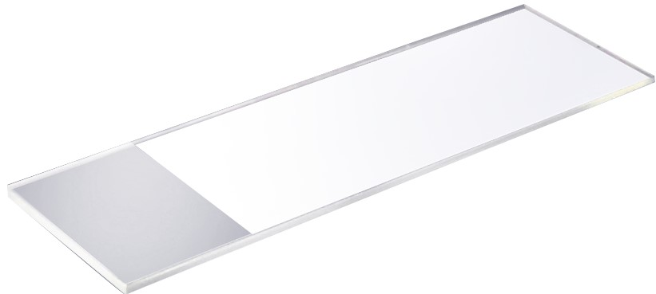 | Glass slide with frosted end
Fig. 14-1. Fixative, pencil and frosted slide |  | Fig. 14-2. Aylesbury spatula | Fig. 14-3. Slide holders

14.2.2.3.2 Collection technique
- Label slide with patient’s name and birth date on frosted end with a pencil.
- Sampling different sites in the FGT (see Fig. 14-4 on the next page):
  - Cervical smear
- Take cervical smear by inserting the Aylesbury spatula; the extended tip goes into the endocervical os and the short tip fully contacts the ectocervix with emphasis on the squamo-columnar junction.
- Firmly rotate spatula one full turn – 360°.
- Spread the material evenly along the length of a slide and turn the spatula to spread both sides onto the slide. Do not apply material on the frosted end.
    - Endocervical smear
- Take endocervical smear by gently inserting cytology brush into endocervical canal and rotate the brush one full turn – 360°.
- Spread material evenly by rotating the brush back and forth over the slide.
  - Vaginal or vault smear
- Take vaginal/vault smear using spatula end of the Aylesbury spatula. Obtain specimen by gently scrapping the vaginal/vault wall.

- Spread the material evenly along the length of a slide and turn the spatula to spread both sides onto the slide. Do not apply material on the frosted end.
- Immediately fix by spraying with a cytology fixative (within 10 seconds) and allow to air-dry.
- Package slide into slide container and transport to lab at room temperature.

Quick guide for collection using conventional method
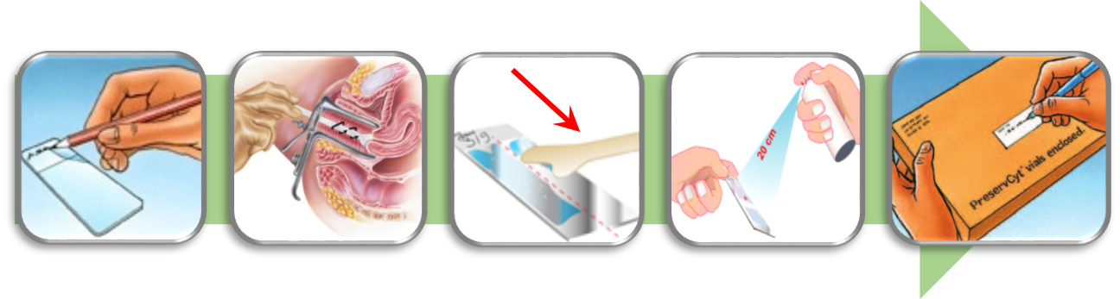
 | Record | Collect | Smear | Fix | Ship
Fig. 14-4. A quick guide for collection using conventional method.

14.2.2.4 LBC method

14.2.2.4.1 Materials required
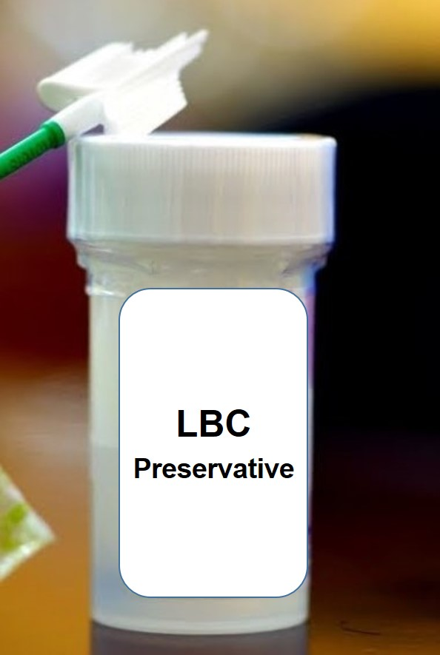 |  | 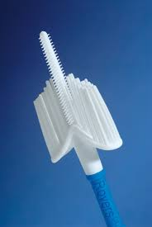 | 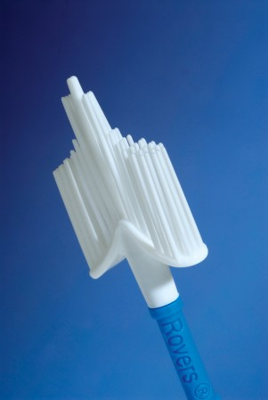
Fig. 14-5. LBC Preservative |  | Fig. 14-6. Combi brush | Fig. 14-7. Cervex brush
Figures 14-5, 14.6 and 14.7 are material required for collection for LBC

14.2.2.4.2 Collection technique
- Label the vial with the patient’s name, date of birth and apply the label horizontally around the bottle.
- Sampling different sites in the FGT (see Fig. 14-8 below):
- Cervical sample
- Insert the central bristles of the brush into the endocervical canal deep enough to allow the shorter bristles to fully contact the ectocervix.
- Firmly rotate the brush 360° in a clockwise direction by rolling the shaft between the thumb and forefinger.
  - Cervex Combi Brush: Rotate 1.5 to 2 times
  - Cervex Brush (broom): Rotate 5 times
- Use wide sweeping motions if there is extensive erosion or if the cervical os is too wide.
- Endocervical sample
- Take endocervical smear by gently inserting cytology brush into endocervical canal, rotate the brush one full turn – 360° and then rinse into the preservative solution.
- Vaginal or Vault smear
- Take vaginal/vault smear by firmly sweeping the vaginal/vault wall.
- Rinse the brush immediately into LBC preservative by pushing/squashing it into the bottom of the vial 10 times, forcing the bristles to bend apart – Do not leave the tip of the brush in the vial when using Thin Prep.
- As a final step, swirl the brush to ensure that no material remains attached.
- Discard the collection device into the biohazard waste box.
- Tighten the cap so that the black lines on the vial and cap overlap (to ensure there is no leakage).
- Place the vial and request form in a specimen bag and transport to the laboratory at room temperature.
Quick guide for collection using LBC
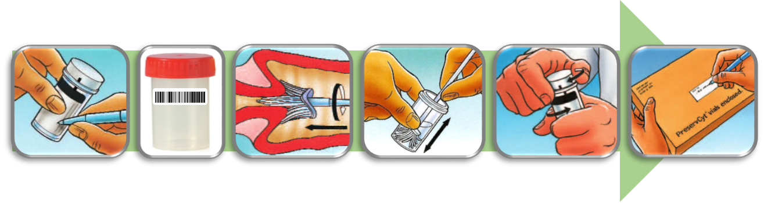
 | Record | Paste | Collect | Rinse | Tighten | Ship
Fig. 14-8. A quick guide for collection using LBC.

14.2.3 Non-gynaecological / General cytology

14.2.3.1 Respiratory system
- Figure 14-9 shows examples of collection material for respiratory specimens which include:
- Sputum
- Bronchial brushings / washings
- Tracheal aspirates
- Nasal smears
- Broncho-alveolar lavage (BAL)
- Pharyngeal brushings
- Antral aspirates/sinus washings
Fig. 14-9. Supplies for respiratory specimens

14.2.3.1.1 Sputum
Submit sputum after an early morning deep cough to ensure that sputum, and not saliva, is collected.
  - Collect 6 sputa on consecutive days – 6 specimens on the same day do not yield equivalent results.
  - Provide full clinical details including history, examination and results of ancillary investigations, e.g. radiology.
  - State clearly if the patient is a smoker or asthmatic.
  - State clearly if the patient has been treated with positive pressure oxygen.
  - Label the specimen containers and complete the cytology request form.
  - Give the patient clear instructions on how to produce a specimen as shown in Fig. 17-5 on page 142.
  - Use the supplied universal containers
- The specimen container must be tightly capped and clearly labeled (this should be done by the health care professional requesting the specimen, and should include the relevant clinical information as well as the diagnostic tests required).

- The specimen should be transported to the laboratory as soon as possible after collection.
- If there is a delay in transport to the laboratory, for example from an outside clinic, then specimens should be refrigerated.
DO NOT FREEZE SPECIMENS.

14.2.3.2 Fluids
- Examples include:
- Pleural
- Peritoneal
- Pericardial
- Hydrocoele
- Cerebrospinal fluid (CSF)
- Cyst fluid
- Amniotic fluid
- Peritoneal washings
- Endometrial fluid
- Ventricular fluid
- Percutaneous lung fine needle aspiration (FNA)
- Endoscopic bronchial FNA
- Ensure that fluids reach the laboratory as soon as possible as degenerate fluids are not suitable for accurate cytodiagnosis. Please preserve fluids in 50−70% alcohol if a delay in transit is anticipated.
- CSF must reach the cytology laboratory on the day of collection, preferably within 4 hrs of collection.
- If a clot forms in the fluid, it will be sectioned and examined. A separate report will be issued.
- If the fluid has been obtained during an intra-operative procedure, please state this clearly on the requisition slip.

14.2.3.2.1 CSF
  - Follow instructions for completing request form in Section 9 on page 59.
  - Follow same procedures as described in Section 17.3 on pages 140.
  - Use plain tube for collection.
14.2.3.3 Gastro-intestinal tract
- Examples include:
- Oesophageal brushing
- Gastric brushings
- Duodenal brushings

- Ampullary brushings
- Pancreatic duct aspirates
- Bile duct aspirates
- Bile duct brushings
- Colonic brushings
- FNA pancreas percutaneous or FNA of liver.
  - It is very important that the clinician fixes the slides immediately (within 10 sec) with cytology spray fixative to prevent the degeneration of cells as this compromises cytodiagnosis. Please see 14.2.1.3 on page 101 for correct fixation of specimens.

14.2.3.4 Urogenital tract
- Examples include:
- Voided urine (NOTE: 24-hour urine collections are unsuitable for cytodiagnosis)
- Catheterised urine
- Ureteric urine
- Renal cyst aspirate
- Renal pelvis brushings
- Urethral smear
- Percutaneous FNA of bladder and renal masses.
- State clearly if the patient has recently:
- Undergone catheterization
- Undergone cystoscopy
- Undergone retrograde radiography
- Cells in urine deteriorate rapidly. Specimens must reach the laboratory within 24 hrs.

14.2.3.5 The breast
- Examples include:
- Nipple discharge
- Nipple smears
- Breast aspirates.

14.2.4 Fine needle aspiration (FNA)
The cytology department may provide 2 FNA services:
- Impalpable / Deep / Image-guided FNA
- Contact the radiologist to arrange for the procedure.
- Please note that cystic lesions cannot be processed on site.
- Superficial or palpable lesions.

FNA biopsy clinics:
- In some hospitals there is a clinic which provides an FNA service staffed by the NHLS.
- For the location and hours of these clinics please contact the local cytology laboratory.
- Patients who are on oxygen, receiving blood products or are too ill to be transported by wheelchair to the clinic will be aspirated in the ward. For children under the age of 13 years who require FNA, please contact the laboratory to discuss if FNA should be performed under sedation or not. Please contact the clinic/pathologist to arrange for these procedures to be done in the ward/outpatient clinic.
  - Send the bedletter with the patient (if an inpatient) or a note with the clinical history and referring doctor/contact telephone number (if an outpatient).
  - Please make every effort to ensure the patient has his FNA before admission.
  - Indicate clearly the area to be aspirated (preferably mark the lesions on the patient to ensure the correct site is aspirated).
  - Please inform the laboratory if the patient has undergone previous FNAs.
  - If a booked FNA is cancelled, inform the laboratory well in advance.
  - If you cannot refer a patient to an FNA clinic run by the Cytopathology unit, see the technique of fine needle aspiration below.
  - Training on the correct technique of FNA is available from the NHLS cytology laboratories. Please contact your local laboratory to arrange this refer Table 7-1 on page 19-51

14.2.4.1 FNA collection procedure
PLEASE NOTE: This procedure is for palpable lesions and NOT for deep-seated lesions, which should be conducted under radiological guidance. If an abscess is suspected, please submit material for Microscopy, Culture and Sensitivity (MC&S) and/or fungal culture.
If a non-Hodgkins lymphoma is suspected, please rinse the needle and perform a separate pass. Please place material in a suitable fixative, e.g. RPM1 and submit to the laboratory as a matter of urgency.
The patient is booked for the procedure to be performed.
  - Identify yourself and explain the procedure to the patient.
  - Check the patient’s file or doctor’s request note to establish the site of the lesion and to check the patient’s identity.
  - Record the clinical information, patient’s information, the aspirators name, site of the lesion and the number of passes and number of slides on the request form.
  - Follow instructions for completing the request form in Section 9 on page 59.
How to prepare the FNA smear:
  - Label all slides (on the frosted portion) in pencil with the patient’s name or hospital number.
NOTE: Do not label slides with barcodes. Put barcodes on slide container.
  - Examine the nature of the lesion, i.e. solid, cystic, mobile, etc.
  - Clean the overlying skin with antiseptic.
  - Mobilise the lesion with two fingers to lessen the movement of the lesion when it is pricked.
  - Pull the plunger back no more than 1 milliliter (mL), not directly in the centre of the lesion to avoid necrotic material.
PLEASE NOTE: Aspirates from children as well as all thyroids should be done with a 23-gauge needle.
  - Insert the sterile 22-gauge (or 23-gauge as noted above) needle with an attached 10 or 20 mL syringe into the lesion (not directly in the centre of the lesion) with the dominant hand while the mass is stabilized with the non-dominant hand.
  - The syringe-piston retracted to approximately the 5 mL mark to produce and maintain a negative pressure.
  - Move the needle up and down and around in all angles to loosen the cells.
  - The needle is moved in various directions to sample cells from different areas of the mass while maintaining the negative pressure.
  - Do not allow the needle to leave the lesion.
  - Allow the plunger to return to its original position when only the nub of the syringe is filled with aspirate material. Withdraw after releasing the plunger.
  - Withdraw the needle and disconnect the syringe.
  - Fill the syringe with air and reconnect to the syringe.
  - Express the material/aspirate onto the slide NEAR to the frosted end (see Fig. 14-10 on the next page) while holding the needle to prevent it from being disconnected from the syringe if the needle is blocked.

Frosted end | 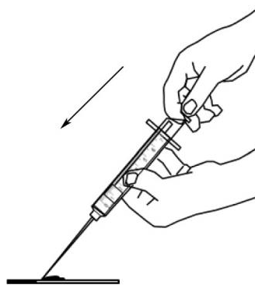
Fig. 14-10. Deliver material onto slide.
  - Place the second slide on the first, and gently but firmly allow the material to spread to the edges (see Fig. 14-11 below).
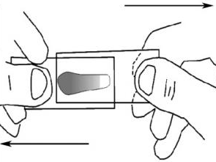
Fig. 14-11. Put slides together.
  - Pull the 2 slides apart keeping them firmly but gently completely apposed (see Fig. 14-12 below).
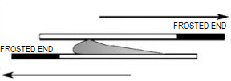
Fig. 14-12. Pull slides apart.
  - Hold the slide horizontally (if the slide is held at an angle, the material may be sprayed off the slide), and the aerosol spray fixative 17−22 cm from the glass slide. Spray-fix the first slide, and allow the second one to air-dry.
  - Clearly mark the slides as to which is fixed and which is air-dried.
  - Repeat the procedure if needed.
  - Fix slides immediately.
  - Fig. 14-13 bon the next page shows prepared FNA slide smear.
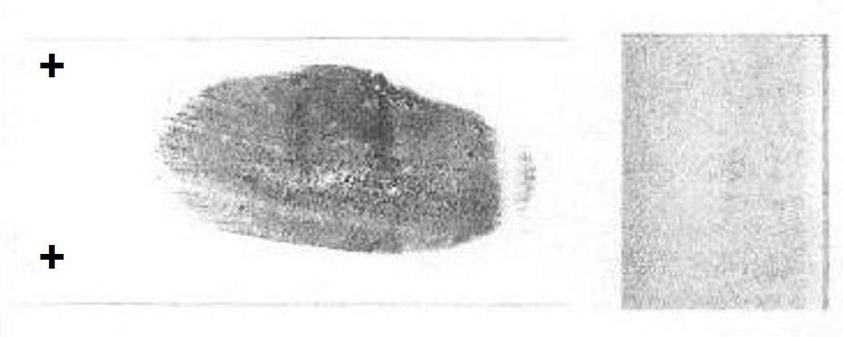
Fig. 14-13. Example of a prepared smear showing appearance of properly smeared specimen with good distribution of material.
  - Label all slides (on the frosted portion) in pencil with the patient’s name or hospital number.
NOTE: Do not label slides with barcodes. Put barcodes on slide container.
  - If Tuberculosis (TB) is suspected clinically, rinse the needle and syringe in TB transport medium (available from certain NHLS cytology laboratories) or in sterile saline and send for mycobacterial culture and/or GeneXpert.
  - After the procedure, discard the needle into a sharps-container, and apply plaster on the needle hole of the patient.
  - Inform the patient where and when to get their results.
  - Send the sample and the request form to the laboratory for processing and diagnosis.

14.2.4.2 Special investigations
Special stains are available e.g. Ziehl-Neelson for mycobacteria (TB testing), silver stains for fungi etc. Other special investigations available include immunocytochemistry, and flow cytometry. Please note that these special stains will only be requested by the pathologist based on the relevant clinical information supplied by or in consultation with the clinician.

14.2.4.3 Oral and maxillo-facial pathology
The discipline offers the following services:
  - Surgical pathology diagnoses, including biopsies and other tissue specimens (e.g. resections) from the oral cavity, jaw bones and surrounding anatomical regions. Kindly refer to the description of the routine diagnostic service in Anatomical Pathology for further details and the array of special services offered. Please submit whenever possible a (panoramic) radiograph and/or computerized tomography (CT) scans for accurate diagnosis of bone lesions. NOTE: Frozen sections on bony specimens are not possible.

  - Microscopic examination of oral mucosa surface brushings to detect fungal infection and bacterial overloads can be performed. Kindly sample with a cervi-brush and submit exfoliative smears (on glass slides fixed with cytospray or alcohol) to the anatomical pathology laboratory with the specific request to stain for periodic acid-shift (PAS).
  - On-site clinical and radiological consultations in oral mucosal diseases and jaw lesions on request.
  - Punch and/or scalpel biopsies, surface cytology brushings/modified deep (semi-invasive) cytology sampling for oral mucosal lesions and fine needle aspirations/core needle biopsies of oral deep soft tissues can be performed under local anaesthesia in the FNA clinic.

SECTION 15.0
CHEMICAL PATHOLOGY

15.0 CHEMICAL PATHOLOGY

15.1 Sample types
15.1.1 Blood samples
  - Blood must be collected into the appropriate tube, and must be transported at the correct temperature, and must reach the laboratory within a period not exceeding the tests’ stability.
  - For certain tests, other special collection or transport conditions are required. For all test requirements, see Table 24-1 from page 226.

15.1.2 Urine sample

15.1.2.1 Random urine samples
  - Urine should be collected into appropriately labeled sterile universal specimen containers supplied by the laboratory.
  - All urine specimes should be stored cool or refridgerated until transported.
  - Some urine tests may require additives as indicated in Table 24-1 on page 226.
  - Please note that some additives may be corrosive and/or toxic.
  - Some urine specimens may need to be transported immediately to the laboratory on ice as indicated in Table 24-1 on page 226.

15.1.2.2 24-hour urine collection
  - The 24-hour collection container should be collected from the laboratory and labeled with appropriate patient identification.
  - Instructions for 24-hour urine collection for the patient:
- Void (discard) first morning urine.
- Collect all urine passed for 24 hrs including the first morning urine of the next day into a small clean container and after each void carefully transfer contents into the 24-hour urine container.
- Return the 24-hour urine container to the clinic after completing the collection.
- The facility must ensure that the 24-hour urine collection is sent to the laboratory as soon as possible.
  - Some urine collections may need to be stored in the refrigerator or on ice until delivery to the laboratory (see Table 24-1 on page 226).
  - Some urine collections require an accompanying serum sample, for example creatinine clearance (see Table 24-1 on page 226).

  - Some urine collections may require additives as indicated in Table 24-1 page 226. Please note: some additives may be corrosive and/or toxic.

15.1.3 Cerebrospinal fluid (CSF)
  - Please follow collection instructions in Section 17.3 on pages 140.
  - Tubes:
- Glucose: grey top tubes
- CSF chemistry: collection tube containing no additives
  - For certain investigations, paired samples are required, for example:
- CSF Immunoglobulin G (IgG) index and assessment for oligoclonal banding (in suspected multiple sclerosis): A simultaneous CSF (clear on tan tube) and blood (yellow top tube) are mandatory.
- CSF glucose: A simultaneous blood sample for glucose (grey top tube) is recommended.

15.1.4 Fluids
  - Tubes:
- Glucose: Grey top tubes
- Fluid chemistry: Collection tube without additives (clear or tan top).

15.1.5 Stool
  - Collect into a sterile universal container. Refer to Table 24-1 on 226 for specific test-related stool collection instructions.
  - Some tests can only be performed on diarrhoeal stools, for example stool osmolality.
  - Some tests require paired samples, a clotted blood sample (red or yellow top tube) and the stool sample, for example alpha-1 antitrypsin clearance.
  - Some tests require shipment to the laboratory on ice, for example stool osmolality.

15.1.6 Stones
  - Collect specimen and put in a dry container.
  - Please send stone intact; do not reduce or sample.
  - Do not send more than one stone per anatomical site.

15.1.7 Saliva
See Table 24-1 on 226 for saliva collection for cortisol determination.

15.2 Special instructions

15.2.1 Unstable analytes
- For certain analytes, the time period between collection and analysis is critical, e.g.:
- Blood gas
- Ammonia
- Ionised calcium
- Lactate
- Please refer to Table 24-1 on page 226 for specific instructions.

15.2.2 Fasting blood samples
  - A variety of tests require prior fasting:
- Glucose (e.g. fasting plasma glucose, oral glucose tolerance test)
- Triglycerides
- Lipid electrophoresis
- Gastrin
- Collect the blood specimens using the guidelines in Section 13 on page 83 and in Table 24-1 on page 226.
- Complete the request form and follow instructions for completing the request form on in Section 9 on page 59.
- For all tests that require fasting, the patient should be fasted for at least 8−12 hours (hrs) beforehand.
- Some fasts may require close clinical monitoring such as the elderly, acutely ill patients and babies.
- If patients cannot go without water, sips of water may be taken during the fast.

15.2.3 Oral glucose tolerance test (OGTT)
  - Take note of medication known to affect glucose tolerance e.g. corticosteroids, oestrogen and thiazide diuretics.
  - Perform test after 3 days of unrestricted diet, containing at least 150 grams (g) of carbohydrate per day, and an overnight fast (at least 8 hrs).
  - Patients should sit quietly for 30 minutes (min) prior to and for the duration of the test. Smoking, walking/exercise, food or drinking (other than water) should be avoided.
  - Take baseline/fasting glucose sample (grey top tube). Label the specimen and request form, place both in a specimen transport bag, and keep securely until the OGTT samples have all been taken. Then send all the samples in one specimen transport bag to the laboratory for analysis.

  - Non-pregnant adults and pregnant women: a glucose load containing the equivalent of 75 g anhydrous glucose dissolved in 250 mL water is ingested over 5 min.
  - Children: 1.75 g/kg (kilogram) anhydrous glucose dissolved in water to a maximum of 75 g is ingested over 5 min.
  - Timing commences at the initiation of drinking the glucose load.
  - Due to the risk of skin contamination with glucose, discard used gloves and wash hands including those of the patient.
  - Repeat a glucose measurement 2 hrs post-glucose load.

15.2.4 Blood gas analysis
  - Arterial puncture to facilitate the collection of a whole blood specimen carries a slight medical risk and should not be undertaken by anyone who has not been properly trained to perform it.
  - Arterial collection of blood is suitable for all acid-base derangements, while venous blood only allows assessment of metabolic abnormalities.
  - Please state clearly on the request form whether the sample is arterial or venous in origin.
  - When collecting venous blood, avoid prolonged application of a tourniquet as it may cause changes in the results.
  - Arterial and venous specimens are best collected anaerobically with lypholised heparin anticoagulant in sterile syringes. If preheparanised syringes are unavailable, then liquid balanced heparin may be used. The syringe should contain only enough heparin to wet the wall and fill the dead space occupied by the hub.
  - Avoid exposure of arterial blood to the atmosphere as it causes changes to results.
  - If any air bubbles are present in the syringe expel these immediately upon removing the needle from the puncture site.
  - Dispose of the needle safely in a sharps container.
  - If the syringe is open to air, place a tightly fitting cap on the tip of the syringe to maintain anaerobic conditions.
  - The blood gas analysis must be performed within 30 min of collection. Minimise the effects of glycolysis and respiration by submerging the blood gas syringe in a mixture of ice and water and deliver to the laboratory as soon as possible.

15.2.5 Aldosterone and renin
  - The following factors should be noted when preparing patients for investigation for hyperaldosteronism:
- Patients should maintain liberal dietary salt intake prior to testing.
- Hypokalaemia should be corrected with supplemental potassium chloride tablets prior to testing (the absence of hypokalaemia does in no way exclude primary hyperaldosteronism).
  - The following drugs may confound interpretation of results and should be discontinued before further investigation:
- At least 4 weeks before testing: Diuretics (including spironolactone).
- At least 2 weeks before testing: Beta-blockers, clonidine, methyl-dopa, non-steroidal anti-inflammatories, angiotensin-converting enzyme (ACE) inhibitors, angiotensin II receptor blockers and dihydropyridine calcium channel blockers.
- The best drugs to use in the interim are prozasin or verapamil slow-release.
- After discontinuation of the above mentioned drugs, it is recommended that serum creatinine and electrolytes are repeated.
- Contraceptive agents (which may influence results) are not withdrawn unless confident of alternative effective contraception.
  - Minimum sample volumes: Aldosterone 1.5 mL and renin 1.8 mL (avoid haemolysis).

15.2.6 Urinary vanillyl mandelic acid (VMA), metanephrines and plasma cathecholamines
- It is recommended that all medication (in particular anti-hypertensives, anti-inflammatories, anti-histamines, and aminophylline/theophylline) should be discontinued for 3 days prior to and during 24-hr urine collection.
- Most anti-hypertensives cause falsely increased values. The following are contra-indicated due to analytical interference (this is method dependent) and should be replaced by alternatives: ACE inhibitors, methyldopa, beta-blockers.
- The following anti-hypertensives are preferred because they do not cause falsely elevated values: clonidine or guanethidine.
- Taper and discontinue treatment with the following psycho-active drugs two weeks before assessment: Tricyclic anti-depressants, monoamine oxidase inhibitors (MAOIs), phenothiazines and lithium.
- Patients should avoid caffeine and nicotine 2 days before and during the 24-hr urine collection.

- The 24-hr urine collection containers can be obtained from the laboratory prior to the collection. The container must be acidified with hydrochloric acid.
- Supply 3 consecutive 24−hr urine collections (acidified, see Table 24-1 on page 226).
- For fractionated plasma catecholamines add stabilizer to sample (see Table 24-1 on 226).
- Please note all current medication on the request form.

15.2.7 Urine 5-HIAA (5-hydroxy-indoleacetic acid)
- The 24-hour urine collection containers can be obtained from the laboratory prior to the collection.
- Urine should be collected into a dark container, and the specimen refrigerated during collection.
- Patients should avoid dietary sources of 5-hydoxyindoles (e.g. walnuts, bananas, avocados, eggplant, pineapples, plums and tomatoes) 3−4 days before and during 24-hour urine collection.
- It is recommended that the following medication should be discontinued for 3 days prior to and during 24-hr urine collection: L-dopa, methyldopa, isoniazid, imipramine, MAOIs, phenothiazines, reserpine, cough and cold preparations containing guaiphenesin or glycerol guaiacolate.
- Essential medication should be replaced by suitable alternatives.
- Please note all current medication on the request form.

15.2.8 Prolactin
The following drugs may cause increased prolactin levels:
- Dopamine receptor antagonists, e.g. phenothiazines, metoclopramide, sulpiride
- Dopamine depleting agents, e.g. methyl-dopa, reserpine
- Oestrogens
- H2-receptor blockers, e.g. cimetidine
- Tricyclic antidepressants.

15.2.9 Lactate
- Patient should be at absolute rest for 2 hrs before blood is drawn.
- Patient may not move hand or arm immediately before or during the procedure.

- A tourniquet should preferably not be used, but if one is used it should only be applied for 30 seconds (sec). If applied longer, the tourniquet should be removed with the needle still in the vein and the blood allowed to circulate for at least 2 min before the sample is collected.
- Discard the first 2 mL of blood.

15.2.10 Porphyrins
- All specimens (EDTA [purple top] blood, urine and stool) should be collected, if clinically relevant, during an acute exacerbation and must be protected from light during collection and transport.
- Please indicate clearly on the request form the presence of skin lesions, abdominal complaints or neurological features in the clinical presentation as this will assist in the interpretation of the results.

15.2.11 Alpha-1 antitrypsin clearance
- Collect a random stool specimen and, during the collection, a clotted (yellow top) blood specimen.

15.2.12 Aluminum serum and urine sample collection
  - The use of a stainless steel needle for the collection of blood should be avoided to minimise contamination. An acceptable alternative is the use of a polypropylene intravenous cannula.
  - Phlebotomy should be performed with a syringe, the blood transferred into trace element tubes (royal blue top, additive-free) and left standing to form a clot.
  - The tubes are spun and serum transferred with a plastic pipette to another trace metal tube before being sent to the referral laboratory for analysis. Polypropylene tubes are recommended for use; glass and rubber stoppers should be avoided.
  - The use of anticoagulants is very problematic and can cause contamination, as most of them are either metal chelators or polyanions. Therefore, no serum separators or anticoagulants should be used.
  - All polythene plastic containers that are used for the collection of urine should be acid washed before use. For further handling of the sample powder-free gloves must be worn.
  - Likely sources of contamination for aluminum samples come from water, dust and reagent acids.

SECTION 16.0
HAEMATOLOGY

16.0 HAEMATOLOGY

16.1 Specimen collection

16.1.1 General guidelines
  - Collect the blood specimens using guidelines in Section 13 on page 83.
  - Use the guide in Table 13-1 on page 87 for appropriate containers.
  - Observe the safety precautions (refer to Section 12 on page 79).
  - See Table 24-1 from page 226 for list of tests offered.
  - Always put on appropriate personal protective equipment.
  - Always discard all collection material in appropriate biohazard containers.
  - Complete the request form and follow instructions for completing the request form in Section 9 on page 59.

16.1.2 Bone marrow
  - Make an appointment in advance with the laboratory for bone marrow collection.
  - In smaller laboratories, please book Monday to Thursday preferably in the morning, so that the slides and trephine biopsy can be sent with the courier service in the afternoons to the relevant testing laboratory.
- Please discuss the patient with the laboratory staff where the marrow will be interpreted to ensure that all the relevant samples have been collected for analysis.
  - Bone marrow aspirates clot faster than peripheral blood; it is therefore advisable to make a smear immediately at the bedside without delay and store the rest of the aspirate in an EDTA (purple top) tube. More films can then be performed in the laboratory as required.
  - For most haematology conditions the following samples are required to ensure an accurate diagnosis: Peripheral blood smear, aspirate smear, an aspirate sample for cytogenetics in a heparin tube (green top), extra peripheral blood slides/aspirate slides to be prepared for fluorescence in situ hybridization (FISH) if required, a peripheral blood/aspirate sample for flow cytometry and a sample for polymerase chain reaction (PCR) – discuss with the tertiary institution.
  - Please perform an imprint of the trephine biopsies to ensure the assessment of cytology in the event that the aspirate is suboptimal.
  - Complete the request form (please refer to Section 9 on page 59).
  - Air dry the slides completely before packing.
  - Pack slides separately.

  - Collect blood specimens for full blood count, platelet count and differential count at the same time since these results will be needed for interpretation of results.
  - Discard all collection materials in appropriate biohazard containers.
- Aspirate specimens must be accompanied by a full clinical history.
- Do not flush the syringe with heparin prior to aspiration as this causes a blue stain on the slides rendering interpretation of morphology difficult.
- DO NOT spray fixative onto slides.
- Each slide must be individually labelled.
- Please pack aspirate slides in a separate specimen bag from trephine biopsy, as the transporting medium of the trephine biopsy may leak and destroy the integrity of the aspirate slide, making interpretation impossible. Also, exposure to formalin vapour may affect morphology and staining of slides.
Please ensure that the correct standard operating procedure (SOP) is being used for fixing the trephine biopsy as this is a very critical step in ensuring a good sample for analysis.
- Please ensure that the correct medium for transportation of the trephine biopsy is being used. Refer to the relevant SOP of the laboratory.

16.2 Immunophenotyping by Flow cytometry
  - Sample type: EDTA (purple top) tube (peripheral blood or bone marrow aspirate) or heparinized (green top) tube.
- Other fluids: Cerebrospinal fluid (CSF), ascitic tap or pleural fluid. Prior arrangement and discussion with the laboratory is required.
- Volume: 2−3 mL.
- Storage condition: Room temperature.
- Detailed clinical history required.
- Sample will be rejected after 24 hrs. Exception cluster of differentiation (CD) 4 count: 96 hrs.
- If transportation delays are anticipated, please discuss with relevant laboratory, for a possible stabilising medium.
- Common indications for immunophenotyping: CD4 count and percentage (%), lymphocyte subsets (B-cells, T-cells, [Natural Killer] NK-cells), acute leukaemias, chronic lymphoid leukaemias, plasma cell myeloma, CD34 stem cell enumeration, Deoxyribonucleic acid (DNA) ploidy analysis, paroxysmal nocturnal haemoglobinuria and platelet flow cytometry for selected platelet disorders.
SECTION 17.0
CLINICAL MICROBIOLOGY
AND
INFECTIOUS DISEASES

17.0 CLINICAL MICROBIOLOGY AND INFECTIOUS DISEASES
- It is of critical importance that clinicians use the following guidelines for the proper collection and transport of specimens.
- Complete diagnostic information is crucial to ensure optimal processing of specimens.
The quality of results depends on the quality of specimens
- Consequences of poorly collected and/or poorly transported specimens include:
- Failure to isolate the causative micro-organism, and
- Recovery of contaminants or normal microbial flora, which may be misleading, and result in incorrect treatment of the patient.

17.1 General guidelines for specimen collection
- To minimise contamination, use strict aseptic technique when collecting specimens.
- Collect specimens prior to initiation of antimicrobial therapy.
- Collect specimens from anatomical sites most likely to yield pathogens and least likely to yield contaminants.
- Use appropriate collection containers/devices.
- Tissue or fluid submitted for culture is always superior to material on swabs, see figure 17-1 on the next page for quality microbiological results.
- Submit adequate volumes of specimens.
- Always wear appropriate protective clothing.
- If the patient may be infected with pathogens known to be hazardous to laboratory personnel (based on provisional clinical diagnosis), please notify the laboratory prior to sending the specimen – Please see Table 7-1 on pages 19−51 for relevant contact telephone numbers.
- Provide complete information including:
- The type of specimen submitted (be specific: e.g. pleural fluid).
- Specific site from which specimen was collected.
- Specific pathogens that are being sought (to optimize culture conditions for these organisms).
- Methods by which specimens were collected, e.g. midstream urine specimen or catheter urine specimen.
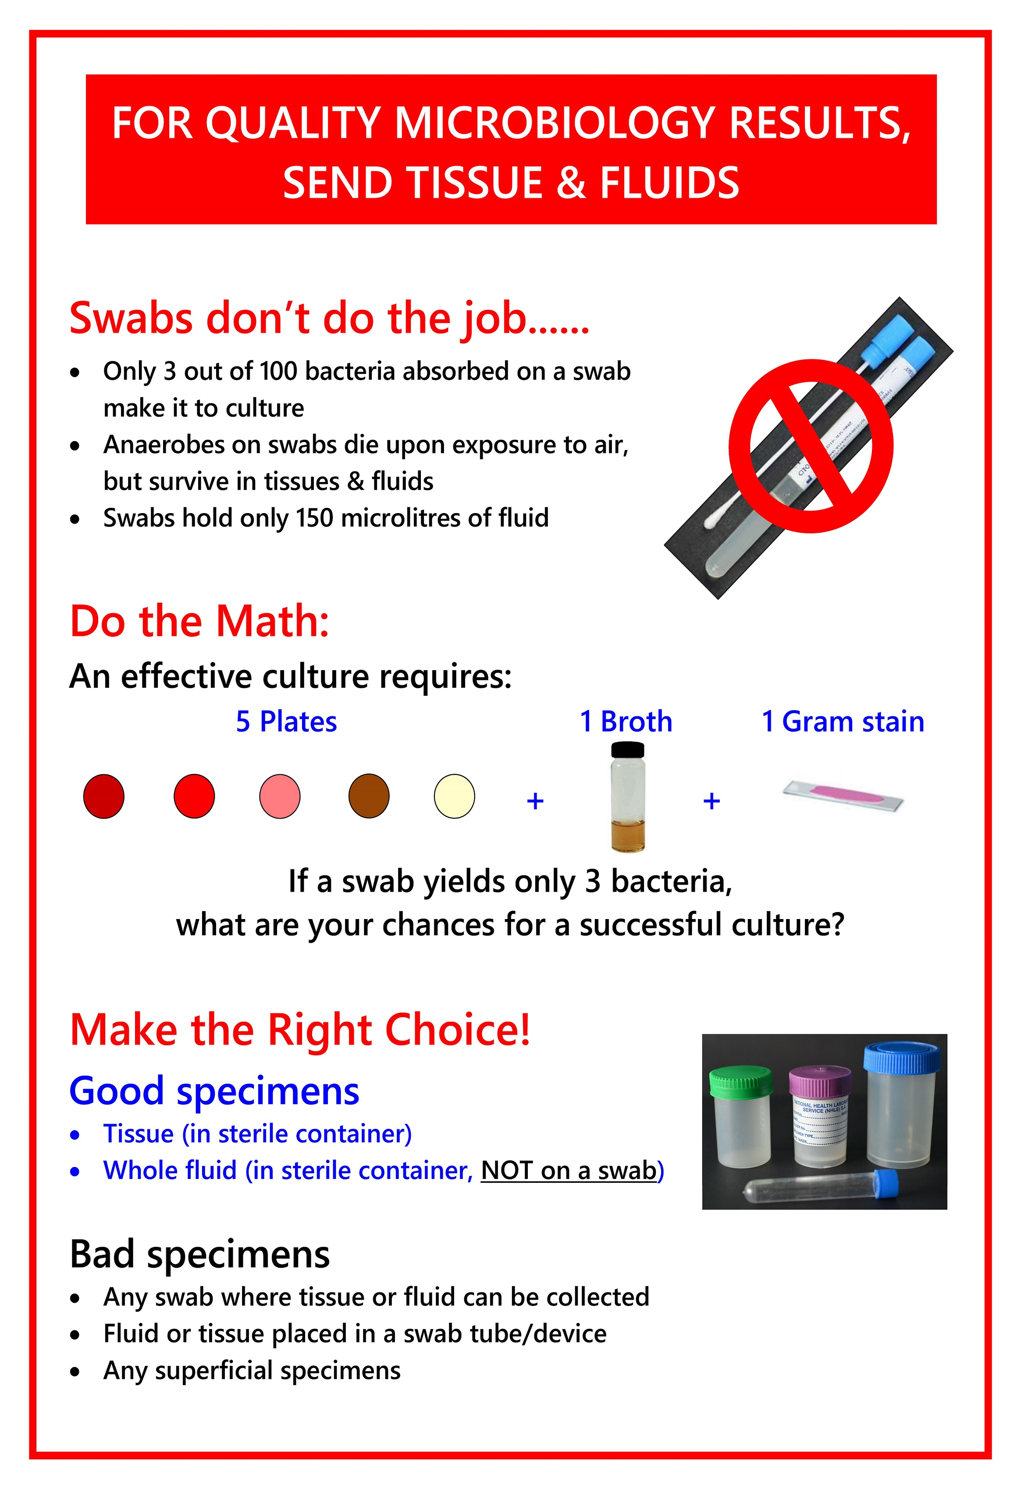
Fig. 17-1. Quality microbiology specimens.

17.1.1 Guidelines for proper specimen transport
- Collect specimens in sturdy, sterile, screw-cap, and leak-proof containers with lids that do not create aerosols when opened.
- Please contact a microbiologist for advice regarding appropriate specimens to collect and how to collect them.
- All specimens should be transported to the laboratory promptly. Failure to do so may result in fastidious bacteria dying and becoming overgrown by non-fastidious bacteria.
- If prompt delivery is not possible specimens should be refrigerated at 4−8°C, with the following exceptions:
- Blood cultures should be kept at room temperature.
- Cerebrospinal Fluid (CSF) specimens should be kept at room temperature unless they are to be cultured for viruses. If viral cultures are requested an aliquot should be removed aseptically and stored at 4−8°C.
- Specimens that may harbour temperature-sensitive organisms such as Neisseria species should be left at room temperature.

17.1.2 Specimen containers
Sterile plastic/glass tubes or plastic vials with/without transport medium. The purpose of the transport medium is to maintain viability of organisms and to prevent contaminants (which may be present in the specimen) from overgrowing pathogens. Refer to Section 10.0 on page 65 for images of different specimen containers.

17.1.2.1 Swabs
Table 17-1. Swab types
Swab type | Comments
Calcium alginate-tipped (CalgiSwabs) | - Can be toxic for viruses and some strains of gonococci; therefore, these swabs should be used only if the specimen is inoculated directly onto culture media or transported in non-nutrient media containing charcoal to absorb or neutralise inhibitory substances.  - UNSUITABLE for Polymerase Chain Reaction (PCR) testing.
Cotton-tipped | - May contain fatty acids that could be inhibitory to some bacteria and Chlamydia spp.
Dacron-tipped | - Can be used for collection of viral samples and facilitate survival of Streptococcus pyogenes (group A strep).  - Suitable for PCR testing (if non-wooden shafts).
Wooden-shaft | - Wood may contain toxic products which could inactivate HSV.  - UNSUITABLE for PCR testing.
Flexible wire shafts and small tips | - Enable easier collection of nasopharyngeal and male urethral specimens.

17.1.2.2 Sterile screw-cap universal containers
- Useful for collection of urine, sputum, stool, broncho-alveolar lavage (BAL), and biopsy/tissue specimens.
- Add a small amount of sterile saline to biopsy/tissue specimens to prevent specimens from drying out.
- Never place biopsy/tissue specimens in formalin* or swab container/swab collection device or wrap in gauze.
*NOTE: Formalin kills micro-organisms and therefore renders specimens unsuitable for microbiological testing.

17.1.2.3 Sterile Petri dishes / slides
- Useful for hair or skin-scraping specimens.
- Tape petri dish/slides securely prior to transport.

17.1.2.4 Sterile tubes
- Sterile screw-cap glass/plastic tubes without additives.
- Can be used for collection of sterile fluids, pus, broncho-alveolar lavage (BAL)/bronchial brush specimens and other aspirates.

17.1.2.5 Viral transport medium (VTM)
- Refer to Virology section (Section 21.0).

17.2 Blood cultures

17.2.1 General principles
- Blood cultures are the specimens of choice for the microbiological diagnosis of septicaemia, infective endocarditis and pyrexia of unknown origin (PUO).
- If a blood culture is positive, empirical antimicrobial agents can be advised based on Gram stain results.
- Blood must be collected as early as possible in the course of a febrile episode, and ideally before administration of antibiotics.
- Blood obtained from one venepuncture site defines one blood culture, regardless of the number of bottles filled.
- Each blood culture should be collected from a different venepuncture site.
- Although firm evidence is unavailable, it is believed that the routine use of anaerobic bottles is not warranted, particularly in resource-limited settings.
- If collecting blood from patients already on antimicrobials, culture bottles containing polymeric beads (which inactivate antibiotics), should be used.
- Blood should not be drawn through indwelling venous or arterial lines unless line sepsis is suspected. If blood for culture is drawn from an indwelling line, another blood culture should be simultaneously collected from a peripheral site so that the differential time to positivity may be calculated. Remember to indicate clearly on the bottles which one was taken from the line and which one from the peripheral site.
- Collection of arterial blood cultures does not provide any advantage over venous blood cultures.
- PLEASE NOTE: Blood for fungal culture should be collected directly into standard blood culture bottles.
- If blood/bone marrow is sent for the isolation of Mycobacterium tuberculosis or non-tuberculous Mycobacteria, BACTEC Myco/F Lytic bottles should be used. An EDTA tube (purple top) is NOT acceptable.
- It is a medico-legal requirement to indicate the following in the patient’s notes: Collection of blood for culture, indication, site(s), date and time of collection and name of phlebotomist.

17.2.2 Optimal number of blood cultures
- One blood culture is rarely, if ever, sufficient or advisable. It is difficult to interpret a positive result on a single culture, unless an unequivocal pathogen is isolated.
- Two blood specimens collected from different sites are usually sufficient.
- Except in very unusual cases, no more than 3 sets of blood cultures should be collected in one 24-hr period. If all sets are negative after 24 hrs and sepsis is still suspected, more cultures may be collected. More than three blood cultures in one 24-hr period may have to be collected from patients already on antibiotics; however, if clinical condition allows, rather stop antibiotics and re-culture after 48 hrs.

17.2.3 Timing of blood culture collection
- Blood can be obtained from two separate sites within minutes of each other from patients who are acutely ill or those in whom the likelihood of continuous bacteraemia is high.
- If patients are suspected to have intermittent bacteraemia, multiple blood cultures should be collected 6−36 hrs apart.
- Antibiotics should not be withheld in sick patients apart from a reasonable delay to collect more than one culture sample.

17.2.4 Volume of blood to be collected
- Adequate volumes of blood are critical as it improves detection of pathogens and reduce time to detection.
- Adults: A minimum of 10 mL (and preferably 20 mL) of blood should be obtained per draw (i.e. 10 mL per bottle).
- Infants and children: See Table 17-2 below.
Table 17-2. Blood volumes for children
Weight (kg) | Blood volume (mL) | Bottle type
≤ 1 – 2 | 1 – 2 | Paediatric bottle x1
2.1 – 13 | 4 | Paediatric bottle x1
13.1 – 36 | 8 – 10 | Adult bottle x1 or  Paediatric bottles x2
>36 | 20 | Adult bottles x2
17.2.5 Blood culture collection procedure
- Please also see the quick guides for blood culture collection in adults and children in Fig 17-2 on page 138 and Fig 17-3 on page 139.
- Gather all supplies that will be required, including:
- Blood culture bottles
- Vacutainer (“bulldog”) and butterfly needle/double-needle collection set or needle and syringe
- Sterile gloves
- Surgical mask
- Tourniquet
- 70% isopropyl or ethyl alcohol solution (or other suitable skin disinfectant such as chlorhexidine or povidone iodine)
- Sterile pack containing cotton/gauze swabs, sterile paper sheet and waste bag
- Forceps (optional)
- Alcohol swabs (Webcols)
- Adhesive strip
- Sharps waste disposal bin
- Patient labels
- Plastic bag for specimen transport
- Wash hands with soap and water or disinfect with alcohol hand disinfectant before opening the sterile blood culture pack onto the trolley.
- Remove the sterile sheet and place under the patient’s arm. Pour alcohol solution (or other suitable skin disinfectant) into fluid recess located on blood culture tray/pack. Drop needle and syringe onto sterile field.
- Apply tourniquet and palpate for a suitable vein. Wash hands with soap and water or disinfect with alcohol hand disinfectant. Dry hands or rub the hand disinfectant in until dry. Put on sterile gloves.
- Remove the blood culture bottle’s lid without touching the top of the bottle. Disinfect the top of each bottle with an alcohol swab (not iodine) before inoculating the bottle.
- Clean the puncture site with a 70% isopropyl or ethyl alcohol solution (or other suitable skin disinfectant). Cleanse in a circular manner, beginning at the centre of the site and working outwards. Allow 1−2 min for the disinfectant to dry.
- Do not touch the venepuncture site after preparation and prior to performing venepuncture.
- Insert the needle into the vein and collect at least 10 mL of blood in adults and at least 1 mL of blood in children.
- Release tourniquet. Remove needle from puncture site. Place dry cotton ball on puncture site and apply pressure. If iodine was used to cleanse the site, remove remaining iodine with 70% alcohol as it can cause irritation in some patients.
- If blood is drawn for other tests as well, always collect/inoculate blood culture bottles first.
- If a needle and syringe was used, do not change the needle before injecting the blood into the culture bottle(s).
- Gently invert blood culture bottles to mix the blood and culture medium.
- Label the blood culture bottles as follows:
- Do not remove the “tear-off” label on the bottle
- Make sure that patient labels do not cover the bottle’s bar code label or bottom of the bottle.
- Complete lab request form legibly and indicate date, time and site of collection, the diagnosis and clinician’s name and contact details.
- Deliver blood culture bottles to the laboratory promptly. If there is a delay in transport to the laboratory, do not refrigerate the bottles, rather leave them at room temperature.

QUICK GUIDE TO BLOOD CULTURE COLLECTION IN ADULTS
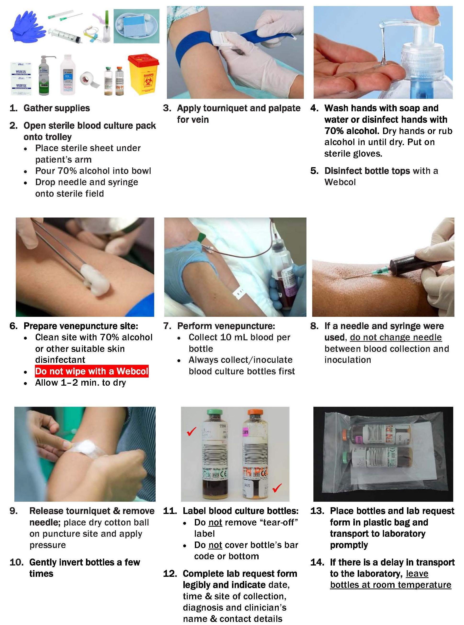
Fig. 17-2. A quick guide to performance of blood culture collection in adults.
QUICK GUIDE TO BLOOD CULTURE COLLECTION IN CHILDREN
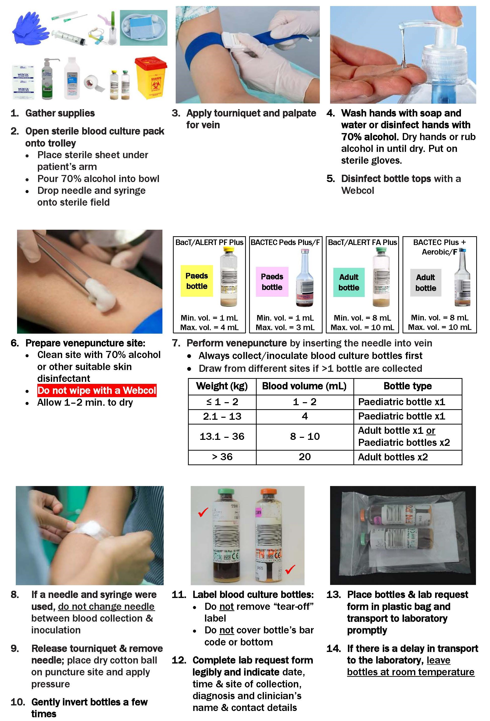
Fig. 17-3: A quick guide to performance of blood culture collection in children.

17.3 Cerebrospinal fluid (CSF)
CSF is collected for the diagnosis of meningitis and is usually obtained by lumbar puncture. Subdural taps and ventricular aspiration may also be used.
- Please also see the quick guide to performance of lumbar puncture procedure in Fig. 17-4 on the next page.
- The lumbar puncture should be performed using an aseptic technique and should not be undertaken by anyone who has not been properly trained to perform it. Infection control guidelines recommend that the clinician wear a surgical mask when performing a lumbar puncture.
- The patient is appropriately draped and an area overlying the lumbar spine is disinfected using the same skin preparation as required for collection of blood cultures (see Section 17.2.5 on page 136).
- All microbiological CSF specimens should be collected in (clear top) collection tubes without additives or if these are not available, red top tubes without gel may also be used.
NOTE: Please collect CSF in separate tubes for chemistry, cell count, microbiology and other tests (e.g. virology). DO NOT SEND ONE SAMPLE FOR MULTIPLE TESTS. When a single sample is sent with a request for multiple tests, the sample has to be split. This process can result in contamination of the sample and a false-positive culture result.
- Each bacteriological and fungal test requires at least 1.5 mL of CSF, although larger volumes are preferred.
- The specimen should be transported to the laboratory promptly and processed as soon as possible.
- If delay in processing is unavoidable, the specimen should be held at room temperature.
- When requesting antigen testing on CSF, please ensure that you have specified whether bacterial or cryptococcal antigen detection is required.
NOTE: Processing CSF for mycobacteria
The number of mycobacteria present in the CSF is small; therefore, a large volume of CSF (5 –10 mL) is necessary to maximize recovery of the organism in culture.

QUICK GUIDE TO LUMBAR PUNCTURE PROCEDURE
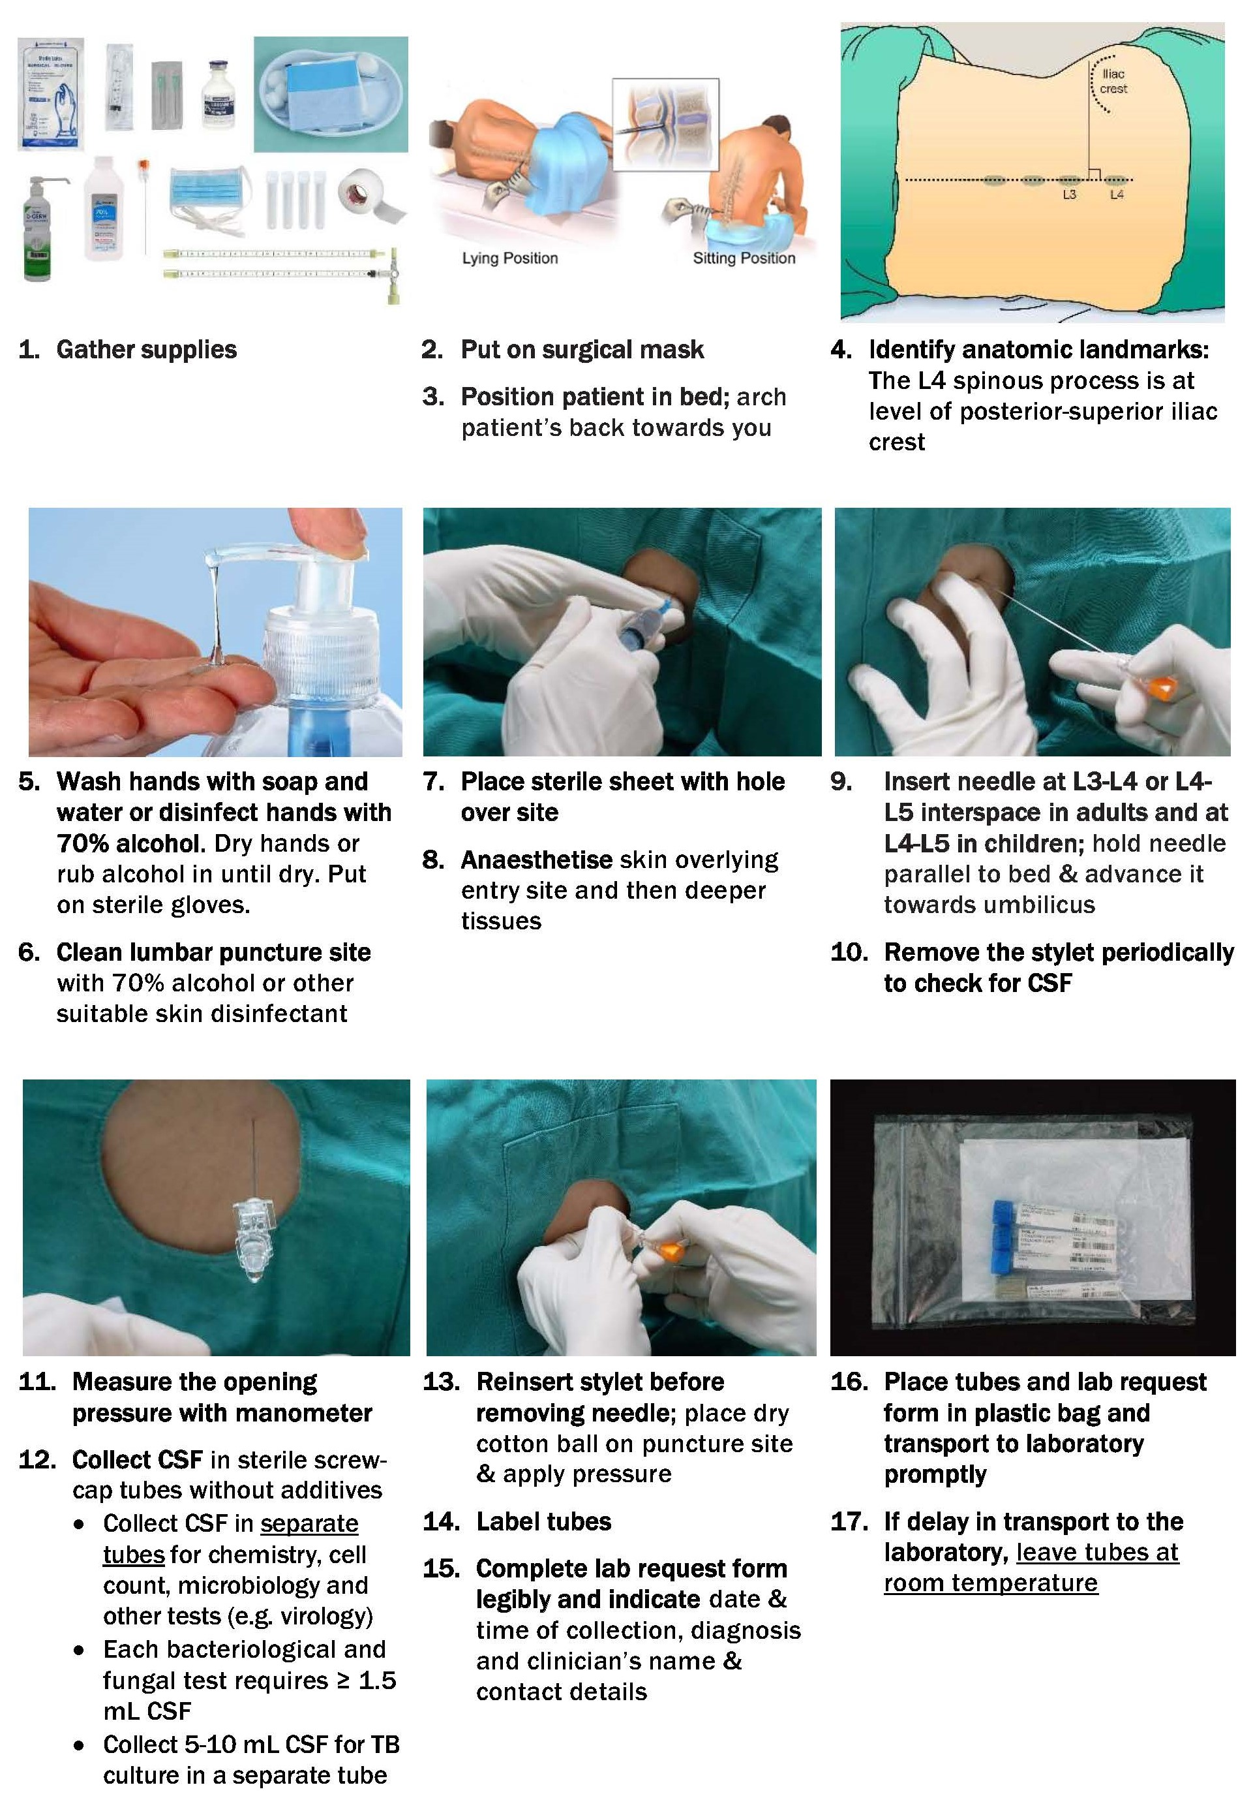
Fig. 17-4. A quick guide to performance of lumbar puncture procedure.

17.4 Bone marrow
- Aspirate bone marrow for Mycobacterial culture into a BACTEC Myco/F Lytic blood culture bottle or sterile heparinised tube.
- Also make 2 smears for special fungal stains if required and submit this together with the culture specimen.
- Aspirate bone marrow for typhoid/enteric fever into an aerobic blood culture bottle with or without antibiotic-neutralising beads (depending on whether patient has already received antibiotics or not).

17.5 Sterile fluids and tissue specimens
Sterile fluids (e.g. synovial, culdocentesis and serous cavity fluids) should be collected aseptically. Submit fluid and tissue in containers indicated in Tables 17-3 (below) and 17-4 (on next page) respectively.
Table 17-3. Containers for sterile fluids
Sterile fluids
Sterile universal containers or sterile tubes without additives | 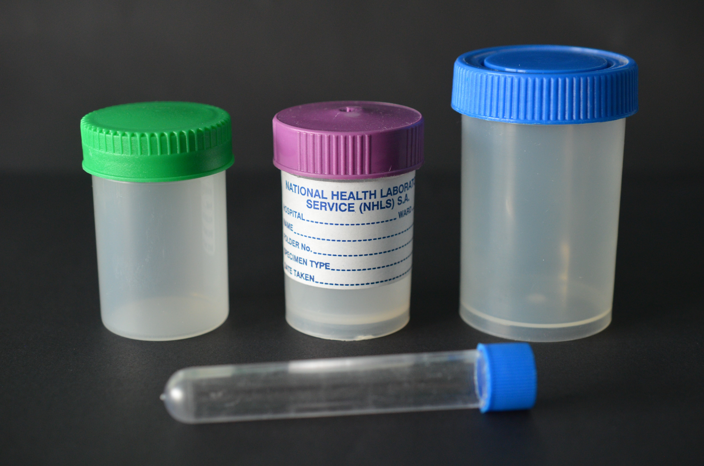
Blood culture bottle:  - Collect 8-10 mL per bottle (adults) and 1-4 mL per bottle (children)  - Submit ≥ 1 mL of fluid in EDTA tube for cell count | 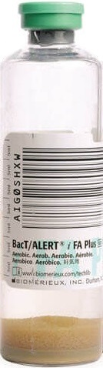 | or | 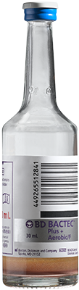 | + | 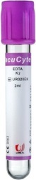
Heparin tube:  - For bloody specimens (to prevent clotting) | 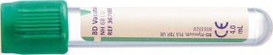
DO NOT SEND IN SYRINGE WITH NEEDLE | 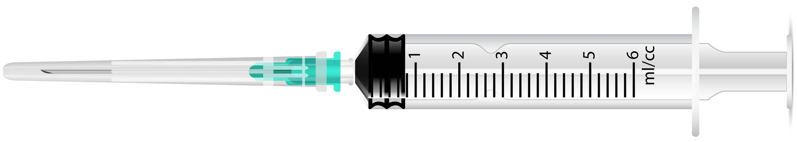

Table 17-4. Containers for tissue specimens
Tissue
Collect aseptically at time of surgery | - Sterile universal container (keep specimen moist by adding sterile saline)  - Do not use formalin

NOTE: Swabs are the least desirable sample for culture of fluids and are discouraged

17.6 Nasopharyngeal and respiratory tract specimens

17.6.1 Specimens for lower respiratory tract infections
- Appropriate specimens include sputum, tracheal aspirates, bronchial washings, bronchial brushes, bronchial brush specimens, lung biopsy specimens, broncho-alveolar lavage (BAL) fluid, transtracheal aspirates, lung aspirates and nasogastric aspirates.
- Endotracheal tube tips should NEVER be submitted for culture.
NOTES:
- If infection with Legionella pneumophila is suspected, a urine specimen should be submitted for urine antigen testing.
- Sputum induced with hypertonic saline has greater sensitivity for the diagnosis of Pneumocystis jiroveci than expectorated sputum.
- If bacterial pneumonia is suspected, submission of concomitant blood cultures is recommended.

17.6.1.1 Sputum specimens
- The patient should be given clear instructions on how to produce an early morning sputum specimen as shown in Fig. 17-5 on page 145.
- Aerosols containing TB bacilli may be produced during collection of a sputum specimen and it is therefore advisable to collect specimens away from other people and in a well-ventilated area.
- An adequate specimen should contain at least 5 mL of sputum.
- The specimen should be collected in a sterile universal container.
- PLEASE close the lid tightly to prevent leaking of the specimen, and clearly label the container. This should be done by the health care professional requesting the specimen. Please indicate the relevant clinical information on the request form as well as the diagnostic tests required.
- For the diagnosis of pulmonary TB, clearly identify the type of investigation required as per the algorithms in Figs. 17-6 and 17-7 on pages 146 and 148 respectively. If MC&S for organisms other than TB is required, please request a standard MC&S.
- The specimen should be transported to the laboratory as soon as possible after collection.
- If there is a delay in transport to the laboratory, e.g. specimen from an outside clinic, specimens should be refrigerated. DO NOT FREEZE SPECIMENS.
- Discard all collection material in appropriate biohazard containers.

Induced sputum collection procedure:
- Have patient rinse mouth with water after brushing the gums and tongue.
- With the aid of a nebulizer, have patient inhale about 25 mL of 3-10% sterile saline.
- Collect induced sputum in a sterile container. PLEASE close the lid tightly to prevent leaking of the specimen.
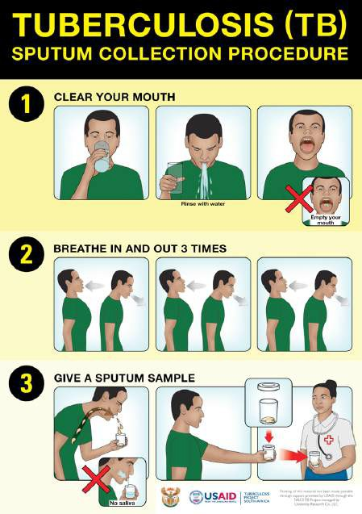
Fig. 17-5. Sputum collection procedure.

17.6.1.2 Xpert MTB / RIF Ultra diagnostic algorithm (National)
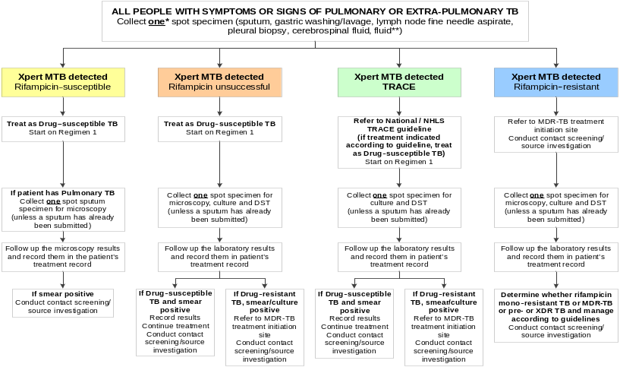

Fig. 17-6. Algorithm for management of patients with MTB detected by Xpert

NOTE: Please refer to the latest National guidelines as these may change.
*For pulmonary TB, collect 2 sputum specimens, 1 hour apart. Submit both, with one form, requesting Xpert.
Laboratory will reflex test 2nd specimen according to Xpert results, in line with algorithm on the above page.
**Xpert may be requested on pleural, pericardial and ascitic fluids. For these fluids, Xpert will only be performed on fluids that are purulent (not clear) as the yield is superior with these (until further evidence for clear fluids is available).
KEY:
MTB: Mycobacterium tuberculosis complex
MDR: Multidrug-resistant
DST: Drug susceptibility testing
XDR: Extensively drug-resistant

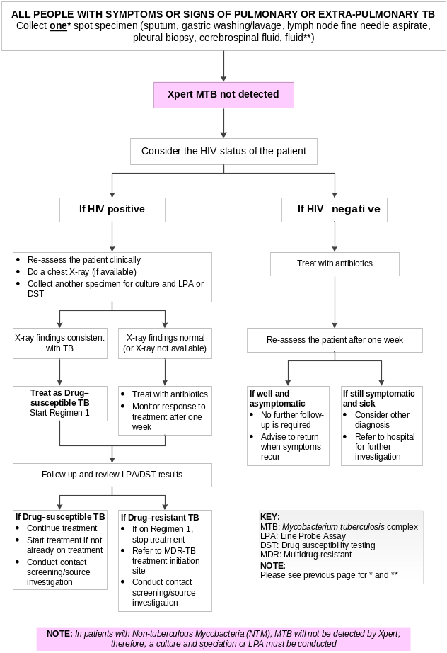
Fig. 17-7. Algorithm for management of patients with negative Xpert results.

17.6.2 Nasopharyngeal specimens

17.6.2.1 Throat swabs
- Routinely used for the diagnosis of Group A streptococcal pharyngitis.
- Depress tongue gently with a tongue depressor.
- Extend sterile swab between the tonsillar pillars and behind the uvula.
- Avoid touching the cheeks, tongue, uvula or lips.
- Sweep the swab back and forth across the posterior pharynx, tonsillar areas, and any inflamed or ulcerated areas to obtain a sample.
- Send the swab to the laboratory in suitable transport media, as soon as possible.
NOTE: Do not attempt to collect a throat swab if the epiglottis is inflamed or if diphtheria is suspected as sampling may result in airway obstruction.

17.6.2.2 Nasal swabs
Submitted primarily for the detection of nasal carriers of Staphylococcus aureus.
NOTE: Nasal cultures do not predict the etiologic agents of sinusitis, otitis media or lower respiratory tract infections.
- Carefully insert a moistened sterile swab at least 1 centimeter (cm) into the nose.
- Rotate swab against the nasal mucosa and leave in place for 10-15 sec.
- Repeat the process on the other side using the same swab.
- Send the swab to the laboratory in suitable transport media as soon as possible.

17.6.2.3 Nasopharyngeal swabs
- Collected primarily for the detection of carriers of Neisseria meningitidis and to diagnose Bordetella pertussis (see Section 17.6.2.5.2 on the next page or additional information on collection for B. pertussis).
- If pertussis is suspected, the laboratory must be alerted before the specimen is sent to ensure that the appropriate culture media is available.
- Nasopharyngeal swabs should not be used to detect the etiological agents of sinusitis.
Collection procedure:
- Remove excess secretions or exudate from the nose.
- Carefully insert a flexible wire calcium alginate-tipped swab through the nose into the posterior nasopharynx.
- Rotate the swab against the nasopharyngeal membrane and allow it to remain in place for 10-15 sec.
- Keep the swab near the septum and floor of the nose during collection.
- Send the swab to the laboratory in suitable transport media, as soon as possible. DO NOT REFRIGERATE SPECIMENS.

17.6.2.4 Nasopharyngeal aspirates
Nasopharyngeal aspirates are appropriate specimens for the detection of:
- Bordetella pertussis
- Corynebacterium diphtheriae
- Neisseria gonorrhoea
- Neisseria meningitidis
The laboratory must be alerted before the specimen is sent to ensure that the appropriate culture media is available.

17.6.2.5 Unusual pharyngeal pathogens

17.6.2.5.1 Neisseria gonorrhoeae (gonococcal pharyngitis)
- Nasopharyngeal aspirates or swabs of the tonsillar pillars and the posterior pharynx should be collected.
- Swabs should only be used if there is a very short interval between collection and plating.
- The swab should be placed in a non-nutrient transport medium such as Amies or Stuart’s transport medium.
- If a delay in transport to the laboratory is inevitable, the specimen should be inoculated onto New York City agar at the time of collection.
NOTE: Since this is not part of routine testing, please indicate a request for N. gonorrhoea culture clearly on the request form.

17.6.2.5.2 Bordetella pertussis (whooping cough)
- Sputum samples and/or nasopharyngeal swabs/aspirates transported in Regan-Lowe (RL) or Amies charcoal transport medium (see Fig. 17-8 on next page).
- Small-tipped calcium alginate and dacron swabs are suitable for culture.
- Rayon and cotton swabs should be avoided for culture since they contain fatty acids that are toxic to B. pertussis.
- Ideally the specimen should be inoculated at the patient’s bedside onto charcoal-based media and 2 slides should also be made.
- Contact the laboratory to obtain appropriate culture media before samples are collected.
- Dacron-tipped swabs with non-wooden shafts are suitable for PCR.

17.6.2.5.3 Corynebacterium diphtheriae
- Suspected cases:
- Swabs should be collected prior to treatment and taken from the oropharynx and underneath the pseudomembrane (if present).
- Pseudomembrane tissue should also be collected if possible.
- Dacron, rayon or nylon-flocked swabs should be used and placed in Amies or Stuart’s transport media (see Fig. 17-8 below).
- Tissue should be placed in sterile saline (not formalin).
- Specimens must be transported to the laboratory, with ice packs, as soon as possible.
- Contacts:
- Nasopharyngeal and oropharyngeal swabs should be collected prior to chemoprophylaxis.
- Following completion of chemoprophylaxis, swabs should be collected again from C. diphtheriae-positive contacts after 2 weeks of commencing with chemoprophylaxis to ensure eradication of carriage.
- Dacron, rayon or nylon-flocked swabs should be used and placed in Amies or Stuart’s transport media (see Fig. 17-8 below).
Fig. 17-8. Amies transport medium (with charcoal).

17.7 Oral cultures
Indicated for the diagnosis of oral candidaemia and fusospirochetal disease (Vincent’s angina).
- Rinse the mouth with sterile saline.
- Wipe the lesion with sterile gauze.
- Swab or scrape areas of exudation or ulceration.

17.8 Ocular specimens

17.8.1 General considerations
- Several different techniques are used to collect specimens from different parts of the eye by an ophthalmologist as per clinical guidelines.
- The following specimen types can be tested by the laboratory:
- Conjunctiva/lid margin samples
- Corneal scrapings
- Intra-ocular fluid
- Lacrimal gland
- Lacrimal sac
- Lacrimal duct
- These specimens should be inoculated directly onto culture/transport media at the patient's bedside or theatre and slides are to be prepared at the time of collection (available from the laboratory).
- A conjunctival swab should accompany any specimen collected by an invasive method, as this will serve as a control (the conjunctiva is consistently colonised with environmental/ocular adnexal flora).
- Send prepared smears and inoculated media promptly to the laboratory.

17.8.2 Special considerations
- N. gonorrhoea: Use a swab with Amies transport medium to collect the specimen; inoculate the scrapings onto a New York City agar plate at the patient's bedside.
- Fungi: Inoculate onto appropriate media e.g. Sabouraud dextrose agar at the patient's bedside.
- Anaerobes: Inoculate into anaerobic transport media or directly onto appropriate media at the patient's bedside.
- Viruses: Use dacron/cotton swabs with non-wooden shafts and send the specimen in the appropriate viral transport medium.
- C. trachomatis: Use only a dacron swab (available on request from the laboratory) to collect the specimen. Please mark the request form clearly when testing for Chlamydia is required.
NOTE: All special transport media and agar plates must be collected from the laboratory BEFORE samples are collected.

17.9 Tissue biopsies, aspirates / swabs of abscesses and fluids

17.9.1 General principles
- The character of the lesions in question may limit the usefulness of these cultures. Lesions connecting with skin, mucosal surfaces or the gastro-intestinal tract will be encumbered by the presence of indigenous microflora. Therefore, for meaningful culture results, surgically obtained tissue samples, aspirates of closed abscesses and aliquots of pus/fluid are preferred rather than swabs.
- Swabs of superficial skin ulcers, the skin surface of sinus tracts and from open abscesses often yield mixed bacterial flora, which do not reflect the organisms of true infectious significance. Therefore, every effort should be made to sample from deeper aspects of the lesion with careful avoidance of the contaminated tissue surface.
- When anaerobic bacteria are suspected, the specimen should ideally be inoculated into anaerobic transport medium (available on request from the laboratory) at the bedside and promptly transported to the laboratory.
- When looking for fastidious or unusual organisms please notify the laboratory so that cultures can be appropriately set up and held for prolonged incubation as needed.
- Providing the laboratory with the location and type of wound/abscess/ tissue as well as a clinical diagnosis are useful as it can hasten recognition of specific pathogens associated with the specific type of infection.
- Specimens can be transported to the laboratory using:
- A sterile universal container
- Transport medium (e.g. Amies or Stuart’s medium).

17.9.2 Tissue biopsies
- Specimens collected at the time of surgery/endoscopy should be submitted in sterile universal containers without formalin (see Section 17.5, Table 17-4 on page 143).
- The specimen should be kept moist by the addition of normal saline.
- PLEASE close the lid tightly to prevent the contents from leaking.

17.9.3 Pus specimens

17.9.3.1 Aspirates
- Disinfect collection site with 70% alcohol or other suitable skin disinfectant. Allow 1-2 minutes for the disinfectant to dry.
- Obtain specimen via percutaneous needle aspiration or surgery using strict aseptic technique.
- Aspirate the deepest part of the lesion using a 3−5 mL syringe and a 22-23 gauge needle.
- If the initial aspirate fails to yield material, inject normal saline subcutaneously and repeat the aspiration attempt.
- Please refer to Section 17.5, Table 17-3 on page 142 for suitable containers to use.

17.9.3.2 Deep lesions
- Disinfect collection site with 70% alcohol or other suitable skin disinfectant. Allow 1–2 minutes for disinfectant to dry.
- Aspirate the deepest part of the lesion.
- If the specimen is collected in theatre, submit a portion of the wall of the lesion as well.
- Please refer to Section 17.5 on pages 142 for suitable containers to use.

17.9.3.3 Burn wounds
- The surface of burn wounds may become colonised by the patient’s own microbial flora or by environmental organisms.
- While surface cultures of burn wounds may be helpful from the standpoint of evaluating potential pathogens that exist on the patient and in the burns ward, they do not give any indication of the status of the wound itself.
- Assess the burn wound site clinically for signs of inflammation and purulence. Remove all superficial slough and debris prior to sampling. Disinfect collection site with 70% alcohol or other suitable skin disinfectant. Allow 1−2 minutes for disinfectant to dry.
- Submit tissue as specimen of choice. Collect two punch biopsies and submit one for culture (in a sterile universal container with sterile saline) and the other one for histology (in a container with formalin). PLEASE close the lids tightly to prevent contents from leaking.
- If exudate appears, sample it firmly with a swab.
- Sampling of different areas of the burn wound is recommended, as organisms may not be evenly distributed.

17.9.3.4 Pus swabs
- Disinfect collection site with 70% alcohol or other suitable skin disinfectant. Allow 1−2 minutes for disinfectant to dry.
- Use a premoistened swab to firmly swab the base or margin of the lesion.
- Take care to avoid adjacent skin margins.
NOTE: Dry swabs are unacceptable specimens. Send sample to the laboratory as soon as possible or submit in a suitable transport medium (e.g. Amies or Stuart’s) if a delay is anticipated.

17.9.4 Ulcers
- Disinfect collection site with 70% alcohol or other suitable skin disinfectant. Allow 1−2 minutes for disinfectant to dry.
- Remove overlying debris.
- Curette the base of the ulcer; collect exudate from ulcer using a syringe or swab.

17.9.5 Rectal biopsy
- Specimens requiring microbiological culture should NOT be submitted in formalin. Submit specimens in a sterile universal container in normal saline to prevent it from drying out. PLEASE close the lid tightly to prevent contents from leaking.

17.10 Stool specimens

17.10.1 General principles
- Specimens should be collected in sterile universal containers. PLEASE close the lid tightly to prevent contents from leaking.
- Containers should be clean and dry. The presence of water or urine can result in inaccurate interpretation of results.
- Suspected clinical diagnosis should be indicated on the request form. This is essential where special media or tests are required for culture and identification of certain organisms, e.g. Clostridioides (previously Clostridium) difficile, Vibrio cholerae or opportunistic parasites in HIV infection.
- Obtain unformed stool specimens.
- Do not submit more than one stool specimen for a particular patient in a 24-hour period.
- Stool specimens should preferably be sent within the first 3 days of admission.
NOTE: Diarrhoea developing after this period is usually nosocomial in origin, i.e. antibiotic-associated diarrhoea. In these cases, C. difficile testing should be requested.

17.10.2 Rectal swabs
- Rectal swabs should NOT be submitted UNLESS:
- Stool cannot be obtained (e.g. during initial stage of typhoid/enteric fever when patients are often constipated), or
- Screening for carriage of multidrug-resistant (MDR) organisms (e.g. carbapenem-resistant Enterobacteriaceae [CRE] or vancomycin-resistant enterococci [VRE]).
- Please indicate the purpose of the rectal swab (e.g. VRE or CRE screening) clearly on the request form.
- These swabs must be placed in transport media after collection, e.g. Cary-Blair, Amies or Stuart’s transport medium, which is available from the laboratory.
- Collection method:
  - Moisten the swab in sterile transport medium.
  - Gently insert the swab 2−3 cm into the anal canal and rotate to sample anal crypts. Remove the swab and inspect for visible faeces.
  - Immediately insert the swab into the transport medium and deliver to the laboratory promptly. If delays are anticipated, the swab in transport medium can be refrigerated.

17.10.3 Parasites
- Requests for parasite examination must be clearly stated on the request form.
- Stool specimens should be transported to the laboratory as soon as possible – within 1 hr if Entamoeba histolytica is suspected.
- Substances such as bismuth, antibiotics and anti-motility agents can interfere with parasite detection.
- Please provide relevant clinical information, e.g. opportunistic parasites in HIV infection require special staining procedures.
- Several specimens may be needed to identify the presence of parasites due to intermittent excretion. Therefore, stool specimens should be collected every other day or on consecutive days but not all on the same day.
NOTE: Optimal collection time of urine for Schistosoma haematobium (bilharzia) and stool for Schistosoma mansoni is between 10:00 am and 2:00 pm. Please state clearly on the request form that bilharzia/Schistosoma microscopy is requested.

17.10.3.1 Cellotape preparation for pinworm (Enterobius vermicularis)
- The sticky surface of cellotape should be pressed against the patient’s perianal skin in the morning before going to the bathroom or taking a bath (since the female worm lays her eggs during the night on the peri-anal skin). Please see Fig. 17-9 on the next page.
- The tape should be placed on a glass slide and sent to the laboratory for microscopic examination of eggs.
- Repeated examinations may be indicated.
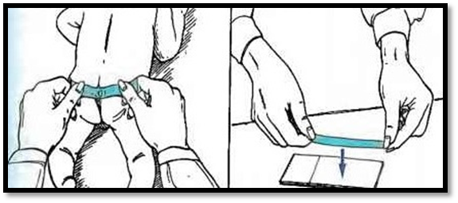
Fig. 17-9. Cellotape method for pinworm diagnosis.

17.11 Urine specimens

17.11.1 General principles
- Urine is normally a sterile body fluid. If urine specimens are not collected properly, contamination with normal flora of the perineum, urethra and vagina can occur, resulting in inaccurate results.
- Please stipulate the type of specimen, e.g. midstream urine, suprapubic urine aspirate or catheter urine specimen.
- Early morning and midstream urines are the preferred specimens and have the best yield.
- Suprapubic aspirates may be required from infants.
- Specimens > 48 hrs old may be rejected unless refrigeration has occurred.
- Do not force fluids prior to urine collection as this will dilute colony counts and result in potential misinterpretation.
- Never submit urine collected in a bedpan or urinal.

17.11.2 Midstream or clean-catch specimen collection

17.11.2.1 Females
- Thoroughly cleanse the urethral area with soap and water (not disinfectant); rinse the area with wet gauze pads (see Fig. 17-10 on the next page).
- While holding the labia apart, begin voiding.
- After several millilitres have passed, collect a midstream portion without stopping the flow of urine.
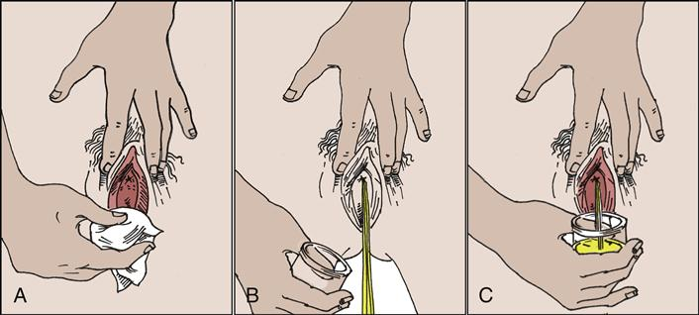
Fig. 17-10. Collection of urine midstream specimen in females.

17.11.2.2 Males
- Cleanse the glans with soap and water (not disinfectant); rinse with wet gauze pads (see Fig. 17-11 below).
- Holding the foreskin retracted, begin voiding.
- After several mL have passed, collect a midstream portion without stopping the flow of urine.
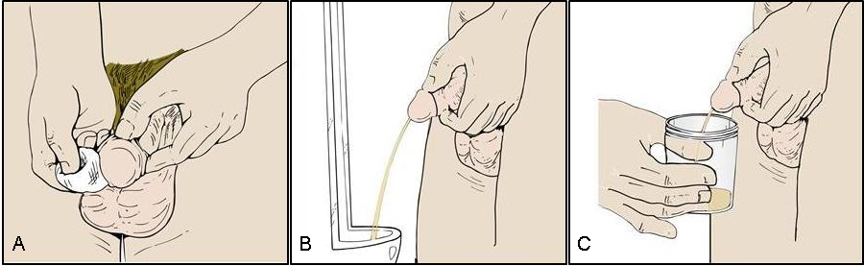
Fig. 17-11. Collection of urine midstream specimen in females.

17.11.3 Catheter specimens

17.11.3.1 Indwelling urinary catheter specimen collection
Urine collected from indwelling catheters is often contaminated with colonising flora; therefore, specimens should be collected as follows (see Fig. 17-12 on the next page):
- Disinfect the catheter collection port with 70% alcohol. Allow to dry.
- Use a needle and syringe to aseptically collect 5−10 mL urine.
- Transfer sample to sterile container. PLEASE close the lid tightly to prevent contents from leaking.
NOTES:
- DO NOT submit Foley catheters or their tips as these specimens are of no value due to extensive contamination by colonising flora. If submitted, these specimens will be rejected.
- DO NOT collect urine from the collection bag.
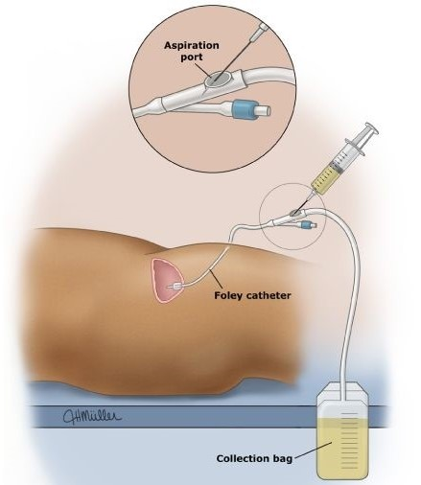
Figure 17-12. Collection of catheter urine specimen.

17.11.3.2 Straight / in-out catheter specimen collection
- Thoroughly cleanse the urethral area with soap and water; rinse the area with wet gauze pads.
- Aseptically, insert a catheter into the bladder.
- After allowing about 15 mL to pass, collect urine to be submitted in a sterile container.
- Remove the catheter immediately. This specimen should be clearly marked as an “In-out catheter specimen”.
NOTE: If preparation is inadequate, the procedure may introduce urethral flora into the bladder and increase the risk of iatrogenic infection.

17.11.4 Parasites, dysmorphic cells and casts
- Requests for parasites and/or casts must be clearly stated on the request form.
- These specimens must arrive promptly at the laboratory.
- Urine for Schistosoma haematobium is best collected between 10:00 am and 2:00 pm when ova excretion is the highest.

17.11.5 Renal tuberculosis
- Urine specimens for acid-fast bacilli (AFB) and TB culture may be a useful adjunct in the diagnosis of renal TB.
- Up to 3 early morning (first void) specimens should be submitted (200−400 mL urine per sample).
- Urine microscopy for AFB is not a sensitive screening tool. However, TB culture has a better yield provided a sufficient number of specimens are submitted (i.e. sensitivity of culture is 80−90% if at least three early morning urine specimens are cultured).

17.12 Mycology specimens
Please indicate clearly on the request form if mycology investigations are required.

17.12.1 Tissue specimens
- Collect tissue biopsies aseptically.
- Put the specimen in a sterile universal container and do NOT add saline.
- Transport to the laboratory immediately or refrigerate at 2−8°C if transport is delayed.

17.12.2 Purulent exudates and fluids
- Pus should be aspirated aseptically from closed lesions where possible and placed in a sterile universal container and transported to the laboratory as soon as possible.
- Wound dressings can be sent for examination of granules if mycetoma or actinomycosis is suspected clinically.
- Pus swabs are generally inferior specimens and should be avoided.
- Other swabs (e.g. vaginal, penile, throat, oral) should be transported to the laboratory as soon as possible.
- Aspirate bone marrow into a BACTEC Myco/F Lytic blood culture bottle or sterile heparinised tube. Also make 2 smears for special fungal stains and submit together with the culture specimen.
- Pleural, peritoneal and joint fluids should be collected aseptically in a clean sterile universal container. Bloody specimens can be collected in a heparinised collection tube to prevent clotting.
- Corneal scrapings obtained by a platinum spatula must be transferred onto an agar plate (blood, Sabouraud dextrose) at the patient's bedside or in theater during surgery. Smears of the scraped material should also be prepared on clean, alcohol flamed slides.

17.12.3 Urine, stool and rectal swabs
- Collect urine in a sterile universal container and send to laboratory without delay.
- Stool specimens or rectal swabs for fungal culture are rarely useful as the significance of fungi present in such contaminated material is controversial.

17.12.4 Lower respiratory tract infections
- Collect specimens appropriately as described in Section 17.6.1 on page 143 into sterile universal containers without additives and send to the laboratory for processing.
- When a delay in transport is expected, refrigeration is not advisable if histoplasmosis is suspected.
- Collect three early morning specimens.
- Lung biopsy or aspirates are also appropriate specimens.
- Please specify on the request form if a fungal infection is suspected.

17.12.5 Skin
- Clean the area of skin from which a specimen is to be collected with 70% alcohol if ointments or other topical medications have recently been applied.
- Scrape the active peripheral edge of the lesion with a scalpel or the end of a microscope slide.
- Place the scales in a sterile Petri dish or container or between 2 glass slides taped together and send promptly to the laboratory.

17.12.6 Nails
- Cleanse nails thoroughly with an alcohol wipe.
- Scrape deeply using a blunt scalpel to obtain recently invaded nail tissue.
- Initial scrapings are usually contaminated and thus should be discarded.
- Clippings of whole thickness of affected nail can be obtained using nail clippers.
- Place the scrapings and nail clippings in a sterile Petri dish or container and send promptly to the laboratory.

17.12.7 Hair and scalp
- Send basal portions of infected hair and scalp skin scrapings from the affected areas promptly to the laboratory in a sterile container to prevent overgrowth of contaminating fungi.

17.12.8 Beta−D glucan Fungitell® assay
- This is an adjunct test for the qualitative detection and quantitation of (1-3)-β-D glucan (BDG), a component of the fungal cell walls of most fungi.
- The test should be performed in conjunction with microbiological culture of appropriate samples, septic markers and radiology where applicable.
- This test detects BDG in the blood of patients with invasive fungal infections, including Pneumocystis jiroveci.
- Not recommended for Cryptococcus spp. and zygomycetes as these fungi release little or no BDG in human serum.
- Please ensure that a separate/dedicated sample tube is submitted when referring samples for BDG testing. When a single sample is sent with a request for multiple tests, the sample has to be split. This process can result in contamination of the sample and a false-positive result by the BDG assay.
- Conditions interfering with BDG results include:
- Haemolysis
- Sample turbidity due to lipemia/bilirubin
- False-negatives
- Early candidaemia (recommend submitting repeat sample if continued clinical suspision and initial BDG sample negative)
- Certain strains of Candida parapsilosis
- Immune complex disease
- Cryptococcus neoformans
- Zygomycetes
- False-positives
- Haemodialysis with cellulose membrane
- Administration of blood products (immunoglobulin or albumin)
- Antibiotics: Amoxicillin-clavulanate, piperacillin-tazobactam (not due to antibiotic itself; however, BDG is present in cellulose filters used during manufacturing)
- Use of surgical gauze containing glucan
- Severe bacterial infections and mucositis.
SECTION 18.0
COMMUNICABLE AND REPORTABLE DISEASES

18.0 COMMUNICABLE AND REPORTABLE DISEASES
Category 1 organisms
Definition:
Notifiable medical conditions that require immediate reporting by the most rapid means available upon diagnosis followed by a written or electronic notification to the Department of Health within 24 hours of diagnosis by healthcare providers, private health laboratories or public health laboratories.
Notifiable medical conditions:
- Acute flaccid paralysis  - Acute rheumatic fever  - Anthrax  - Botulism  - Cholera  - Diphtheria  - Enteric fever (typhoid or paratyphoid fever)  - Food-borne disease outbreak*  - Haemolytic uraemic syndrome (HUS)  - Listeriosis  - Malaria  - Measles | - Meningococcal disease  - Pertussis  - Plague  - Poliomyelitis  - Rabies (human)  - Respiratory disease caused by a novel respiratory pathogen**  - Rift valley fever (human)  - Smallpox  - Viral haemorrhagic fever diseases***  - Yellow fever
*Food-borne disease outbreak is the occurrence of two or more cases of a similar food-borne disease resulting from the ingestion of a common food.
**Examples of novel respiratory pathogens include novel influenza A virus and Middle East respiratory syndrome (MERS) coronavirus (MERS-CoV).
***Viral haemorrhagic fever diseases include Ebola virus, Marburg virus, Lassa virus, Lujo virus, new world arena viruses, Crimean-Congo haemorrhagic fever or other newly identified viruses causing haemorrhagic fever.

Category 2 organisms
Definition:
Notifiable medical conditions to be notified through a written or electronic notification to the Department of Health within seven (7) days of clinical or laboratory diagnosis by health care providers, private health laboratories or public health laboratories.
Notifiable medical conditions:
- Agricultural or stock remedy poisoning  - Bilharzia (schistosomiasis)  - Brucellosis  - Congenital rubella syndrome  - Congenital syphilis  - Haemophilus influenzae type b  - Hepatitis A  - Hepatitis B  - Hepatitis C  - Hepatitis E  - Lead poisoning  - Legionellosis  - Leprosy | - Maternal death (pregnancy, childbirth and puerperium)  - Mercury poisoning  - Soil-transmitted helminths (Ascaris lumbricoides, Trichuris trichiuria, Ancylostoma duodenale, Necator americanus)  - Tetanus  - Tuberculosis: Pulmonary  - Tuberculosis: Extra-pulmonary  - Tuberculosis: Multidrug- resistant (MDR-TB)  - Tuberculosis: Extensively drug-resistant (XDR-TB)

Category 3 organisms
Definition:
Notifiable medical conditions to be notified through a written or electronic notification to the Department of Health within 7 days of diagnosis by private and public health laboratories
Notifiable Medical Condition / Pathogen(s) to notify
- Ceftriaxone-resistant Neisseria gonorrhoea  - Endemic arboviral diseases: West Nile virus, Sindbis virus, Chikungunya virus  - Non-endemic arboviral diseases: Dengue fever virus, other imported arboviruses of medical importance | - Non-typhoidal Salmonellosis: Salmonella spp. other than S. Typhi and S. Paratyphi  - Rubella virus  - Shiga toxin-producing Escherichia coli  - Shigella spp.

Category 4 organisms
Definition:
Notifiable medical conditions to be notified through a written or electronic notification to the Department of Health within 1 month of diagnosis by private and public health laboratories
Notifiable Medical Condition / Pathogen(s) to notify
- Health care-associated infections or multidrug-resistant organisms of public health importance*  - Carbapenemase-producing Enterobacteriaceae  - Vancomycin-resistant enterococci  - Staphylococcus aureus: hGISA** and GISA*** | - Colistin-resistant Pseudomonas aeruginosa  - Colistin-resistant Acinetobacter baumannii  - Clostridiodes difficile
*Health care-associated infection means an infection occurring in a patient during the process of care in a health establishment which was not present or incubating at the time of admission
**Heterogenous glycopeptide-intermediate S. aureus (hGISA)
***Glycopeptide-intermediate S. aureus (GISA)

Notification of new cancer cases
New regulations with regards to the registration of all new cancer diagnoses were promulgated in April 2011. The amendment makes provision for the establishment of a Population Based Cancer Registry and also stipulates the compulsory notification of all new cancer cases on the prescribed form. Failure to comply with the provisions of the new regulations is regarded as an offence which may lead to prosecution. Cancer notification forms are to be submitted to the National Cancer Register (NCR) within 3 months of diagnosis. Forms are to be completed in duplicate in BLOCK LETTERS. The original must be submitted to the National Cancer Register and the copy to be retained in the patient’s file.
Cancer notification forms can be submitted to the National Cancer Register via:
E-mail: cancer.registry@nhls.ac.za
Fax: (011) 489 9132 / (011) 489 9152
Post: PO Box 1038, Johannesburg, 2000
For a detailed description of the new regulations please see:
Act No. 61 of 2006 – Regulations related to Cancer Registration No. R.380

SECTION 19.0
INFECTION CONTROL

19.0 INFECTION CONTROL

19.1 Hemodialysis water

19.1.1 Test frequency and timing

19.1.1.1 Routine
Collect samples for monitoring purposes at least monthly.

19.1.1.2 Repeat
Collect repeat samples when bacterial counts exceed the allowable level. If culture growth exceeds permissible standards, re-culture the water system, usually weekly, until acceptable results are obtained.

19.1.1.3 Ad hoc
Collect samples when clinical indications suggest pyrogenic and/or septicaemic complications following a specific request by the clinician and/or the infection control practitioner.

19.1.1.4 Timing
If the water system has been treated with formaldehyde or chlorine for sanitisation, flush the system completely before collecting samples. Drain and flush storage tanks and water lines (15 min flush time recommended) before collecting samples. Culture water and dialysis fluid monthly unless a greater frequency is dictated by historical data at your institution.

19.1.2 Specimen collection, transport and storage

19.1.2.1 Dialysis water
- Use standard universal specimen containers (i.e. used for urine/sputum specimens).
- Sample at a point immediately past the water production system, e.g. reverse osmosis system, deionization units.
- Sample wherever storage of water occurs, e.g. storage tank used to store water from the water treatment system.
- Sample just before water enters the dialysis machine or central proportioner.

19.1.2.1 Dialysate
- Following dialysis, collect fluid from dialyser.
- Single-pass system: Sample where dialysate leaves dialyser.
- Re-circulatory system: Sample at the periphery of the re-circulation chamber containing the coil dialyser.

19.1.2.2 Volume
- Collect a minimum of 5 mL from each sample point into sterile universal containers.

19.1.2.3 Method
- At each point of collection, open the valve and allow the water to flow for a minimum of 2 min before the sample is collected.

19.1.2.1 Transport and storage
- Culture of dialysis water and dialysate must preferably start within 30 min of collection. If delays are expected, store the specimens at 4−5ºC and culture within 24 hrs of collection.

19.2 Collection of water from hydrotherapy pools
- At least 30 mL of water sample should be collected from both the deep and shallow ends of the pool. The specimen collection container should contain sodium thiosulphate to neutralize the pool chlorine unless the sample can be processed within 3−4 hrs of collection. Water samples should be tested twice a week. Where there are financial constraints the sampling should not be less than every two weeks.
- The container should be held with the mouth in the direction of the water flow so that the sample does not become contaminated with bacteria from the sampler’s hand.
- Samples must be delivered to the laboratory in a polysterene container with ice packs within 2 hrs of specimen collection.
- If chlorination is done manually, samples should be taken before the next dose is added to the pool or at the beginning of the day before there is any bathing.

19.3 Culture of continuous ambulatory peritoneal dialysis fluid
Specimen collection and transport:
- Enclose dialysate bag in a larger plastic bag. Place this bag into a disposable plastic bag, and transport it to the laboratory.
- Transport
- For immediate delivery, transport at room temperature.
- For delayed delivery (i.e. > 1 hr after collection) refrigerate but DO NOT freeze.

19.4 Culture of intravascular devices

19.4.1 Specimen collection
- To prevent contamination by skin micro-organisms and antibiotic ointment, clean the skin insertion site with an iodophore (e.g. povidone-iodine) and alcohol prior to removal of the cannula.
- Remove the cannula in an aseptic manner once the alcohol has dried and send promptly to the laboratory in a sterile container.
- If purulence of the catheter exit site is evident, send pus in a sterile container for Microscopy, Culture and Sensitivity (MC&S).

19.4.2 Long catheters
- Two portions of these catheters should be sent for culture – the distal intravascular tip and the proximal transcutaneous segment.
- Each segment should be approximately 2 to 3 centimeter (cm) long.

19.4.3 Short catheters
- The cannula is cultured in its entirety following removal of the hub.
- To remove the hub, use sterile scissors, or snap off the steel needles with a sterile hemostat.

19.4.4 Specimen transport
- Transport catheter tips in a sterile universal container (without saline).
- Use a universal sample container.
- If tips are cut to a proper length (send proximal portion, ideally < 5 cm), there is no need to bend them for insertion into the sterile universal container.
- Tips must be cultured within 2 hrs of collection to prevent desiccation of micro-organisms.

19.5 Surveillance cultures for multidrug-resistant micro-organisms and as part of infection prevention and control strategies

19.5.1 Selective culture for fungi
Collect urine, stool and oropharyngeal specimens by using the techniques for obtaining these specimens for routine cultures as described previously. Please state clearly on the request form that fungal culture is required. If known, please specify which Candida spp. is being sought.

19.5.2 Surveillance culture for vancomycin-resistant Enterococci (VRE), methicillin-resistant Staphylococcus aureus (MRSA) and carbapenem-resistant Enterobacteriaceae (CRE)
- All swab specimens are submitted in the transport media that are routinely used for other swab cultures.
- Please state clearly on the request form the type of surveillance required.
- In general sites are as follows:
- MRSA: Anterior nares, axilla, groin.
- VRE & CRE: Rectal swab.
NOTE: Active screening usually performed in certain situations guided by site-specific policies (outbreaks/high risk patients). Discuss with Microbiologist / Infection Control Practitioner regarding local policy.

19.5.3 Selective bowel culture
- A rectal swab or a stool specimen is collected and submitted as if for routine culture.

19.6 Information and samples required to diagnose infusate-related sepsis

19.6.1 Required information
- The time of administration of the infusate.
- The diagnosis of the patient’s underlying condition.
- Time taken until the manifestation of adverse effects (e.g. pyrexia after administration).
- State if there are any other patients with similar symptoms and signs after receiving the same infusate batch number.
- The batch number and details of the infusate in question.
- The blood culture result from the patient taken at the time of suspected infusate related-sepsis.
- If any additives were administered with the infusion or added directly to the bag by a pharmacist.
- How the bag was stored prior to administration.
- The procedure followed when setting up the bag, i.e. how the skin was disinfected and if the health care worker was wearing gloves.
- Was the bag inspected for leaks?

19.6.2 Specimens
The following specimens are required which must be sent to the laboratory in separate sealed plastic bags:
- The full Intravenous (IV) set and infusate in use at the time when the patient spiked a temperature.
- Any “Add-in-line” bags.
- A blood culture taken through the line.
- A blood culture taken from a remote venipuncture site.
- A swab from each catheter hub.
- A swab from the skin site.
- The transcutaneous segment of the catheter.
- The distal portion of the catheter.
- Any other bags with the same batch number.

19.6.3 Collection and sending of infusates
- Aerobic BacT/Alert bottles must be used.
- The plastic cap on the BacT/Alert bottle must be removed, and the rubber bung must be disinfected with an alcohol swab containing 70% isopropyl alcohol.
- When the alcohol has evaporated, under strictly aseptic conditions, inoculate 10 mL of infusate sample into the BacT/Alert bottle.
- Each bottle must be accompanied with its own slip containing; all relevant data regarding the sender (name, address, contact numbers, account details), batch number, site, date, and barcode sticker, which must be removed from the bottle.
- The slips must be attached to the corresponding bottle.
- The bottles must be sent to the referral laboratory in a safe container to prevent breakage of BacT/Alert bottles.

19.7 Polymerase chain reaction (PCR) detection of Bordetella pertussis in nasopharyngeal swabs and aspirates
- Nasopharyngeal samples must be taken with dacron or rayon swabs since calcium alginate strongly inhibits the PCR (non-wooden shafts). If a sample has been taken using another type of swab, and cannot be repeated, the Molecular laboratory will process it according to a protocol with less chance of success than with the dacron swabs.
- If there is inhibition of the internal control, it will be reported as ‘no result’ as inhibition is suspected, and the result for B. pertussis is unknown.
- After streaking the swab head onto a charcoal Bordetella agar plate (preferably done by the clinician at the bedside, or by laboratory staff), it must be placed into a sterile container and sent to the molecular laboratory as soon as possible.
- This can be done by placing the swab into a plastic bag and sealing (not the original swab wrapping, unless that is sealed), or by cutting the shaft off (not too close to the head) and sending in a universal specimen container. Please indicate the type of swab used when sending for analysis.
- Nasopharyngeal and sinus aspirates, sputum and throat swabs can also be sent for analysis.
- Leaking samples, samples older than 10 days and gel swabs will be rejected.

19.8 PCR detection of toxigenic Clostridioides difficile in stool samples
- Loose, unformed stool samples are required for the detection of C. difficile infection. Formed stool will be rejected.
- These are to be collected in sterile containers that will not leak.
- Leaking samples and samples older than 48 hrs will be rejected.
- NOTE: Test-of-cure is not recommended.

19.9 Infection control tests

19.9.1 Clinical specimens
- Peritoneal dialysis bags (MC&S)
- Intravascular device tips (MC&S)
- Screening for VRE
- Screening for CRE
- Screening for MRSA
- Extended identification of aerobes and anaerobes

19.9.2 Specialized antibiotic susceptibility testing
- Etests
- Phenotypic tests for CRE
- Synergy testing by Etests
- Colistin broth microdilution testing
- Nocardia broth microdilution testing
- Heterogenous glycopeptide-intermediate S. aureus (hGISA)
- Minimum inhibitory concentration (MIC) testing

19.9.3 Outbreak investigations
- Clinical – Stool and vomitus
- Foods
- Air sampling
- Rodac surface cultures
- Air settle plates
- Surface swabs
- Positive pressure testing (smoke tubes)
- Testing of water for Legionella
- Culturing of sputum for Legionella
- Urine antigen test for L. pneumophila Serotype Group (SG) 1

19.9.4 Public Health Microbiology
- Water
- Total bacterial counts
- Coliform counts
- Escherichia coli (E Coli) counts
- Water for culture detection and identification of Vibrio cholerae
- Dairy Products
- Total bacterial counts
- Coliform counts
- E. coli counts
- Milk phosphatase
- Culture for bacteria (routine) and culture for yeasts & moulds (only on request)
- Foods
- Total plate counts
- Coliform counts
- E. coli counts
- Culture for Staphylococcus sureus (S. aureus), Bacillus cereus, Clostridium perfringens, Listeria monocytogenes, Campylobacter spp., Salmonella spp., E. coli O157, Shigella spp., Yersinia enterocolitica, Vibrio spp., yeasts and moulds.
- Toxin testing
- S. aureus
- B. cereus
- C. perfringens
- Molecular biology laboratory testing
- PCR for VRE screening
- PCR for B. pertussis
- PCR for Pneumocystis jiroveci
- PCR for C. difficile
- PCR for Influenza A/B and respiratory syncytial virus (RSV)
- Molecular typing (fingerprinting) of nosocomial pathogens in elucidation of nosocomial outbreaks
- Bacterial sequencing.

SECTION 20.0
PUBLIC HEALTH

20.0 PUBLIC HEALTH

20.1 General guidelines for sample collection and transport
It is of critical importance that Clinicians / Environmental Health Practitioners (EHP) use the following guidelines for the proper collection, discarding of consumables utilized in the collection and the appropriate transport of samples, as the quality of results hinges on this.
Consequences of poorly collected and/or poorly transported samples include:
- Failure to isolate the causative microorganism, and
- Recovery of contaminants or normal microbial flora, which may be misleading, and result in improper treatment of the patient.

20.1.1 Clinical samples
- Use strict aseptic technique to prevent contamination when collecting samples.
- Use sterile, leak-proof containers with lids that do not create an aerosol when opened.
- Samples and request forms should ideally be placed in separate plastic bags with the request form in the separate pouch of the plastic bag to prevent damage in the case of a leak in transit and packaged as per the relevant legal requirements.
- Collect clinical samples prior to initiation of antimicrobial therapy.
- Collect samples from anatomic sites most likely to yield pathogens and least likely to yield contaminants.
- Provide complete information on the request form including all clinical data. Ideally, all tests referred electronically to the Public Health laboratory, should be accompanied by the request form.

20.1.2 Environmental, food and water samples
- Use strict aseptic technique to prevent contamination when collecting samples.
- Collect sample in sturdy, sterile, screw cap, and leak-proof containers with lids that do not create aerosols when opened.

20.1.3 Proper sample transport
- Samples should be transported from the collection site to the receiving laboratory promptly at temperature not exceeding 8ºC unless otherwise stated.
- This also applies to samples being transported from a peripheral laboratory to the Public Health laboratory.

20.1.4 Sample containers
- The appropriate sample container must be used for the sample collected / test type.
- The container must be clearly labeled (if necessary use indelible ink) with the following details:
- Sample type
- Patient’s initial and surname – for clinical samples
- Date sample collected
- Sample reference number / patient’s hospital or clinic number
- Submitting institution and ward where applicable
- Contact person’s details to convey results.
- All the sample containers below are obtainable from the nearest laboratory, after prior arrangement:
- Sterile screw-cap universal container: Used for collection of urine and stool
- Sterile tubes: Collection tubes (with/without additives) used for sterile fluids
- Sterile 120 mL plastic bottles: Used for the collection of water samples
- 1 litre plastic water bottles: Used for collection of water samples for Legionella
- Moore pad parcels: Used for collection of river water for cholera culture
- Sterile plastic screw-cap bottles: Used for collection of food samples
- ¼ strength Ringer’s solution: Used for surface swabs
- Selenite Cysteine: Used for surface swabs when testing for Salmonella spp.
- Fraser broth: Used for surface swabs when testing for Listeria spp.
- Sterile swabs: Individually packed, used for surface swabs.

20.2 Samples (milk, food and water)

20.2.1 Collection of specimens to test food products, surfaces and utensils for the presence of food poisoning organisms

20.2.1.1 Food sampling
- Sampling should be systematic, and articles sampled should cover as wide a range as possible.
- All food and beverage components of a shared meal suspected of causing a food borne outbreak should be sampled.
- Where possible, different types of foods must be placed in separate containers (e.g. “curry and rice” – put curry in one specimen container and rice in another).
- The quantity of food taken for each sample must be sufficient (at least 100 grams (g)).
- PLEASE NOTE: Sterile 120 mL sample containers are available from the Public Health laboratory.
- Specimen labels must be filled in completely before the specimen is dispatched. The following information must appear on the label:
- The date and time of sampling
- If the sample has been submitted in a cooler box on ice
- Sample type, i.e. chicken, gravy, water, etc.
- Site sample was taken from (samples may be taken from one site where the food outbreak occurred but the same item may have been sampled from leftovers in the fridge and from the remains of a meal).
- The name of the outbreak should be recorded in the “Sample Description” column.
- All details of the sender including:
- Name and ID number
- Department / Health Authority address
- Telephone number
- Cell phone number
- Fax number
- E-mail address
- Alternative contact name and phone number.
- Please use the back of the document to fill in details of symptoms, toxic reactions, deaths etc. The specimen must be immediately placed in a cooler box surrounded by crushed ice or ice packs, or any other suitable refrigeration, which is capable of reducing the temperature of the sample.
- If samples are to be transported or sent over long distances, please DO NOT use crushed ice as it will melt and may affect the integrity of the sample(s).
- Preserve the cold chain until delivered to the Public Health laboratory. The temperature of the samples must not exceed 8ºC.

20.2.1.2 Clinical samples for food poisoning
- When investigating a suspected food poisoning outbreak, clinical samples are often not taken. Thus critical information in tracing the outbreak is unavailable.
- It is essential to link the organisms isolated from the food samples with organisms isolated from the people affected.
- Clinical specimens include faeces (or rectal swab) and vomitus.
- Please note that these samples and request forms should be labeled: “Food-borne disease outbreak” or “Food-borne pathogens”.
- Stools: Macroscopic examination for leucocytes, red blood cells and examination for parasites.
- Stools and rectal swabs: Culture for Salmonella, Shigella, E. coli 0157, Clostridium perfringens, Bacillus cereus, Staphylococcus aureus, Campylobacter jejuni, Listeria monocytogenes, Vibrio cholerae and Yersinia enterocolytica.
- Vomitus: Cultured for S. aureus and B. cereus.

20.2.1.3 Specimen collection and transport
- The specimens must be clearly labeled with the patient’s name, hospital number, date and time of collection and a brief history of food/fluids consumed by the patient.
- It would be ideal to send the patient stool and relevant food samples to the laboratory at the same time.
- Samples should be hand delivered in a cooler box directly to the laboratory.
- Samples from remote areas should not be dispatched via conventional delivery systems on a Friday or before a public holiday.
- Stools and or rectal swabs may be sent as part of the investigation of a suspected food poisoning outbreak.
- Specimens should be submitted as soon as possible.
- When testing food handlers or other individuals in a potential chain of transmission stool cultures should be collected and tested until there are a minimum of two consecutive negative stool samples collected more than 24 hrs apart.
- Stool samples should be submitted to the laboratory in a sterile universal container.
- Care should be taken to ensure that the specimen is not contaminated with urine.
- Rectal swabs should be submitted to the laboratory in an appropriate transport medium.
- Vomitus
- A vomiting episode occurring between 15 min and a couple of hrs after the ingestion of foodstuffs or fluids may indicate that the food poisoning is due to a pre-formed enterotoxin.
- The major aetiological considerations are S. aureus and B. cereus and the vomitus may be investigated for these organisms.
- The samples should be collected in sterile universal containers and sent to the laboratory as soon as possible with the food that was eaten.
- Food samples
- Culture for Salmonella, Shigella, E. coli 0157, C. perfringens, B. cereus, S. aureus, C. jejuni, L. monocytogenes, V. cholerae and Y. enterocolytica will be performed at the Public Health laboratory.
- Toxin tests
- C. perfringens toxin test will be done on samples of faeces only.
- Toxin tests for S. aureus and B. cereus will be done if these organisms are isolated from clinical or food samples.

20.3 Environmental swabs
- Samples are collected by swabbing from a group of four articles or components of the same kind, and must not include samples taken from any article or components of any other kind: If the number of articles or components of one kind sampled is less than four, the sample is collected from this lesser number.
- Sterile absorbent cotton wool-tipped swabs are used for collection of bacteriological samples.
- For the purpose of sampling two McCartney 10 mL bottles containing 10 mL of ¼ strength Ringer’s solution are required for each article or group of articles or component or group of components.

20.3.1 Area to be swabbed
- In the case of cups, glasses and other drinking utensils, the samples are collected from the exterior and interior surface to a depth of at least 12 mm from the top of the rim.
- In the case of spoons and ice-cream scoops, the samples are collected from the entire inner and outer surface of the bowl.
- In the case of plates, saucers bowls etc., over an area of approximately 2500 mm² of the surface which comes in contact with the food.
- In case of all other articles or components, samples are collected from all parts of the surface likely to come into contact with the food.

20.3.2 Method of swabbing
- The defined area or areas of each article or component or group of articles from which a sample is to be taken shall be swabbed as follows:
- First, with a swab moistened with Ringer’s solution from one of the McCartney bottles (after the excess moisture has been expressed from the swab on the inside of the bottle before removal) swab an area of 50 x 50 mm. After sampling, the swab should be immediately immersed in the same bottle and the protruding portion of the stick above the neck of the bottle broken off and the screw-top replaced.
- Immediately afterwards, over the same defined area(s) with a dry swab which shall be placed in the second bottle of Ringer’s solution.
- In each case, the bottles are suitably marked so as to identify the article or component from which the sample was taken and to distinguish the wet from the dry swab.
- The person who collects these samples must, at the time sampling, record in duplicate the name and address of the premises, the number of articles or components in the group sampled, the time of taking the sample and the identification mark on each bottle.
- As soon as possible after sampling the bottles containing the swabs, together with the duplicate copy of the particulars mentioned in the previous paragraph, must be delivered to the laboratory within three hours after collection. Where this is not possible, samples must be maintained at a temperature not higher than 5ºC.

20.4 Collection of milk samples
- Samples are collected using aseptic technique and are transferred to sterile sample containers taking precautions to prevent the contamination of the samples.
- Sample containers are surrounded by crushed ice or other suitable refrigerant which can come into contact with the container and is capable of reducing and maintaining the temperature until delivery to the laboratory at a temperature not exceeding 2−8ºC.
- In the case of milk or cream it must be clearly stated whether it is pasteurised, certified, raw or ultra-light treated (UHT).
- The volume of the sample must be sufficient, i.e. ± 100 mL. Sterile 120 mL sample containers are available from the nearest laboratory.
- A minimum of 50 g of reconstituted powdered milk should be sent to the laboratory at room temperature. Where the powdered milk has been reconstituted, please indicate on the request form if the milk has been pasteurised or not. The water that was used for reconstituting the milk must be sent to the laboratory for investigation as well.

20.5 Collection of domestic potable water samples
- A sterile container should be used. Sterile 120 mL containers are available from the nearest laboratory.
- Alternatively, a glass bottle may be used that has been boiled for 5 min and then placed in an oven to air dry at 100°C.
- Allow the water to run for 5 min.
- Collect 100−200 mL in a sterile container and ensure that the lid is securely in place.
- Provide all relevant information, including address, telephone and fax numbers, on the request form.
- Place the sample in a cooler box with ice packs and transport to the laboratory without delay.
- Tests performed for microbiological potability include total plate count (TPC), coliforms and E. coli.
- Samples must be received in the testing laboratory Mondays to Thursdays from 08h30−14h00.

20.6 Collection of water samples for the culture of Salmonella spp. (including S. Typhi), Shigella spp., E. coli 0157 and Vibrio cholerae

20.6.1 Sample collection
- One-litre bottles are available from the laboratory. These may be used for TPC, coliforms, E. coli, Salmonella and Shigella testing. For E. coli 0157 and V. cholerae testing, an additional one-litre sample is required for each test.
- Sterile 100 mL containers are also available, and these may be used for TPC, coliforms, and E. coli testing.
- Request forms are also available from the laboratory. Please ensure that a separate request form is used for each sample type, e.g. water, food or milk.
- Liaise with the laboratory ahead of the time if you wish to bring a large batch of samples. This is to ensure that adequate media stocks are on-hand.
- Start the sampling session early enough in the day to ensure that the samples can reach the laboratory early enough to be processed on the same day.
- In case there are delays, it is best not to take samples the day before a long weekend or on a Friday.
- When sampling from a borehole or tap allow the water to run for a few minutes so that you do not sample stagnant water in the pipes. Bacterial counts from stagnant water may not be reflective of the true water quality.
- Ensure that the sample is clearly labeled with a marker pen and that the sample container is not leaking.
- Immediately place the sample into a cooler box containing plastic ice packs. Please note that ice blocks from a domestic refrigerator are not a suitable alternative.
- As soon as the sampling session is completed transport the samples to the laboratory without delay.

20.6.2 Procedure for neutralising chlorine in water samples
- Sodium thiosulphate is used to neutralise chlorine in water samples.
- This is to prevent false negative results due to chlorine activity after the sample is taken.
- Please note that this is only for chlorinated water as supplied by your local municipality and does not apply to river water, dam water, borehole water or other environmental water samples.
- 0.5 mL of a 1% solution of sodium thiosulphate is added to a 100 mL sample of water. This will inactivate up to 60 parts per million chlorine in the sample.
- It is still important to transport the sample to the laboratory in a cooler box with ice packs as soon as possible.

20.7 Collection of water samples for Legionella culture (tested according to ISO 11731)

20.7.1 Sample containers
- Samples of water should be collected in glass, polyethylene or similar containers able to hold a volume of 1000−2000 mL. One litre sample bottles are available from the laboratory.
- If used previously, they should be cleaned, rinsed with distilled or mains tap water and then pasteurised either with flowing hot water (> 70ºC) or steam for a period of not less than 5 min or autoclaved at 121 ± 1ºC for 15 min.
- Small sterile containers with a capacity of 100−250 mL may be used to collect slime, deposit or sediment.
- Access to sample points may be difficult, which can make the use of glass containers unsafe because of possible breakage.

20.7.2 Sampling in the presence of Biocide
- If the water sampled contains or is thought to contain an oxidizing biocide, then add an excess of an inactivating agent to the container before or at the time of sampling.
- Chlorine and other oxidizing biocides are inactivated by the addition of potassium thiosulphate or sodium thiosulphate to the container at a concentration of 100 mg per litre.
- For other biocides the addition of a universal neutralising agent is not yet practicable.

20.7.3 Sampling frequency
- In South Africa there are no standards as yet but it is suggested that each system should be sampled at least annually and preferably every 6 months.
- If a cooling system has not been in use during the winter months it should be tested before start up.

20.7.4 Sample volume
- A minimum of 500 mL is required but 2000 mL is preferred, especially if the water is clear.

20.7.5 Transport to the laboratory
- Samples should be transported to the laboratory between 2ºC and 8ºC and should be protected from sunlight during transportation.
- Deliver the samples to the laboratory as soon as possible, preferably within 1 working day but not more than 2 days.
- The maximum time interval between taking the sample and processing is 5 days.
- If the delivery of the sample to the laboratory is delayed the specimens should be stored at 2−8ºC.

20.8 Available Public Health tests
Table 20-1: Public Health specimen instructions
Public Health test |  |  | Sample required
Moore pad culture (cholera) |  |  | Moore pads
Salmonella / Shigella / V. cholerae / E. coli 0157:H7 agglutination |  |  | Plate or slope
Surface swabs |  |  | Swab in ¼ strength Ringer’s solution or selenite cystine or Fraser broth
Food samples |  |  | Sample required
Food testing |  |  | Minimum 100 g sample for all tests
Individual tests |  | Standard agar plate count
 |  | Coliform count
 |  | E. coli Type 1 count
 |  | Culture for S. aureus & count
 |  | B. cereus & count
 |  | C. perfringens & count
 |  | Salmonella
 |  | Shigella
 |  | Y. enterocolytica
 |  | E. coli 0157
 |  | Faecal enterococci
 |  | Listeria species
 |  | Vibrio species
 |  | Campylobacter species
Milk and dairy products |  |  | Sample required
Milk & dairy product testing |  |  | Minimum 100 mL sample for al tests
Individual tests | Standard agar plate count
Individual tests | Coliform count
Individual tests | E. coli Type 1 count
Individual tests | Alkaline phosphatase test
Individual tests | S. Typhi / Salmonella species
Individual tests | S. aureus
Individual tests | C. perfringens
Individual tests | B. cereus

Water samples |  | Sample required
Water testing |  | 120 mL sample for all tests
Individual tests | Standard agar plate count
Individual tests | Coliform count
Individual tests | E. coli Type 1 Count
Individual tests | Dialysis water (plate count)
Individual tests | Culture for S. Typhi / Salmonella species | 1 litre of water
Individual tests | Shigella species | 1 litre of water
Individual tests | E. coli 0157 | 1 litre of water
Individual tests | V. cholerae | 1 litre of water
Individual tests | Legionella species | 1 litre of water

SECTION 21.0
VIROLOGY

21.0 VIROLOGY

21.1 General
- Be specific in your request, i.e. state the specific virus AND the specific test method, e.g. human immunodeficiency virus (HIV) serology, HIV polymerase chain reaction (PCR), Cytomegalovirus (CMV) viral load etc. Alternatively state clinical presentation or syndrome including relevant risk factors (e.g. underlying illness, contact) and any suspected viral cause. Contact your local virology department if uncertain or advice is required.
- In general, if the disease is localized in an accessible organ system, e.g. pneumonia, diarrhoea, meningitis, send an appropriate sample from the organ system in question, e.g. broncho-alveolar lavage (BAL), stool and cerebrospinal fluid (CSF).
- For systemic diseases such as measles, rubella and for hepatitis, a clotted (yellow or red top) blood sample for serological testing is usually indicated.
- All HIV serology, PCR and viral load and drug resistance testing require a dedicated sample for testing.
- For needlestick injuries, please refer to your local health facilty’s needlestick injury protocol – testing of source patient (HIV serology, Hepatitis B surface antigen serology, Hepatitis C antibody serology) and exposed health care worker (HIV serology, Hepatitis B surface antibody serology, Hepatitis C antibody serology) is necessary.
- Diagnosis of congenital infection in neonates:
- CMV: Urine or saliva should be collected within 21 days of life – diagnosed by PCR (PCR on blood or dried blood spots (DBS) is less sensitive); CMV IgM antibodies may be false-negative or false-positive.
- Rubella: In patients with suspected congenital rubella, specimens include throat swabs, urine, and cataracts from surgery for rubella virus PCR or serology for rubella virus IgM antibodies.

21.2 Guide to appropriate specimen collection and transport
Any patient test result from the virology laboratory is dependent on the quality of the specimen received. A poorly collected and/or poorly transported specimen can result in:
- Failure to identify a causative virus
- Contamination with bacteria or fungi
- Haemolysis of blood samples.
Specimen requirements:
- Each specimen must be collected using aseptic/sterile technique.
- The lid of all specimen containers must be tightened to prevent leakage and contamination.
- The specimen container must be labeled with the correct patient details which must match the request form properly.
- Specimens must be kept cold during transportation by using ice are transported on ice packs and must reach the laboratory within 24 hrs of collection.
- Specimens must be transported promptly to the laboratory.
- Failure to do this may result in loss of specimen integrity and degradation of viral nucleic acids.
Certain specimens (e.g. respiratory specimens, biopsies) must be placed in viral transport medium (VTM) during transit. VTM prevents specimens from drying and prevents the growth of microbial contaminants. It is available from your local laboratory. Frozen VTM must be thawed before use. Once inoculated, VTM can be kept at 2−8ºC.
Table 21-1. Specimen collection methods
Specimen | Collection method
Biopsies / Tissue specimens | - Tissue specimens should preferably be sent in a sterile container with VTM. If VTM is not available, use sterile water or saline – DO NOT use formalin.  - Brain tissue for rabies investigation should be transported in sterile 50% glycerol saline. Please refer to the Rabies: Ante-mortem and post-mortem specimen collection guide on page 204 for further details.
Bone marrow | - Bone marrow aspirate must be collected in an Ethylenediaminetetraacetic acid (EDTA) (purple-top) tube.
CSF | Please refer to Section 17.3 on page 140 for advice on the proper collection of CSF specimens using aseptic technique.  NOTE: As far as possible CSF must be collected PRIOR to the administration of antiviral or antimicrobial therapy (but without causing delay to the initiation of such therapy on the basis of clinical suspicion!).  - Ideally 1−2 mL should be submitted to the laboratory for virological testing – larger volumes increase the chance of viral detection.  - The ideal tube for collecting CSF specimens for virological testing is a sterile tube with no additives or clot activators.  - CSF specimens should be transported promptly to the laboratory. Failure to do so may result in the non-detectability of some viruses. VTM is not required.

Specimen | Collection method
Ulcer swab | - Remove a sterile swab (without gel) from container.  - Rub swab tip in the lesion/ulcer in a circular motion and place tip into VTM.  - Break off upper portion of swab and tighten container lid.  Dacron swabs are preferable for PCR testing since cotton and wood may inhibit the PCR.
Stool | - Specimens should be submitted in a sterile screw-cap container as soon as possible after colletion (i.e. within 1−2 hrs). Care should be taken to ensure that the sample is not contaminated with urine.  - The sample should be a freshly passed stool (3−4 g) is sufficient for virological testing.  - No VTM is needed.  - Specimens for acute flaccid paralysis (AFP) surveillance should be sent to the laboratory on ice.
Respiratory samples: Broncho-alveolar lavage (BAL) / Throat swabs / Nasal washings / Naso-pharyngeal aspirates | NOTES: All respiratory tract specimens should be placed in VTM.  - Infections of the lower respiratory tract are a major cause of morbidity and mortality.  - Diagnosis of these infections is frequently complicated by specimen contamination with upper respiratory tract secretions during collection.  - Please refer to Section 17.6 on page 143 for guidelines on the proper collection of respiratory tract specimens.  - All specimen containers must be tightly closed – leaking specimens will compromise the quality of results.  - Specimens must be transported promptly to the laboratory. Failure to do so may result in loss of specimen integrity which can lead to unreliable results  - If prompt delivery is not possible, specimens should be kept at 4−8°C until delivery to the laboratory. Samples should reach the laboratory within 24 hrs after collection.  Throat swabs:  - Remove a sterile swab (without gel) from container.  - Use a tongue depressor and good light. Rub swab tip against posterior pharyngeal wall of pharynx and place tip into VTM. Break off upper portion of swab and tighten container lid.  - Dacron swabs are preferable for PCR testing since cotton and wood may inhibit the PCR. Multiple swabs taken from the respiratory tract of the same patient can be pooled into a single container of VTM.
Specimen | Collection method
Respiratory samples: Nasal washings / Naso-pharyngeal aspirates / BAL | Nasal washings / Naso-pharyngeal aspirates:  - Use a sterile syringe to aspirate.  - Expel specimen into VTM.  - Tighten container lid.  BAL:  - Add to a sterile tube.
Urine | - Urine must be sent in a sterile universal container  - Please refer to Section 17.11 on page 157 for guidelines on the proper collection of urine specimens.
Vesicle / Eye fluid | - Aspirate at least 0.2 mL vesicle/blister fluid using an insulin syringe.  - VTM should be decanted to about 0.5 mL to avoid over-dilution of specimen.  - Once specimen is collected, aspirate VTM into and out of syringe several times.  - Release fluid into container and tighten lid.  - Do not leave needle and syringe in container. These should be discarded in an appropriate sharps container.

21.3 Viral hepatitis screening
Table 21-2: Guidance on the correct test to be requested
QUESTION | CORRECT TEST
Does my patient have acute hepatitis A? | Hepatitis A virus (HAV) IgM antibodies
Does my patient have hepatitis B? (acute or chronic) | Hepatitis B virus surface antigen (HBsAg)
Does my patient have acute hepatitis B? | Hepatitis B virus core IgM (anti-HBc IgM)  NB: Only if HBsAG is positive
Does my patient have highly active hepatitis B? | Hepatitis B virus e-antigen (HBeAg) and e-antibody (HBeAb)
Does my patient have hepatitis C? | Hepatitis C virus antibodies (anti-HCV)
Is my patient immune to hepatitis B? (can be due to previous infection or vaccination) | Hepatitis B virus surface antibodies (anti-HBs)
Is my patient immune to hepatitis A? (can be due to previous infection or vaccination) | Hepatitis A virus IgG antibodies (anti-HAV IgM

Kindly note the following:
- Send a clotted (yellow or red top tube) blood sample for all viral hepatitis serology testing.
- Hepatitis A and B are common in South Africa (SA). Hepatitis C is relatively uncommon, especially in children.
- Hepatitis A does not cause a chronic infection, and therefore does not cause cirrhosis or hepatocellular carcinoma. On the other hand, hepatitis B and C infections can become chronic and cause cirrhosis and hepatocellular carcinoma.
- Positive Hepatitis C serology should be confirmed by molecular testing.
- Hepatitis E is not common in SA, but it can be suspected in patients who travelled to endemic countries.

21.4 HIV testing
- HIV infection diagnosis in an adult or child older than 24 months of age is made by a serology test on a clotted (yellow or red top tube) blood sample. If the screening serology is positive, confirmatory serology will automatically be done on the same sample. A second clotted blood sample should be sent for repeat testing to confirm the diagnosis.
- Children between the age of 18 and 24 months are screened using serology and confirmed by PCR.
- In HIV-exposed children less than 24 months of age, HIV is diagnosed by a PCR on a DBS or an EDTA (purple top) blood sample. Please refer to the Quick Guide to Sample Collection for PCR on the next page for guidelines on DBS collection. HIV viral load testing is available for monitoring in patients already on antiretroviral therapy and is performed on an EDTA (purple top tube) or PPT (pearl top tube) blood sample.
- HIV drug resistance genotyping is offered for patients failing PI-based antiretroviral therapy for at least >1 year. The patient’s viral load and treatment history must be indicated on the request form. Sample type for testing is PPT or EDTA blood. Resistance testing for patients failing dolutegravir based regimens must be discussed with the virology laboratory.
PLEASE NOTE: Separate specimens are required for CD4 and for HIV viral load testing as these tests are performed in separate sections of the laboratory. Please also keep in mind that specimens for CD4 must be kept at room temperature, while specimens for HIV viral load testing should be refrigerated. Specimens for CD4 should be placed in a separate bag to keep from mixing them with other specimens and getting accidentally put in the refrigerator.
Fig. 21-1. QUICK GUIDE TO SAMPLE COLLECTION FOR HIV PCR
Two types of blood samples can be used for an HIV PCR test:
- Dried blood spots (DBS)
- Dried blood spots are technically easier to obtain and are suitable for blood sampling in the primary healthcare setting.
- The DBS card has 5 pre-printed circles with perforated edges and space for labeling.
- Dried blood spots can be collected from a heel-, toe- or fingerprick or prepared from venous blood.
Added DBS is the preferred specimen type as blood specimens prone to degradation and DBS is stable at room temperature.
- Whole blood in an EDTA (purple top) tube
- Mix blood well to avoid clotting. Clotted blood samples interfere with HIV PCR test results.

Materials required
  - DBS collection kit
  - Instructions for performing the procedure are printed on the back of each kit. The kit contains consumables for:
  - Blood sampling
  - Disinfectant for skin (e.g. alcohol swab)
  - Single use, loaded lancing device (e.g. Hemocue)
  - Cotton wool or gauze
  - Collection
  - DBS card
  - Desiccant sachet
  - Sealable plastic bag
  - PLUS, you will need
  - CCMT (ARV) NHLS laboratory request form with bar-coded stickers
  - Powder-free gloves
  - Drying rack
  - Biohazard bag: A sealable plastic bag for specimen packaging.
Method
- Confirm the patient’s identity and check the expiry date on the filter paper card.
- Write the name, date of birth and today's date onto the filter paper card and complete the request form.
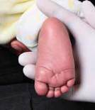
- Select an appropriate puncture site.

Heelprick position

Toe prick position

In infants and small children, you can use the sides of the heel or big toe. Draw an imaginary line from the midpoint of the big toe to the heel and one form the between the 4th and 5th toe to the heel. The areas to the side of these lines on the heel and big toe are safe to use.
In children older than 9 months the finger may be used.
- Warm the area, e.g. with a soft cloth moistened with warm water, for 3 – 5 minutes to encourage blood flow.
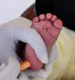
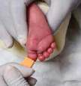
- Wash your hands, dry thoroughly and put on gloves.

- Clean the area with an alcohol swab and allow it to dry thoroughly. Failure to allow the alcohol to dry may dilute the specimen.
- Puncture the site using a freshly unpacked sterile lancet.
- Dispose of the lancet safely into a sharps / infectious waste disposal container.
- Wipe away the first blood drop using a clean
cotton wool swab. The initial drop contains tissue luid that may dilute the specimen.

- Allow another large blood drop to form.
- Lightly touch filter paper card onto blood drop. Apply blood only to the side of the filter paper card with the printing on. Allow blood to soak through and to radiate to completely fill the circle but do not layer more than one blood drop onto the same circle. Do not touch the blood spots with your hands or gloves!
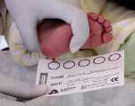
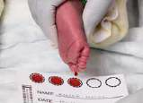
- Allow the next drop of blood
to form and soak it onto the
next marked circle. Repeat
until at least three marked
circles are filled with blood.
- The pre-printed circles hold
± 75 μL blood each when
completely filled. Samples
with insufficient blood cannot
be processed since the PCR
result may be unreliable.
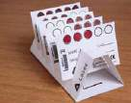
- Apply pressure to the puncture site using clean gauze (or cotton wool) to stop further bleeding and apply a plaster strip to puncture site.
- Place the card in the drying rack without the blood touching the rack.
- Do not allow blood spots to come into contact with any surface or
each other.
- Allow to dry thoroughly for at least 3 hrs while keeping it away
from sunlight, dust or insects.
- Place the card with a desiccant sachet into an airtight sealable bag.
- Close bag and send it together with the request form to the laboratory.
- During transport the samples should not be left in the car as
exposure to sunlight and heat may deteriorate the samples.
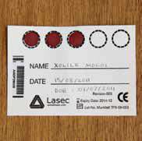

Features of acceptable and unacceptable DBS samples
Acceptable:
- At least three pre-printed circles should be completely filled with blood.
- The CCMT (ARV) NHLS laboratory bar-coded sticker should be
affixed and the DBS card completely and accurately labelled.
Unacceptable:
The laboratory cannot process these DBS cards and repeat samples will be required to obtain a PCR result.
- Patient details on DBS card are not legible.
- Patient details on DBS card and CCMT (ARV) NHLS laboratory request form do not match and no barcode sticker is affixed.
- Insufficient sample for processing.
- Blood spotted outside the pre-printed circle and DBS cards containing clotted/crusted blood.
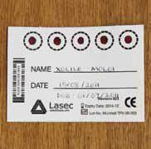

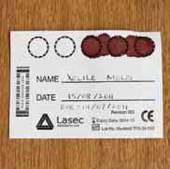
- Blood spots with serum rings due to contamination with alcohol.

21.5 Expanded Program on Immunisation (EPI)-related surveillance

21.5.1 Acute flaccid paralysis (AFP) surveillance

21.5.1.1 Case definition
- A child under 15 years of age with sudden onset of weakness (AFP) of any limb(s), excluding injury but including Guillian-Barrè syndrome and transverse myelitis OR
- A person of any age with paralytic illness in whom a clinician suspects polio.

21.5.1.2 Suspected AFP notification and testing protocol in brief
- Report the case to the local/provincial surveillance officer and obtain an Epidemiological identification (EPID) number.
- Complete the case investigation form with the relevant information, including the EPID number. The case investigation form can be obtained from your local surveillance or infection control officer. Alternatively, the form can be downloaded from the following website:
http://www.nicd.ac.za/assets/files/AFP_CIF_and_ Specimen_Collection_Guide.pdf.
- Conduct a thorough neurological examination and carefully document site of paralysis, muscle tone, power and reflexes.
- Collect two stool samples, taken 24−48 hrs apart, within 14 days of onset of paralysis.
- Send the stool samples ON ICE, together with the case investigation form to the laboratory to reach the NICD within 3 days after sample collection.

21.5.2 Measles (rash-based) surveillance

21.5.2.1 Case definition
- Fever
- Maculopapular rash
- Cough, coryza or conjunctivitis

21.5.2.2 Suspected measles notification and testing protocol in brief
- Report the case to the local / provincial surveillance officer and obtain an EPID number.
- Complete the case investigation form with the relevant information, including the EPID number. The case investigation form can be obtained from your local surveillance or infection control officer. Alternatively, the form can be downloaded from the following website: http://nicd.ac.za/assets/files/DOH_Measles_CIF.pdf.
- Send the case investigation form AND a clotted (yellow or red top) blood sample to the laboratory.
- The samples should be stored at 4−8ºC until shipment takes place and should be transported to the NICD on frozen ice packs.
- Throat swabs using the specific VTM will only be collected under specific situations in consultation with NICD. The VTM will be supplied by NICD to the district CDC/EPI coordinator, in consultation with the provincial office.

21.6 Special viral pathogens

21.6.1 Suspected human rabies
- Initial symptoms are often non-specific and may include fever, headache, malaise, and pruritis and paresthesia/tingling or pain around the original wound site (which may be healed by the time rabies disease presents).
- A history of animal, particularly dog, exposures provide important epidemiological evidence towards the rabies diagnosis. Lack of history of animal exposure does not exclude the diagnosis of rabies, e.g. these events may be mundane (i.e. licks on broken skin or mucosal membranes such as the eyes and nose; small nicks or scratches may also transmit the viruses), young children may not report all exposures, exposures to animals such as bats may be cryptic and the patient may be unaware of the exposure event.
- Thereafter rabies in humans may present in two ways: Furious/encephalitic rabies or dumb/paralytic rabies.
- Symptoms of furious/encephalitic rabies include restlessness, agitation, hallucinations, difficulty with speaking and swallowing, hypersalivation, hydrophobia and aerophobia.
- With dumb/paralytic rabies symptoms appear over a longer period of time, and include ascending (often asymmetrical) flaccid paralysis and confusion with progression to coma.
- Although these signs are characteristic of rabies they may or may not be present in all patients. Rabies disease is always progressive with rapid deterioration of patients over a couple of days. Few patients are hospitalised for more than 1−2 weeks.

21.6.1.1 Protocol for request of laboratory investigation of suspected human rabies cases
- Fully complete the suspected human rabies case history form.
- Call the NICD-NHLS Hotline at (082) 883 9920 to inform them about the suspected rabies case.
- Collect appropriate ante- or post-mortem samples according to the Rabies: Ante-mortem and Post-mortem Specimen Collection Guide on next page.

RABIES: Ante-mortem & Post-mortem Specimen Collection Guide
Ante-mortem specimens
Suitable ante-mortem specimens for rabies testing include saliva, nuchal skin biopsy and CSF. Submitting a full range of specimens for a suspected rabies cases is recommended.
Post-mortem specimens
It is important to conduct laboratory investigations on persons who died from a suspected rabies virus infection. A brain specimen is the preferred specimen, which may be conducted by a Forensic Pathologist. However, if not available, clinicians may obtain a post-mortem nuchal skin biopsy for rabies diagnosis.
Saliva specimens
- Collect at least 500 μL of saliva into a universal specimen container – often easiest using a syringe or suction device. Sputum is NOT an acceptable specimen. Swabs are not preferred.
- If possible, collect 3 specimens in total: 1 specimen daily on 3 consecutive days (NOT 3 specimens on the same day).
CSF specimens
- Collect at least 500 μL of CSF in a sterile tube without additives or clot activator.
Nuchal skin biopsy
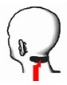

- A section of skin, 5−6 mm in diameter and ≈ 5−7 mm depth, must be taken
from the nape of the neck (see Fig. to the right). It is important that
specimens contain hair follicles and should be of sufficient depth to include
the cutaneous nerves at the base of hair follicles.
- Collect the skin biopsy. This can be done as an excision or punch biopsy.
- Moisten a piece of gauze with saline or water.
- Place the skin biopsy onto, and cover with, a piece of moist gauze.
- Place the gauze with the biopsy into a screw-top container.
Brain specimens
- Whole, half or sections of both the cerebellum and the cerebrum should be submitted.
- Place the specimen in a sterile screw-top container and submerge the specimen in 50% glycerol saline (half volume glycerol and half phosphate buffered saline [PBS]). If glycerol saline is not available: Freeze and send ASAP. DO NOT place in formalin.
Transportation
- The specimens should be packaged in accordance with the guidelines for the transport of dangerous biological goods (triple packaging using absorbent material) and transported directly to:
Special Pathogens Unit
National Institute for Communicable Diseases (NICD)
National Health Laboratory Service (NHLS)
No. 1 Modderfontein Rd
Sandringham, 2131
Gauteng, South Africa
- Keep the specimen cool and send ASAP.
- ALL specimens should be labeled AND accompanied by a fully completed Suspected Human Rabies Case History Form.
Please inform the NICD-NHLS Hotline [(082) 883 9920], a 24-hour service for all healthcare professionals countrywide, when submitting specimens for rabies diagnosis.
NOTE: The Hotline is NOT a service for the public. Public should contact the Department of Health for any queries.
- Send the samples and the fully completed case history form to the laboratory as soon as possible. The case history form can be obtained from the following website:
http://www.nicd.ac.za/assets/files/Rabies_CIF_and_specimen_collection_guide1.pdf.

21.6.2 Suspected viral haemorrhagic fever (VHF)
- The diagnosis of VHF should be considered for any patient who presents with:
- Acute onset of fever (less than 3 weeks’ duration).
- Severe prostrating or life-threatening illness.
- Bleeding manifestations (at least two of the following: haemorrhagic or purpuric rash, petechiae, epistaxis, haematemesis, haemoptysis, blood in stool, or other evidence of bleeding) may be present.
- No predisposing factors for a bleeding diathesis.
- An appropriate travel or exposure history.
- A wide range of conditions (bacterial, viral, and parasitic infections as well as non-infectious causes) should be considered in the differential diagnosis of VHF.

21.6.2.1 Suspected VHF protocol in brief
- Follow your local regional or provincial protocol for the management of suspected or confirmed viral haemorrhagic fever cases.
- Contact your local virologist or infectious disease specialist physician to discuss the case, including appropriate specimen collection.
- Report all suspected cases to the NICD & NHLS 24-hour Hotline for Clinical Advice at (082) 883 9920.

21.6.2.2 The following five principles should be observed in the collection of all patient specimens
  - Only specimens essential for diagnosis or monitoring should be obtained.
  - Specimens should be collected by an experienced staff member. Staff should wear the appropriate personal protective equipment as per institutional protocols for infection control, including long sleeved gown, apron, gloves, and face shield or surgical mask with eye protection during specimen collection.
  - Wherever possible, glass containers should not be used. Disposable sharp objects, such as scalpel blades, should be placed in puncture-resistant waste containers immediately after use and later autoclaved before disposal or incineration.
  - Blood samples must be collected with extreme care to avoid self-inoculation. Needles should not be bent, broken, removed from disposable syringes, or otherwise handled. After use, blood-taking equipment should be immediately placed in a rigid plastic waste container filled with disinfectant solution and autoclaved before disposal or incineration.
  - The entire outside surface of each specimen container should be wiped with disinfectant, and a label should be attached bearing the patient’s name, hospital number, source of the specimen and date of collection. Clinical laboratory specimens should be placed in plastic bags that are sealed, and then transported in durable, leak proof containers directly to the receiving area of the laboratory by the responsible health care worker. The outside of these bags should be wiped with a disinfectant solution such as 1:100 dilution of household bleach before leaving the patient’s room.
Laboratory staff should be alerted to the nature of the specimens
Adapted from: Abraham E, et al. Viral Hemorrhagic Fevers (VHFs) Contingency Plan – Ontario, Canada.

SECTION 22.0
GENETIC TESTING:
SAMPLE COLLECTION, TRANSPORT,
AND PATIENT REFERRAL

22.0 GENETIC TESTING: COLLECTION, TRANSPORT, AND PATIENT REFERRAL
Results of tests for inherited disorders carry serious medical and social implications for the patient and his/her family. For this reason, patients should be counselled by a clinician/medical geneticist/genetic counsellor on the genetic background, informativity and potential implications of the test results. The relevant details may be obtained by contacting the laboratory (see Table 7-1 on pages 19−51).
Written, informed consent should be obtained for certain types of genetic testing e.g. predictive or carrier. This should be obtained from the patient, or in the case of a minor, from the parents or guardians. It is also very important to provide the laboratory with a detailed family history (a pedigree sketch, if possible) and clinical information, as this may have an impact on the test report and subsequent counselling. This information may be provided by completing a special Genetic test request form, which should be available from the referral laboratory. Alternatively, the Hospital, Clinic or Comprehensive Care request form may be used, with additional notes attached.

22.1 Cytogenetics
Cytogenetic studies refer to the study of chromosomes. Cytogenetic tests can be divided into:
    - Traditional cytogenetic tests (e.g. cell culture, karyotyping and fluorescent in situ hybridization [FISH]), and
    - Molecular cytogenetic tests (e.g. multiple ligase-dependent probe amplification (MLPA), quantitative fluorescence polymerase chain reaction (QF-PCR) for aneuploidy and microarray analysis).

22.1.1 Specimen types
- Peripheral blood
- Amniotic fluid
- Bone marrow
- Chorionic villi samples (CVS), products of conception (POC), and skin
- Specimens for FISH studies.

22.1.2 Specimen collection
All samples are to be kept at room temperature or in fridge until collected for transport to the laboratory.

22.1.2.1 Peripheral blood
- For traditional cytogenetic tests, samples should be collected using sterile technique into a 5 mL heparinised (green top) tube. A minimum of 2 mL blood should be collected. If using a paediatric tube, 0.5 mL of blood is sufficient for the culture and analysis.
- For molecular cytogenetic test, blood samples should be collected using sterile technique into a 5 mL EDTA (purple top) tube. A minimum of 2 mL blood should be collected. If using a paediatric tube, 0.5 mL of blood is sufficient.
- For haematological cytogenetics, a minimum of 4 mL of blood should be collected into a heparinised (green top) tube. A blast count of at least 20% is required for initiation of peripheral blood leukaemic cell cultures.

22.1.2.2 Amniotic fluid
- Approximately 10−15 mL of amniotic fluid should be collected into a sterile 25 mL universal container supplied by the laboratory. If the initial volume of sample is blood−stained, the remainder should be collected into a second tube to reduce the amount of maternal contamination (both tubes are submitted). Some sample syringes have a rubber plunger which is toxic to cells. It is therefore advisable to transfer the fluid into a universal container as soon as possible after sampling. The amniotic fluid should reach the laboratory within 24 hrs of sampling.
- If molecular prenatal testing (i.e. mutation analysis for single gene disorders) is requested in addition to cytogenetic analysis, an additional volume of the fluid should be collected (approximately 5 mL) into a separate, clearly marked, universal container.

22.1.2.3 Bone marrow aspirate
- At least 1−5 mL of bone marrow should be collected into a 5 mL heparinised (green top) tube, using sterile techniques.

22.1.2.4 Chorionic villus samples (CVS), products of conception (POC), and skin
- All specimens should be taken using sterile technique and transported to the laboratory in sterile saline. DO NOT fix in formalin.
- Whole foetuses or large tissue specimens are not a suitable sample type for genetic testing, as genetic laboratories do not have resection or appropriate disposal facilities.

22.1.2.5 Specimens for FISH studies
Different types of samples can be used for constitutional and oncology FISH studies. Most constitutional FISH tests, except 22q deletion syndrome, have been replaced by MLPA. The following samples can be used for FISH:
- Amniotic fluid
- EDTA and heparinised blood samples
- Peripheral blood smears
- Heparinised bone marrow aspirate samples
- Bone marrow smears
- Fluid samples (e.g. pleural or ascitic fluid)
- Paraffin-embedded tissue (3−5 µm sections on positively charged slides)
- Cytological preparations
- Cell suspensions from cultured peripheral blood lymphocytes or bone marrow aspirates
- Single cell isolated from solid tumours
- Single cell suspensions
- Buccal swabs.

22.1.3 Specimen transport
- Specimens should be transported in cooler boxes (ice packs may be used) and protected from direct sunlight.
NB: Specimens MUST NOT BE FROZEN. Cooler boxes and ice packs may be used.
- Fresh specimens for culture and FISH studies must reach the referral laboratory within 48 hrs of sampling.
- Older specimens will be discarded due to significant risks of infection.

22.2 Molecular genetics
Molecular genetic testing is based on analysis of extracted genetic material (DNA or RNA), for the purpose of mutation detection. This, for the most part, involves testing for heritable monogenic disorders and certain types of cancers. DNA-based parentage and human leukocyte antigen (HLA) typing is also offered.
Requests for testing are categorised as:
- Diagnostic: The patient is symptomatic.
- Predictive: The patient is asymptomatic but is at risk of having inherited a mutation previously detected in other members of his/her family, and developing symptoms at a later stage in life. It is important to realise that some predictive genetic tests have a predictive testing protocol attached to them. For example, predictive testing for Huntington Disease follows an international protocol whereby individuals have to see a genetic counsellor, among other specialists, before the laboratory will perform the test. The referral laboratory can put you in touch with a genetic counsellor or medical geneticist who can advise you on how to refer your patient (see Table 7-1 on page 19 - 51).
- Carrier: The patient is asymptomatic but may be carrying a disease-causing mutation, which could be passed onto his/her offspring in the case of autosomal recessive or X-linked conditions.
- Prenatal: DNA of an unborn foetus is tested for the presence of a disease-causing mutation.
- Preclinical: There is a known disease in the family and family members are tested before symptoms present as early intervention and management is warranted (e.g. sibling of a child with cystic fibrosis or Fanconi anaemia), or individuals who are tested as part of newborn screening programmes.

22.2.1 Specimen types
- Peripheral blood
- Amniotic fluid
- CVS
- Tissue (fresh, or fresh frozen, or formalin-fixed paraffin-embedded (FFPE) tissue)
- Dried blood spot
- Other (buccal swabs, saliva, etc.).

22.2.2 Specimen collection
All samples are to be kept at room temperature or in the fridge until collected for transport to the laboratory.

22.2.2.1 Peripheral blood
At least 5 mL of blood should be collected into an EDTA (purple top) tube. Where possible, two or three tubes should be collected to allow for potential future testing and storage. In paediatric cases, an attempt should be made to obtain at least 2 mL of blood. A lesser volume may yield insufficient DNA for certain types of analyses. In problematic cases, the testing laboratory should be contacted for details. Blood should be received within 72 hrs of sampling, as prolonged delay will compromise the quality of the extracted DNA and may result in sample rejection.
NB: It is essential to ensure proper mixing of the blood with the anticoagulant in the tube, as even partial clotting will drastically affect the DNA yield.

22.2.2.2 Amniotic fluid
Molecular prenatal testing may be requested alone or in addition to cytogenetic analysis. It is however recommended that mutation analysis be accompanied by karyotyping for aneuploidies and chromosomal structural aberrations. Care must be taken to collect a sufficient volume of the fluid, and to transport it according to the requirements for both types of investigations (see CYTOGENETICS). Amniotic fluids should be collected into sterile 25 mL universal containers supplied by the laboratory. If the initial volume of sample is blood-stained, the remainder should be collected into a second tube to reduce the amount of maternal contamination (both tubes are submitted). An additional universal container should be collected if both molecular (e.g. mutation analysis) and cytogenetic testing is required. Some sample syringes have a rubber plunger which is toxic to cells. It is therefore advisable to transfer the fluid into a universal container as soon as possible after sampling. Amniotic fluids should reach the laboratory within 48−72 hrs of collection for molecular testing.

22.2.2.3 CVS and fresh tissue
- All samples should be taken using sterile technique and transported in sterile saline to the laboratory. Do not freeze. Do not fix in formalin. Fresh tissue samples for DNA extraction should not be larger than approximately 1 cm³.
- NB: Whole organs or large tissue specimens are not a suitable sample type for genetic testing, as genetic laboratories do not have resection facilities.

22.2.2.4 Formalin-fixed paraffin-embedded (FFPE) tissue
- DNA can be extracted from tissue sections and used in molecular assays. This is most commonly done in cancer genetics, though it is also occasionally performed as part of other types of genetic investigations. Paraffin blocks or mounted (unfixed) sections may be submitted.
- It may be important to mount (do not fix) the section on a slide and delineate the extent of the tumour and the normal tissue in a section using a koki pen. This is specifically required for microsatellite instability (MSI) testing in Lynch syndrome and should be performed as shown on the next page. The laboratory where the test is performed should be contacted to confirm details.

22.2.2.5 Other sample types
Genetic material can also be extracted from other specimen types such as buccal swabs, saliva, body fluids, etc. This however should be discussed with the referral laboratory before submitting the sample, to confirm suitability for the specific investigation and methodology employed by the laboratory.
Samples for mitochondrial genetics include peripheral blood – as per Section 22.2.2.1 on page 212, urine – 10 mL preferrably early morning urine sample in a universal urine container, tissue (i.e. muscle/liver) – to be frozen immediately and transported to the laboratory on dry ice unless it can be delivered to the lab on ice within 12 hrs.

22.2.2.6 Specimen transport
Specimens for DNA studies
Specimens must be transported at room temperature and be protected from direct sunlight. All fresh blood / tissue / fluid samples should reach the laboratory within 3 days of sampling.
NB: With the exception of tissue biopsy samples for mitochondrial genetics, specimens MUST NOT BE FROZEN. Cooler boxes and ice packs may be used.
A: Following histological examination, the extent of the tumour must be delineated on the original Haematoxylin & Eosin (H&E) slide, by outlining it in a koki pen. The normal parts of the section should be marked out in a similar manner.
T = tumour, N = normal as illustrated in Fig. 39 below
B: Additional slides (3 or 4, if possible) of about ~ 8 microns in thickness must then be cut for DNA extraction, using a fresh blade to prevent DNA contamination from other specimens. These unstained sections should then be lined up against the H&E slide and the tumour and normal parts outlined with a koki pen.
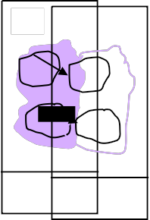
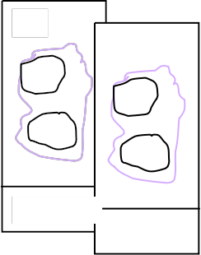
T
T
N
N
SAMPLE ID
SAMPLE ID
T
N
SAMPLE ID
T
T
N
N
SAMPLE ID
SAMPLE ID
Figure 39. Mounting unfixed sections

22.3 Referral of patients for genetic counselling and/or assessment by a medical geneticist
Patients with confirmed or suspected genetic conditions, and their families, should be referred. There is also a Medical Geneticist and Genetic Counsellor on call to answer any queries relating to genetic testing and/or patients with confirmed or suspected genetic diagnoses that clinical colleagues may have. Clinical genetic services are available Gauteng, Western Cape, KwaZulu Natal and Free State. The NHLS Clinical Genetics Section can put you in touch with any existing Clinical Genetic Services within your province. The phone numbers can be found in Table 7-1 on pages 19-51.

SECTION 23.0
IMMUNOLOGY

23.0 IMMUNOLOGY

23.1 General
The five major disciplines in Immunology are Auto-immune disease diagnostics, Allergology, Tissue Immunology, Immunodeficiency testing and Serology. Only four National Central laboratories cater for all these disciplines and most NHLS laboratories refer spesialised Immunology tests to these major centres. The majority of testing is done on serum, therefore 5 mL clotted blood (red or yellow top tube) will suffice, with the exception of:
- Immunodeficiency testing (i.e. lymphocyte- and neutrophil function analysis etc.) require EDTA (purple top tube) blood.
- Tissue immunology (entails the isolation of viable cells or DNA) require ACD (light yellow top tube), EDTA (purple top tube) or heparinised (green top tube) blood, depending on the test and/or testing site requirement. Please liaise with the testing laboratory when human leukocyte antigen (HLA) typing is required.

23.2 Allergology – Testing for allergens (allergies)
Allergology or the identification of known allergen sensitisation are requested to diagnose:
- Atopy (i.e. causes for rhinitis/hay fever)
- Food allergies
- Sensitisation to occupational allergens
- Possible parasitic infections.
There are over 600 allergens available as well as a variety of mixed associated allergens (i.e. paediatric foods, nut mixes, mould mixes etc.). It is impossible to cater for all these allergens and allergen availability should be confirmed with the testing laboratory. Please indicate clearly on the request form which specific allergens should be tested for.

23.3 Laboratory investigations for primary immunodeficiency diseases (PID)
Warning signs of primary / genetic immunodeficiency:
Recurrent infections are the hallmark of genetic immunodeficiency, remembered by the acronym SPUR – Serious, Persistent, Unusual, Recurrent.
The warning sign may however include auto-immune manifestations in the very young.
A family history of primary immunodeficiency must always be pursued in the work-up of suspected PID.
SPUR infections may be:
Serious infections
- Eight or more new ear infections within 1 year.
- Two or more serious sinus infections within 1 year.
- Failure of an infant to gain weight or grow normally.
- Need for intravenous antibiotics to clear infections.
- Two or more deep-seated infections.
Persistent infections
- Two or more months on antibiotics with little effect.
- Two or more pneumonias within 1 year.
- Persistent thrush in mouth or elsewhere on skin, after age 1.
Unusual infectious agents
- Parasitoses (e.g. Pneumocystis jiroveci and Giardia)
- Bacille Calmette-Guérin (BCG)-osis
- Vaccine-associated poliomyelitis, infections with other live vaccines (measles, varicella, rotavirus).
Recurrent infections
- Deep skin or organ abscesses.
- Neisseria infections
- Herpes viral infections
- Infections with encapsulated bacteria (Streptococcus pneumoniae, Haemophilus influenzae type b, Moraxella catarrhalis).
Some of these infections may be alerted to by vigilance of the laboratory service, before a clinical diagnosis is even considered and should be flagged by the Pathologist as possible PID when signing out these results – these include BCG-osis in an HIV-negative infant, disseminated poliovirus infection, staphylococcal liver abscess culture in a child, recurrent meningococcal infection. They also include results of severe lympho/neutropenia, microplatelets, and agammaglobulinemia.
Basic tests for screening for the majority of clinically relevant PID – FBC & differential, IgG, IgM, IgA & IgE can be performed at or via a regional laboratory, these should point out the major antibody deficiencies which make up over 50% of PID.

23.3.1 Quick reference guide for tests, TrakCare codes and NHLS labs for PID testing

23.3.1.1 General screening tests
- Full Blood Count (FBC) with differential count and peripheral smear:
The following effects, if noted on the peripheral smear, may be relevant to Pelvic inflamatory disease (PID) or other pathology:
- Neutropenia: May be congenital or cyclic or may occur in aplastic anaemia.
- Lymphopenia: Suggests a T-cell disorder because 70% of circulating lymphocytes are T-cells.
- Leukocytosis that persists between infections may occur in leukocyte adhesion deficiency.
- Thrombocytopenia with low mean platelet volume (MPV) in male infants suggests Wiskott-Aldrich syndrome.
- Anaemia may suggest anaemia of chronic disease or auto-immune haemolytic anaemia, which may occur in common variable immune deficiency (CVID) and other immunodeficiencies.
- Peripheral blood smear should be examined for Howell-Jolly bodies and other unusual Red Blood Cell (RBC) forms, which suggest primary asplenia or impaired splenic function. Granulocytes may have morphologic abnormalities (e.g. giant granules in Chédiak-Higashi syndrome).
- Granules of myeloid cells not stained – Myeloperoxidase deficiency.
- Exclude chronic infection: HIV, cytomegalovirus (CMV), Epstein-Barr virus (EBV) and tuberculosis (TB).
NOTE: For PID testing, please contact the individual laboratory and discuss the case prior to sending samples.
Table 23-1. List of PID tests
Test | Sample
Immunoglobulins | Clotted blood
Sweat test | In vivo
Auto-immune  Antinuclear antibodies (ANA) / Celiac screen / Thyroid / Anti-neutrophil cytoplasmic antibodies (ANCA) / Diabetes mellitus (DM) | Clotted blood
Allergy: FX5 / Paediatric food and Phadiotop® | Clotted blood
Lymphocyte phenotyping | 1 EDTA tube, should reach lab within 24 hrs
Test | Sample
Immunoglobulins | Clotted blood
Sweat test | In vivo
Auto-immune  ANA / Celiac screen / Thyroid / ANCA / DM | Clotted blood
Allergy: FX5 / Paediatric food and Phadiotop® | Clotted blood
Lymphocyte phenotyping | 1 EDTA tube, should reach lab within 24 hrs
Humoral (B-cells & Ig subclasses)
IgG subclasses | Clotted blood
Vaccination response | Clotted sample  Batched test, processed weekly
T-cell function
Lymphocyte proliferation | Heparin. Must be arranged with lab.
Naive / memory CD4 & CD8 cells | 1 EDTA tube, should reach lab within 24 hrs
Phagocyte functions
Oxidative burst | Heparin tube should reach lab within 6 hrs
Phagocytic index & chemotaxis | Heparin tube should reach lab within 6 hrs
Complement
Total haemolytic C' (CH50/100) | Clotted sample on ice. Send to lab immediately.
Complement C3, C4 | Clotted sample
C6 | Clotted sample
Complement factor B | Clotted sample
C1 Esterase inhibitor | Clotted sample
Specific panels
Lamina-associated domain (LAD) / Auto-immune lymphoproliferative syndrome (ALPS) / αβ / γδ T-cells | EDTA (purple top) tube
Confirmatory / Genetic tests: Please contact the individual laboratory and discuss the case prior to sending samples.
SECTION 24.0
LIST OF TESTS OFFERED BY THE NHLS

24.0 LIST OF TESTS OFFERED BY THE NHLS
Table 24-1 from the next page onwards shows the tests, specimen types and special instructions for tests performed by the NHLS laboratories. Refer to your local laboratory or service level agreements signed between NHLS and the different provinces for turnaround time (TAT). The clinic and hospital TATs will also vary because of the transport between laboratory and clinic or hospital. Some tests are only done in certain laboratories depending on the resources available and the number of requests received per laboratory, please consider this factor as well for TATs.

Table 24-1: NHLS test list
TEST NAME | SPECIMEN TYPE | SPECIAL INSTRUCTIONS
11-deoxycortisol | 5 mL clotted blood (yellow top tube) | For transport separate serum and send frozen on dry ice.
17-hydroxyprogesterone | 5 mL clotted blood (yellow top tube) | NOTE: Please ensure that the patient's age is indicated on the request form. Please contact the referral laboratory for transport conditions.
5-hydroxy-indoleacetic acid  (5-HIAA) | 24 hr urine collection (best practice) OR 20 mL random urine for babies | NOTE: Urine should be collected into a dark container, and the specimen refrigerated during collection. Acidify with HCl. See Section 15.2.7 on page 122 for detailed instructions and precautions.
5-α-Reductase Deficiency  (SRD5A2) (DNA analysis) | 5 mL blood in EDTA (purple top) tube | DNA may be extracted from various specimen types, depending on the test, the patient and reason for testing. See Section 22 for additional information.
α-1-antitrypsin clearance | Timed (24 hr) stool collected into a pre-weighed container AND 5 mL clotted blood (yellow top tube) | NOTE: Clotted blood sample to be taken during stool collection. See Section 15.2.11 on page 123 for detailed instructions.
α-1-antitrypsin | 5 mL clotted blood (yellow top tube)
α-1-antitrypsin Deficiency  (Serpina1) (DNA analysis) | 5 mL blood in EDTA (purple top) tube | DNA may be extracted from various specimen types, depending on the test, the patient and reason for testing. See Section 22 for additional information.
α-1-iduronidase enzyme activity  (Hurler's disease) | Adult: 12−15 mL ACD solution B (light yellow top tube) blood (3 tubes); Children: 5 mL ACD solution B (light yellow top tube) – 1 full tube
α-foetoprotein (amniotic fluid) | 5 mL amniotic fluid in a (clear top) collection tube without additives
α-foetoprotein (serum) | 5 mL clotted blood (yellow top tube)
α-galactosidase enzyme activity  (Fabry's disease) | 10 mL clotted blood in red top tube (no gel)
α-Thalassaemia (DNA analysis) | 5 mL blood in EDTA (purple top) tube | A full bood count and Haemoglobin electrophoresis must be done prior to DNA analysis. DNA may be extracted from various specimen types, depending on the test, the patient and reason for testing. See Section 22 for additional information.

TEST NAME | SPECIMEN TYPE | SPECIAL INSTRUCTIONS
α-Thalassaemia Mental Retardation Syndrome (DNA analysis) | 5 mL blood in EDTA (purple top) tube | DNA may be extracted from various specimen types, depending on the test, the patient and reason for testing. See Section 22 for additional information.
Acetominophen (Paracetamol) | 5 mL clotted blood (yellow top tube)
Acetylcholine Receptor Antibodies | 5 mL clotted blood (yellow top tube) | For transport separate serum and send frozen on dry ice.
Acid base studies | 25 mL random urine in a universal container ON ICE | NOTE: Deliver sample immediately to the laboratory on ice. Please discuss with the referral laboratory before sample collection.
Acid phosphatase (prostatic) | 5 mL clotted blood (yellow top tube) | Separate serum promptly. Add 1 drop (30 µL) stabiliser (0.8 M acetic acid) to 1 mL serum within 1 hr of collection. Sample is stable at 4°C for 8 days.
Acid phosphatase (total) | 5 mL clotted blood (yellow top tube) | Separate serum promptly. Add 1 drop (30 µL) stabiliser (0.8 M acetic acid) to 1 mL serum within 1 hr of collection. Sample is stable at 4°C for 8 days.
Acidified Glycerol Lysis Test | 5 mL blood in EDTA (purple top) tube AND 5 mL blood in EDTA (purple top) tube from a healthy control | NOTE: Please arrange test with the referral laboratory before sample collection. Specimen must reach the laboratory within 4 hrs of collection.
Activated protein C resistance  (APCR) | 5 mL blood in sodium citrate (blue top) tube | NOTE: Please provide full clinical history. Sample must reach the laboratory within 6 hrs of collection. For transport separate plasma and send frozen on dry ice.
Acute flaccid paralysis (AFP)  surveillance | 2 x fresh stool sample in a universal container on ice taken 24−48 hrs apart within 14 days of onset of paralysis | NOTE: Case notification required. See Section 21.5.1 on page 202 for specific guidelines on this notifiable condition.
Acylcarnitine profile (serum) | 5 mL clotted blood (yellow top tube) | NOTE: Deliver sample immediately to the laboratory on ice. For transport separate serum and send frozen on dry ice.
Acylcarnitine profile (urine) | 25 mL random urine in a universal container | NOTE: Deliver sample immediately to the laboratory on ice. For transport send frozen on dry ice.
ADAMTS13 antigen, activity and auto- antibody | 5 mL blood in sodium citrate (blue top) tube | Full clinical history required. Sample must reach the laboratory within 6 hrs of collection. Transport and separate plasma frozen on dry ice.

TEST NAME | SPECIMEN TYPE | SPECIAL INSTRUCTIONS
Adenosine deaminase (CSF) | 0.5 mL CSF in a (clear top) collection tube without additives
Adenosine deaminase (fluid) | 5 mL fluid in a (clear top) collection tube without  additives | NOTE: Pus and bloody fluid samples are unsuitable.
Adenosine deaminase (serum) | 5 mL clotted blood (yellow top tube)
Adenovirus isolation (culture) | Random urine sample in a universal container OR respiratory tract sample in viral transport medium (VTM). | NOTE: Transport specimen to the laboratory at 4ºC. Refrigerate specimen if transport is delayed.
Adenovirus PCR | Random urine sample in a universal container, respiratory tract sample in viral transport medium (VTM), 5 mL blood in EDTA (purple top) tube, 5 mL clotted blood (yellow or red top tube), 1 mL CSF in a (clear top) collection tube without additives OR 1−2 g fresh stool sample in a universal container. | NOTE: Transport specimen to the laboratory at 4ºC. Refrigerate specimen if transport is delayed.
Adenovirus typing | Random urine sample in a universal container, respiratory tract sample in viral transport medium (VTM), 5 mL blood in EDTA (purple top) tube, 5 mL clotted blood (yellow or red top tube), 1 mL CSF in a (clear top) collection tube without additives OR 1−2 g fresh stool sample in a universal container. | NOTE: Transport specimen to the laboratory at 4ºC. Refrigerate specimen if transport is delayed.
Adenovirus type 40/41 Antigen  Rapid test | 1−2 g fresh stool sample in a universal container | NOTE: Transport specimen to the laboratory at 4ºC. Refrigerate specimen if transport is delayed.
Adrenal Antibodies | 5 mL clotted blood (yellow top tube)
Adrenocorticotrophic hormone | 5 mL blood in EDTA (purple top) tube on ice | NOTE: Deliver sample immediately to the laboratory on ice. Consider factors such as prior administration of corticosteroids and time of sampling (diurnal variation). For transport centrifuge sample immediately and send frozen on dry ice.
Alanine aminotransferase (ALT) | 5 mL clotted blood (yellow top tube)
TEST NAME | SPECIMEN TYPE | SPECIAL INSTRUCTIONS
Albumin (CSF) | 0.5 mL CSF in a (clear top) collection tube without additives
Albumin (fluid) | 5 mL fluid in a (clear top) collection tube without  additives
Albumin (Microalbumin) (urine) | 25 mL random (early morning) or timed urine in a universal container | NOTE: Testing is not recommended in blood-stained urine.
Albumin (serum) | 5 mL clotted blood (yellow top tube) | NOTE: Avoid prolonged stasis during venesection.
Alcohol (ethanol) (serum) | 5 mL clotted blood (yellow top tube) | NOTE: Results cannot be used for medico-legal purposes. Do not clean collection site with alcohol.
Aldolase | 5 mL clotted blood (yellow top tube)
Aldosterone | 5 mL clotted blood (yellow top tube) | NOTE: See Section 15.2.5 on page 121 for detailed instructions and precautions.
Alkaline phosphatase (ALP) | 5 mL clotted blood (yellow top tube)
Alkaline phosphatase (bone  specific) | 5 mL clotted blood (yellow top tube) | NOTE: Avoid haemolysis during venesection. For transport < 72 hrs send serum on ice; otherwise if delayed > 72 hrs send frozen on dry ice.
Alkaline phosphatase iso-enzymes | 5 mL clotted blood (yellow top tube) | NOTE: Avoid haemolysis during venesection. A fasting sample is preferred.
Allergy Test: Food Panel (RAST) | 5 mL clotted blood (yellow top tube)
Allergy Test: Inhalant Panel  (RAST) | 5 mL clotted blood (yellow top tube)
Allergy Test: Inhalant screen  (Phadiatop) | 5 mL clotted blood (yellow top tube)
Allergy tests (IgE-specific  Antibodies ) | 5 mL clotted blood (yellow top tube) | NOTE: Please specify allergens on the request form. Testing is done in batches.
Aluminium (serum) | 5 mL blood in a trace metal (royal blue top, additive-free) tube | NOTE: Test very prone to contamination. See Section 15.2.12 on page 123 for detailed instructions.

TEST NAME | SPECIMEN TYPE | SPECIAL INSTRUCTIONS
Aluminium (urine) | 25 mL random urine in a universal container. Contact laboratory in case an acid-washed container is required (supplied by lab) | NOTE: Test very prone to contamination. See Section 15.2.12 on page 123 for detailed instructions.
Amikacin | 5 mL clotted blood (yellow top tube) | NOTE: Trough levels to be collected 30 min prior to next dose, peak levels to be collected 30 min after a 1 hr infusion. Please state the time of last dose on the request form.
Amino Acids (CSF) (quantitative) | 0.5 mL CSF in a (clear top) collection tube without additives | NOTE: Deliver sample to the laboratory immediately after collection. If delivery is delayed, send frozen on dry ice. Individual amino acids may also be requested.
Amino Acids (serum or plasma) (quantitative) | 5 mL clotted blood (yellow top tube) OR heparinised blood (green top tube) | NOTE: Minimum acceptable volume 1 mL. Deliver sample to the laboratory immediately after collection. If delivery is delayed, separate and send frozen on ice. Pre-prandial sample preferred. Individual amino acids mat also be requested.
Amino Acids (urine) | 25 mL random urine in a universal container | NOTE: Deliver sample to the laboratory immediately after collection. If delivery is delayed, send frozen on dry ice. Individual amino acids may also be requested.
Aminolaevulinic acid (ALA) | Random or 24 hr urine sample | NOTE: Protect specimen from light during collection and transport. Random urine sample can be taken during an acute attack. Early morning urine is needed for latent porphyria.
Aminophylline (see Theophylline)
Ammonia | 5 mL blood in EDTA (purple top) tube on ice | NOTE: Neither patient nor phlebotomist may smoke in the 8-hour period prior to sample collection. Sample must reach the laboratory on ice within 15 min of collection.
Amphetamines (urine) (qualitative) | 25 mL random urine in a universal container | For transport send fresh urine on ice.
Amylase (fluid) | 5 mL fluid in a (clear top) collection tube without  additives

TEST NAME | SPECIMEN TYPE | SPECIAL INSTRUCTIONS
Amylase (serum) | 5 mL clotted blood (yellow top tube) | Separate serum from cells within 2 hrs after collection. For transport < 48 hrs send on ice; otherwise if delayed > 48 hrs send frozen on dry ice.
Amylase (urine) | 25 mL random urine in a universal container | NOTE: Deliver sample immediately to the laboratory on ice. Serum lipase recommended for acute pancreatitis. For transport alkalanise urine (just above pH 7) with 1 M NaOH and send on ice.
Andermann Syndrome (SLC12A6 gene) (Afrikaner) (DNA analysis) | 5 mL blood in EDTA (purple top) tube | DNA may be extracted from various specimen types, depending on the test, the patient and reason for testing. See Section 22 for additional information.
Androgen Receptor Insensitivity  (AR) (DNA analysis) | 5 mL blood in EDTA (purple top) tube | DNA may be extracted from various specimen types, depending on the test, the patient and reason for testing. See Section 22 for additional information.
Androstenedione | 5 mL clotted blood (yellow top tube)
Angelman/Prader Willi Syndrome Methylation study (DNA analysis) |  | DNA may be extracted from various specimen types, depending on the test, the patient and reason for testing. See Section 22 for additional information.
Angiotensin-converting enzyme  (ACE) | 5 mL clotted blood (yellow top tube) | NOTE: Icteric and lipaemic samples are not suitable. Collect fasting sample and separate serum within 6 hrs of collection.
Anti-Adrenal Antibodies | 5 mL clotted blood (yellow top tube)
Anti - Aquaporin 4 (AQP4) Antibodies | 5 mL clotted blood (yellow top tube)
Anti - Cardiac Muscle Antibodies | 5 mL clotted blood (yellow top tube)
Anti - Cardiolipin (ACLA) Antibodies | 5 mL clotted blood (yellow top tube)
Anti - Centromere Antibodies | 5 mL clotted blood (yellow top tube)
Anti - Cyclic Citrunillated Peptide  (CCP) Antibodies | 5 mL clotted blood (yellow top tube)
TEST NAME | SPECIMEN TYPE | SPECIAL INSTRUCTIONS
Anti - DNase B titre | 5 mL clotted blood (yellow top tube)
Anti - double stranded DNA Antibodies | 5 mL clotted blood (yellow top tube)
Anti - Endomysium Antibodies | 5 mL clotted blood (yellow top tube)
Anti - Extractable Nuclear  Antigen (ENA) Antibodies | 5 mL clotted blood (yellow top tube)
Antifactor Xa activity test for Lower Molecular Weight heparin (LMWH) and Direct oral anticoagulants (DOACs) e.g. Rivaroxaban | 5 mL blood in sodium citrate (blue top) tube | Sample must be taken 3 hrs after last dose of LMWH. Sample must reach the laboratory within 30 min of collection. For transport, separate plasma within 1 hr of collection and send frozen on dry ice. For DOACs e.g. Rivaroxaban, please contact the relevant laboratory.
Anti - Fibrillarin Antibodies | 5 mL clotted blood (yellow top tube)
Anti - Ganglioside Antibody screen (Immunoblot) | 5 mL clotted blood (yellow top tube)
Anti - Glomerular Basement  Membrane (GBM) Antibodies | 5 mL clotted blood (yellow top tube)
Anti - Glutamic Acid  Decarboxylase (GAD) Antibodies | 5 mL clotted blood (yellow top tube)
Anti - Glutamic Acid Decarboxylase/Islet Antigen 2 (GAD/IA2) Antibodies | 5 mL clotted blood (yellow top tube)
Anti - Histone Antibodies | 5 mL clotted blood (yellow top tube)
Anti - IgE Receptor Antibodies | 5 mL clotted blood (yellow top tube) | NOTE: Samples are batched and sent overseas to Germany for testing. TAT is approximately 3 months.
Anti - Islet Antigen 2 (IA2) Antibodies | 5 mL clotted blood (yellow top tube)
Anti - Jo-1 Antibodies | 5 mL clotted blood (yellow top tube)
Anti - La (SSB) Antibodies | 5 mL clotted blood (yellow top tube)
TEST NAME | SPECIMEN TYPE | SPECIAL INSTRUCTIONS
Anti - Liver/Kidney Microsomal  Antibodies | 5 mL clotted blood (yellow top tube)
Anti - Mi-2 Antibodies | 5 mL clotted blood (yellow top tube)
Anti - Mitochondrial Antibodies | 5 mL clotted blood (yellow top tube)
Anti - Mullerian hormone | 5 mL clotted blood (yellow top tube) | NOTE: Deliver sample to the laboratory on ice.
Anti - Myeloperoxidase (MPO  pANCA) Antibodies | 5 mL clotted blood (yellow top tube)
Anti - Neuronal Antibody screen  (Cerebellum / Paraneoplastic) | 5 mL clotted blood (yellow top tube)
Anti - Neutrophil Cytoplasmic  Antibodies (ANCA) | 5 mL clotted blood (yellow top tube)
Anti - N-Methyl-D-aspartate  (NMDA) Receptor Antibodies | 5 mL clotted blood (yellow top tube)
Anti - Nuclear Antibodies (ANA) | 5 mL clotted blood (yellow top tube)
Anti - Nucleosome Antibodies | 5 mL clotted blood (yellow top tube)
Anti - Pancreas Islet cell  Antibodies | 5 mL clotted blood (yellow top tube)
Anti - Parietal cell Antibodies | 5 mL clotted blood (yellow top tube)
Anti - Phosphatidyl serine  Antibodies | 5 mL clotted blood (yellow top tube)
Anti - Phospholipid Antibodies | 5 mL clotted blood (yellow top tube) | NOTE: When requested both anti-cardiolipin antibodies (ACLA) and anti-β2 glycoprotein 1 antibodies will be tested.
Anti - Polymyositis/Scleroderma  (PM/Scl) Antibodies | 5 mL clotted blood (yellow top tube)
Anti - Proteinase 3 (PR3 cANCA) Antibodies | 5 mL clotted blood (yellow top tube)
Anti - Reticulin Antibodies | 5 mL clotted blood (yellow top tube)
TEST NAME | SPECIMEN TYPE | SPECIAL INSTRUCTIONS
Anti - Ribonucleoprotein (RNP) Antibodies | 5 mL clotted blood (yellow top tube)
Anti - Ribosomal P Antibodies | 5 mL clotted blood (yellow top tube)
Anti - Ro (SSA) Antibodies | 5 mL clotted blood (yellow top tube)
Anti - Saccharomyces cerevisiae  Antibodies (ASCA) | 5 mL clotted blood (yellow top tube)
Anti - Scleroderma 70 (Scl70) Antibodies | 5 mL clotted blood (yellow top tube)
Anti - Skeletal (Striated) Muscle  Antibodies | 5 mL clotted blood (yellow top tube)
Anti - Skin Auto-antibodies | 5 mL clotted blood (yellow top tube)
Anti - Smith (Sm) Antibodies | 5 mL clotted blood (yellow top tube)
Anti - Smooth Muscle Antibodies | 5 mL clotted blood (yellow top tube)
Anti - Streptolysin O (ASO) titre | 5 mL clotted blood (yellow top tube)
Anti - Thrombin | 5 mL blood in sodium citrate (blue top) tube | Sample must reach the laboratory within 4 hrs of collection or send frozen plasma on dry ice. Drug history is important.
Anti - Thyroid peroxidase  Antibodies | 5 mL clotted blood (yellow top tube)
Anti - Tissue Transglutaminase  Antibodies | 5 mL clotted blood (yellow top tube)
Anti - U1 Ribonucleoprotein  (RNP) Antibodies | 5 mL clotted blood (yellow top tube)
Anti - β2 Glycoprotein 1  Antibodies | 5 mL clotted blood (yellow top tube)
Apolipoprotein A1 | 5 mL clotted blood (yellow top tube) | For transport separate serum and send on ice.
Apolipoprotein B | 5 mL clotted blood (yellow top tube) | For transport separate serum and send on ice.

TEST NAME | SPECIMEN TYPE | SPECIAL INSTRUCTIONS
Apt test (foetal haemoglobin) | 5–10 mL gastric aspirate or meconium in a universal container | Transport sample on ice.
Autosomal recessive polycystic kidney disease (PKHD1) Afrikaner (DNA analysis) | 5 mL blood in EDTA (purple top) tube | DNA may be extracted from various specimen types, depending on the test, the patient and reason for testing. See Section 22 for additional information.
ARMS PCR BRAF (Hairy cell leukaemia) | 5−10 mL blood in EDTA (purple top) tube or Bone marrow aspirate or Extracted genomic DNA > 10 ng/μl | Transport EDTA sample at room temperature within 48 hrs. Transport DNA pellet at room temperature or on ice.
ARMS PCR BRAF (solid tumour) | FFPE tissue block or fresh tissue biopsy or 5−10 4 μm FFPE sections on normal glass slides | Tumour ringed area on H&E slide plus histology report to accompany tissue block
Arsenic (hair) | Hair plus roots | NOTE: At least 100 mg hair plus roots is required - mark root end with a piece of cotton.
Arsenic (nails) | Nails | NOTE: At least 100 mg of nails is required.
Arsenic (blood) | 5 mL blood in EDTA (purple top) tube | NOTE: Patient must not eat seafood for 72 hrs before sample collection.
Arsenic (urine) | 25 mL random urine in a universal container. Contact laboratory in case an acid-washed container is required (supplied by lab) | NOTE: Patient must not eat seafood for 72 hrs before sample collection.
ARXdup24 (DNA analysis) | 5 mL blood in EDTA (purple top) tube | DNA may be extracted from various specimen types, depending on the test, the patient and reason for testing. See Section 22 for additional information.
Aryl sulphatase A enzyme activity (leukocyte) (metachromatic leukodystrophy) | 4 mL UNSPUN blood in heparin (green top) tube or EDTA (purple top) tube | NOTE: Mark clearly on request form: DO NOT SPIN. Sample must reach laboratory within 24 hrs of collection. Transport at room temperature.
Aryl sulphatase A enzyme activity (plasma) | 5 mL clotted blood (yellow top tube) or 5 mL blood in heparin (green top) tube | Blood must be immediately separated and frozen before sending. Sample must reach laboratory within 24 hrs of collection.

TEST NAME | SPECIMEN TYPE | SPECIAL INSTRUCTIONS
Ashkenazi Jewish Screen (common Ashkenazi mutations: Cystic fibrosis, Fanconi Anaemia, Tay Sachs Disease, Canavan Disease, Familial Dysautonomia, Mucolipidosis IV, Niemann-Pick Disease Type A, Glycogen Storage Disease Type 1a, Bloom Syndrome) (DNA analysis) | 5 mL blood in EDTA (purple top) tube | DNA may be extracted from various specimen types, depending on the test, the patient and reason for testing. See Section 22 for additional information.
Aspartate aminotransferase (AST) | 5 mL clotted blood (yellow top tube)
Asperigillus Precipitin | 5 mL clotted blood (yellow top tube)
Astrovirus antigen ELISA | 1−2g fresh stool sample in a universal container | NOTE: Transport specimen to the laboratory at 4ºC. Refrigerate specimen if transport is delayed. Samples are batched and testing is performed once a week.
Auto-immune encephalopathy | 5 mL clotted blood (yellow top tube)
Avian Precipitin (Budgerigar) | 5 mL clotted blood (yellow top tube)
Avian Precipitin (Parrot) | 5 mL clotted blood (yellow top tube)
Avian Precipitin (Pigeon) | 5 mL clotted blood (yellow top tube)
β-2 microglobulin (serum) | 5 mL clotted blood (yellow top tube) | For transport < 72 hrs separate serum and send on ice. If transport delayed > 72 hrs separate serum and send frozen on dry ice.
β-2 microglobulin (urine) | 25 mL random urine in a universal container | NOTE: If sample pH < 6, add 1 M NaOH to adjust to pH 7−9 and send fresh. Freezing not recommended.
β-2 transferrin (CSF) | Fluid in a (clear top) collection tube without additives | NOTE: Preferably collect 1 mL of fluid in question from ear / nose.
β-D Glucan | 5 mL clotted blood (separate yellow top tube) | NOTE: Samples must be kept at 2−8ºC.
β-galactocerebrosidase enzyme  activity (Krabbe’s disease) | Adult: 12−15 mL ACD solution B (light yellow top) tube blood (3 tubes); Children: 5 mL ACD solution B (light yellow top) tube (1 full tube)
TEST NAME | SPECIMEN TYPE | SPECIAL INSTRUCTIONS
β-glucocerebrosidase enzyme  activity (Gaucher’s disease) | Adult: 12−15 mL ACD solution B (light yellow top) tube blood (3 tubes); Children: 5 mL ACD solution B (light yellow top) tube (1 full tube)
β-human chorionic gonadotrophin (serum) (quantitative) | 5 mL clotted blood (yellow top tube) | For transport < 72 hrs separate serum and send on ice. If transport delayed > 72 hrs separate serum and send frozen on dry ice.
β-human chorionic gonadotrophin (urine) (qualitative) | 5 mL random urine in a universal container
β-Thalassaemia (DNA analysis) | 5 mL blood in EDTA (purple top) tube | A full bood count and Haemoglobin electrophoresis must be done prior to DNA analysis. DNA may be extracted from various specimen types, depending on the test, the patient and reason for testing. See Section 22 for additional information.
B-type natriuretic peptide (BNP) | 5 mL blood in EDTA (purple top) tube | NOTE: Avoid haemolysis during venesection. For transport < 24 hrs, separate plasma and send on ice; otherwise if delayed > 24 hrs send frozen plasma (min 500 µL) on dry ice.
Barbiturates (serum) | 5 mL clotted blood (yellow top tube) ON ICE
Barbiturates (urine) (qualitative screen) | 25 mL random urine in a universal container | For transport send fresh urine on ice.
Bardet-Biedl Syndrome (common Caucasian BBS1 mutation) (DNA analysis) | 5 mL blood in EDTA (purple top) tube | DNA may be extracted from various specimen types, depending on the test, the patient and reason for testing. See Section 22 for additional information.
Bardet-Biedl Syndrome BBS10 (common Xhosa BBS10) (DNA analysis) | 5 mL blood in EDTA (purple top) tube | DNA may be extracted from various specimen types, depending on the test, the patient and reason for testing. See Section 22 for additional information.
Barth Syndrome (TAZ1) (DNA  analysis) | 5 mL blood in EDTA (purple top) tube | Only upon biochemical confirmation. DNA may be extracted from various specimen types, depending on the test, the patient and reason for testing. See Section 22 for additional information.
TEST NAME | SPECIMEN TYPE | SPECIAL INSTRUCTIONS
Beckwith-Wiedemann syndrome | 5 mL blood in EDTA (purple top) tube | DNA may be extracted from various specimen types, depending on the test, the patient and reason for testing. See Section 22 for additional information.
Benzodiazepines (serum) | 5 mL clotted blood (yellow top tube)
Benzodiazepines (urine) (semi- quantitative screen) | 25 mL random urine in a universal container | For transport send fresh urine on ice.
Bile acids (serum or urine) | For pregnant women 5 mL clotted blood (yellow top tube); random urine in a universal container for all other patients | NOTE: Deliver sample to the laboratory on ice. For transport separate and send serum on ice.
Bilharzia (Schistosoma) Antibodies | 5 mL clotted blood (yellow top tube)
Bilirubin (amniotic fluid) (OD  450) | 15 mL amniotic fluid in a collection tube without  additives | NOTE: Protect sample from light. Avoid contamination with blood during sampling.
Bilirubin (conjugated/direct) | 5 mL clotted blood (yellow top tube)
Bilirubin (total) | 5 mL clotted blood (yellow top tube)
Bilirubin (urine) (qualitative dipstix) | 25 mL random urine in a universal container | NOTE: Protect sample from light (sample must be wrapped in tin foil). Deliver to the laboratory within 4 hrs of collection.
Biotinidase Deficiency (BDT) (DNA analysis) | 5 mL blood in EDTA (purple top) tube | DNA may be extracted from various specimen types, depending on the test, the patient and reason for testing. See Section 22 for additional information.
Biotinidase enzyme activity | 5 mL blood in EDTA (purple top) tube | NOTE: Deliver sample immediately to the laboratory on ice. Test must be arranged with the referral laboratory before sample collection.
BK virus PCR | 5 mL blood in EDTA (purple top) tube OR random urine sample in a universal container | NOTE: Transport specimen to the laboratory at 4ºC. Refrigerate specimen if transport is delayed.
Bleeding time | No blood sample is required as the test is done on the patient at the bedside | NOTE: Please contact the laboratory to arrange for the test.
Blood cultures | Adults: 20 mL blood divided between 2 blood culture bottles; Children: See Section 17.2.4 on page 136 for guidance on paediatric volumes. | NOTE: Do not stick patient label underneath the bottom of the bottle or over the bottle's barcode label. See Section 17.2.5 on page 142 for detailed collection instructions.
TEST NAME | SPECIMEN TYPE | SPECIAL INSTRUCTIONS
Blood gas | Capped heparin syringe, no air bubble | NOTE: See Section 15.2.4 on page 120 for detailed instructions and precautions.
Blood Grouping: ABO Blood  Grouping | 5 mL blood in EDTA (purple top) tube | NOTE: Samples must be kept at 2–8ºC.
Blood Grouping: Atypical  antibody identification | 5 mL blood in EDTA (purple top) tube | NOTE: Samples must be kept at 2–8ºC.
Blood Grouping: Atypical antibody titration | 5 mL blood in EDTA (purple top) tube | NOTE: Samples must be kept at 2–8ºC.
Blood Grouping: Blood Group system phenotyping | 5 mL blood in EDTA (purple top) tube | NOTE: Samples must be kept at 2–8ºC.
Blood Grouping: Rhesus (Rh typing) | 5 mL blood in EDTA (purple top) tube | NOTE: Samples must be kept at 2–8ºC.
Blood-brain barrier studies (CSF IgG index) | 1 mL CSF in a (clear top) collection tube without additives AND 2 mL clotted blood (yellow top tube) | NOTE: Submit simultaneous clotted blood sample (yellow top tube).
Bloom Syndrome (Ashkenazi  Jewish) (DNA analysis) | 5 mL blood in EDTA (purple top) tube | DNA may be extracted from various specimen types, depending on the test, the patient and reason for testing. See Section 22 for additional information.
BMT Chimerism analysis (DNA  analysis) | 5 mL blood in EDTA (purple top) tube
Bone Marrow Aspirate for  Tuberculosis Culture | Collect in BACTEC Myco/F Lytic blood culture bottle or sterile heparinised tube | NOTE: Please clearly indicate sample type on request form.
Bone Marrow Aspirate for Salmonella Typhi/Tyhoid fever | Collect in an aerobic blood culture bottle | NOTE: Please clearly indicate sample type on request form.
Bone Marrow Aspirate (BMA) Morphology | 6 x BMA slides | Full clinical history must be provided. Request Full Blood Count with Differential on the same day. Sample must reach the laboratory immediately after collection.
Bone Marrow trephine (BMT) (Histology) | Core biopsy in sterile container with formalin | Contact relevant laboratory for preferred medium
TEST NAME | SPECIMEN TYPE | SPECIAL INSTRUCTIONS
Bordetella pertussis culture | Sputum samples and/or nasopharyngeal swab/aspirate in a sterile universal container | Please see Section 17.6.2.5.2 on page 150 for more details.
Bordetella pertussis PCR | Sputum samples and/or nasopharyngeal swab/aspirate in a sterile universal container | Please see Section 17.6.2.5.2 on page 150 for more details.
Bordetella pertussis serology | 5 mL clotted blood (yellow top tube) | Paired serum samples for specific anti-PT antibodies should be collected during the early catarrhal stage (acute serum) and about 1 month later (convalescent serum). Serology should not be used for diagnosis in infants.
Breast Cancer Familial (common mixed ancestry mutations) (DNA analysis) | 5 mL blood in EDTA (purple top) tube | DNA may be extracted from various specimen types, depending on the test, the patient and reason for testing. See Section 22 for additional information.
Breast Cancer Familial (common Afrikaner mutations) (DNA analysis) | 5 mL blood in EDTA (purple top) tube | DNA may be extracted from various specimen types, depending on the test, the patient and reason for testing. See Section 22 for additional information.
Breast Cancer Familial (common  Indian mutations) (DNA analysis) | 5 mL blood in EDTA (purple top) tube | DNA may be extracted from various specimen types, depending on the test, the patient and reason for testing. See Section 22 for additional information.
Breast Cancer Familial (comprehensive BRCA1/BRCA2 mutation screen) (DNA analysis) | 5 mL blood in EDTA (purple top) tube | DNA may be extracted from various specimen types, depending on the test, the patient and reason for testing. See Section 22 for additional information.
Breast Cancer Familial common (common Ashkenazi Jewish mutations) (DNA analysis) | 5 mL blood in EDTA (purple top) tube | DNA may be extracted from various specimen types, depending on the test, the patient and reason for testing. See Section 22 for additional information.
Brucella abortus (Malta fever)  agglutination test | 5 mL clotted blood (yellow top tube)
Brucella IgG & IgM Antibodies | 5 mL clotted blood (yellow top tube)
Bruton's X-linked  Agammaglobulinemia (exon3  BTK) (DNA analysis) | 5 mL blood in EDTA (purple top) tube | DNA may be extracted from various specimen types, depending on the test, the patient and reason for testing. See Section 22 for additional information.

TEST NAME | SPECIMEN TYPE | SPECIAL INSTRUCTIONS
Buffy coat smear | 5 mL blood in EDTA (purple top) tube | NOTE: Requested as part of the Full Blood Count and platelets. Please arrange this test with the laboratory before sample collection.
C1-Esterase inhibitor | 5 mL clotted blood (yellow top tube) | For transport separate serum and send on ice.
CA 125 | 5 mL clotted blood (yellow top tube) | For transport separate serum and send on ice.
CA 15-3 | 5 mL clotted blood (yellow top tube) | For transport separate serum and send on ice.
CA 19-9 | 5 mL clotted blood (yellow top tube) | For transport separate serum and send on ice.
CA 72-4 | 5 mL clotted blood (yellow top tube) | For transport separate serum and send on ice.
Cadmium (blood) | 5 mL blood in EDTA (purple top) tube
Cadmium (urine) | 25 mL random urine in a universal container. Contact laboratory in case an acid-washed container is required (supplied by lab).
Caeruloplasmin | 5 mL clotted blood (yellow top tube)
Calcitonin | 5 mL clotted blood (yellow top tube) | NOTE: Fasting blood sample required. Deliver sample on ice to the laboratory and separate serum within 15 min of collection.
Calcium (ionised) | Capped heparin syringe, no air bubble | NOTE: Deliver sample on ice to the laboratory within 30 min of collection. Maintain anaerobic conditions.
Calcium (total) | 5 mL clotted blood (yellow top tube) | NOTE: Avoid prolonged stasis during venesection.
Calcium (urine) | Random or timed urine (U-Ca/day) | NOTE: Collect urine in a container with HCl (urine pH <3).
Calculus (stone) analysis | Clinical specimen in a universal container | NOTE: Send the specimen as is; do not put in any fluid.
Calprotectin | Random stool specimen in universal container
CALR exon 9 / MPL exon 10 mutations in Myeloproliferative neoplasms | 5−20 mL peripheral blood collected in an EDTA (purple top) tube | NOTE: Samples must reach the Molecular Haematology laboratory within 72 hrs of collection.
Canavan Disease (Ashkenazi  Jewish) (DNA analysis) | 5 mL blood in EDTA (purple top) tube | DNA may be extracted from various specimen types, depending on the test, the patient and reason for testing. See Section 22 for additional information.
TEST NAME | SPECIMEN TYPE | SPECIAL INSTRUCTIONS
Cannabinoids (urine) (semi- quantitative screen) | 25 mL random urine in a universal container | Please freeze if delivery delayed > 3 days.
Carbamazepine (Tegretol) | 5 mL clotted blood (yellow top tube) | NOTE: Collect trough level just before next dose. Please state the time of last dose on the request form.
Carbohydrate-deficient  transferrin (CDT) | 5 mL clotted blood (yellow top tube) | For transport separate serum and send frozen on dry ice.
Carbon dioxide (total) (serum bicarbonate) | 5 mL clotted blood (yellow top tube) | For transport separate serum and send tightly stoppered on ice.
Carbon dioxide (total) (urine bicarbonate) | 10 mL random urine in a universal container | NOTE: Fill container and deliver to the laboratory on ice. Interpretation requires simultaneous serum result.
Carboxyhaemoglobin | Contact laboratory for collection details | NOTE: Completely fill tube (no air). Deliver to the laboratory immediately on ice. Arrange test with the laboratory before sample collection.
Carcinoembryonic antigen (CEA) | 5 mL clotted blood (yellow top tube)
Carnitine profile (serum) | 5 mL clotted blood (yellow top tube) | NOTE: Deliver sample to the laboratory immediately on ice. For transport separate serum and send frozen on dry ice.
Carnitine profile (urine) | 25 mL random urine in a universal container | NOTE: Deliver sample to the laboratory immediately on ice. For transport send frozen on dry ice.
CAST assay (Cellular Assay  Stimulation Test) | 10 mL blood in EDTA (purple top) tube ON ICE | NOTE: Sample must be wrapped in bubble wrap to prevent lysis. Sample must reach the testing laboratory within 24 hrs of collection. Some allergy tests are only available as CAST assays.
Catecholamines (fractionated) (plasma) (adrenaline, noradrenaline, dopamine) | 2 x 5 mL blood in EDTA (purple top) tube ON ICE | NOTE: Discontinue interfering food/beverages and medication (see Section 15.2.6 on page 121 for detailed instructions). 10% Sodium metabisulphite is added as a stabiliser to the sample after collection. The sample should be spun down and the plasma snap frozen and transported frozen to the referral laboratory. Record must be made of whether the collection was during active or supine state.

TEST NAME | SPECIMEN TYPE | SPECIAL INSTRUCTIONS
Catecholamines (urine) | 24 hr urine collection | NOTE: 24 hr urine sample must be collected in a container with 10 mL 2 M HCl. See Section 15.2.6 on page 121 for detailed instructions.
Cell count | 3 mL serosal fluid in an EDTA (purple top) tube OR 1 mL CSF in a tube without any additives | NOTE: For serosal fluid please contact your laboratory for sample tube type.
Cerebrotendinous Xanthomatosis (CYP27A1) (DNA analysis) | 5 mL blood in EDTA (purple top) tube | DNA may be extracted from various specimen types, depending on the test, the patient and reason for testing. See Section 22 for additional information.
Charcot-Marie-Tooth (CMT1A/ HMSN1A) (PMP22 duplication) (DNA analysis) | 5 mL blood in EDTA (purple top) tube | DNA may be extracted from various specimen types, depending on the test, the patient and reason for testing. See Section 22 for additional information.
Chitotriosidase enzyme activity  (Gaucher's disease) | 5 mL clotted blood (yellow top tube)
Chlamydia polyvalent Antibodies (IFA) | 5 mL clotted blood (yellow top tube)
Chloride (CSF) | Test discontinued in several laboratories. Contact lab to confirm if test is still offered.
Chloride (serum) | 5 mL clotted blood (yellow top tube)
Chloride (stool) | Watery stool in a universal container
Chloride (urine) | 25 mL random urine in a universal container
Cholera culture | Fresh stool sample in a universal container OR rectal swabs | NOTE: Please indicate this request on the form as this is not part of the routine stool culture. Transport samples refrigerated in Cary-Blair media.
Cholesterol (fluid) | 5 mL fluid in a (clear top) collection tube without additives
Cholesterol (serum) (total) | 5 mL clotted blood (yellow top tube) | For transport separate serum and send on ice
Cholinesterase (pseudo) (serum) | 5 mL clotted blood (yellow top tube) | NOTE: Avoid haemolysis during venesection.
Cholinesterase (red cell) | Contact laboratory for tube type

TEST NAME | SPECIMEN TYPE | SPECIAL INSTRUCTIONS
Cholinesterase phenotyping (dibucaine and fluoride numbers) | 5 mL clotted blood (yellow top tube) | NOTE: Defer testing until after scoline apnoea has resolved.
Chromium (urine) | 25 mL random urine in a universal container. Contact laboratory in case an acid-washed container is required (supplied by lab)
Chromium (blood) | 5 mL blood in EDTA (purple top) tube
Chromogranin A | Contact laboratory for tube type and special instructions | NOTE: Patient must rest for 30 min pre-test. Deliver sample to the laboratory on ice. Spin and transfer serum/plasma to cryotubes and transport on ice.
Chromosome analysis  (constitutional) | 5 mL blood in lithium heparin (green top) tube without gel; 10 mL amniotic fluid; 10−15 mg chorionic villus sample in a universal container; products of conception in a sterile container OR a minimum of 2 g tissue in normal saline in a universal container | NOTE: Specimens must reach the referral laboratory within 48 hrs of collection. Ensure meticulously sterile sampling conditions. Do not use expired tubes and avoid clotting.
Chromosome analysis (oncology) | 5 mL leukaemic blood in sodium/lithium heparin (green top) tube; bone marrow aspirate in a sodium heparin (green top) tube OR a minimum of 2 g tissue in normal saline in a universal container | NOTE: Ensure meticulously sterile sampling conditions.
Chromosome breakage analysis: Fanconi Anaemia | 5 mL blood in lithium heparin (green top) tube without gel | NOTE: Do not use expired tubes and avoid clotting. Blood must reach the referral laboratory within 48 hrs of collection.
Chylomicrons | 5 mL fluid in a (clear top) collection tube without  additives
Chymotrypsin | 5 mL clotted blood (yellow top tube)
Circulating Immune Complexes  (CIC) | 5 mL clotted blood (yellow top tube)
Citrate (urine) | 25 mL random urine in a universal container or timed urine | NOTE: Collect 24 hr urine in 20 mL conc. HCl (urine pH < 3).

TEST NAME | SPECIMEN TYPE | SPECIAL INSTRUCTIONS
Citrulline | 5 mL blood in EDTA (purple top) tube or heparin (green top) tube | NOTE: Deliver sample to the laboratory immediately on ice. Arrange test with referral laboratory before sample collection.
Clonazepam (Rivotril) | Contact laboratory for tube type | NOTE: Indicate on the request form weight and age of patient, and time of dose prior to specimen collection. Preferably take trough level just before next dose.
Clostridioides (previously Clostridium) difficille testing | Watery, unformed stool sample in a sterile universal container (the stool should take the form of the container) | NOTE: Submit 3 freshly passed stool specimens on separate days to increase the probability of detection. Samples must reach the referral laboratory within 4 hrs of collection or on ice within 48 hrs of collection.
Clozapine (Leponex) | 5 mL clotted blood (yellow top tube)
CNS virus panel PCR | 1 mL CSF in a (clear top) collection tube without additives | NOTE: Specific viruses in the panel depend on the assay used by the different referral laboratories. Transport specimen to the laboratory at 4ºC.
Cobalt (serum) | 5 mL blood in a trace metal (royal blue top, additive-free) tube
Cobalt (urine) | 25 mL random urine in a metal-free container
Cocaine (urine) (qualitative screen) | 25 mL random urine in a metal-free container | For transport send fresh urine on ice.
Codeine (urine) (semi-quantitative screen for opiates) | 25 mL random urine in a universal container | For transport send fresh urine on ice.
Coeliac disease: Anti-gliadin (deamidated) antibodies (IgA and IgG) | 5 mL clotted blood (yellow top tube) | NOTE: If the patient is on gluten-free diet, the diagnostic tests for Coeliac disease may be false-negative.
Coeliac disease: Anti-tissue transglutaminase (tTG) antibodies (IgA and IgG) | 5 mL clotted blood (yellow top tube) | NOTE: If the patient is on a gluten-free diet, the diagnostic tests for Coeliac disease may be falsely negative.
Cysticerosis | 5 mL clotted blood (yellow top tube) or CSF
Cold agglutinins | 5 mL blood in EDTA (purple top) tube | Blood tubes, syringes, needles must be kept at 37ºC before and after blood collection. Please arrange test with the laboratory before sample collection.
TEST NAME | SPECIMEN TYPE | SPECIAL INSTRUCTIONS
Complement C3 | 5 mL clotted blood (yellow top tube)
Complement (Total, Classic) | 5 mL clotted blood (yellow top tube) ON ICE | NOTE: The sample must be spun down and frozen within 2 hrs of collection and transported to the referral laboratory on ice.
Complement C4 | 5 mL clotted blood (yellow top tube)
Complement C6 | 5 mL clotted blood (yellow top tube)
Congenital adrenal hyperplasia  (CYP21A2) (DNA analysis) | 5 mL blood in EDTA (purple top) tube | DNA may be extracted from various specimen types, depending on the test, the patient and reason for testing. See Section 22 for additional information.
Coombs (Direct - screening) | Contact laboratory for tube type
Coombs (Direct - typing) | Contact laboratory for tube type
Coombs (Indirect) | Contact laboratory for tube type
Copper (liver) (Wilson's disease) | Liver biopsy | NOTE: Collect biopsy specimens into sterile plastic tubes. Transport at room temperature.
Copper (blood) | 5 mL clotted blood (yellow top tube) | NOTE: Avoid haemolysis during venesection.
Copper (urine) | 24 hr urine collection (best practice) OR random urine in a universal container | NOTE: For transport send urine on ice.
Corneal scraping MC&S | Labeled slides and brain heart infusion (BHI) plate | NOTE: Please contact the laboratory for special instructions on sample collection.
Cortisol (saliva) | Saliva collected into a Salivette device | NOTE: Patient must not eat, chew gum or brush teeth 30 min before collection. Rinse mouth with cold water 5 min before collecting at least 0.5 mL saliva into device (contact referral laboratory for details). Sample stable for 1 week at 37ºC.
Cortisol (serum) | 5 mL clotted blood (yellow top tube)
Cortisol (urine) | 24-hour urine collection | NOTE: Contact referral laboratory about preservative requirements.

TEST NAME | SPECIMEN TYPE | SPECIAL INSTRUCTIONS
Costello Syndrome (HRAS1) (DNA analysis) | 5 mL blood in EDTA (purple top) tube | DNA may be extracted from various specimen types, depending on the test, the patient and reason for testing. See Section 22 on page 209 for additional information.
Cotinine (nicotine) | 5 mL clotted blood (yellow top tube) | For transport separate serum and send at room temperature.
Coxiella burnetii (Q-fever) IFA | 5 mL clotted blood (yellow top tube)
Coxsackievirus B1 - 6 neutralising antibody titres | 5 mL clotted blood (yellow top tube) | NOTE: Two samples taken 14 days apart is needed for meaningful interpretation.
C-peptide | 5 mL clotted blood (yellow top tube)
CPT2 Deficiency (CPT2) (DNA  analysis) | 5 mL blood in EDTA (purple top) tube | DNA may be extracted from various specimen types, depending on the test, the patient and reason for testing. See Section 22 for additional information.
Craniosynostoses (FGFR-related) (DNA analysis) | 5 mL blood in EDTA (purple top) tube | DNA may be extracted from various specimen types, depending on the test, the patient and reason for testing. See Section 22 for additional information.
C-reactive protein (CRP) | 5 mL clotted blood (yellow top tube)
Creatine kinase | 5 mL clotted blood (yellow top tube)
Creatine kinase isoenzymes | 5 mL clotted blood (yellow top tube) | NOTE: Avoid haemolysis during venesection. Arrange test with referral laboratory before sample collection.
Creatine kinase MB (CK-MB) | 5 mL clotted blood (yellow top tube)
Creatinine (fluid) | 5 mL fluid in a (clear top) collection tube without  additives
Creatinine (serum) | 5 mL clotted blood (yellow top tube)
Creatinine (urine) | Random or timed urine
Creatinine clearance | 5 mL clotted blood (yellow top tube) AND 24-hour urine collection | NOTE: Submitted blood sample must be taken within urine collection period. Supply patient's mass and height on the request form for calculation of corrected creatinine clearance.
TEST NAME | SPECIMEN TYPE | SPECIAL INSTRUCTIONS
Cryoglobulins | 2 x 5 mL clotted blood (yellow top tube) | NOTE: Sample must be collected and delivered at 37ºC. Please state on the request form if patient is receiving anticoagulant therapy.
Cryohaemolysis test | 5 mL patient blood in EDTA (purple top) tube AND 5 mL EDTA (purple top) control blood | NOTE: This test must be arranged with the laboratory before sample collection.
Cryptococcocal antigen test (CrAg) | ≥ 1.5 mL CSF in a clear top tube without additives OR 3 mL clotted blood in red or yellow top tube. | Please see Section 17.3 on pages 140 for lumbar puncture procedure.
Crystals (synovial fluid) | 1 mL synovial fluid in a (clear top) collection tube  without additives | NOTE: Please state clearly on the request form that the sample was aspirated from a joint.
CSF bacterial antigen test | ≥ 1.5 mL CSF in a (clear top) tube without additives | Performed only on request.
CSF Culture | ≥ 1.5 mL CSF in a (clear top) tube without additives | Please see Section 17.3 on pages 140 for lumbar puncture procedure. Transport at room temperature as sending on ice may affect the viability of some fastidious organisms.
CSF Microscopy | ≥ 1.5 mL CSF in a (clear top) tube without additives | A Gram stain and cell count will be performed.  Please send a separate tube for this test.
C-telopeptide | 5 mL blood in EDTA (purple top) tube | NOTE: A morning fasting sample is required. If transport < 24 hrs send at room temperature; otherwise separate plasma and send frozen on ice.
Cyanide | 2 x 5 mL blood in EDTA (purple top) tube
Cyclosporine | 5 mL blood in EDTA (purple top) tube | NOTE: Collect peak level 2 hrs after dose and trough level just before the next dose. Indicate clearly on request form whether sample is peak or trough. For transport send whole blood on ice.
Cystic Fibrosis (3120+1G>A)  (DNA analysis) | 5 mL blood in EDTA (purple top) tube | DNA may be extracted from various specimen types, depending on the test, the patient and reason for testing. See Section 22 for additional information.

TEST NAME | SPECIMEN TYPE | SPECIAL INSTRUCTIONS
Cystic Fibrosis (Ashkenazi  Jewish) (DNA analysis) | 5 mL blood in EDTA (purple top) tube | DNA may be extracted from various specimen types, depending on the test, the patient and reason for testing. See Section 22 for additional information.
Cystic Fibrosis (50 CFTR mutation screen) (DNA analysis) | 5 mL blood in EDTA (purple top) tube | DNA may be extracted from various specimen types, depending on the test, the patient and reason for testing. See Section 22 for additional information.
Cystic Fibrosis DeltaF508 (DNA  analysis) | 5 mL blood in EDTA (purple top) tube | DNA may be extracted from various specimen types, depending on the test, the patient and reason for testing. See Section 22 for additional information.
Cysticercus Antibodies | 5 mL clotted blood (yellow top tube)
Cystine (leukocytes) | 5 mL blood in heparin (green top) tube or EDTA (purple top) tube | NOTE: Minimum 2 mL blood required. Mark clearly on request form: DO NOT SPIN. Sample to be taken just before next dose of phosphocysteamine (patients on 12-hourly dosage regimen to omit dose on morning of clinic visit). Do not refrigerate or freeze.
Cytology (Fine Needle Aspirate) | Fine Needle Aspirate (FNA) taken from head and neck, breast, lymph nodes, and other non-palpable lesions | See Section 14.2.4.1 on page 109 for guidelines on FNA procedure. FNA of deep-seated lesions must be performed under ultrasound or CT scan guidance. Smears to be stained with Pap stain must be fixed with a cytofixative or immersed into a suitable jar containing 96% ethanol and smears for Giemsa staining must be air-dried. Aspirates from different anatomical sites must be clearly defined.
Cytology (Gynaecological) | Pap smear taken from cervix, endocervix, vagina, vault or endometrium | NOTE: Please refer to Section 14.2.2.3 on page 103 for instructions on preparing a slide smear. Label the slides on the frosted end with a lead pencil. DO NOT label the slide with a barcode sticker. Smears must be fixed immediately with Cytofixative before drying. Specimens collected with cotton wool swabs are not acceptable for routine gynaelogical processing.

TEST NAME | SPECIMEN TYPE | SPECIAL INSTRUCTIONS
Cytology (Non-Gynaecological) | Sputum sample in a universal container; other respiratory tract samples, random urine sample, other body fluids OR CSF in a (clear top) collection tube without additives | NOTE: Samples must reach the laboratory within 24 hrs of collection. If transportation is delayed, add equal amounts of 96% ethanol to the volume of the specimen. Syringes with needles still attached will not be accepted. Specimen collection containers must contain no additives.
Cytomegalovirus (CMV) IgG antibodies | 5 mL clotted (yellow top) OR EDTA (purple top) blood | NOTE: Sample should be separated within 48 hrs of collection.
Cytomegalovirus (CMV) IgG antibodies avidity index | 5 mL clotted (yellow top) OR EDTA (purple top) blood | NOTE: Only done if both CMV IgG & IgM are positive.
Cytomegalovirus (CMV) IgM antibodies | 5 mL clotted (yellow top) OR EDTA (purple top) blood | NOTE: Sample should be separated within 48 hrs of collection.
Cytomegalovirus (CMV) isolation  (culture) | Random urine sample in a universal container OR respiratory tract sample in viral transport medium (VTM) | NOTE: Transport specimen to the laboratory at 4ºC. Refrigerate specimen if transport is delayed.
Cytomegalovirus (CMV) PCR | 1 mL CSF in a (clear top) collection tube without additives; 5 mL random urine sample, tissue  biopsy material, fluid aspirate or amniotic fluid in a universal container | NOTE: Biopsy material must be sent in normal saline (NEVER in formalin). Transport specimen to the laboratory at 4ºC. Refrigerate specimen if transport is delayed.
Cytomegalovirus (CMV) viral load | 5 mL blood in EDTA (purple top) tube OR 1 mL CSF in a (clear top) collection tube without additives | NOTE: Transport specimen to the laboratory at 4ºC. Refrigerate specimen if transport is delayed.
D-Dimer | 5 mL blood in sodium citrate (blue top) tube | NOTE: Samples must reach the laboratory within 6 hrs of collection or frozen plasma must be sent on dry ice.
Deafness (DNA analysis) | 5 mL blood in EDTA (purple top) tube | DNA may be extracted from various specimen types, depending on the test, the patient and reason for testing. See Section 22 for additional information.
Dehydroepiandrosterone sulphate (DHEAS) | 5 mL clotted blood (yellow top tube) | For transport < 48 hrs separate serum and send on ice. If transport delayed > 48 hrs, separate serum and send frozen on dry ice.

TEST NAME | SPECIMEN TYPE | SPECIAL INSTRUCTIONS
Dentatorubral Palidolyusian  Atrophy (DRPLA) (DNA analysis) | 5 mL blood in EDTA (purple top) tube | DNA may be extracted from various specimen types, depending on the test, the patient and reason for testing. See Section 22 for additional information.
Deoxypyridinoline | 25 mL random early morning urine in a universal container
Dichloromethane | 25 mL random urine in a universal container | Transport urine on ice.
Differential white cell count | 5 mL blood in EDTA (purple top) tube | NOTE: Sample must reach the laboratory as soon as possible after collection, preferably within 12 hrs.
Digoxin (Lanoxin) | 5 mL clotted blood (yellow top tube) | NOTE: Collect the sample 8−24 hrs after the last dose. Please state the time of the last dose on the request form.
Diphtheria | Collect an oropharyngeal swab from the affected area (including pseudomembrane if present)
Dolutegravir (ARV drug levels) | 2 mL blood in EDTA (purple top) tube | Patient’s drug regimen must be provided
Down Syndrome screening  (maternal blood) | 5 mL clotted blood (yellow top tube) | NOTE: Maternal blood sample required. Indicate the following (specific form available from referral laboratory): Gestation (sonar/ dates), maternal age/weight, DM, twins, previous abnormal pregnancy.
Drugs of abuse screen (urine) (qualitative) | 25 mL random urine in a universal container | NOTE: Includes screening tests (semi-quantitative) among others: Amphetamines, cocaine, cannabinoids, opiates, methadone, phencyclidine, barbiturates, benzodiazepines, tricyclic antidepressants. For transport send fresh urine on ice.
Duchenne / Becker Muscular Dystrophy (del/dup MLPA screen) (DNA analysis) | 5 mL blood in EDTA (purple top) tube | DNA may be extracted from various specimen types, depending on the test, the patient and reason for testing. See Section 22 for additional information.
Dystonia (DYT1) (DNA analysis) | 5 mL blood in EDTA (purple top) tube | DNA may be extracted from various specimen types, depending on the test, the patient and reason for testing. See Section 22 for additional information.
Echinococcus Antibodies | 5 mL clotted blood (yellow top tube)
TEST NAME | SPECIMEN TYPE | SPECIAL INSTRUCTIONS
Efavirenz (Stocrin) (ARV drug levels) | Contact laboratory for tube type | Patient’s drug regimen must be provided
Elastase | Fresh stool sample in a universal container | NOTE: Deliver sample to the laboratory on ice. For transport < 72 hrs send on ice; otherwise send frozen on dry ice. Stool volume: 5 mL.
Electron Microscopy  (Anatomical Pathology) | Samples must be fixed in 2.5% gluteraldehyde  solution | NOTE: Please phone the laboratory before collection to allow for preparation of the correct transport medium (2.5% gluteraldehyde solution).
Entamoeba histolytica IgG | 5 mL clotted blood (yellow top tube)
Entamoeba histolytica microscopy | Fresh stool sample in a universal container | NOTE: Stool sample has to reach laboratory within 30 min. of collection
Enterobius vermicularis (pinworm) | Collect samples using cellotape method | Please see Section 17.10.3.1 on page 156 for collection instructions.
Enterovirus isolation (culture) | 1−2 g fresh stool sample in a universal container | NOTE: Transport specimen to the laboratory at 4ºC. Refrigerate specimen if transport is delayed. The specific enterovirus isolated can be identified with additional testing.
Enterovirus PCR | 1 mL CSF in a (clear top) collection tube without additives; respiratory tract sample in viral transport medium (VTM) OR fresh stool sample in a universal container | NOTE: Transport specimen to the laboratory at 4ºC. Refrigerate specimen if transport is delayed.
Enterovirus typing | As for Enterovirus PCR (see above) | NOTE: Transport specimen to the laboratory at 4ºC. Refrigerate specimen if transport is delayed.
Eosinophils | Random urine sample, fresh sputum sample OR  nasal secretions in a universal container | NOTE: Refrigerate specimen if transport is delayed.
Epstein-Barr virus (EBV) IgG antibodies (EBVNA) | 5 mL clotted (yellow top) OR EDTA (purple top) blood | NOTE: Sample should be separated within 48 hrs of collection.
Epstein-Barr virus (EBV) IgM antibodies (VCA IgM) | 5 mL clotted (yellow top) OR EDTA (purple top) blood | NOTE: Sample should be separated within 48 hrs of collection.
Epstein-Barr virus (EBV) Monospot | 5 mL clotted (yellow top) OR EDTA (purple top) blood | NOTE: Sample should be separated within 48 hrs of collection.
TEST NAME | SPECIMEN TYPE | SPECIAL INSTRUCTIONS
Epstein-Barr virus (EBV) PCR | 1 mL CSF in a (clear top) collection tube without additives  5 mL EDTA (purple top) OR clotted (red or yellow top) blood | NOTE: Transport specimen to the laboratory at 4ºC. Refrigerate specimen if transport is delayed.
Epstein-Barr virus (EBV) viral load | 5 mL blood in EDTA (purple top) tube OR 1 mL CSF in a (clear top) collection tube without additives | NOTE: Transport specimen to the laboratory at 4ºC. Refrigerate specimen if transport is delayed.
Erythrocyte sedimentation rate (ESR) | Contact relevant laboratory for preferred tube type | NOTE: Sample must reach the laboratory within 6 hrs of collection.
Erythropoietin | 5 mL clotted blood (yellow top tube)
Ethylene glycol (antifreeze) | 5 mL blood in heparin (green top) tube OR 25 mL random urine in universal container | NOTE: Urine is the preferred sample.
Everolimus (Certican) | 5 mL blood in EDTA (purple top) tube
Eye samples for MC&S | Various samples | NOTE: Please see Section 17.8 on page 151 for specific guidelines on sample collection. Special transport media and plates must be collected from the laboratory before sample collection.
Factor V | 5 mL blood in sodium citrate (blue top) tube | NOTE: Please provide full clinical history. Samples must reach laboratory within 4 hrs or frozen plasma must be sent on dry ice.
Factor VII | 5 mL blood in sodium citrate (blue top) tube | NOTE: Please provide full clinical history. Samples must reach laboratory within 4 hrs or frozen plasma must be sent on dry ice.
Factor X | 5 mL blood in sodium citrate (blue top) tube | NOTE: Please provide full clinical history. Samples must reach laboratory within 4 hrs or frozen plasma must be sent on dry ice.
Factor XI | 5 mL blood in sodium citrate (blue top) tube | NOTE: Please provide full clinical history. Samples must reach laboratory within 4 hrs or frozen plasma must be sent on dry ice.
TEST NAME | SPECIMEN TYPE | SPECIAL INSTRUCTIONS
Factor XIII | 5 mL blood in sodium citrate (blue top) tube | NOTE: Sample must reach the laboratory within 2 hrs of collection or frozen plasma must be sent on dry ice.
Factor B (complement) | 5 mL clotted blood (yellow top tube)
Factor II | 5 mL blood in sodium citrate (blue top) tube | NOTE: Please provide full clinical history. Samples must reach laboratory within 4 hrs or frozen plasma must be sent on dry ice.
Factor II G20210A mutation  (DNA analysis) | 5 mL blood in EDTA (purple top) tube | NOTE: Please provide full clinical history.
Factor IX | 5 mL blood in sodium citrate (blue top) tube | NOTE: Please provide full clinical history. Samples must reach laboratory within 4 hrs or frozen plasma must be sent on dry ice.
Factor IX Inhibitor level | 5 mL blood in sodium citrate (blue top) tube | NOTE: Please provide full clinical history. Samples must reach laboratory within 4 hrs or frozen plasma must be sent on dry ice.
Factor V Leiden mutation (DNA  analysis) | 5 mL blood in EDTA (purple top) tube | NOTE: Please provide full clinical history.
Factor VIII & IX Inhibitor Screen | 5 mL blood in sodium citrate (blue top) tube | NOTE: Please provide full clinical history. Samples must reach laboratory within 4 hrs or frozen plasma must be sent on dry ice.
Factor VIII | 5 mL blood in sodium citrate (blue top) tube | NOTE: Please provide full clinical history. Samples must reach laboratory within 4 hrs or frozen plasma must be sent on dry ice.
Factor VIII Inhibitor level | 5 mL blood in sodium citrate (blue top) tube | NOTE: Please provide full clinical history. Samples must reach laboratory within 4 hrs or frozen plasma must be sent on dry ice.
Factor XII | 5 mL blood in sodium citrate (blue top) tube | NOTE: Please provide full clinical history. Samples must reach laboratory within 4 hrs or frozen plasma must be sent on dry ice.

TEST NAME | SPECIMEN TYPE | SPECIAL INSTRUCTIONS
Faecal occult blood | 5 mL random stool sample in a universal container. Contact the laboratory to confirm special instructions | NOTE: Contact the laboratory for advice on possible dietary restrictions, storage temperature and whether diarrhoeal stools are suitable. Deliver sample to the laboratory immediately after collection.
Familial Adenomatous Polyposis (FAP) (APC) Common mutations (DNA analysis) | 5 mL blood in EDTA (purple top) tube | DNA may be extracted from various specimen types, depending on the test, the patient and reason for testing. See Section 22 for additional information.
Familial Dysautonomia (Ashkenazi Jewish) (DNA analysis) | 5 mL blood in EDTA (purple top) tube | DNA may be extracted from various specimen types, depending on the test, the patient and reason for testing. See Section 22 for additional information.
Familial Hypercholesterolaemia (LDLR) common Afrikaner, Ashkenazi Jewish and Indian mutations) (DNA analysis) | 5 mL blood in EDTA (purple top) tube | DNA may be extracted from various specimen types, depending on the test, the patient and reason for testing. See Section 22 for additional information.
Fanconi Anaemia (FANCA) (Afrikaner) (DNA analysis) | 5 mL blood in EDTA (purple top) tube | DNA may be extracted from various specimen types, depending on the test, the patient and reason for testing. See Section 22 for additional information.
Fanconi Anaemia (FANCC) (Ashkenazi Jewish) (DNA analysis) | 5 mL blood in EDTA (purple top) tube | DNA may be extracted from various specimen types, depending on the test, the patient and reason for testing. See Section 22 for additional information.
Fanconi Anaemia DNA test (FANCG 637-643 7bp deletion) (DNA analysis) | 5 mL blood in EDTA (purple top) tube | DNA may be extracted from various specimen types, depending on the test, the patient and reason for testing. See Section 22 for additional information.
Fat globules | Random stool sample in a universal container | NOTE: Sudan staining of fat globules will be performed. Stool volume: 5 mL.
Ferritin | 5 mL clotted blood (yellow top tube)
Fetal sexing (DNA analysis) | 5 mL blood in EDTA (purple top) tube | DNA may be extracted from various specimen types, depending on the test, the patient and reason for testing. See Section 22 for additional information.

TEST NAME | SPECIMEN TYPE | SPECIAL INSTRUCTIONS
FGFR-related craniosynostosis syndromes  Achondroplasia  Apert syndrome  Camtodactyly, tall stature, scoliosis and hearing loss (CATSHL)  Crouzon syndrome  Crouzon syndrome with acanthosis nigricans  Crouzon/Jackson-Weiss syndrome  Crouzon/Pfeiffer syndrome  Hypochondroplasia  Jackson-Weiss syndrome  Muenke syndrome  Pfeiffer syndrome  Saethre-Chotzen syndrome  Thanatophoric Dysplasia I  Thanatophoric Dysplasia I (SADDAN)  Thanatophoric Dysplasia II | 5 mL blood in EDTA (purple top) tube | FGFR3 and FGFR2 genes (common mutations).  DNA may be extracted from various specimen types, depending on the test, the patient and reason for testing. See Section 22 for additional information.
Fibrillarin antibodies | 5 mL clotted blood (yellow top tube)
Fibrinogen | 5 mL blood in sodium citrate (blue top) tube | NOTE: Samples must reach the laboratory within 6 hrs of collection or frozen plasma must be sent on dry ice.
Fibrinogen degradation product | 5 mL blood in sodium citrate (blue top) tube | Sample must reach the laboratory within 4 hrs of collection. Please contact the referral laboratory if a delay is expected.
Fibroblasts (tissue culture) | Skin biopsy | NOTE: Send sample sterile in tissue culture medium (preferred) or saline. Do not freeze. Arrange with referral laboratory before sample collection.
FISH Constitutional: DiGeorge syndrome (22q11.2 microdeletion) | 5 mL blood in a lithium heparin (green top without gel) tube OR 10 mL amniotic fluid in a universal container | NOTE: Do not use expired tubes and avoid clotting. Blood sample must reach the referral laboratory within 48 hrs of collection.

TEST NAME | SPECIMEN TYPE | SPECIAL INSTRUCTIONS
FISH Constitutional: Pallister-Killian (tetrasomy 12p) | Buccal swabs (preferred) or 5 mL blood in a lithium heparin (green top without gel) tube or 10 mL amniotic fluid in a universal container | NOTE: Do not use expired tubes and avoid clotting. Blood sample must reach referral laboratory within 48 hrs of collection.
FISH 1p/19q codeletion in brain tumours | FFPE tissue block or at least four tissue sections on positively charged slides | Ringed tumour area on H&E slide to be submitted.
FISH Oncology: 10q23 deletion  PTEN | Bone marrow aspirate OR leukaemic blood in lithium or sodium heparin (green top) tubes | As methodologies and sample requirements differ between the laboratories nationally, the specific testing laboratory should be contacted for information regarding the correct sample type, volume, sample container/tube and transport conditions.
FISH Oncology: 11q13 rearrangement CCND1 | Bone marrow aspirate OR leukaemic blood in lithium or sodium heparin (green top) tubes. For solid tumors, FFPE tissue block or sections mounted on a positively charged slide | As methodologies and sample requirements differ between the laboratories nationally, the specific testing laboratory should be contacted for information regarding the correct sample type, volume, sample container/tube and transport conditions.
FISH Oncology: 11q22 deletion  ATM | Bone marrow aspirate OR leukaemic blood in lithium or sodium heparin (green top) tubes | As methodologies and sample requirements differ between the laboratories nationally, the specific testing laboratory should be contacted for information regarding the correct sample type, volume, sample container/tube and transport conditions.
FISH Oncology: 11q23 rearrangement KMT2A (MLL) | Bone marrow aspirate OR leukaemic blood in lithium or sodium heparin (green top) tubes | As methodologies and sample requirements differ between the laboratories nationally, the specific testing laboratory should be contacted for information regarding the correct sample type, volume, sample container/tube and transport conditions.
FISH Oncology: 13q14 / 17p13 deletion D13S319/TP53 | Bone marrow aspirate OR leukaemic blood in lithium or sodium heparin (green top) tubes | As methodologies and sample requirements differ between the laboratories nationally, the specific testing laboratory should be contacted for information regarding the correct sample type, volume, sample container/tube and transport conditions.
FISH Oncology: 13q14 deletion  RB1 | Bone marrow aspirate OR leukaemic blood in lithium or sodium heparin (green top) tubes | As methodologies and sample requirements differ between the laboratories nationally, the specific testing laboratory should be contacted for information regarding the correct sample type, volume, sample container/tube and transport conditions.

TEST NAME | SPECIMEN TYPE | SPECIAL INSTRUCTIONS
FISH Oncology: 13q14.3 deletion (D13S319) | Bone marrow aspirate OR leukaemic blood in lithium or sodium heparin (green top) tubes | As methodologies and sample requirements differ between the laboratories nationally, the specific testing laboratory should be contacted for information regarding the correct sample type, volume, sample container/tube and transport conditions.
FISH Oncology: 14q32 rearrangement IGH@ | Bone marrow aspirate OR leukaemic blood in lithium or sodium heparin (green top) tubes. For solid tumors, FFPE tissue block or sections mounted on a positively charged slide. | As methodologies and sample requirements differ between the laboratories nationally, the specific testing laboratory should be contacted for information regarding the correct sample type, volume, sample container/tube and transport conditions.
FISH Oncology: 16p11 rearrangement FUS | Bone marrow aspirate OR leukaemic blood in lithium or sodium heparin (green top) tubes | As methodologies and sample requirements differ between the laboratories nationally, the specific testing laboratory should be contacted for information regarding the correct sample type, volume, sample container/tube and transport conditions.
FISH Oncology: 17p13.1 /  11q22.3 deletion TP53/ATM | Bone marrow aspirate OR leukaemic blood in lithium or sodium heparin (green top) tubes | As methodologies and sample requirements differ between the laboratories nationally, the specific testing laboratory should be contacted for information regarding the correct sample type, volume, sample container/tube and transport conditions.
FISH Oncology: 17p13.1 deletion  TP53 | Bone marrow aspirate OR leukaemic blood in lithium or sodium heparin (green top) tubes. For solid tumors, FFPE tissue block or sections mounted on a positively charged slide. | As methodologies and sample requirements differ between the laboratories nationally, the specific testing laboratory should be contacted for information regarding the correct sample type, volume, sample container/tube and transport conditions.
FISH Oncology: 17q21 rearrangement RARA | Bone marrow aspirate OR leukaemic blood in lithium or sodium heparin (green top) tubes | As methodologies and sample requirements differ between the laboratories nationally, the specific testing laboratory should be contacted for information regarding the correct sample type, volume, sample container/tube and transport conditions.
FISH Oncology: 18q21 rearrangement BCL2 (MALT1) | Bone marrow aspirate OR leukaemic blood in lithium or sodium heparin (green top) tubes | As methodologies and sample requirements differ between the laboratories nationally, the specific testing laboratory should be contacted for information regarding the correct sample type, volume, sample container/tube and transport conditions.
FISH Oncology: 20q12 deletion  (D20S108) | Bone marrow aspirate OR leukaemic blood in lithium or sodium heparin (green top) tubes | As methodologies and sample requirements differ between the laboratories nationally, the specific testing laboratory should be contacted for information regarding the correct sample type, volume, sample container/tube and transport conditions.
TEST NAME | SPECIMEN TYPE | SPECIAL INSTRUCTIONS
FISH Oncology: 2p24 / CEP 2 for  amplification of MYCN gene | FFPE tissue block or sections mounted on a positively charged slide | NOTE: Ringed Haematoxylin and Eosin stain should be submitted.
FISH Oncology: 3q27 rearrangement BCL6 | Bone marrow aspirate OR leukaemic blood in lithium or sodium heparin (green top) tubes. For solid tumors, FFPE tissue block or sections mounted on a positively charged slide. | As methodologies and sample requirements differ between the laboratories nationally, the specific testing laboratory should be contacted for information regarding the correct sample type, volume, sample container/tube and transport conditions.
FISH Oncology: 6q23 deletion  MYB | Bone marrow aspirate OR leukaemic blood in lithium or sodium heparin (green top) tubes | As methodologies and sample requirements differ between the laboratories nationally, the specific testing laboratory should be contacted for information regarding the correct sample type, volume, sample container/tube and transport conditions.
FISH Oncology: 7q22 and 7q35 deletion | Bone marrow aspirate OR leukaemic blood in lithium or sodium heparin (green top) tubes | As methodologies and sample requirements differ between the laboratories nationally, the specific testing laboratory should be contacted for information regarding the correct sample type, volume, sample container/tube and transport conditions.
FISH Oncology: 7q31 deletion | Bone marrow aspirate OR leukaemic blood in lithium or sodium heparin (green top) tubes | As methodologies and sample requirements differ between the laboratories nationally, the specific testing laboratory should be contacted for information regarding the correct sample type, volume, sample container/tube and transport conditions.
FISH Oncology: Acute Lymphocytic Leukaemia, Acute Myeloid Leukaemia 11q23 rearrangement KMT2A (MLL) | Bone marrow aspirate OR leukaemic blood in lithium or sodium heparin (green top) tubes | As methodologies and sample requirements differ between the laboratories nationally, the specific testing laboratory should be contacted for information regarding the correct sample type, volume, sample container/tube and transport conditions.
FISH Oncology: Acute Myeloid Leukaemia (Acute Promyelocytic Leukaemia) t(15;17) PML/RARA | Bone marrow aspirate OR leukaemic blood in lithium or sodium heparin (green top) tubes | As methodologies and sample requirements differ between the laboratories nationally, the specific testing laboratory should be contacted for information regarding the correct sample type, volume, sample container/tube and transport conditions.
FISH Oncology: Acute Myeloid Leukaemia t(8;21) RUNX1/RUNX1T1 (AML1/ETO) | Bone marrow aspirate OR leukaemic blood in lithium or sodium heparin (green top) tubes. For solid tumors, FFPE tissue block or sections mounted on a positively charged slide. | As methodologies and sample requirements differ between the laboratories nationally, the specific testing laboratory should be contacted for information regarding the correct sample type, volume, sample container/tube and transport conditions.

TEST NAME | SPECIMEN TYPE | SPECIAL INSTRUCTIONS
FISH Oncology: Acute Myeloid Leukaemia Inversion 16 CBFB/ MYH 11 | Bone marrow aspirate OR leukaemic blood in lithium or sodium heparin (green top) tubes | As methodologies and sample requirements differ between the laboratories nationally, the specific testing laboratory should be contacted for information regarding the correct sample type, volume, sample container/tube and transport conditions.
FISH Oncology: Aneuploidy in bladder cancer (CEP3 / CEP7 / CEP17 / 9p21) | Cytology Prepared slides
FISH Oncology: B lymphoblastic leukaemia / lymphoma t(1;19) TCF3/PBX1 (E2A/PBX1) | Bone marrow aspirate OR leukaemic blood in lithium or sodium heparin (green top) tubes | As methodologies and sample requirements differ between the laboratories nationally, the specific testing laboratory should be contacted for information regarding the correct sample type, volume, sample container/tube and transport conditions.
FISH Oncology: Burkitt's lymphoma t(8;14) MYC/IGH@ | Bone marrow aspirate OR leukaemic blood in lithium or sodium heparin (green top) tubes. For solid tumors, FFPE tissue block or sections mounted on a positively charged slide. | As methodologies and sample requirements differ between the laboratories nationally, the specific testing laboratory should be contacted for information regarding the correct sample type, volume, sample container/tube and transport conditions.
FISH Oncology: CCND1 for  amplification of Cyclin D1 | Bone marrow aspirate OR leukaemic blood in lithium or sodium heparin (green top) tubes. For solid tumors, FFPE tissue block or sections mounted on a positively charged slide. | As methodologies and sample requirements differ between the laboratories nationally, the specific testing laboratory should be contacted for information regarding the correct sample type, volume, sample container/tube and transport conditions.
FISH Oncology: CEP 12 for aneuploidy | Bone marrow aspirate OR leukaemic blood in lithium or sodium heparin (green top) tubes. For solid tumors, FFPE tissue block or sections mounted on a positively charged slide. | As methodologies and sample requirements differ between the laboratories nationally, the specific testing laboratory should be contacted for information regarding the correct sample type, volume, sample container/tube and transport conditions.
FISH Oncology: CEP 18 / CEP X for copy numbers of chromosome 18 / X | Bone marrow aspirate OR leukaemic blood in lithium or sodium heparin (green top) tubes. For solid tumors, FFPE tissue block or sections mounted on a positively charged slide. | As methodologies and sample requirements differ between the laboratories nationally, the specific testing laboratory should be contacted for information regarding the correct sample type, volume, sample container/tube and transport conditions.
FISH Oncology: CEP 3 for aneuploidy | Bone marrow aspirate OR leukaemic blood in lithium or sodium heparin (green top) tubes. For solid tumors, FFPE tissue block or sections mounted on a positively charged slide. | As methodologies and sample requirements differ between the laboratories nationally, the specific testing laboratory should be contacted for information regarding the correct sample type, volume, sample container/tube and transport conditions.
TEST NAME | SPECIMEN TYPE | SPECIAL INSTRUCTIONS
FISH Oncology: CEP 8 for aneuploidy | Bone marrow aspirate OR leukaemic blood in lithium or sodium heparin (green top) tubes | As methodologies and sample requirements differ between the laboratories nationally, the specific testing laboratory should be contacted for information regarding the correct sample type, volume, sample container/tube and transport conditions.
FISH Oncology: Chronic Eosinophilic Leukaemia 4q12 rearrangement FIP1L1/PDGFRA | Bone marrow aspirate OR leukaemic blood in lithium or sodium heparin (green top) tubes | As methodologies and sample requirements differ between the laboratories nationally, the specific testing laboratory should be contacted for information regarding the correct sample type, volume, sample container/tube and transport conditions.
FISH Oncology: Chronic Lymphocytic Leukaemia profile (p53, ATM, and 13q deletions, trisomy 12) | 5 mL peripheral blood or bone marrow in lithium or sodium heparin (green top) tubes with transport medium OR 2 unstained blood or bone marrow slides | NOTE: Samples must be kept at room temperature. Samples must reach the referral laboratory within 24 hrs of collection.
FISH Oncology: Chronic Myeloid Leukaemia, Acute Lymphocytic Leukaemia t(9;22) BCR/ABL1 | Bone marrow aspirate OR leukaemic blood in lithium or sodium heparin (green top) tubes | As methodologies and sample requirements differ between the laboratories nationally, the specific testing laboratory should be contacted for information regarding the correct sample type, volume, sample container/tube and transport conditions.
FISH Oncology: CLL (13q34/13q14.3/CEP12) | Bone marrow aspirate OR leukaemic blood in lithium or sodium heparin (green top) tubes | As methodologies and sample requirements differ between the laboratories nationally, the specific testing laboratory should be contacted for information regarding the correct sample type, volume, sample container/tube and transport conditions.
FISH Oncology: CLL (17p13.1 /  11q22.3 deletion TP53/ATM,  13q34 / 13q14.3 (D13S319), CEP 12 for trisomy 12) | Bone marrow aspirate OR leukaemic blood in lithium or sodium heparin (green top) tubes | As methodologies and sample requirements differ between the laboratories nationally, the specific testing laboratory should be contacted for information regarding the correct sample type, volume, sample container/tube and transport conditions.
FISH Oncology: Deletion 1p36 &  duplication of 1q21 | Bone marrow aspirate OR leukaemic blood in lithium or sodium heparin (green top) tubes | As methodologies and sample requirements differ between the laboratories nationally, the specific testing laboratory should be contacted for information regarding the correct sample type, volume, sample container/tube and transport conditions.
FISH Oncology: EGFR for amplification of Epidermal Growth Factor Receptor | FFPE tissue block or sections mounted on a positively charged slide | NOTE: For solid tumors, a ringed Haematoxylin and Eosin stain should be submitted.
TEST NAME | SPECIMEN TYPE | SPECIAL INSTRUCTIONS
FISH Oncology: ERBB2 (HER2/  neu) | FFPE tissue block or sections mounted on a positively charged slide | NOTE: For solid tumors, a ringed Haematoxylin and Eosin stain should be submitted.
FISH Oncology: ETV6 (TEL)  12p13 gene rearrangement | Bone marrow aspirate OR leukaemic blood in lithium or sodium heparin (green top) tubes | As methodologies and sample requirements differ between the laboratories nationally, the specific testing laboratory should be contacted for information regarding the correct sample type, volume, sample container/tube and transport conditions. In the eventuality of insufficient Bone Marrow sample, unstained blood/bone marrow slides can be used but cannot guarantee results.
FISH Oncology: Ewing's sarcoma  22q12 rearrangement EWSR1 | FFPE tissue block or sections mounted on a positively charged slide | NOTE: Ringed Haematoxylin and Eosin stain should be submitted.
FISH Oncology: Follicular lymphoma t(14;18) IGH@/BCL2 | Bone marrow aspirate OR leukaemic blood in lithium or sodium heparin (green top) tubes. For solid tumors, FFPE tissue block or sections mounted on a positively charged slide. | As methodologies and sample requirements differ between the laboratories nationally, the specific testing laboratory should be contacted for information regarding the correct sample type, volume, sample container/tube and transport conditions. In the eventuality of insufficient Bone Marrow sample, unstained blood/bone marrow slides can be used but cannot guarantee results.
FISH Oncology: Inversion 16 CBFB | Bone marrow aspirate OR leukaemic blood in lithium or sodium heparin (green top) tubes | As methodologies and sample requirements differ between the laboratories nationally, the specific testing laboratory should be contacted for information regarding the correct sample type, volume, sample container/tube and transport conditions. In the eventuality of insufficient Bone Marrow sample, unstained blood/bone marrow slides can be used but cannot guarantee results.
FISH Oncology: Lymphoma / Lung cancer 2p23 rearrangement ALK | Bone marrow aspirate OR leukaemic blood in lithium or sodium heparin (green top) tubes. For solid tumors, FFPE tissue block or sections mounted on a positively charged slide. | As methodologies and sample requirements differ between the laboratories nationally, the specific testing laboratory should be contacted for information regarding the correct sample type, volume, sample container/tube and transport conditions. In the eventuality of insufficient Bone Marrow sample, unstained blood/bone marrow slides can be used but cannot guarantee results.
TEST NAME | SPECIMEN TYPE | SPECIAL INSTRUCTIONS
FISH Oncology: Mantle Cell Lymphoma, Multiple myeloma t(11;14) CCND1/IGH | Bone marrow aspirate OR leukaemic blood in lithium or sodium heparin (green top) tubes. For solid tumors, FFPE tissue block or sections mounted on a positively charged slide. | As methodologies and sample requirements differ between the laboratories nationally, the specific testing laboratory should be contacted for information regarding the correct sample type, volume, sample container/tube and transport conditions. In the eventuality of insufficient Bone Marrow sample, unstained blood/bone marrow slides can be used but cannot guarantee results.
FISH Oncology: Multiple myeloma t(14;16) IGH/MAF | Bone marrow aspirate OR leukaemic blood in lithium or sodium heparin (green top) tubes | As methodologies and sample requirements differ between the laboratories nationally, the specific testing laboratory should be contacted for information regarding the correct sample type, volume, sample container/tube and transport conditions. In the eventuality of insufficient Bone Marrow sample, unstained blood/bone marrow slides can be used but cannot guarantee results.
FISH Oncology: Multiple myeloma t(4;14) IGH@/FGFR3/ WHSC1 | Bone marrow aspirate OR leukaemic blood in lithium or sodium heparin (green top) tubes | As methodologies and sample requirements differ between the laboratories nationally, the specific testing laboratory should be contacted for information regarding the correct sample type, volume, sample container/tube and transport conditions. In the eventuality of insufficient Bone Marrow sample, unstained blood/bone marrow slides can be used but cannot guarantee results.
FISH Oncology: MYC for  amplification of MYC gene | Bone marrow aspirate OR leukaemic blood in lithium or sodium heparin (green top) tubes. For solid tumors, FFPE tissue block or sections mounted on a positively charged slide. | As methodologies and sample requirements differ between the laboratories nationally, the specific testing laboratory should be contacted for information regarding the correct sample type, volume, sample container/tube and transport conditions.
FISH Oncology: MYC Translocations 8q24 rearrangement MYC | Bone marrow aspirate OR leukaemic blood in lithium or sodium heparin (green top) tubes. For solid tumors, FFPE tissue block or sections mounted on a positively charged slide. | Paraffin embedded/Tissue section

TEST NAME | SPECIMEN TYPE | SPECIAL INSTRUCTIONS
FISH Oncology: Myelodysplastic syndrome, Acute Myeloid Leukaemia 5q31 deletion  EGR1 locus | Bone marrow aspirate OR leukaemic blood in lithium or sodium heparin (green top) tubes | As methodologies and sample requirements differ between the laboratories nationally, the specific testing laboratory should be contacted for information regarding the correct sample type, volume, sample container/tube and transport conditions. In the eventuality of insufficient Bone Marrow sample, unstained blood/bone marrow slides can be used but cannot guarantee results.
FISH Oncology: NMYC/CEP2  2p24.1 | FFPE tissue block or sections mounted on a positively charged slide | NOTE: Ringed Haematoxylin and Eosin stain needs to be submitted.
FISH Oncology: Pediatric  Acute Lymphocytic Leukaemia t(12;21) ETV6/RUNX1 (TEL/ AML1) | Bone marrow aspirate OR leukaemic blood in lithium or sodium heparin (green top) tubes | As methodologies and sample requirements differ between the laboratories nationally, the specific testing laboratory should be contacted for information regarding the correct sample type, volume, sample container/tube and transport conditions. In the eventuality of insufficient Bone Marrow sample, unstained blood/bone marrow slides can be used but cannot guarantee results.
FISH Oncology: Rhabdomyosarcoma 13q14 FOXO1 (FKHR) rearrangement | Bone marrow aspirate OR leukaemic blood in lithium or sodium heparin (green top) tubes. For solid tumors, FFPE tissue block or sections mounted on a positively charged slide. | NOTE: Ringed Haematoxylin and Eosin stain needs to be submitted.
FISH Oncology: Sex-mismatched allografts CEP X / CEP Y for XX / XY ratios | Bone marrow aspirate OR leukaemic blood in lithium or sodium heparin (green top) tubes | As methodologies and sample requirements differ between the laboratories nationally, the specific testing laboratory should be contacted for information regarding the correct sample type, volume, sample container/tube and transport conditions. In the eventuality of insufficient Bone Marrow sample, unstained blood/bone marrow slides can be used but cannot guarantee results.
FISH Oncology: SS18 t(X;18) | FFPE tissue block or sections mounted on a positively charged slide | NOTE: Ringed Haematoxylin and Eosin stain needs to be submitted.
FISH Oncology: Synovial sarcoma 18q11.2 rearrangement SYT1 | FFPE tissue block or sections mounted on a positively charged slide | NOTE: Ringed Haematoxylin and Eosin stain needs to be submitted.

TEST NAME | SPECIMEN TYPE | SPECIAL INSTRUCTIONS
FISH Oncology: t(11;19)MECT1- MAML2 | FFPE tissue block or sections mounted on a positively charged slide | NOTE: Ringed Haematoxylin and Eosin stain needs to be submitted.
FISH Oncology: t(17;22)  COL1A1/PDGFB | FFPE tissue block or sections mounted on a positively charged slide | NOTE: Ringed Haematoxylin and Eosin stain needs to be submitted.
FISH Oncology: TFE3 Xp11 | FFPE tissue block or sections mounted on a positively charged slide | NOTE: Ringed Haematoxylin and Eosin stain needs to be submitted.
FISH Oncology: TOP2A /CEP17 for TOP2A amplification | FFPE tissue block or sections mounted on a positively charged slide | NOTE: Ringed Haematoxylin and Eosin stain needs to be submitted.
FKRP-related muscular dystrophy | 5 mL blood in EDTA (purple top) tube | Afrikaner founder mutation and European/German mutation  DNA may be extracted from various specimen types, depending on the test, the patient and reason for testing. See Section 22 for additional information.
FLT3 (TKD, ITD mutations) (DNA  analysis) | 5 mL blood OR Bone Marrow in EDTA (purple top) tube
Fluid aspirate MC&S | 5-10 mL aspirated fluid | Please refer to Section 17.5 on page 142 for collection container options.
Fluoride | 25 mL random urine in a universal container | Transport sample on ice.
FMR1-Related Disorders (POI, FXTAS) (DNA analysis) | 5 mL blood in EDTA (purple top) tube | DNA may be extracted from various specimen types, depending on the test, the patient and reason for testing. See Section 22 for additional information.
Folate (serum) | 5 mL clotted blood (yellow top tube) | For transport separate serum and send frozen on dry ice.
Follicle stimulating hormone (FSH) | 5 mL clotted blood (yellow top tube) | For transport separate serum and send at room temperature.
Fragile X Syndrome (FRAXA) (DNA analysis) | 5 mL blood in EDTA (purple top) tube | DNA may be extracted from various specimen types, depending on the test, the patient and reason for testing. See Section 22 for additional information.
Fragile X syndrome (FRAXE) mild  MR (DNA analysis) | 5 mL blood in EDTA (purple top) tube | DNA may be extracted from various specimen types, depending on the test, the patient and reason for testing. See Section 22 for additional information.
TEST NAME | SPECIMEN TYPE | SPECIAL INSTRUCTIONS
Fragment Analysis – CALR exon 9 mutation | 5-10 mL blood in EDTA (purple top) tube or bone marrow aspirate or extracted DNA >10 ng/L cytogenetic pellet | Transport EDTA sample within 48 hrs at room temperature. Transport DNA pellet at room temperature or on ice.
Free fatty acids | 5 mL clotted (yellow top) OR EDTA (purple top) blood | NOTE: Deliver sample to the laboratory on ice.
Free light chains | 5 mL clotted blood (yellow top tube)
Free T3 (Tri-iodothyronine) | 5 mL clotted blood (yellow top tube)
Free T4 (Thyroxine) | 5 mL clotted blood (yellow top tube)
Friedreich ataxia (DNA analysis) | 5 mL blood in EDTA (purple top) tube | DNA may be extracted from various specimen types, depending on the test, the patient and reason for testing. See Section 22 for additional information.
Frozen section (Anatomical pathology) | Fresh unfixed specimen | NOTE: Pre-arrange with laboratory before surgery where available.
Fructosamine | 5 mL clotted blood (yellow top tube)
Full Blood Count (FBC), FBCD | 5 mL blood in EDTA (purple top) tube | NOTE: Sample must reach the laboratory within 24 hrs of collection.
Fungal MC&S | Sample from potentially infected site in a universal container | Please refer to Section 17.12 on page 160 for collection instructions.
Gabapentin (Neurontin) | 2 x 5 mL blood in EDTA (purple top) tube | NOTE: Collect blood sample just before next dose.
Galactokinase enzyme activity  (Galactosaemia type 2) | 5 mL blood in EDTA (purple top) tube
Galactomannan antigen | 5 mL clotted blood (yellow top tube)
Galactosaemia (GALT) S135L (DNA analysis) | 5 mL blood in EDTA (purple top) tube | DNA may be extracted from various specimen types, depending on the test, the patient and reason for testing. See Section 22 for additional information.
Galactosaemia DNA test (GALT) (Q188R European mutation) (DNA analysis) | 5 mL blood in EDTA (purple top) tube | DNA may be extracted from various specimen types, depending on the test, the patient and reason for testing. See Section 22 for additional information.
TEST NAME | SPECIMEN TYPE | SPECIAL INSTRUCTIONS
Galactosaemia enzyme screening test | 5 mL unspun heparin (green top) tube | Together with patient’s sample, send parent’s sample and a normal control. Samples must reach laboratory within 24 hrs. Indicate on the form that specimens must not be spun.
Galactosaemia full gene sequencing (GALT) (DNA analysis) | 5 mL blood in EDTA (purple top) tube | DNA may be extracted from various specimen types, depending on the test, the patient and reason for testing. See Section 22 for additional information.
Galactose-1 phosphate uridyl transferase enzyme activity (Galactosaemia type 1) | Contact laboratory for tube type | NOTE: Minimum 4 mL blood required. Requires control sample if specimen is to be sent away. Send samples on ice. Do NOT centrifuge. Recent (120 days) blood transfusion contra-indicates test. Patient to be on galactose (lactose) containing diet.
Gamma glutamyl transferase (GGT) | 5 mL clotted blood (yellow top tube)
Gastrin | 5 mL clotted blood (yellow top tube) | NOTE: Deliver sample to the laboratory on ice. Separate and freeze serum within 2 hrs of collection. Patient must fast for 10 hrs before test. Discontinue interfering medication e.g. omeprazole, cimetidine.
Gaucher Disease (Afrikaner) (DNA analysis) | 5 mL blood in EDTA (purple top) tube | DNA may be extracted from various specimen types, depending on the test, the patient and reason for testing. See Section 22 for additional information.
Gaucher Disease (Ashkenazi  Jewish) (DNA analysis) | 5 mL blood in EDTA (purple top) tube | DNA may be extracted from various specimen types, depending on the test, the patient and reason for testing. See Section 22 for additional information.
Gaucher Disease (Black) (DNA  analysis) | 5 mL blood in EDTA (purple top) tube | DNA may be extracted from various specimen types, depending on the test, the patient and reason for testing. See Section 22 for additional information.
Gaucher Disease (DNA analysis) | 5 mL blood in EDTA (purple top) tube | DNA may be extracted from various specimen types, depending on the test, the patient and reason for testing. See Section 22 for additional information.
Genital swab for MC&S | Genital swab in suitable transport medium | NOTE: Vaginal swabs are NOT suitable for the isolation of Neisseria gonorrhoeae or Chlamydia antigen detection.
TEST NAME | SPECIMEN TYPE | SPECIAL INSTRUCTIONS
Gentamicin | 5 mL clotted blood (yellow top tube) | NOTE: Trough levels to be collected 30 min prior to next dose, peak levels to be collected 30 min after a 1 hr infusion. Please state the time of last dose on the request form.
Gilbert / Crigler-Najjar (UGT1A1) (DNA analysis) | 5 mL blood in EDTA (purple top) tube | DNA may be extracted from various specimen types, depending on the test, the patient and reason for testing. See Section 22 for additional information.
Glucose (CSF) | 0.5 mL CSF in a fluoride (grey top) tube | NOTE: Simultaneous blood glucose measurement is recommended.
Glucose (fluid) | 1 mL fluid in a fluoride (grey top) tube
Glucose (plasma) | 5 mL blood in a fluoride (grey top) tube | NOTE: State on the request form whether random or fasting sample. Fasting requires no food for 8−12 hrs before collection. If patients cannot go without, water sips may be taken during the fast. See Section 15.2.3 on page 119 for details of oral glucose tolerance testing.
Glucose (urine) (dipstix) | 25 mL random urine in a universal container | NOTE: Deliver sample to the laboratory on ice within 4 hrs of collection.
Glucose-6-phosphatase enzyme activity (Glycogen storage disease type 1a) | Liver biopsy (preferably 2 specimens) | NOTE: Collect biopsy specimens into sterile platic tubes and freeze to −80°C immediately. Arrange test with referral laboratory before sample collection and transport on dry ice.
Glucose-6-phosphate dehydrogenase (G6PD) deficiency screen (DNA analysis) | 5 mL blood in EDTA (purple top) tube | NOTE: This is a qualitative screening test only. Please provide full clinical history. Refrigerate sample if kept overnight.
Glutaric Aciduria Type 1 (GCDH) (DNA analysis) | 5 mL blood in EDTA (purple top) tube | DNA may be extracted from various specimen types, depending on the test, the patient and reason for testing. See Section 22 for additional information.
Glutaric Aciduria type 1 (GCDH, A293T) (DNA analysis) | 5 mL blood in EDTA (purple top) tube | DNA may be extracted from various specimen types, depending on the test, the patient and reason for testing. See Section 22 for additional information.

TEST NAME | SPECIMEN TYPE | SPECIAL INSTRUCTIONS
Glutathion Synthetase  Deficiency (GSS) (DNA analysis) | 5 mL blood in EDTA (purple top) tube | DNA may be extracted from various specimen types, depending on the test, the patient and reason for testing. See Section 22 for additional information.
Glycated haemoglobin (HbA1c) | 5 mL blood in EDTA (purple top) tube
Glycine (CSF) | 1 mL CSF in a (clear top) collection tube without additives AND 5 mL clotted blood (yellow top tube). | NOTE: Submit simultaneous blood sample in a yellow or green top tube.
Glycogen Storage Disease 1A (Ashkenazi Jewish) (DNA analysis) | 5 mL blood in EDTA (purple top) tube
Glycogen Storage Disease 1A full gene sequencing (DNA analysis) | 5 mL blood in EDTA (purple top) tube | DNA may be extracted from various specimen types, depending on the test, the patient and reason for testing. See Section 22 for additional information.
Growth hormone | 5 mL clotted blood (yellow top tube) | For transport separate serum and send frozen on dry ice.
Haematocrit (Hct) | 5 mL blood in EDTA (purple top) tube | NOTE: Refrigerate the sample if it is kept overnight.
Haemochromatosis (HFE) (DNA  analysis) | 5 mL blood in EDTA (purple top) tube | DNA may be extracted from various specimen types, depending on the test, the patient and reason for testing. See Section 22 for additional information.
Haemoglobin | 5 mL blood in EDTA (purple top) tube | NOTE: Refrigerate the sample if it is kept overnight.
Haemoglobin (Unstable) (Heat stability test) | 5 mL blood in EDTA (purple top) tube | NOTE: Sample must be tested within 24 hrs of collection.
Haemoglobin A2 (HbA2) | 5 mL blood in EDTA (purple top) tube | NOTE: Please arrange test with the referral laboratory before sample collection.
Haemoglobin electrophoresis  (HPLC) | 5 mL blood in EDTA (purple top) tube | NOTE: Refrigerate the sample if it is kept overnight. The sample must be tested within 72 hrs of sampling.
Haemoglobin F (HbF) | 5 mL blood in EDTA (purple top) tube | NOTE: Refrigerate the sample if it is kept over night. Please arrange test with the referral laboratory before sample collection.
Haemoglobin H inclusion bodies | 5 mL blood in EDTA (purple top) tube | NOTE: Sample must be tested within 72 hrs of sampling.
TEST NAME | SPECIMEN TYPE | SPECIAL INSTRUCTIONS
Haemoglobin S (HbS) | 5 mL blood in EDTA (purple top) tube | NOTE: Refrigerate the sample if it is kept over night. Please arrange test with the referral laboratory before sample collection.
Haemophilia A (F8A intron 1 inversion) (DNA analysis) | 5 mL blood in EDTA (purple top) tube | DNA may be extracted from various specimen types, depending on the test, the patient and reason for testing. See Section 22 for additional information.
Haemophilia A (F8A intron 22 inversion) (DNA analysis) | 5 mL blood in EDTA (purple top) tube | DNA may be extracted from various specimen types, depending on the test, the patient and reason for testing. See Section 22 for additional information.
Haemophilia A (F8A mutation screen) (DNA analysis) | 5 mL blood in EDTA (purple top) tube | DNA may be extracted from various specimen types, depending on the test, the patient and reason for testing. See Section 22 for additional information.
Haemophilia A (F8A, exon 14) (DNA analysis) | 5 mL blood in EDTA (purple top) tube | DNA may be extracted from various specimen types, depending on the test, the patient and reason for testing. See Section 22 for additional information.
Haemophilia B (F9) (DNA  analysis) | 5 mL blood in EDTA (purple top) tube | DNA may be extracted from various specimen types, depending on the test, the patient and reason for testing. See Section 22 for additional information.
Haemosiderin | 30 mL random urine in a universal container | NOTE: Fresh urine specimen is preferred.
Haloperidol (Serenace) | 2 x 4 mL blood in EDTA (purple top) tube
Ham’s Test | 5 mL blood in EDTA (purple top) tube AND 5 mL clotted blood (yellow top tube) | NOTE: Contact the referral laboratory before sample collection as the test must be booked.
Haptoglobin | 5 mL clotted blood (yellow top tube) | For transport separate serum and send at room temperature.
Heinz bodies | 10 mL blood in EDTA (purple top) tube | NOTE: Sample must be tested within 24 hrs of collection. Refrigerate sample if kept overnight.
Helicobacter pylori antibodies | 5 mL clotted blood (yellow top tube)
Hereditary neuropathy with liability to pressure palsies (DNA analysis) | 5 mL blood in EDTA (purple top) tube | DNA may be extracted from various specimen types, depending on the test, the patient and reason for testing. See Section 22 for additional information.
TEST NAME | SPECIMEN TYPE | SPECIAL INSTRUCTIONS
Heparin-induced thrombocytopaenia | 5 mL clotted blood (yellow top tube) | NOTE: Sample must be tested within 24 hrs of sampling. Keep the sample at 2−8ºC; do not freeze.
Hepatitis A virus (HAV) IgG antibodies (anti-HAV IgG) | 5 mL clotted (yellow top) OR EDTA (purple top) blood | NOTE: Sample should be separated within 48 hrs of collection.
Hepatitis A virus (HAV) IgM antibodies (anti-HAV IgM) | 5 mL clotted (yellow top) OR EDTA (purple top) blood | NOTE: Sample should be separated within 48 hrs of collection.
Hepatitis B virus (HBV) core IgM antibodies (anti-HBc IgM) | 5 mL clotted (yellow top) OR EDTA (purple top) blood | NOTE: Sample should be separated within 48 hrs of collection.
Hepatitis B virus (HBV) core Total Antibodies (IgG and IgM) Aantibodies (anti-HBc) | 5 mL clotted (yellow top) OR EDTA (purple top) blood | NOTE: Sample should be separated within 48 hrs of collection.
Hepatitis B virus (HBV) e Antibodies (anti-HBe) | 5 mL clotted (yellow top) OR EDTA (purple top) blood | NOTE: Sample should be separated within 48 hrs of collection.
Hepatitis B virus (HBV) e Antigen (HBeAg) | 5 mL clotted (yellow top) OR EDTA (purple top) blood | NOTE: Sample should be separated within 48 hrs of collection.
Hepatitis B virus (HBV) e Antibodies (anti-HBs) | 5 mL clotted (yellow top) OR EDTA (purple top) blood | NOTE: Sample should be separated within 48 hrs of collection.
Hepatitis B virus (HBV) surface Antigen (HBsAg) | 5 mL clotted (yellow top) OR EDTA (purple top) blood | NOTE: Sample should be separated within 48 hrs of collection.
Hepatitis B virus (HBV) qualitative PCR | 5 mL EDTA (purple top) OR clotted (yellow top) blood
Hepatitis B virus (HBV) viral load | 5 mL EDTA (purple top) OR clotted (yellow top) blood | NOTE: Transport specimen to the laboratory at 4ºC. Refrigerate specimen if transport is delayed.
Hepatitis B virus (HBV) drug resistance testing (Lamivudine) | 5 mL EDTA (purple top) OR clotted (yellow top) blood | NOTE: Only performed if HBV viral load is detectable. Transport specimen to the laboratory at 4ºC.
Hepatitis C Total Antibody | 5 mL clotted (yellow top) OR EDTA (purple top) blood | NOTE: Sample should be separated within 48 hrs of collection.
Hepatitis C virus (HCV) genotyping and drug resistance testing per gene | 5 mL blood in EDTA (purple top) tube | NOTE: Only performed if HCV PCR is positive. Transport the specimen at 4ºC.
TEST NAME | SPECIMEN TYPE | SPECIAL INSTRUCTIONS
Hepatitis C virus (HCV) PCR | 5 mL blood in EDTA (purple top) tube | NOTE: Transport specimen to the laboratory at 4ºC. Refrigerate specimen if transport is delayed.
Hepatitis C virus (HCV) viral load | 5 mL blood in EDTA (purple top) tube | NOTE: Transport specimen to the laboratory at 4ºC. Refrigerate specimen if transport is delayed.
Hepatitis D virus (Delta virus, HDV) PCR | 5 mL blood in EDTA (purple top) tube | Refrigerate specimen if transport is delayed.
Hepatitis E virus (HEV) IgG antibodies | 5 mL clotted (yellow top) OR EDTA (purple top) blood | NOTE: Sample should be separated within 48 hrs of collection.
Hepatitis E virus (HEV) IgM antibodies | 5 mL clotted (yellow top) OR EDTA (purple top) blood | NOTE: Sample should be separated within 48 hrs of collection.
Hepatitis E virus (HEV) PCR | 5 mL EDTA (purple top) OR clotted (yellow top) blood | NOTE: Transport specimen to the laboratory at 4ºC. Refrigerate specimen if transport is delayed.
Hepatitis E virus (HEV) viral load | 5 mL EDTA (purple top) OR clotted (yellow top) blood | NOTE: Transport specimen to the laboratory at 4ºC. Refrigerate specimen if transport is delayed. On special request only – contact the referral laboratory (Tygerberg Virology) prior to sample collection.
Hereditary Hearing Loss GJA1  (Connexin 43) (DNA analysis) | 5 mL blood in EDTA (purple top) tube | DNA may be extracted from various specimen types, depending on the test, the patient and reason for testing. See Section 22 for additional information.
Hereditary Hearing Loss GJB2 (Connexin 26) (Ashkenazi) (DNA analysis) | 5 mL blood in EDTA (purple top) tube | DNA may be extracted from various specimen types, depending on the test, the patient and reason for testing. See Section 22 for additional information.
Hereditary Hearing Loss GJB2  (Connexin 26) (DNA analysis) | 5 mL blood in EDTA (purple top) tube | DNA may be extracted from various specimen types, depending on the test, the patient and reason for testing. See Section 22 for additional information.
Hereditary Hearing Loss GJB6  (Connexin 30) (DNA analysis) | 5 mL blood in EDTA (purple top) tube | DNA may be extracted from various specimen types, depending on the test, the patient and reason for testing. See Section 22 for additional information.
Heroin | 25 mL random urine in a universal container | For transport send fresh urine on ice.
TEST NAME | SPECIMEN TYPE | SPECIAL INSTRUCTIONS
Herpes simplex virus (HSV) types 1 & 2 IgG antibodies | 5 mL clotted (yellow top) OR EDTA (purple top) blood | NOTE: Sample should be separated within 48 hrs of collection.
Herpes simplex virus (HSV) types 1 & 2 IgM antibodies | 5 mL clotted (yellow top) OR EDTA (purple top) blood | NOTE: Sample should be separated within 48 hrs of collection.
Herpes simplex virus (HSV) PCR | 1 mL CSF in a (clear top) collection tube without additives; tissue biopsy material, fluid aspirate or lesion fluid in a universal container, ulcer swab (sterile swab without gel) in VTM | NOTE: Biopsy material must be sent in normal saline (never in formalin). Transport specimen to the laboratory at 4ºC. Refrigerate specimen if transport is delayed.
Herpes simplex virus isolation  (culture) | Lesion fluid OR swab from the ulcer base in viral  transport medium (VTM) | NOTE: Transport specimen to the laboratory at 4ºC. Refrigerate specimen if transport is delayed.
Hexosaminidase A enzyme acitvity (Tay-Sachs disease) | 13 mL ACD solution B (light yellow top) blood | Sample must reach referral laboratory within 24 hrs of collection.
Human herpesvirus 6 (HHV-6) PCR | 5 mL blood in EDTA (purple top) tube OR 1 mL CSF in a (clear top) collection tube without additives | NOTE: Transport specimen to the laboratory at 4ºC. Refrigerate specimen if transport is delayed.
Human herpesvirus 8 (HHV-8, Kaposi’s sarcoma herpesvirus, KSHV) PCR | 5 mL blood in EDTA (purple top) tube; 5 mL pleural fluid OR tissue biopsy material in a universal container | NOTE: Biopsy material must be sent in normal saline (NEVER in formalin). Transport specimen to the laboratory at 4ºC. Refrigerate specimen if transport is delayed.
High Density Lipoprotein (HDL) Cholesterol | 5 mL clotted blood (yellow top tube) | For transport separate serum and send on ice.
Hippuric acid (screen for toluene exposure) | 25 mL random urine in a universal container
Histology | Any tissue in fixative | NOTE: Please ensure that the specimen is completely embedded in the solution.
Histoplasma Antigen test | 5 mL blood in EDTA (purple top) tube OR random urine sample in a universal container | NOTE: Please keep the sample at 2−4ºC during transport.
Histoplasma serology | 5 mL clotted blood (yellow top tube)
HIV EIA (3rd generation) | 5 mL clotted (red or yellow top) OR EDTA (purple top) blood | NOTE: Sample should be separated within 48 hrs of collection. Confirmatory testing is done if the screen test result is positive
TEST NAME | SPECIMEN TYPE | SPECIAL INSTRUCTIONS
HIV-1/2 Antibody/Antigen EIA (4th generation) screen | 5 mL clotted (red or yellow top) OR EDTA (purple top) blood | NOTE: Sample should be separated within 48 hrs of collection. Confirmatory testing is done if the screen test result is positive
HIV p24 antigen | 5 mL clotted (red or yellow top) OR EDTA (purple top) blood | NOTE: Sample should be separated within 48 hrs of collection.
HIV rapid (4th generation) | 5 mL clotted (red or yellow top) OR EDTA (purple top) blood | NOTE: Sample should be separated within 48 hrs of collection.
HIV-1 PCR | 1 x dried blood spot (DBS) card (minimum 3 spots) OR 1 mL EDTA (purple top) blood | NOTE: DBS cards should be stored and transported in a specimen packet with a desiccant sachet at room temperature. Transport EDTA specimen to the laboratory at 4ºC, and refrigerate if transport is delayed.
HIV-1 viral load | 5 mL EDTA (purple top) or PPT (pearl/white top) blood | NOTE: Sample must be separated within 6 hrs of collection, and reach the referral laboratory within 2−3 days of collection. Transport specimen at 2−4ºC.
HIV-1 drug resistance testing | 10 mL EDTA (purple top) or PPT (pearl/white top) blood | NOTE: Transport specimen to the laboratory at 4ºC. Refrigerate specimen if transport is delayed.
HLA antibody screening | 5−10 mL clotted blood (yellow top tube)
HLA cadaver group and cross- match | 7 mL x 2 ACD solution B (light yellow top) tube blood (donor)  AND 5 mL clotted (yellow or red top) blood (recipient) | NOTE: Transport at room temperature
HLA class I antibody identification | 5–10 mL clotted blood (yellow top tube)
HLA class I single Ab identification | 5–10 mL clotted blood (yellow top tube)
HLA class II antibody identification | 5–10 mL clotted blood (yellow top tube)
HLA class II single Ab identification | 5–10 mL clotted blood (yellow top tube)
HLA Donor blood group | 7 mL ACD solution B (light yellow top) tube blood
HLA Recipient group and cross-match | 7 mL ACD solution B (light yellow top) tube blood  AND 5 mL clotted blood (yellow or red top tube)
TEST NAME | SPECIMEN TYPE | SPECIAL INSTRUCTIONS
HLA SABMR donor screening  (DNA-based) | 10 mL blood in EDTA (purple top) tube
HLA serological typing | 7 mL ACD solution B (light yellow top) tube blood
HLA-A* (Class I Molecular typing) | 10 mL blood in EDTA (purple top) tube
HLA-B* (Class I Molecular typing)
HLA-B27 (Class I Molecular Typing) | 10 mL blood in EDTA (purple top) tube
HLA-B27 (Serology) | 7 mL ACD (light yellow top) tube blood | Transport at room temperature
HLA-C* (Class I Molecular typing) | 10 mL blood in EDTA (purple top) tube
HLA-DQB1* (Class II Molecular Typing) | 10 mL blood in EDTA (purple top) tube
HLA-DRB1* (Class II Molecular Typing) | 10 mL blood in EDTA (purple top) tube
HLA-DRB3* (Class II Molecular Typing) | 10 mL blood in EDTA (purple top) tube
HLA-DRB4* (Class II Molecular Typing) | 10 mL blood in EDTA (purple top) tube
HLA-DRB5* (Class II Molecular Typing) | 10 mL blood in EDTA (purple top) tube
HNPP (Hereditary Neuropathy with Liability to Pressure Nerve Palsy) (PMP22 deletion analysis) (DNA analysis) | 10 mL blood in EDTA (purple top) tube | DNA may be extracted from various specimen types, depending on the test, the patient and reason for testing. See Section 22 for additional information.
Homocysteine (plasma) | 5 mL blood in EDTA (purple top) tube | NOTE: For methionine load: record patient weight on request form. Overnight fast (last meal low in protein) required. Take baseline and 6 hrs post methionine load (0.1 g/kg in 200 mL orange juice). Deliver samples to the laboratory on ice within 30 min of collection. Separate samples immediately and transport plasma on ice.
TEST NAME | SPECIMEN TYPE | SPECIAL INSTRUCTIONS
Homocysteine (urine) | 25 mL random urine in a universal container | Transport sample on ice.
Homovanillic acid (HVA) | 24-hour urine sample in a collection container with HCl (best practice); 20 mL random urine for children | NOTE: Acidify urine collection with 10 mL conc. HCl. Urine sample must be refrigerated during collection.
HTLV I/II antibodies | 5 mL clotted (yellow top) blood OR 1 mL CSF in a (clear top) collection tube without additives | NOTE: Blood sample should be separated within 48 hrs of collection. Transport specimen to the laboratory at 4ºC. Refrigerate specimen if transport is delayed.
HTLV-1 PCR | 5 mL EDTA (purple top) blood OR 1 mL CSF in a (clear top) collection tube without additives | NOTE: Transport specimen to the laboratory at 4ºC. Refrigerate specimen if transport is delayed.
Human papilloma virus (HPV)  genotyping | Cervical swab OR cytobrush in liquid transport medium (SurePath OR ThinPrep OR Equivalent) | NOTE: Transport specimen to the laboratory at 4ºC. Refrigerate specimen if transport is delayed.
Human placental lactogen | 5 mL clotted blood (yellow top tube)
Huntington Disease (HTT) (DNA  analysis) | 5 mL blood in EDTA (purple top) tube | DNA may be extracted from various specimen types, depending on the test, the patient and reason for testing. See Section 22 for additional information.
Huntington disease-like 2 (JPH3) (DNA analysis) | 5 mL blood in EDTA (purple top) tube | DNA may be extracted from various specimen types, depending on the test, the patient and reason for testing. See Section 22 for additional information.
Immunoglobulin A (IgA) | 5 mL clotted blood (yellow top tube)
Immunoglobulin D (IgD) | 5 mL clotted blood (yellow top tube)
Immunoglobulin E (IgE Total) | 5 mL clotted blood (yellow top tube)
Immunoglobulin G (IgG) | 5 mL clotted blood (yellow top tube)
Immunoglobulin G (IgG) Subclasses | 5 mL clotted blood (yellow top tube) | NOTE: Test includes IgG1, IgG2, IgG3 & IgG4.
Immunoglobulin M (IgM) | 5 mL clotted blood (yellow top tube)
Immunofixation, serum | 5 mL clotted blood (yellow top tube) | See protein electrophoresis, serum.
Immunofixation, urine | Specimen collection: Timed or random (50 mL) urine collection | See protein electrophoresis, urine.
TEST NAME | SPECIMEN TYPE | SPECIAL INSTRUCTIONS
Immunophenotyping (Flow): Acute Lymphocytic Leukemia | 5−10 mL EDTA (purple top) or heparinised (green top) blood OR 2 mL bone marrow aspirate in an EDTA (purple top) tube | NOTE: Please provide full clinical history. Specimen must reach the referral laboratory on same day as sampling. Specimen must NOT be refrigerated during transport.
Immunophenotyping (Flow): CD34 (stem cell enumeration) | 5−10 mL EDTA (purple top) or heparinised (green top) blood; 2 mL bone marrow aspirate in an EDTA (purple top) tube OR fluid from an apharesis bag | NOTE: Specimen must reach the referral laboratory on same day as sampling. Specimen must NOT be refrigerated during transport.
Immunophenotyping (Flow): CD4 | 5 mL blood in EDTA (purple top) tube | NOTE: Specimen must reach the referral laboratory on same day as sampling. Specimen must NOT be refrigerated during transport.
Immunophenotyping (Flow): Chronic Lymphocytic Leukaemia | 5−10 mL EDTA (purple top) or heparinised (green top) blood OR 2 mL bone marrow aspirate in an EDTA (purple top) tube | NOTE: Please provide full clinical history. Specimen must reach the referral laboratory on same day as sampling. Specimen must NOT be refrigerated during transport.
Immunophenotyping (Flow): DNA Ploidy | 5 mL blood in EDTA (purple top) tube | NOTE: Specimen must reach the referral laboratory on same day as sampling. Specimen must NOT be refrigerated during transport.
Immunophenotyping (Flow):  Leukaemia Profile | 5−10 mL EDTA (purple top) or heparinised (green top) blood OR 2 mL bone marrow aspirate in an EDTA (purple top) tube | NOTE: Please provide full clinical history. Specimen must reach the referral laboratory on same day as sampling. Specimen must NOT be refrigerated during transport.
Immunophenotyping (Flow): Lymphocyte function | 5 mL blood in EDTA (purple top) tube | NOTE: Please arrange the test with the referral laboratory BEFORE sample collection. Specimen must reach the referral laboratory on same day as sampling. Specimen must NOT be refrigerated during transport.
Immunophenotyping (Flow):  Multiple Myeloma Profile | 5−10 mL EDTA (purple top) or heparinised (green top) blood OR 2 mL bone marrow aspirate in an EDTA (purple top) tube | NOTE: Please provide full clinical history. Specimen must reach the referral laboratory on same day as sampling. Specimen must NOT be refrigerated during transport.
Immunophenotyping (Flow): Neutrophil function | 5 mL blood in EDTA (purple top) tube | NOTE: Please arrange the test with the referral laboratory BEFORE sample collection. Specimen must reach the referral laboratory on same day as sampling. Specimen must NOT be refrigerated during transport.

TEST NAME | SPECIMEN TYPE | SPECIAL INSTRUCTIONS
Immunophenotyping (Flow): Paroxysmal Nocturnal Haemoglobinuria (PNH) | 5 mL blood in EDTA (purple top) tube | NOTE: Specimen must reach the referral laboratory on same day as sampling. Specimen must NOT be refrigerated during transport.
Immunophenotyping (Flow):  Platelet Profile | 5 mL blood in EDTA (purple top) tube | NOTE: Specimen must reach the referral laboratory on same day as sampling. Specimen must NOT be refrigerated during transport.
Immunophenotyping (Flow): T-, B- & NK-cell counts | 10 mL EDTA (purple top) blood OR bronchoalveolar lavage fluid in a universal container | NOTE: Test must be arranged with the referral laboratory before sample collection.
Immunophenotyping (Flow):  T-lymphocyte subset analysis | 5 mL blood in EDTA (purple top) tube | NOTE: Specimen must reach the referral laboratory on same day as sampling. Specimen must NOT be refrigerated during transport.
Infection Control testing | Various samples | NOTE: Please see Section 19 for specific guidelines on sample collection and Infection Control tests offered.
Insulin | 5 mL clotted blood (yellow top tube) | NOTE: Fasting specimen is preferred. Avoid haemolysis.
Insulin-like growth factor 1 | 5 mL clotted blood (yellow top tube) | NOTE: State age and sex of patient on the request form.
Interleukin (1–6) | 5 mL clotted blood (yellow top tube)
International Normalised Ratio (INR) | 5 mL blood in sodium citrate (blue top) tube | NOTE: Samples must reach the laboratory within 6 hrs of collection or frozen plasma must be sent on dry ice.
Intravascular device tips for  MC&S | Place tip in a universal container
Intrinsic Factor Blocking Antibodies | 5 mL clotted blood (yellow top tube)
Iodine | 24-hour urine collection (preferred) OR 25 mL random urine in a universal container | NOTE: Protect sample from light during collection and transport. Transport specimen on ice.
Iron | 5 mL clotted blood (yellow top tube)
Iron studies (iron, transferrin, transferrin saturation, ferritin) | 5 mL clotted blood (yellow top tube) | NOTE: Avoid haemolysis during venesection.
Isopropanol stability test | 5 mL EDTA (purple top) blood AND 5 mL EDTA (purple top) blood from a healthy control | NOTE: Specimen must reach the referral laboratory within 4 hrs after collection.
TEST NAME | SPECIMEN TYPE | SPECIAL INSTRUCTIONS
JAK2 exon 12 mutations (DNA  analysis) | 5 mL blood in EDTA (purple top) tube
JAK2 G1849T (V617F) mutation  (DNA analysis) | 5 mL blood in EDTA (purple top) tube
JC virus PCR | 1 mL CSF in a (clear top) collection tube without additives | NOTE: Transport specimen to the laboratory at 4ºC. Refrigerate specimen if transport is delayed.
Kanamycin | 5 mL clotted blood (yellow top tube) | NOTE: Trough levels to be collected 30 min prior to next dose, peak levels to be collected 30 min after a 1 hr infusion. Please state the time of last dose on the request form.
Kennedy's Disease (DNA  analysis) | 5 mL blood in EDTA (purple top) tube | DNA may be extracted from various specimen types, depending on the test, the patient and reason for testing. See Section 22 for additional information.
Ketones (acetoacetate) (quantitative) | Contact laboratory for tube type | NOTE: Deliver sample to the laboratory on ice within 30 min of collection. Contact the referral laboratory for sample processing details.
Ketones (serum) (qualitative) | 5 mL clotted blood (yellow top tube)
Ketones (β-hydroxybutyrate)  (quantitative) | Contact laboratory for tube type | NOTE: Deliver sample to the laboratory on ice within 30 min of collection. Contact the referral laboratory for sample processing details.
Kleihauer test | 5 mL EDTA (purple top) blood (maternal blood) | NOTE: Please arrange test with the referral laboratory before sample collection.
Lactate (CSF) | Contact laboratory for tube type | NOTE: Deliver sample to the laboratory on ice. Contact referral laboratory for collection details.
Lactate (plasma) | 5 mL blood in a fluoride (grey top) tube | NOTE: Avoid use of tourniquet during venesection. See Section 15.2.9 on page 122 for detailed instructions and precautions.
Lactate dehydrogenase (LDH)  (fluid) | 5 mL fluid in a (clear top) collection tube without  additives
Lactate dehydrogenase (LDH) (serum) | 5 mL clotted blood (yellow top tube)
TEST NAME | SPECIMEN TYPE | SPECIAL INSTRUCTIONS
Lactate dehydrogenase isoenzymes | 5 mL clotted blood (yellow top tube) | NOTE: Avoid haemolysis during venesection.
Lamellar body count (amniotic  fluid) | 15 mL amniotic fluid in a collection tube without  additives | NOTE: Avoid contamination with blood and meconium during sampling.
Lamotrigine (Lamictin) | 5 mL clotted blood (yellow top tube) | NOTE: Please indicate weight and age of patient, and time of last dose prior to specimen collection on the request form.
Larvae of Strongyloides stercoralis | Sputum, vomitus or other body fluids from a potentially infected site in a universal container | NOTE: Handle sample with care as the larvae may be infective.
Lead (urine) | 25 mL random urine in a universal container. Contact laboratory in case an acid-washed container is required (supplied by lab).
Lead (whole blood) | 5 mL blood in EDTA (purple top) tube
Leber hereditary optic neuropathy (LHON) (DNA analysis) | 5 mL blood in EDTA (purple top) tube | DNA may be extracted from various specimen types, depending on the test, the patient and reason for testing. See Section 22 for additional information.
Legionella antibodies | 5 mL clotted blood (yellow top tube)
Legionella culture | Broncho-alveolar lavage (BAL) fluid or lung biopsy material in a sterile universal container
Legionella urine antigen test | Urine sample in a universal container
Leigh syndrome (LS) SURF1  (DNA analysis) | 5 mL blood in EDTA (purple top) tube | DNA may be extracted from various specimen types, depending on the test, the patient and reason for testing. See Section 22 for additional information.
Leigh syndrome (mitochondrial  DNA analysis) | Frozen muscle biopsy (preferred) or 5 mL EDTA (purple top) blood | Muscle is the preferred specimen. Blood will be accepted. DNA may be extracted from various specimen types, depending on the test, the patient and reason for testing. See Section 22 for additional information.
Leigh syndrome PDHA1 (DNA  analysis) | 5 mL blood in EDTA (purple top) tube | DNA may be extracted from various specimen types, depending on the test, the patient and reason for testing. See Section 22 for additional information.
TEST NAME | SPECIMEN TYPE | SPECIAL INSTRUCTIONS
Leishmania (cutaneous) – Microscopy & PCR | Skin biopsy samples should be taken from the edge of the lesion, not the centre. | If possible, the sample should be divided in 2 (send one half in saline and the other half in 70% ethanol, both on ice). The ideal would be to send 2 biopsies. NOTE: Please indicate clearly which container contains 70% ethanol and which one contains saline.
Leishmania (mucocutaneous) | Please contact the referral laboratory for collection and transport details.
Leishmania (visceral) | Please contact the referral laboratory for collection and transport details.
Leptospira antibodies | 5 mL clotted blood (yellow top tube)
Lesch-Nyhan syndrome (HPRT1) (DNA analysis) | 5 mL blood in EDTA (purple top) tube | DNA may be extracted from various specimen types, depending on the test, the patient and reason for testing. See Section 22 for additional information.
Leucocyte (Neutrophil) Alkaline Phosphotase | 5 mL blood in EDTA (purple top) tube | NOTE: Test must be arranged with the laboratory in advance as the test must be performed within 30 min of sampling.
Liddle syndrome (ENaC) (SCNN1B exon 13) (DNA analysis) | 5 mL blood in EDTA (purple top) tube | DNA may be extracted from various specimen types, depending on the test, the patient and reason for testing. See Section 22 for additional information.
Liddle Syndrome (ENaC) SCNN1B R563Q) (African) (DNA analysis) | 5 mL blood in EDTA (purple top) tube | DNA may be extracted from various specimen types, depending on the test, the patient and reason for testing. See Section 22 for additional information.
Lipase | 5 mL clotted blood (yellow top tube)
Lipid electrophoresis | 5 mL clotted blood (yellow top tube) | NOTE: Fasting blood sample required. For transport separate serum send send on ice (do not freeze).
Lipogram (HDL, LDL, total cholesterol & triglycerides) | 5 mL clotted blood (yellow top tube) | NOTE: Fasting blood sample required.
Lipoid Proteinosis (Afrikaner founder mutations) (DNA analysis) | 5 mL blood in EDTA (purple top) tube | DNA may be extracted from various specimen types, depending on the test, the patient and reason for testing. See Section 22 for additional information.
TEST NAME | SPECIMEN TYPE | SPECIAL INSTRUCTIONS
Lipoprotein (a) | Contact your laboratory for tube type | For transport separate serum and send on ice.
Liquid Based Cytology (LBC) | LBC Vial | NOTE: Rinse the brush immediately into LBC vial solution by pushing/squashing it into the bottom of the vial 10 times, forcing the bristles to bend apart. Do not leave the tip of the brush inside the vial.
Lithium | 5 mL clotted blood (yellow top tube) | NOTE: Use lithium-free collection tubes. Draw trough level 12 hrs after evening dose. Follow up at the same time of day. If toxicity is suspected, please mark as STAT and arrange for immediate analysis by the laboratory.
Low Density Lipoprotein (LDL) Cholesterol | 5 mL clotted blood (yellow top tube) | NOTE: In some laboratories, a lipogram is required, as the LDL cholesterol is calculated using the Friedewald equation. In a few laboratories, LDL cholesterol is measured.
LPL (Lipoprotein Lipase Type 1  Hyperlipoproteinaemia) (DNA  analysis) | 5 mL blood in EDTA (purple top) tube | DNA may be extracted from various specimen types, depending on the test, the patient and reason for testing. See Section 22 for additional information.
Lupus Anticoagulant | 15 mL blood in sodium citrate (blue top) tube | NOTE: This test is not suitable for heparinised patients. Samples must reach the laboratory within 6 hrs of collection or frozen plasma must be sent on dry ice.
Luteinizing hormone (LH) | 5 mL clotted blood (yellow top tube) | For transport separate serum and send on ice.
Lymphocytotoxic Antibodies | 5 mL clotted blood (yellow top tube)
Lynch sydrome (5 common South African variants) | 5 mL blood in EDTA (purple top) tube | DNA may be extracted from various specimen types, depending on the test, the patient and reason for testing. See Section 22 for additional information.
Lysergic acid diethylamide (LSD) (urine screen) | 25 mL random urine in a universal container
Magnesium (red cell) | 5 mL blood in lithium-heparin (green top) tube
Magnesium (serum) | 5 mL clotted blood (yellow top tube)
Magnesium (urine) | 24-hour urine collection | NOTE: Collect 24-hour urine sample in a collection container with HCl (urine pH < 3).
TEST NAME | SPECIMEN TYPE | SPECIAL INSTRUCTIONS
Malaria rapid screen | 5 mL blood in EDTA (purple top) tube
Malaria smear | 5 mL blood in EDTA (purple top) tube | NOTE: Sample must be tested within 24 hrs of collection.
Mandelic acid (urine) | 5 ml random urine in a universal container
Mandrax (methaqualone) | 25 mL random urine in a universal container | For transport send fresh urine on ice.
Manganese (blood) | 5 mL blood in EDTA (purple top) tube
Manganese (urine) | 25 mL random urine in a universal container. Contact laboratory in case an acid-washed container is required (supplied by lab) | NOTE: Urine sample must be refrigerated after collection.
Mast cell tryptase (suspected anaphylaxis) | 5 mL clotted blood (yellow top tube) | For transport separate serum and send on ice.
Maternal Cell Contamination  screen (DNA analysis) | 5 mL blood in EDTA (purple top) tube | DNA may be extracted from various specimen types, depending on the test, the patient and reason for testing. See Section 22 for additional information.
MCAD (ACADM, A985G) (DNA  analysis) | 5 mL blood in EDTA (purple top) tube | DNA may be extracted from various specimen types, depending on the test, the patient and reason for testing. See Section 22 for additional information.
McArdle's Disease (PYGM R50X) (DNA analysis) | 5 mL blood in EDTA (purple top) tube | DNA may be extracted from various specimen types, depending on the test, the patient and reason for testing. See Section 22 for additional information.
Measles virus IgM antibodies for measles surveillance | 5 mL clotted blood (yellow top tube) | NOTE: Please see Section 18 for specific guidelines on this notifiable condition. Requires case notification and EPID form. Rubella IgM will also be done.
Measles virus IgG antibodies | 5 mL clotted (yellow top) OR EDTA (purple top) blood | NOTE: Sample should be separated within 48 hrs of collection.
Measles virus PCR | 5 mL EDTA (purple top) blood; 1 mL CSF in a (clear top) collection tube without additives; random urine sample OR respiratory tract sample in a universal container | NOTE: Transport specimen to the laboratory at 4°C. Refrigerate specimen if transport is delayed.

TEST NAME | SPECIMEN TYPE | SPECIAL INSTRUCTIONS
MELAS (Mitochondrial Encephalopathy with Lactic Acidosis and Stroke-like Episodes) (DNA analysis) | Frozen muscle biopsy OR 10 mL random urine sample in a universal container | NOTE: DNA may also be extracted from blood or other body tissues, but urine and muscle are most reliable.
Mercury (blood) | 5 mL blood in EDTA (purple top) tube
Mercury (urine) | 25 mL random urine in a universal container. Contact laboratory in case an acid-washed container is required (supplied by lab).
MERRF (Myocloncal Epilepsy with Ragged-Red Fibers) (DNA analysis) | Frozen muscle biopsy OR 10 mL random urine sample in a universal container | NOTE: DNA may also be extracted from blood or other body tissues, but urine and muscle are most reliable.
Metabolic screen | 25 mL random urine in a universal container | NOTE: Minimum 10 mL urine required. Deliver sample immediately to the laboratory on ice. For transport send urine frozen on dry ice.
Metanephrines (fractionated) | 24-hour urine collection | NOTE: Collect urine in acid (urine pH < 3). Supply patient height and weight on the request form. See Section 15.2.6 on page 121 for detailed instructions and precautions.
Methadone (qualitative) | 25 mL random urine in a universal container | For transport send fresh urine on ice.
Methaemoglobin | Contact laboratory for collection details | NOTE: Please arrange the test with the laboratory before sample collection. The collection tube must be filled completely, leaving no residual air. The sample must be delivered immediately to the laboratory on ice.
Methamphetamine (Screen for ecstacy, MDMA) | 25 mL random urine in a universal container | For transport send fresh urine on ice.
Methanol | 25 mL random urine in a universal container
Methotrexate | 5 mL clotted blood (red top tube)
Methylhippuric acid (screen for xylene exposure) | 25 mL random urine in a universal container
Microarray (constitutional) | 5−10 mL blood in EDTA (purple top) tube | NOTE: Referral via Genetic Services, accompanied by a completed Constitutional Microarray request form.
TEST NAME | SPECIMEN TYPE | SPECIAL INSTRUCTIONS
Microarray DNA copy number microarray: Panel for CLL (913q14.3, TP53, ATM, Trisomy 12) | 10 mL blood in EDTA (purple top) tube OR 1 mL bone marrow aspirate in EDTA (purple top) tube | NOTE: Specimen must be transported at room temperature, and should reach the referral laboratory within 48 hrs of collection.
Microdeletion / duplication syndromes (MLPA) (DNA analysis)  1p36 deletion syndrome;  2p16 microdeletion;  2q23 microdeletion/MBD5;  2q33 microdeletion/SATB2;  3q29 microdeletion;  9q22.3 microdeletion;  15q24 deletion syndrome; 17q21 microdeletion;  22q13 / Phelan-McDermid;  Cri du Chat syndrome, 5p15;  DiGeorge syndrome 22q11; Distal 22q11 region;  DiGeorge region 2, 10p14;  Langer-Giedion syndrome, 8q; Miller-Dieker syndrome, 17p; NF1 microdeletion syndrome; Prader-Willi / Angelman; MECP2 / Xq28 duplication; Rubinstein-Taybi syndrome; Smith-Magenis syndrome; Sotos syndrome 5q35.3; Williams syndrome;  Wolf-Hirschhorn 4p16.3 | 5 mL blood in EDTA (purple top) tube | DNA may be extracted from various specimen types, depending on the test, the patient and reason for testing. See Section 22 for additional information.
Microfilaria Microscopy | 5 mL blood in EDTA (purple top) tube | NOTE: Please contact the referral laboratory for special sampling instructions.
Microsatellite instability analysis  (MSI) (DNA analysis) | FFPE tissue sections OR 5 mL EDTA (purple top) blood | See special instructions in Section 22.2.3.4 on page 213 under Genetic Testing.

TEST NAME | SPECIMEN TYPE | SPECIAL INSTRUCTIONS
Mitochondrial deletion screen (Kearn Sayers, Pearsons disease, CPEO) (DNA analysis) | Frozen muscle biopsy required for CPEO and Kearn Sayers; 5 mL EDTA blood required for Pearsons disease | NOTE: DNA from blood may be accepted for Kearn Sayers patients under the age of 20 (although not recommended), but muscle is essential for CPEO.
Mitochondrial DNA mutation screen (DNA analysis) | Frozen muscle biopsy OR 10 mL random urine sample in a universal container | NOTE: DNA may also be extracted from blood or other body tissues, but urine and muscle are most reliable.
Mitochondrial neurohepatopathy (MPV17, c.106C>T common mutation) (DNA analysis) | 5 mL blood in EDTA (purple top) tube | DNA may be extracted from various specimen types, depending on the test, the patient and reason for testing. See Section 22 for additional information.
Molluscum contagiosum electron Microscopy (EM) | Lesion fluid (between two glass slides) | NOTE: On special request only – contact the referral laboratory (Tshwane Academic) prior to sample collection.
Morphine (screen for opiates) | 25 mL random urine in a universal container | For transport send fresh urine on ice.
MTHFR C677T mutation (DNA  analysis) | 5 mL blood in EDTA (purple top) tube
Mucolipidosis IV (Ashkenazi  Jewish) (DNA analysis) | 5 mL blood in EDTA (purple top) tube | DNA may be extracted from various specimen types, depending on the test, the patient and reason for testing. See Section 22 for additional information.
Mucopolysaccharides  (glycosaminoglycans) | 25 mL random urine in a universal container | NOTE: Minimum 5 mL urine required. Deliver sample immediately to the laboratory on ice. For transport send urine frozen on dry ice.
Mucormycosis | Nasal scraping or tissue specimen in a universal container | NOTE: Test must be arranged with the laboratory before sample collection. Tissue should be submitted in normal saline.
Multiple Endocrine Neoplasia  Type I (DNA analysis) | 5 mL blood in EDTA (purple top) tube | DNA may be extracted from various specimen types, depending on the test, the patient and reason for testing. See Section 22 for additional information.
Multiple Endocrine Neoplasia  Type 2A (DNA analysis) | 5 mL blood in EDTA (purple top) tube | DNA may be extracted from various specimen types, depending on the test, the patient and reason for testing. See Section 22 for additional information.
Mumps virus IgG antibodies | 5 mL clotted (yellow top) OR EDTA (purple top) blood | NOTE: Sample should be separated within 48 hrs of collection.
TEST NAME | SPECIMEN TYPE | SPECIAL INSTRUCTIONS
Mumps virus IgM antibodies | 5 mL clotted (yellow top) OR EDTA (purple top) blood | NOTE: Sample should be separated within 48 hrs of collection.
Mumps virus PCR | 1 mL CSF in a (clear top) collection tube without additives; 5 mL random urine sample in a universal container | NOTE: Transport specimen to the laboratory at 4°C. Refrigerate specimen if transport is delayed.
Mycophenolic acid (Cellcept) | 5 mL clotted blood (yellow top tube) | NOTE: Separate serum within 4 hrs of collection.
Mycoplasma IgG & IgM antibodies | 5 mL clotted blood (yellow top tube)
Myoadenylate deaminase deficiency (AMPD1, C34T) (DNA analysis) | 5 mL blood in EDTA (purple top) tube | DNA may be extracted from various specimen types, depending on the test, the patient and reason for testing. See Section 22 for additional information.
Myoglobin (plasma) | Contact laboratory for tube type | NOTE: Deliver sample to the laboratory immediately after collection.
Myoglobin (urine) (qualitative) | 25 mL random urine in a universal container | NOTE: Deliver sample immediately to the laboratory on ice.
Myotonic Dystrophy (DNA  analysis) | 5 mL blood in EDTA (purple top) tube | DNA may be extracted from various specimen types, depending on the test, the patient and reason for testing. See Section 22 for additional information.
N-Acetyl Transferse 2 (NAT2) (DNA analysis) | 5 mL blood in EDTA (purple top) tube | DNA may be extracted from various specimen types, depending on the test, the patient and reason for testing. See Section 22 for additional information.
NARP (Neurogenic Weakness with Ataxia and Retinitis Pigmentosa) (DNA analysis) | 5 mL blood in EDTA (purple top) tube | DNA may be extracted from various specimen types, depending on the test, the patient and reason for testing. See Section 22 for additional information.
Neuron specific enolase | 5 mL clotted blood (yellow top tube) | For transport separate serum and send frozen on dry ice.
Neutrophil oxidative burst test | 5 mL heparinised (green top tube) blood | NOTE: Arrange test with referral laboratory before sample collection.
Nickel (blood) | 5 mL heparinised (green top tube) blood
Nickel (urine) | 25 mL random urine in a metal-free container without preservative
TEST NAME | SPECIMEN TYPE | SPECIAL INSTRUCTIONS
Niemann Pick Disease Type A (Ashkenazi Jewish) (DNA analysis) | 5 mL blood in EDTA (purple top) tube | DNA may be extracted from various specimen types, depending on the test, the patient and reason for testing. See Section 22 for additional information.
Nitroprusside | 2 x 5 mL blood in EDTA (purple top) tube | NOTE: Thiocyanate levels are used to monitor nitroprusside therapy.
Nocardia culture | Sample from potentially infected site in a sterile universal container | NOTE: Please state clearly on the request form that Nocardia culture is requested as prolonged incubation is required.
NPM1 (DNA analysis) | 5 mL EDTA (purple top) blood OR Bone Marrow
Oculocutaneous Albinism type 2 (OCA2 deletion) (DNA analysis) | 5 mL blood in EDTA (purple top) tube | DNA may be extracted from various specimen types, depending on the test, the patient and reason for testing. See Section 22 for additional information.
Oestradiol (E2) | 5 mL clotted blood (yellow top tube) | For transport < 48 hrs separate serum and send on ice; otherwise if delayed > 48 hrs separate serum and send frozen on dry ice.
Oligoclonal bands | 1 mL CSF in a (clear top) collection tube witout additives AND 5 mL clotted (yellow top) blood | NOTE: Please submit with concomitant serum sample for meaningful result interpretation.
Opiates (qualitative) | 25 mL random urine in a universal container | For transport send fresh urine on ice.
Orf virus electron microspy (EM) | Lesion fluid (between two glass slides) | NOTE: On special request only – contact the referral laboratory (Tshwane Academic) prior to sample collection.
Organic acids | 25 mL random urine in a universal container | NOTE: Minimum 5 mL urine required. Deliver sample immediately to the laboratory. For transport send urine frozen on dry ice.
Orotic acid (urea cycle disorder) | 5 mL EDTA (purple top) or heparinised (green top) blood | NOTE: Deliver sample immediately to the laboratory on ice. For transport separate plasma and send frozen on dry ice.
Osmolality (serum) | 5 mL clotted blood (yellow top tube) | NOTE: Deliver sample to the laboratory on ice. For transport separate serum and send on ice.
Osmolality (stool) | Watery stool sample in a universal container | NOTE: Deliver sample to the laboratory on ice.
Osmolality (urine) | 25 mL random urine in a universal container | NOTE: Deliver sample to the laboratory on ice.
TEST NAME | SPECIMEN TYPE | SPECIAL INSTRUCTIONS
Osmotic fragility | 5 mL blood in EDTA (purple top) tube | NOTE: Test must be arranged with the referral laboratory before sample collection.
Osteocalcin | 5 mL clotted blood (yellow top tube) | NOTE: Deliver sample to the laboratory on ice. Separate immediately and transport frozen.
Osteogenesis imperfecta type III (OI-III) (DNA analysis) | 5 mL blood in EDTA (purple top) tube | Testing for the c.831dupC FKBP10 variant (common in the Indigenous Black South African population). NOTE: DNA may be extracted from various specimen types, depending on the test, the patient and reason for testing. See Section 22 for additional information.
OTC (Ornithine Carbamoyltransferase Deficiency) (DNA analysis) | 5 mL blood in EDTA (purple top) tube | DNA may be extracted from various specimen types, depending on the test, the patient and reason for testing. See Section 22 for additional information.
Oxalate | 24-hour urine collection (best practice) | NOTE: Collect urine in a collection container with acid (conc. HCl). Transport sample on ice.
Oxcarbazepine (Trileptal) | 5 mL blood in EDTA (purple top) tube
Pandemic influenza A (H1N1)  PCR | Respiratory tract sample in viral transport medium (VTM) | NOTE: Transport specimen to the laboratory at 4°C. Refrigerate specimen if transport is delayed.
Paraneoplastic Antibodies | 5 mL clotted blood (yellow top tube)
Parasite Microscopy | Stool, urine, fluid aspirate OR tissue sample in a universal container | NOTE: Optimal collection time of urine for Schistosoma haematobium (bilharzia) and stool for Schistosoma mansoni is between 10:00 am and 2:00 pm. Please state clearly on the request form that Bilharzia (Schistosoma) microscopy is requested.
Parathyroid hormone (PTH) | 5 mL blood in EDTA (purple top) tube | NOTE: Deliver sample to the laboratory on ice. For transport separate plasma and send on frozen on dry ice.
Parentage testing (DNA  analysis) | 5 mL blood in EDTA (purple top) tube | DNA may be extracted from various specimen types, depending on the test, the patient and reason for testing. See Section 22 for additional information.
Partial thromboplastin time (PTT) | 5 mL blood in sodium citrate (blue top) tube | NOTE: Samples must reach the laboratory within 6 hrs of collection or frozen plasma must be sent on dry ice.
TEST NAME | SPECIMEN TYPE | SPECIAL INSTRUCTIONS
Parvovirus B19 IgG antibodies | 5 mL clotted (yellow top) OR EDTA (purple top) blood | NOTE: Sample should be separated within 48 hrs of collection.
Parvovirus B19 IgM antibodies | 5 mL clotted (yellow top) OR EDTA (purple top) blood | NOTE: Sample should be separated within 48 hrs of collection.
Parvovirus B19 PCR | 5 mL EDTA (purple top) blood OR biopsy material from an amniocentesis or cordocentesis in a universal container OR bone marrow aspirate in a sterile universal container | NOTE: Biopsy material must be sent in normal saline (never in formalin). Transport specimen to the laboratory at 4ºC. Refrigerate specimen if transport is delayed.
PCR for B-cell immunoglobulin gene rearrangement (IgH) | 5 mL blood, bone marrow aspirate, CSF, pleural or ascitic fluid in an EDTA (purple top) collection tube OR unstained peripheral blood or bone marrow slides | Refrigerate blood and bone marrow if kept overnight. Transport slides at room temperature.
PCR for T-cell gene rearrangement | 5 mL blood, bone marrow aspirate, CSF, pleural or ascitic fluid in an EDTA (purple top) collection tube OR unstained peripheral blood or bone marrow slides | Refrigerate blood and bone marrow if kept overnight. Transport slides at room temperature.
PCR: t(11;14) CCND1/IGH@ | 5 mL blood in EDTA (purple top) tube
PCR: t(14;18) IGH@/BCL2 | 5 mL blood in EDTA (purple top) tube
Pertussis | Please see Bordetella pertussis in this table | Please see Bordetella pertussis in this table
Pethidine (screening or  confirmation) | 25 mL random urine in a universal container
pH | 5 mL urine, body fluids or stool | NOTE: Performed with dipstix.
Phenobarbital (Gardenal) | 5 mL clotted blood (yellow top tube) | NOTE: Trough sample recommended. Separate serum from cells within 2 hrs of collection. For transport < 48 hrs send on ice; otherwise if delayed > 48 hrs send frozen on dry ice.
Phenylcyclidine (PCP) (qualitative) | 25 mL random urine in a universal container | For transport send fresh urine on ice.
Phenytoin (Epanutin) | 5 mL clotted blood (yellow top tube) | NOTE: A trough level (just before the next dose) is used to assess adequate therapy. A peak level (4−5 hrs after dose and delayed up to 8 hrs if taken with food) is used to assess toxicity.

TEST NAME | SPECIMEN TYPE | SPECIAL INSTRUCTIONS
Phosphate (serum) | 5 mL clotted blood (yellow top tube)
Phosphate (urine) | Random (2nd morning void) or timed urine | NOTE: Collect urine in container with HCl (pH < 3). For tubular reabsorption of phosphate: a simultaneous clotted (yellow top) blood sample is required.
Phosphatidyl glycerol (amniotic  fluid) | 15 mL amniotic fluid in a collection tube without  additives | NOTE: Avoid contamination with blood and meconium during sampling.
Pinworm (Enterobius vermicularis) | Collect samples using cellotape method | Please see Section 17.10.3.1 on page 156 for collection instructions.
Platelet count | 5 mL blood in EDTA (purple top) tube | NOTE: Sample must reach the laboratory within 24 hrs of collection.
Platelet function tests | 5 x 5 mL blood in sodium citrate (blue top) tubes | NOTE: Test must be arranged with the referral laboratory before sample collection. Do not refrigerate or transport samples on ice.
Pneumocystis jiroveci (PCP) antigen detection (IFA) | Induced sputum or broncho-alveolar (BAL) washings in a firmly closed screw-top universal container
Pneumocystis jiroveci (PCP) PCR | Induced sputum or broncho-alveolar (BAL) washings in a firmly closed, screw-top universal container
POLG (Alpers syndrome) (DNA  analysis) | 5 mL blood in EDTA (purple top) tube | DNA may be extracted from various specimen types, depending on the test, the patient and reason for testing. See Section 22 for additional information.
Polio Types 1−3 neutralising antibody titres | 5 mL clotted blood (yellow top tube) | NOTE: Two samples taken 14 days apart is needed for meaningful interpretation.
Porphobilinogen (PBG) | 25 mL random urine in a universal container | NOTE: Protect samples from light during collection and transport. See Section 15.2.10 on page 123 for detailed instructions.
Porphyria (plasma emission spectra) | 5 mL blood in EDTA (purple top) tube | NOTE: Protect samples from light during collection and transport. See Section 15.2.10 on page 123 for detailed instructions.
TEST NAME | SPECIMEN TYPE | SPECIAL INSTRUCTIONS
Porphyria Cutanea Tarda (DNA  analysis) | 5 mL blood in EDTA (purple top) tube | DNA may be extracted from various specimen types, depending on the test, the patient and reason for testing. See Section 22 for additional information.
Porphyria screen (total porphyrins: acute or chronic) | 5 mL EDTA (purple top) blood; 25 mL early morning urine sample in a universal container AND fresh random stool sample in a universal container | NOTE: Protect samples from light during collection and transport. See Section 15.2.10 on page 123 for detailed instructions.
Porphyria Variegata (PPOX  R59W) (DNA analysis) | 5 mL blood in EDTA (purple top) tube | DNA may be extracted from various specimen types, depending on the test, the patient and reason for testing. See Section 22 for additional information.
Porphyrins (fractionation) | 5 mL EDTA (purple top) blood; 25 mL early morning urine sample in a universal container AND fresh random stool sample in a universal container | NOTE: Protect samples from light during collection and transport. See Section 15.2.10 on page 123 for detailed instructions.
Potassium (serum) | 5 mL clotted blood (yellow top tube) | NOTE 1: Avoid haemolysis during venesection.  NOTE 2: Specimens must reach the laboratory within 24 hrs of collection.
Potassium (stool) | Watery stool sample in a universal container
Potassium (urine) | Random or timed urine
Prader-Willi / Angelman Syndrome Methylation Study (DNA analysis) | 5 mL blood in EDTA (purple top) tube | DNA may be extracted from various specimen types, depending on the test, the patient and reason for testing. See Section 22 for additional information.
Pre-albumin | 5 mL clotted blood (yellow top tube) | Transport sample at room temperature.
Primary Hyperoxaluria Type 1 (DNA analysis) | 5 mL blood in EDTA (purple top) tube | DNA may be extracted from various specimen types, depending on the test, the patient and reason for testing. See Section 22 for additional information.
Primary Immune-deficiency  testing | Please contact the referral laboratory for tube type | NOTE: Please arrange the test with the referral laboratory before sample collection.

TEST NAME | SPECIMEN TYPE | SPECIAL INSTRUCTIONS
Pro-BNP (NT) | Contact laboratory for tube type | NOTE: Avoid haemolysis during venesection. Deliver sample immediately to the laboratory on ice. For transport separate serum and send on ice.
Procalcitonin (PCT) | 5 mL clotted blood (yellow top tube) | For transport separate serum and send frozen on dry ice.
Progesterone | 5 mL clotted blood (yellow top tube) | For transport separate serum and send on ice.
Prolactin | 5 mL clotted blood (yellow top tube) | NOTE: See Section 15.2.8 on page 122 for detailed instructions and precautions. For transport separate serum and send on ice.
Proliferating Cell Nuclear Antibodies (Pcna) | 5 mL clotted blood (yellow top tube)
Prostatic specific antigen (free)  (ratio) | 5 mL clotted blood (yellow top tube) | For transport separate serum and send frozen on dry ice.
Prostatic specific antigen (PSA)  (total) | 5 mL clotted blood (yellow top tube) | For transport separate serum and send frozen on dry ice.
Protein (total) (CSF) | 0.5 mL CSF in a (clear top) collection tube without additives
Protein (total) (fluid) | 5 mL fluid in a (clear top) collection tube without  additives
Protein (total) (serum) | 5 mL clotted blood (yellow top tube)
Protein (total) (urine) | Random or timed urine
Protein C | 5 mL blood in sodium citrate (blue top) tube on ice | NOTE: Please provide full clinical history. Samples must reach the laboratory within 6 hrs of collection or frozen plasma must be sent on dry ice.
Protein electrophoresis (Bence- Jones protein) (urine) | Timed or random (50 mL) urine collection. Contact laboratory to confirm if preservative is required.
Protein electrophoresis (serum) | 5 mL clotted blood (yellow top tube)

TEST NAME | SPECIMEN TYPE | SPECIAL INSTRUCTIONS
Protein S | 5 mL blood in sodium citrate (blue top) tube on ice | NOTE: Please provide full clinical history. Samples must reach the laboratory within 6 hrs of collection or frozen plasma must be sent on dry ice.
Prothrombin (DNA analysis) | 5 mL blood in EDTA (purple top) tube
Prothrombin time (PT) | 5 mL blood in sodium citrate (blue top) tube | NOTE: Sample must reach the laboratory within 24 hrs of collection.
Pseudoxanthoma Elasticum (ABCC6) (Afrikaner) (DNA analysis) | 5 mL blood in EDTA (purple top) tube | DNA may be extracted from various specimen types, depending on the test, the patient and reason for testing. See Section 22 for additional information.
Public Health testing | Various samples | Please see Section 20.0 for sampling guidelines for Public Health testing. The nearest Public Health laboratory can also be contacted for further assistance.
Pus for MC&S | Aspirate in a sterile universal container or send pus swab if pus cannot be aspirated | NOTE: Pus aspirate is the preferred specimen. Please indicate the site of pus collection as selective media may be required. Refer to Section 17.9.3 on page 153 for collection instructions.
Pyruvate (blood) | Contact your laboratory for tube type | NOTE: Samples must be delivered to the laboratory on ice within 15 min of collection. Perchloric acid precipitation should be performed immediately. Arrange test with the referral laboratory before sample collection.
Pyruvate (CSF) | Contact the referral laboratory | NOTE: Contact the referral laboratory before sample collection.
QF-PCR: Aneuploidy (DNA  analysis) | 5 mL blood in EDTA (purple top) tube | DNA may be extracted from various specimen types, depending on the test, the patient and reason for testing. See Section 22 for additional information.
QR-PCR: Inversion 16 CBFB AML (Quantitative RNA test) | 5 mL EDTA (purple top) blood OR Bone Marrow | All specimens for RNA-based testing should reach the laboratory within 24 hrs of collection. However, as methodologies and sample requirements differ between the laboratories nationally, the specific testing laboratory should be contacted for information regarding the correct sample type, volume, sample container/tube and transport conditions.
TEST NAME | SPECIMEN TYPE | SPECIAL INSTRUCTIONS
QR-PCR: t(1;19) TCF3/PBX1 (E2A/PBX1) ALL (Quantitative RNA test) | 5 mL EDTA (purple top) blood OR Bone Marrow | All specimens for RNA-based testing should reach the laboratory within 24 hrs of collection. However, as methodologies and sample requirements differ between the laboratories nationally, the specific testing laboratory should be contacted for information regarding the correct sample type, volume, sample container/tube and transport conditions.
QR-PCR: t(12;21) ETV6/RUNX1 (TEL/AML1) ALL (Quantitative RNA test) | 5 mL EDTA (purple top) blood OR Bone Marrow | All specimens for RNA-based testing should reach the laboratory within 24 hrs of collection. However, as methodologies and sample requirements differ between the laboratories nationally, the specific testing laboratory should be contacted for information regarding the correct sample type, volume, sample container/tube and transport conditions.
QR-PCR: t(15;17) PML/RARA APL (Quantitative RNA test) | 5 mL EDTA (purple top) blood OR Bone Marrow | All specimens for RNA-based testing should reach the laboratory within 24 hours of collection. However, as methodologies and sample requirements differ between the laboratories nationally, the specific testing laboratory should be contacted for information regarding the correct sample type, volume, sample container/tube and transport conditions.
QR-PCR: t(8;21) RUNX1/AML1T1 (AML1/ETO) AML (Quantitative RNA test) | 5 mL EDTA (purple top) blood OR Bone Marrow | All specimens for RNA-based testing should reach the laboratory within 24 hrs of collection. However, as methodologies and sample requirements differ between the laboratories nationally, the specific testing laboratory should be contacted for information regarding the correct sample type, volume, sample container/tube and transport conditions.
QR-PCR: t(9;22) BCR/ABL1 mbcr  ALL (Quantitative RNA test) | 5 mL EDTA (purple top) blood OR Bone Marrow | All specimens for RNA-based testing should reach the laboratory within 24 hrs of collection. However, as methodologies and sample requirements differ between the laboratories nationally, the specific testing laboratory should be contacted for information regarding the correct sample type, volume, sample container/tube and transport conditions.

TEST NAME | SPECIMEN TYPE | SPECIAL INSTRUCTIONS
QR-PCR: t(9;22) BCR/ABL1 Mbcr  CML (Quantitative RNA test) | 5 mL EDTA (purple top) blood OR Bone Marrow | All specimens for RNA-based testing should reach the laboratory within 24 hours of collection. However, as methodologies and sample requirements differ between the laboratories nationally, the specific testing laboratory should be contacted for information regarding the correct sample type, volume, sample container/tube and transport conditions.
QR-PCR: t(9;22) BCR/ABL1 p230 CML (Quantitative RNA test) | 5 mL EDTA (purple top) blood OR Bone Marrow | All specimens for RNA-based testing should reach the laboratory within 24 hrs of collection. However, as methodologies and sample requirements differ between the laboratories nationally, the specific testing laboratory should be contacted for information regarding the correct sample type, volume, sample container/tube and transport conditions.
Quinine | 2 x 4 mL EDTA (purple top) blood in foil. | NOTE: Samples must be wrapped in foil and delivered to the laboratory immediately after collection for separation of plasma from cells.
Rabies (suspected) | Please see the Rabies: Ante-mortem & Post-mortem Specimen Collection Guide in Section 21.6.1.1 on page 203. | NOTE: Please see Section 21.6.1.1 on page 203 for specific guidelines on this notifiable condition.
Rectal biopsy | Biopsy material in a sterile universal container with normal saline (for MC&S) and in 10% formalin (for histology) | NOTE: Samples must be kept at 2−8ºC. Please state clearly which transport medium was used.
Rectal swab for MC&S | Rectal swab in transport medium | NOTE: Indicated for typhoid/enteric fever (in initial stage when patients are often constipated) and screening for MDR organisms. Swab must be placed in transport medium and taken to the laboratory immediately after collection.
Red cell membrane studies (hereditary red cell membrane disorders) | 2 x 6 mL ACD solution B (light yellow) blood from patient AND 1 ACD solution B (yellow top) tube blood from healthy control | NOTE: Test must be arranged with referral laboratory before sample collection. Results from FBC and reticulocyte count, haemolytic markers, Coombs test, Hb electrophoresis, osmotic fragility, cryohaemolysis etc. must be available in advance.

TEST NAME | SPECIMEN TYPE | SPECIAL INSTRUCTIONS
Reducing substances (Benedict's screening test) (stool) | Random stool sample in a universal container | NOTE: Minimum 5 mL sample required. Deliver sample to the laboratory on ice. A positive Benedict’s test is followed, in some centres, by thin-layer chromatography to identify specific sugars. For transport send frozen on dry ice.
Reducing substances (Benedict's screening test) (urine) | 25 mL random urine in a universal container | NOTE: Minimum 5 mL sample required. Deliver sample to the laboratory on ice. A positive Benedict’s test is followed, in some centres, by thin-layer chromatography to identify specific sugars. For transport send frozen on dry ice.
Related living donor (RLD) flow  crossmatch | Donor: 2 x 5 mL ACD solution B (light yellow top) blood AND 2 x 5 mL clotted (yellow top) blood; Recipient: 2 x 5 mL ACD solution B (light yellow top) blood AND 2 x 5 mL clotted (yellow top) blood | NOTE: Test must be arranged with the referral laboratory before sample collection. Samples must be stored and transported at room temperature and must reach the laboratory within 24 hrs of collection.
Renal biopsy | Specimen in fixative | NOTE: Prior notification is required, then contact laboratory at least 24 hours in advance for specimen collection.
Renin (active) (mass) | 5 mL blood in EDTA (purple top) tube | NOTE: Do NOT refrigerate sample. See Section 15.2.5 on page 121 for detailed instructions and precautions.
Respiratory syncytial virus (RSV) Rapid EIA | Respiratory tract sample in viral transport medium (VTM) | NOTE: Transport specimen to the laboratory at 4°C. Refrigerate specimen if transport is delayed.
Respiratory virus isolation (culture) | Respiratory tract sample in viral transport medium (VTM) | NOTE: Transport specimen to the laboratory at 4°C. Refrigerate specimen if transport is delayed. The following viruses are included in the panel: CMV, Respiratory syncytial virus (RSV), Adenovirus, Influenza A & B, Parainfluenza virus types 1−3 and Human metapneumovirus.
Respiratory virus panel PCR | Respiratory tract sample in viral transport medium (VTM) | NOTE: Specific panel members depend on the assay used by the different referral laboratories. Most include Influenza A & B, RSV, Adenovirus, Parainfluenza viruses. Transport specimen to the laboratory at 4°C. Refrigerate specimen if transport is delayed.
Reticulocyte count | 5 mL blood in EDTA (purple top) tube | NOTE: Sample must reach the laboratory within 4 hrs of collection.

TEST NAME | SPECIMEN TYPE | SPECIAL INSTRUCTIONS
Rett syndrome (MECP2) (DNA  analysis) | 5 mL blood in EDTA (purple top) tube | DNA may be extracted from various specimen types, depending on the test, the patient and reason for testing. See Section 22 for additional information.
Rheumatoid factor | 5 mL clotted blood (yellow top tube)
Rickettsia conori (tick-bite fever) Antibodies (IFA) | 5 mL clotted blood (yellow top tube)
Rotavirus rapid antigen test | 1−2 g fresh stool sample in a universal container | NOTE: Transport specimen to the laboratory at 4°C. Refrigerate specimen if transport is delayed.
RT-PCR: t(1;19) TCF3/PBX1 (E2A/PBX1) (Qualitative RNA test) | 5 mL EDTA (purple top) blood OR bone marrow | All specimens for RNA-based testing should reach the laboratory within 24 hrs of collection. However, as methodologies and sample requirements differ between the laboratories nationally, the specific testing laboratory should be contacted for information regarding the correct sample type, volume, sample container/tube and transport conditions.
RT-PCR: t(15;17) PML/RARA APL (Qualitative RNA test) | 5 mL EDTA (purple top) blood OR bone marrow | All specimens for RNA-based testing should reach the laboratory within 24 hrs of collection. However, as methodologies and sample requirements differ between the laboratories nationally, the specific testing laboratory should be contacted for information regarding the correct sample type, volume, sample container/tube and transport conditions.
RT-PCR: t(4;11) MLL/AF4 (Qualitative RNA test) | 5 mL EDTA (purple top) blood OR bone marrow | All specimens for RNA-based testing should reach the laboratory within 24 hrs of collection. However, as methodologies and sample requirements differ between the laboratories nationally, the specific testing laboratory should be contacted for information regarding the correct sample type, volume, sample container/tube and transport conditions.
RT-PCR: t(9;22) BCR/ABL1 p190 (Qualitative RNA test) | 5 mL EDTA (purple top) blood OR bone marrow | All specimens for RNA-based testing should reach the laboratory within 24 hrs of collection. However, as methodologies and sample requirements differ between the laboratories nationally, the specific testing laboratory should be contacted for information regarding the correct sample type, volume, sample container/tube and transport conditions.
TEST NAME | SPECIMEN TYPE | SPECIAL INSTRUCTIONS
RT-PCR: t(9;22) BCR/ABL1 p210 (Qualitative RNA test) | 5 mL EDTA (purple top) blood OR bone marrow | All specimens for RNA-based testing should reach the laboratory within 24 hrs of collection. However, as methodologies and sample requirements differ between the laboratories nationally, the specific testing laboratory should be contacted for information regarding the correct sample type, volume, sample container/tube and transport conditions.
RT-PCR: t(9;22) BCR/ABL1 p230 (Qualitative RNA test) | 5 mL EDTA (purple top) blood OR bone marrow | All specimens for RNA-based testing should reach the laboratory within 24 hrs of collection. However, as methodologies and sample requirements differ between the laboratories nationally, the specific testing laboratory should be contacted for information regarding the correct sample type, volume, sample container/tube and transport conditions.
Rubella virus IgG antibodies | 5 mL clotted (yellow top) OR EDTA (purple top) blood | NOTE: Sample should be separated within 48 hrs of collection.
Rubella virus IgG antibodies avidity index | 5 mL clotted (yellow top) OR EDTA (purple top) blood | NOTE: Only done if both Rubella IgG and IgM are positive.
Rubella virus IgM antibodies | 5 mL clotted (yellow top) OR EDTA (purple top) blood | NOTE: Sample should be separated within 48 hrs of collection.
Rubella virus PCR | 5 mL EDTA (purple top) blood; respiratory tract sample in viral transport medium (VTM); random urine sample OR biopsy material from an amniocentesis or cordocentesis in a universal container | NOTE: Transport specimen to the laboratory at 4ºC. Refrigerate specimen if transport is delayed.
Russell-Silver syndrome (DNA analysis) | 5 mL blood in EDTA (purple top) tube | DNA may be extracted from various specimen types, depending on the test, the patient and reason for testing. See Section 22 for additional information.
Ryanodine receptor for AR centronuclear myopathy (RYR1) (common mutations) DNA analysis | 5 mL blood in EDTA (purple top) tube | DNA may be extracted from various specimen types, depending on the test, the patient and reason for testing. See Section 22 for additional information.
S100B protein | 5 mL clotted blood (yellow top tube)
Salicylate (Aspirin) | 5 mL clotted blood (yellow top tube)
TEST NAME | SPECIMEN TYPE | SPECIAL INSTRUCTIONS
Salmonella Typhi | 8−10 mL blood/bone marrow aspirate in an aerobic blood culture bottle; 5 mL random urine sample; random stool sample OR rectal swab in transport medium
Salmonella (non-typhoidal) | 8−10 mL blood in an aerobic blood culture bottle; random stool sample
Schistosoma microscopy | Urine/stool sample in a universal container | Optimal collection time is between 10:00 am and 2:00 pm.  NOTE: Please state clearly on the request form that Schistosoma microscopy is requested.
Selenium (serum) | 5 mL clotted blood (yellow top tube)
Selenium (urine) | 25 mL random urine in a universal container
Seq CML: t(9;22) BCR/ABL1  Mbcr (RNA test) |  | All specimens for RNA-based testing should reach the laboratory within 24 hrs of collection. However, as methodologies and sample requirements differ between the laboratories nationally, the specific testing laboratory should be contacted for information regarding the correct sample type, volume, sample container/tube and transport conditions.
Seq GIST: KIT and PDGFRA (DNA  analysis) | FFPE tissue block OR 5−10 sections AND an H&E slide with the tumour area ringed | NOTE: If sections are sent on slides please use normal glass slides. Please ring tumour area on H&E slide so that only tumour tissue is disected for DNA extraction.
Sequencing CEBPA (AML) | 1 mL EDTA (purple top) blood or bone marrow aspirate or cytogenetic pellet | Transport EDTA sample at room temperature.  Contact laboratory if using cytogenetic pellet.
Sequencing IDH1/2 (Gliomas) | FFPE tissue block or fresh tissue biopsy or 5−10 4 μm FFPE tissue sections on normal glass slides | Ringed tumour area on H&E slide and histopathology report to accompany tissue block.
Sequencing KIT (CBF-AML) | 5−10 mL EDTA (purple top) blood or bone marrow aspirate or extracted genomic DNA > 10 ng/μL cytogenetic pellet | Transport EDTA sample at room temperature.  Contact laboratory if using cytogenetic pellet.
Serotonin | Contact laboratory for tube type | For transport separate serum/plasma and send on ice.

TEST NAME | SPECIMEN TYPE | SPECIAL INSTRUCTIONS
Sex hormone binding globulin  (SHBG) | 5 mL clotted blood (yellow top tube) | NOTE: Used to determine free androgen index (see testosterone). For transport < 72 hrs separate serum and send on ice; otherwise if delayed > 72 hrs separate serum and send frozen on dry ice.
Sexing / Y chromosome marker  (DNA analysis) | 5 mL blood in EDTA (purple top) tube | DNA may be extracted from various specimen types, depending on the test, the patient and reason for testing. See Section 22 for additional information.
Shigella Culture | Stool sample in a sterile universal container
Sickle Cell Anaemia (DNA  analysis) | 5 mL EDTA (purple top) blood OR 5 mL amniotic fluid in a universal container | NOTE: Genetic testing for sickle cell anaemia is usually performed as part of a prenatal investigation. HPLC is the appropriate first line investigation for haemoglobinopathies.
Sickling test (sickle cell anaemia) | 5 mL blood in EDTA (purple top) tube
Sirolimus (Rapamune) | 2 x 5 mL blood in EDTA (purple top) tube
Sodium (serum) | 5 mL clotted blood (yellow top tube)
Sodium (stool) | Watery stool sample in a universal container
Sodium (urine) | Random or timed urine
Soluble transferrin receptor | 5 mL clotted blood (yellow top tube) | For transport separate serum and send on ice.
Specific gravity | 25 mL random urine in a universal container | NOTE: Deliver sample to the laboratory on ice within 4 hrs of collection. Performed with dipstix.
Spinal Muscular Atrophy (MLPA) (DNA analysis) | 5 mL blood in EDTA (purple top) tube | DNA may be extracted from various specimen types, depending on the test, the patient and reason for testing. See Section 22 for additional information.
Spinal Muscular Atrophy (SMN1  exon 7 deletion) (DNA analysis) | 5 mL blood in EDTA (purple top) tube | DNA may be extracted from various specimen types, depending on the test, the patient and reason for testing. See Section 22 for additional information.
Spinocerebellar Ataxias (SCA1,  2, 3, 6, 7, 12, 17) (DNA analysis) | 5 mL blood in EDTA (purple top) tube | DNA may be extracted from various specimen types, depending on the test, the patient and reason for testing. See Section 22 for additional information.
TEST NAME | SPECIMEN TYPE | SPECIAL INSTRUCTIONS
Sputum for MC&S | Fresh sputum sample in a sterile universal container | NOTE: Please refer to Section 17.6.1.1 on page 143 for guidelines on sputum sample collection. Please submit separate specimens if GeneXpert or PCP antigen/PCR detection is requested as well.
SQRT-PCR: t(15;17) PML/RARA APL (Semi-quantitative RNA test) | 5 mL EDTA (purple top) blood OR Bone Marrow | All specimens for RNA-based testing should reach the laboratory within 24 hrs of collection. However, as methodologies and sample requirements differ between the laboratories nationally, the specific testing laboratory should be contacted for information regarding the correct sample type, volume, sample container/tube and transport conditions.
Squamous cell cancer antigen | 5 mL clotted blood (yellow top tube)
Stargardt Disease (ABCA4) (Afrikaner) (DNA analysis) | 5 mL blood in EDTA (purple top) tube | DNA may be extracted from various specimen types, depending on the test, the patient and reason for testing. See Section 22 for additional information.
Steatocrit | Random stool sample in a universal container | NOTE: Minimum 10 g of stool required.
Steroid profile | Preferably a 24-hour urine collection (Contact referral laboratory for further information if required) | NOTE: Please list on request form current hormonal therapy; state whether the patient is pregnant or significantly obese; and where possible the phase of menstrual cycle (if applicable).
Steroid-resistant Nephrotic syndrome (DNA analysis) | 5 mL blood in EDTA (purple top) tube | DNA may be extracted from various specimen types, depending on the test, the patient and reason for testing. See Section 22 for additional information.
Stool culture | Stool sample in a sterile universal container | NOTE: Routine culture includes salmonella and shigella. Culture for Vibrio cholerae, entero-haemorrhagic E. coli and any other stool pathogen is only performed if specifically requested and depending on patient demographics.
Stool microscopy | Stool sample in a sterile universal container | NOTE: Please indicate if patient is HIV-positive or has a travel history.
Subtelomeric deletions / duplications (MLPA) (DNA analysis) | 5 mL blood in EDTA (purple top) tube | DNA may be extracted from various specimen types, depending on the test, the patient and reason for testing. See Section 22 for additional information.
TEST NAME | SPECIMEN TYPE | SPECIAL INSTRUCTIONS
Succinylacetone (tyrosinaemia type 1) | 25 mL random urine in a universal container | NOTE: Collect urine in a container with HCl (pH < 2).
Sucrose lysis test | 10 mL blood in EDTA (purple top) tube | NOTE: Test must be arranged with the referral laboratory before sample collection.
Sulfite (urine) | 5 mL fresh urine in a universal container | If sample delivery will be delayed, send frozen.
Sulfonylureas | 2 x 5 mL blood in EDTA (purple top) tube | NOTE: Test requires 10 mL blood (2 x 5 mL tubes). Separate plasma and transport on ice wrapped in foil.
Sweat test | Pre-arrange with laboratory where available
Syphilis serology | 5 mL clotted blood (yellow top tube) | NOTE: Please contact the laboratory to determine if the traditional or reverse screening algorithm is followed.
Syphilis: Fluorescent treponemal antibody (FTA) IgG test | 5 mL clotted (yellow top) blood OR 1 mL CSF in a (clear top) collection tube without additives
Syphilis: Fluorescent treponemal antibody (FTA) IgM test | 5 mL clotted (yellow top) blood OR 1 mL CSF in a (clear top) collection tube without additives
Syphilis: Rapid plasma regain (RPR) | 5 mL clotted blood (yellow top tube)
Syphilis: Treponemal pallidum haemagglutination (TPHA) test | 5 mL clotted (yellow top) blood or CSF in a clear tube without additive
Syphilis: Venereal disease research laboratory (VDRL) test | 1 mL CSF in a (clear top) collection tube without additives | NOTE: VDRL is the recommended non-treponemal serological test for CSF specimens.
Tacrolimus (FK506) | 5 mL blood in EDTA (purple top) tube
Tay Sachs Disease (Ashkenazi  Jewish) (DNA analysis) | 5 mL blood in EDTA (purple top) tube | DNA may be extracted from various specimen types, depending on the test, the patient and reason for testing. See Section 22 for additional information.  NOTE: Genetic testing for Tay Sachs disease is usually performed to identify the HEXA mutations. Enzyme testing is the appropriate first line investigation.

TEST NAME | SPECIMEN TYPE | SPECIAL INSTRUCTIONS
TB (Tuberculosis): Culture & sensitivity | 8−10 mL blood or bone marrow aspirate in BACTEC Myco/F Lytic bottle; 5−10 mL CSF in a (clear top) collection tube without additives; FNA (rinse FNA residue in needle in TB transport medium or sterile saline); fresh sputum sample, 10−15 mL fluid aspirate, fresh stool sample, tissue sample from potentially infected site OR up to 3 early morning (first void) urine samples (200−400 mL per sample). | NOTE: TB transport medium for FNA specimens can be collected from the laboratory (if available).
TB (Tuberculosis) PCR: GeneXpert Ultra/Hains | Sputum sample in a sterile universal container OR FNA (rinse FNA residue in needle in TB transport medium or sterile saline) | NOTE: Please refer to Section 17.6.1.1 on page 143 for guidelines on sputum specimen collection. TB transport medium for FNA specimens can be collected from the laboratory (if available).
TB (Tuberculosis): Microscopy  (Direct) | Fresh sputum sample in a sterile universal container
TERC and TERT mutations in Aplastic Anaemia | 5−20 mL peripheral blood collected in an EDTA (purple top) tube | NOTE: Samples must reach the Molecular Haematology laboratory within 72 hrs of collection.
Testosterone | 5 mL clotted blood (yellow top tube)
Theophylline | 5 mL clotted blood (yellow top tube) | NOTE: Oral treatment: Peak level – 2 hrs after rapid release preparation or 4 hrs after slow release preparation. IV treatment: Collect specimen 30 min after completion of IV dose. Separate serum from cells within 2 hrs of collection. For transport < 48 hrs send on ice; otherwise if delayed > 48 hrs send frozen on dry ice.
Throat and nose swab for MC&S | Throat or nose swab in Amies/Stuart’s transport medium | NOTE: Please refer to Section 17.6.2.1 and 17.6.2.2 on page 149 for collection instructions. Refer to Section 17.6.2.5.1 on page 150 for specific instructions regarding testing for gonococcal pharyngitis.
Thrombin Time | 5 mL blood in sodium citrate (blue top) tube | NOTE: Samples must reach the laboratory within 6 hrs of collection or frozen plasma must be sent on dry ice. Drug history required.
TEST NAME | SPECIMEN TYPE | SPECIAL INSTRUCTIONS
Thromboelastography (TEG) | 5 mL blood in sodium citrate (blue top) tube | Do not refrigerate or transport sample on ice. Sample must reach the laboratory within 4 hrs of collection.
Thymidine Kinase 2 (DNA  analysis) | 5 mL blood in EDTA (purple top) tube | DNA may be extracted from various specimen types, depending on the test, the patient and reason for testing. See Section 22 for additional information.
Thyroglobulin | 5 mL clotted blood (yellow top tube) | NOTE: Anti-thyroglobulin antibodies assayed concomitantly to assess for potential assay interference. For transport < 72 hrs separate serum and send on ice; otherwise if delayed > 72 hrs separate serum and send frozen on dry ice.
Thyroglobulin Antibodies | 5 mL clotted blood (yellow top tube) | For transport < 72 hrs separate serum and send on ice; otherwise if delayed > 72 hrs separate serum and send frozen on dry ice.
Thyroid Cancer (BRAF) (DNA  analysis) | 5 mL blood in EDTA (purple top) tube | DNA may be extracted from various specimen types, depending on the test, the patient and reason for testing. See Section 22 for additional information.
Thyroid stimulating hormone (TSH) | 5 mL clotted blood (yellow top tube) | For transport separate serum and send on ice.
Thyroid stimulating hormone  (TSH) receptor Antibodies | 5 mL clotted blood (yellow top tube) | For transport < 48 hrs separate serum and send on ice; otherwise if delayed > 48 hrs send frozen on dry ice.
Tissue sample for MC&S | Tissue sample in a sterile universal container | NOTE: A small piece of tissue from the infected site should be submitted in normal sterile saline. Do not send the entire surgical specimen, e.g. a leg. Please indicate on the request form if unusual or fastidious organisms are suspected.
Tobramycin | 5 mL clotted blood (yellow top tube)
Toxocara canis serology | 5 mL clotted blood (yellow top tube)
Toxoplasma gondii IgG | 5 mL clotted blood (yellow top tube)
Toxoplasma gondii IgM | 5 mL clotted blood (yellow top tube)
Toxoplasma gondii PCR | 1 mL CSF in a (clear top) collection tube without additives; 1 mL eye fluid, 3 mL fluid aspirate OR amniotic fluid in a universal container | NOTE: Samples must be transported at 4ºC.
TEST NAME | SPECIMEN TYPE | SPECIAL INSTRUCTIONS
TPMT (Thiopurine  S-Methyltransferase) genotyping (TPMT*3A AND TPMT*3C) (DNA analysis) | 5 mL blood in EDTA (purple top) tube | DNA may be extracted from various specimen types, depending on the test, the patient and reason for testing. See Section 22 for additional information.
Tracheal aspirate for MC&S | Tracheal aspirate in a sterile universal container
Transferrin | 5 mL clotted blood (yellow top tube) | NOTE: For transferrin % saturation request iron and transferrin.
Tricyclic antidepressants (serum) | Contact laboratory for tube type
Tricyclic antidepressants (urine) (screen) | 25 mL random urine sample in a sterile universal container
Triglyceride | 5 mL clotted blood (yellow top tube) | NOTE: Fasting for 8–12 hrs is required.
Troponin I | Contact laboratory for tube type | Separate serum (ensure clotting complete) or plasma from cells within 2 hrs of collection. For transport < 24 hrs send on ice; otherwise if delayed > 24 hrs send frozen on dry ice.
Troponin T | Contact laboratory for tube type | For transport separate plasma and send frozen on dry ice.
Trypanosomes | 5 mL blood in EDTA (purple top) tube | NOTE: In all patients who test positive for African trypanosomiasis, a CSF sample must be submitted to exclude CNS involvement.
Trypsin | Random stool sample in a sterile universal container | NOTE: Fresh random stool sample required. Send sample at room temperature (do not refrigerate).
Tryptase (mast cell) | 5 mL clotted blood (yellow top tube) | Recommended procedure for possible allergic reactions: 3 serial Tryptase tests: 1st sample at 1−2 hrs post event, then 2−3 hrs later and a baseline sample > 14 hrs post event.
Typhoid fever serology (Widal) |  | THIS TEST IS NOT AVAILABLE ANYMORE. NOTE: The diagnosis of typhoid fever is best made by culture of blood, bone marrow, stool or urine. Serological tests are imprecise and difficult to interpret.
Uniparental Disomy 14 (DNA  analysis) | 5 mL blood in EDTA (purple top) tube | DNA may be extracted from various specimen types, depending on the test, the patient and reason for testing. See Section 22 for additional information.
TEST NAME | SPECIMEN TYPE | SPECIAL INSTRUCTIONS
Urea (serum) | 5 mL clotted blood (yellow top tube)
Urea (urine) | Random or timed urine
Uric acid (serum) | 5 mL clotted blood (yellow top tube)
Uric acid (urine) | Random or timed urine | NOTE: Urine sample must be alkalinised with 1 M NaOH (urine pH > 7).
Urinalysis (dipstix) | 25 mL random urine in a sterile universal container | NOTE: Deliver sample immediately to the laboratory on ice.
Urine Culture | Midstream or catheter urine sample in a sterile universal container | NOTE: Transport specimen at 2−4ºC. Specimen must be refrigerated if transport to the laboratory is delayed. Please indicate how sample was taken as this does affect specimen processing. Requests for parasites or casts must be clearly stated on the request form.
Urine Microscopy | Midstream or catheter urine sample in a sterile universal container | NOTE: Collect a midstream specimen from a properly prepared patient. In patients who are catheterised, collect urine from port above the clamped catheter and not from the collection bag.
Urobilinogen (qualitative) | 25 mL random urine in a sterile universal container | NOTE: Deliver sample immediately to the laboratory on ice. Performed with dipstix.
Uronic acid/creatinine ratio (mucopolysaccharidosis screening) | 25 mL random urine in a sterile universal container | NOTE: Sample must reach the laboratory within 24 hrs of collection.
Vaccination studies: Bordetella pertussis Antibodies | 5 mL clotted blood (yellow top tube)
Vaccination studies: Clostridium tetani Antibodies | 5 mL clotted blood (yellow top tube)
Vaccination studies: Corynebacterium diphtheriae Antibodies | 5 mL clotted blood (yellow top tube)
Vaccination studies: Haemophilus influenzae Antibodies | 5 mL clotted blood (yellow top tube)
TEST NAME | SPECIMEN TYPE | SPECIAL INSTRUCTIONS
Vaccination Studies: Streptococcus pneumoniae Antibodies | 5 mL clotted blood (yellow top tube)
Valproate, sodium (Convulex or Epilim) | 5 mL clotted blood (yellow top tube) | NOTE: Draw trough level just before next dose. State time of last dose on the request form.
Vancomycin | 5 mL clotted blood (yellow top tube) | NOTE: Trough levels to be collected 30 min prior to next dose. Please state the time of last dose on the request form.
Vanillyl mandelic acid (VMA) (quantitative) | 24-hour acidified urine collection | NOTE: Collect urine in a container with concentrated HCl (urine pH < 3). Restrict caffeine and nicotine 2 days before and during urine collection. See Section 15.2.6 on page 121 for detailed instructions and precautions.
Varicella zoster virus (VZV) EM | Lesion fluid (between two glass slides) | NOTE: On special request only – contact the referral laboratory (Tshwane Academic) prior to sample collection. Test cannot distinguish between HSV & VZV.
Varicella zoster virus (VZV) IgG antibodies | 5 mL clotted (yellow top) OR EDTA (purple top) blood | NOTE: Sample should be separated within 48 hrs of collection.
Varicella zoster virus (VZV) IgM antibodies | 5 mL clotted (yellow top) OR EDTA (purple top) blood | NOTE: Sample should be separated within 48 hrs of collection.
Varicella zoster virus (VZV)  isolation (culture) | Vesicle fluid in viral transport medium | NOTE: Transport specimen to the laboratory at 4ºC. Refrigerate specimen if transport is delayed.
Varicella zoster virus (VZV) PCR | 1 mL CSF in a (clear top) collection tube without additives; tissue biopsy material, fluid aspirate or vesicle fluid in a universal container and ulcer swab (sterile swab without gel) in VTM | NOTE: Biopsy material must be sent in normal saline (never in formalin). Vesicle fluid must preferably be sent in viral transport medium (VTM). Transport the specimen at 4ºC. Refrigerate specimen if transport is delayed.
Very long chain fatty acids | Contact laboratory for tube type | NOTE: Deliver sample immediately to the laboratory on ice. Separate serum/plasma immediately and send frozen on dry ice.
Viral haemorrhagic fever (VHF  suspected) | Specimens depend on specific VHF virus suspected. Specialist consultation needed. | NOTE: Please see Section 21.6.2 on page 205 for specific guidelines on this notifiable condition.
Virtual crossmatch | None | NOTE: Test must be arranged with the referral laboratory. Donor HLA type must be supplied to the laboratory.
TEST NAME | SPECIMEN TYPE | SPECIAL INSTRUCTIONS
Virus Isolation | Respiratory tract sample in viral transport medium (VTM); random urine sample OR tissue biopsy material in a universal container | NOTE: Please specify virus to be isolated on the request form. Transport specimen to the laboratory at 4ºC. Refrigerate specimen if transport is delayed.
Vitamin A | 5 mL clotted blood (yellow top tube) | NOTE: Cover sample with foil to protect from light.
Vitamin B1 (thiamine) | 5 mL blood in EDTA (purple top) tube | NOTE: Cover sample with foil to protect from light.
Vitamin B12 | 5 mL clotted blood (yellow top tube)
Vitamin D (1,25-dihydroxy) (calcitriol) | 5 mL clotted blood (red top tube) | NOTE: Collection tubes without gel is preferred.
Vitamin D (25-hydroxy) | 5 mL clotted (red top) OR EDTA (purple top) blood | NOTE: Collection tubes without gel is preferred.
Vitamin E (α-tocopherol) | 5 mL clotted blood (yellow top tube) | NOTE: Cover sample with foil to protect from light.
Von Hippel-Lindau (VHL) syndrome | 5 mL blood in EDTA (purple top) tube | Special instructions: DNA may be extracted from various specimen types, depending on the test, the patient and reason for testing. See Section 22 for additional information.
Von Willebrand Factor activity | 5 mL blood in sodium citrate (blue top) tube | NOTE: Please arrange the test with the referral laboratory before sample collection. Sample must reach the laboratory within 6 hrs of collection or freeze plasma at −70ºC and send on dry ice.
Von Willebrand Factor antigen | 5 mL blood in sodium citrate (blue top) tube | NOTE: Please arrange the test with the referral laboratory before sample collection. Sample must reach the laboratory within 6 hrs of collection or freeze plasma at −70ºC and send on dry ice.
Von Willebrand Factor – Collagen binding | 5 mL blood in sodium citrate (blue top) tube | NOTE: Please arrange the test with the referral laboratory before sample collection. Sample must reach the laboratory within 6 hrs of collection or freeze plasma at −70ºC and send on dry ice.
Von Willebrand Factor – Multimeric analysis | 5 mL blood in sodium citrate (blue top) tube | NOTE: Please arrange the test with the referral laboratory before sample collection. Sample must reach the laboratory within 6 hrs of collection or freeze plasma at −70ºC and send on dry ice.
TEST NAME | SPECIMEN TYPE | SPECIAL INSTRUCTIONS
Von Willebrand Factor – Propeptide | 5 mL blood in sodium citrate (blue top) tube | NOTE: Please arrange the test with the referral laboratory before sample collection. Sample must reach the laboratory within 6 hrs of collection or freeze plasma at −70ºC and send on dry ice.
Warfarin levels | 5 mL clotted blood (yellow top tube)
Weil-Felix agglutination test | 5 mL clotted blood (yellow top tube) | NOTE: Non-specific test for detection of antibodies against several different Rickettasiae. Can also test positive in non-rickettsial diseases.
White cell count | 5 mL blood in EDTA (purple top) tube | NOTE: Sample must be tested within 24 hrs after collection.
Whooping cough (Pertussis) | Please see Bordetella pertussis in this table | Please see Bordetella pertussis in this table.
Worm & tapeworm identification | Worm or proglottid in a universal container | NOTE: Please submit proglottids in normal saline.
XALD (X-linked adrenoleukodystrophy) (ABCD1) (DNA analysis) | 5 mL blood in EDTA (purple top) tube | DNA may be extracted from various specimen types, depending on the test, the patient and reason for testing. See Section 22 for additional information.
Xanthochromia index | 5 mL clotted (red top) blood AND 1.5 mL CSF in a red top tube | NOTE: CSF not to be sampled until at least 12 hrs after possible haemorrhage. Minimum of 1.5 mL CSF required. Protect samples from light and deliver to the laboratory immediately after collection.
X-linked mental retardation screen (non-syndromic) (MLPA) (DNA analysis) | 5 mL blood in EDTA (purple top) tube | DNA may be extracted from various specimen types, depending on the test, the patient and reason for testing. See Section 22 for additional information.
Y-Chromosome Microdeletion  (DNA analysis) | 5 mL blood in EDTA (purple top) tube | DNA may be extracted from various specimen types, depending on the test, the patient and reason for testing. See Section 22 for additional information.
Yersinia enterocolitica serology | 5 mL clotted blood (yellow top tube)
Yersinia pseudotuberculosis serology | 5 mL clotted blood (yellow top tube)
Zinc (blood) | Contact laboratory for tube type | NOTE: Avoid haemolysis during venesection.
Zinc (urine) | 24 hr urine collection | NOTE: No preservative required.

SECTIONS 25.0 – 27.0
25.0RESULTS
26.0TIME LIMITS FOR REQUESTING ADDITIONAL TESTS
27.0REFERRAL OF SPECIMENS

25.0 RESULTS
- Test results are made available to users/clients by a variety of modes, not all of which are applicable to every test:
  - All results are available electronically to authorised registered users via the NHLS Results Portal
  - Telephonic enquiry
  - SMS (limited tests only)
  - Final results are printed in hard copy, and delivered/posted to the requesting facility (unless the facility has requested not to receive hard copies).
- Electronic and hard copy reports include reference ranges and interpretations as relevant.
- Provisional results may be present on electronic and interim hard copy reports. Selected results may not be available whilst provisional, in particular but not limited to Histology, Cytology, Genetics and NICD results.
- Reports include results of tests whether analyzed at the registering laboratory or at a referral laboratory. The laboratory details in the report (laboratory name, address, and contact numbers) are those of the registering laboratory. Each test referred to another NHLS laboratory is automatically flagged, and the name and contact number of the referral laboratory is provided.
Printed reports are delivered by the NHLS.
Should you require assistance to interpret any results, please contact your local Laboratory Manager.
Results are available at https://labresults.nhls.ac.za. A login name and password is required for this service and application forms are available on request. NOTE: To reset the Webview password, please contact the NHLS IT Helpdesk at (011) 386 6125 or email helpdesk1@nhls.ac.za.

26.0 TIME LIMITS FOR REQUESTING ADDITIONAL TESTS
Additional tests can (if certain conditions are met) be requested after a specimen has been sent to the laboratory. The majority of the tests can only be done once, when originally requested.

Should additional testing be needed on a specimen previously submitted to a laboratory, call the laboratory to determine whether or not the additional tests can be performed.

27.0 REFERRAL OF SPECIMENS

A list of tests offered by NHLS laboratories is found in Table 24-1 from page 226.

In rare cases where the NHLS cannot offer the tests requested, these will be sent to a referral laboratory. In order to ensure that good quality results are provided to the clients, the selection of the referral laboratory will be done according to the NHLS procedure number GPQ0054, performance of these laboratories is regularly reviewed.

References
      - ISO 15189:2012.
      - NHLS Quality Manual.
      - NHLS Dried Blood Spots Specimen Collection and Transport.
      - Other NHLS handbooks available on Q Pulse.
      - NHLS Guidelines on Poliovirus specimens.
      - Ntusi N, Aubin L, Oliver S, Whitelaw A, Mendelson M. Guideline for the optimal use of blood cultures. S Afr Med J 2010; 100:839-843.
      - Miller MJ, Miller SA. A Guide to Specimen Management in Clinical Microbiology. 3rd ed. ASM Press; 2017.
      - Paxton A. Swapping swabs for syringes and scalpels. CAP Today 2004.
      - Guideline for the Prevention of Mother to Child Transmission of HIV and other Transmittable Infections. South African National Department of Health. 2018.

Acknowledgements
Thanks to the people mentioned below who are members of the working group that produced this document.
Version 1
NHLS Staff
- Alina Esterhuizen
- Bhavini Dajee
- Dianne Birkholtz
- Francois Barton
- Felicity Hlongwane
- Hester Engelbrecht
- Dr. Jeanette Wadula
- Dr. Leanne Mar
- Ngoako Sibiya
- Margaret Qobolo
- Patience Dabula
- Dr. Phillip Fortgens
Association of Public Health Laboratories (APHL) Staff
- Mika Kadono
- Kaiser Shen
- Kim Lewis
- Robert Ferguson
- Dr. Suzan Neill
CDC SA Staff
- Dr. Adeboye Adeleken

Version 2
NHLS Staff
- Dr. Abegail Dlova
- Alucia Matukane
- Dr. Colette Pienaar
- Dawid Brits
- Debra Sheasby
- Estelle Kleinsmidt
- Dr. Grisselda Mavuso
- Dr. Helena Vreede
- Hester Engelbrecht
- Jane Pillay
- Dr. Jeannette Wadula
- Dr. Luyanda Kwofie
- Mbalenhle Ngubo
- Moses Magidi
- Nditsheni Nethavhakone
- Neeshan Ramdin
- Patience Dabula
- Dr. Rendani Mafuyeka
- Samuel Mohlahlo
- Dr. Shelley Macaulay
- Thabo Seale
- Timothy Phihlela

We also thank all the colleagues who contributed in different ways when asked to provide the team with additional information.
Changes to the Handbook
    - This document will be printed depending on availability of resources.
    - The document will be reviewed at least once a year according to Procedure number GPQ0003.
    - Should there be no changes then printing will not be done even when resources are available.
    - In cases where there are changes to the document in between prints, this will be done on Q Pulse and the laboratories will be notified of the changes.
    - The laboratories will inform the clients of the changes and keep record of the proof of communication with the users until the next printing is done.

Acknowledgement of Reading Form
My signature confirms that I have read and understood the contents of this document and agree to abide by its contents.
Name | Signature | Date

