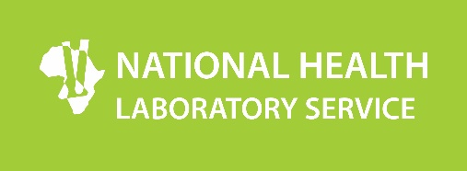

NHLS Amendment Bill – A Summary

The key changes proposed in the NHLS Amendment Bill include the following:

Finances of the Service
In terms of Finances of the Service, the Amendment Bill is proposing that a new clause be inserted which outlines how the Service will be funded. In terms of this new clause:

- The Minister of Health, in consultation with the Finance Minister, must prescribe a financing mechanism for the Service in order to ensure that the Service is adequately and sustainably funded and thereby enabling the Service to achieve its mandate.

- It is proposed that the Service be funded through:
  - Money appropriated by Parliament on such terms and conditions as the Minister, with the concurrence of the Minister of Finance, may determine;
  - Fees collected for services rendered;
  - Income earned on surplus moneys deposited or invested;
  - Grants, donations and bequests made to it;
  - Royalties; or
  - Money received from any other source.

  - The Service must charge such fees for services rendered that are not covered by the financing mechanism determined by the Minister of Health in consultation with the Minister of Finance.

Composition of the Board
The Board of the NHLS will consist of the following members appointed by the Minister of Health:

- The Chief Executive Officer by virtue of his or her office;
- The Chief Financial Officer of the Service by virtue of his or her office;
- Three members representing the National Department of Health, the Department of Science and Technology, nominated by the Director-General of that Department and the higher education sector, nominated by the Council on Higher Education.
- The Board will further consist of six members who have extensive experience and technical expertise in one or more of the following fields: Commerce, finance, auditing and economic matters; corporate management; public health; diagnostic laboratory services; legal matters; and epidemiology.
- And lastly, one representative from organised labour.

This means instead of having a 22-member board with representatives from all nine provinces, the new NHLS Board will be smaller in size and have a significant number of members with technical expertise. This will not only assist in speedy decision-making, but availing a range of technical expertise to the organization at Board level.

Appointment of the Chief Executive Officer
Finally, the Bill also proposes that the appointment of the Chief Executive Officer should be made by the Board in consultation with the Minister of Health.

