NATIONAL HEALTH LABORATORY SERVICE (NHLS)

REQUEST FOR QUOTATIONS

You are hereby invited to submit Quotation for the requirements of
National Health Laboratory service

RFQ number: | 1487039/18-19
Closing date: | 07 MAY 2018
Closing time: | 11:00AM
RFQ validity period: | 30 days (commencing from the RFQ Closing Date)
Important | N/A
RFQ Description: | REQUEST FOR GEL ELECTROPHORESIS SYSTEM
RFQ responses may be submitted to: |  | Or | Hand Delivered at:
 |  |  | 01 MODDERFONTEIN ROAD,SANDRINGHAM,AT NICD STORES THE QUOTE BOX ON THE 07 MAY 2018 (NB: QUOTES DROPPED OFF AT THE NHLS RFQ BOX WILL NOT BE CONSIDERED)
Bidders must acknowledge receipt of this RFQ and send it to Nandipham@nicd.ac.za

This RFQ is subject to the general conditions of the RFQ, National Treasury’s general conditions of contract (GCC) and, if applicable, any other special conditions of contract (SCC).
The following particulars must be furnished

Information of the Bidder
Name of bidder
Registration number
VAT registration number
Contact person
Telephone number
Cell number
E-mail address
Postal address
Physical address

Has an original and valid tax clearance certificate been submitted?

Yes |  | No

State RFQ/RFB number where the tax clearance certificate was submitted: ________________________________

NOTE: If you have submitted an original tax clearance certificate before to the NHLS or any bid or RFQ, it is not necessary for you to submit another tax clearance certificate while the NHLS is still in possession of your valid and original tax clearance certificate. It is the duty of the bidder to ensure that each time a bid or RFQ response is submitted, the tax clearance certificate they submitted previously is still valid on the closing date of the subsequent submission of a response for a particular RFQ.

D | D | M | M | Y | Y
If not, indicate the expiry date of the tax clearance certificate that was previously submitted to NHL.

Yes |  | No
Has an original and valid B-BBEE status level verification certificate or certified copy thereof been submitted?

State RFQ/RFB number where the B-BBEE status level verification certificate was submitted: ________________________________

NOTE :If you have submitted an original or certified copy of the B-BBEE status level verification certificate before to NHLS for any bid or RFQ response, it is not necessary for you to submit another B-BBEE status level verification certificate while NHLS is still in possession of your valid certificate. It is the duty of the bidder to ensure that each time a bid or RFQ response is submitted, the certificate they submitted previously is still valid on the closing date of the subsequent submission of a response for a particular RFQ.

D | D | M | M | Y | Y
If not, indicate the expiry date of the B-BBEE status level verification certificate that was previously submitted to NHLS.

I certify that the information furnished on this form is true and correct.

I further accept that, in addition to cancellation of a contract, action may be taken against me should this declaration prove to be false.

_________________________________________
Name of bidder (duly authorised)

_________________________________________
Signature of bidder

________________________________________
Date

_________________________________________
Capacity under which this RFQ is signed

Contents
1. Terms and conditions of Request For Quotation (RFQ) 5
2. Response format 5
Annex A : Price 7
Annex B : Preferential Procurement Claim form SBD 6.1 8
Annex C : Tax clearance requirements SBD 2 15
Annex D : Declaration Of Interest SBD 4 18
Annex E : Declaration Of Bidders Past Supply Chain Practices SBD 8 23
Annex F : CERTIFICATE OF INDEPENDENT BID DETERMINATION SBD 9 25
Annex G : Government Procurement: General Conditions of Contract – July 2011 28

Terms and conditions of Request For Quotation (RFQ)
  - This document may contain confidential information that is the property of the NHLS
  - No part of the contents may be used, copied, disclosed or conveyed in whole or in part to any party in any manner whatsoever other than for preparing a proposal in response to this Bid, without prior written permission from NHLS and the Client.
  - All Copyright and Intellectual Property herein vests with NHLS and its Client.
  - Late and incomplete submissions will not be accepted.
  - Any bidder who has reasons to believe that the RFQ specification is based on a specific brand must inform NHL before RFQ closing date.
  - Bidders are required to submit an original Tax Clearance Certificate for all price quotations exceeding the value of R30 000 (VAT included). Failure to submit the original and valid Tax Clearance Certificate will result in the invalidation of this RFQ. Certified copies of the Tax Clearance Certificate will not be acceptable.
  - It is the responsibility of the bidder to ensure that NHLS is in possession of the bidder’s valid Tax Clearance certificate. The onus is on the bidder to ensure that NHLS receives a valid Tax Certificate as soon as the validity of the said certificate expires.
  - No services must be rendered or goods delivered before an official NHLS Purchase Order form has been received.
  - This RFQ will be evaluated in terms of the 80/20 preference point system prescribed by the Preferential Procurement Regulations, 2011.
  - All questions regarding this RFQ must be forwarded to the buyer within 24 hours after the RFQ has been issued.
  - It is the responsibility of the bidder to ensure that its response reaches NICD on or before the closing date and time of the RFQ.
PLEASE DO NOT SUBMIT RFQ RESPONSES IN THE NHLS RFQ OR TENDER BOX AS THE RFQ RESPONSES DEPOSITED IN THE NHLS RFQ OR TENDER BOX SHALL NOT BE CONSIDERED.

The Bidder accepts the above terms and conditions and the General Conditions of Contract attached in Annex G. | Accept | Do not accept

Response format
  - Bidders shall submit response in accordance with the response format specified below. Failure to do so shall result rejecting vendor’s response. No referrals may be made to comment. Failure to comply shall result in the vendor being penalised.
2.2 Schedule Index:
2.2.1 Schedule 1: Pages 1 – 6 of this RFQ document
2.2.2 Schedule 2: Original and valid Tax Clearance Certificate (if not submitted before).
2.2.3 Schedule 3 : Price (Submit the price in a sealed envelope.)
2.2.4 Schedule 4: Preferential Procurement Claim form and the certified copy of the B-BBEE Status Level Verification Certificate (SBD 6)
2.2.5 Schedule 5: Declaration of interest (SBD 4)
2.2.6 Schedule 6: General Conditions of Contract
2.2.7 Schedule 7: Specification sheet stating whether you comply or not comply
2.2.8 Schedule 8; Proof of registration with National Treasury

- PRICE

INSTRUCTION TO BIDDERS

- The cost of delivery, labour etc. must be included in this proposal.
- Bidders must keep all items listed below in stock.

RFQ Number .........................................

Name of bidder ............................................................................................................

Total Price INCL VAT
...........................................................................................................

BIDDER MUST PROVIDE PRICE BREAKDOWN IN SOUTH AFRICAN RAND VALUE AS PER THE TABLE BELOW
Description | Quantity | Price (Vat Exclusive) | Price (Vat Inclusive)
GEL ELETROPHORESIS SYSTEM | 1

Bidder must tick next to each specification whether they comply or not, if not submitted the bidder will be disqualified.

Required specification | Comply | Not Comply
Horizontal gel box (approx. 7 x 10cm)
Two casting trays with combs
Power supply for gel box (300V)
RSA compatible power chords

Preferential Procurement Claim form SBD 6.1
PREFERENCE POINTS CLAIM FORM IN TERMS OF THE PREFERENTIAL PROCUREMENT REGULATIONS 2011

This preference form must form part of all Bids invited. It contains general information and serves as a claim form for preference points for Broad-Based Black Economic Empowerment (B-BBEE) Status Level of Contribution

NB: Prior to completing this form, bidders must study the general conditions, definitions and directives applicable in respect of B-BBEE, as prescribed in the preferential procurement regulations, 2011.
- General conditions
  - The following preference point systems are applicable to all Bids:
    - the 80/20 system for requirements with a Rand value of up to R500 000 (all applicable taxes included); and
    - the 90/10 system for requirements with a Rand value above R500 000 (all applicable taxes included).
  - The value of this RFQ is estimated to not exceed R500 000 (all applicable taxes included) and therefore the80/20 preference points system shall be applicable.
  - Preference points for this bid shall be awarded for:
- Price; and
- B-BBEE status level of contribution.
1.3.1 The maximum points for this Bid are allocated as follows:
POINTS
1.3.1.1 PRICE 80
1.3.1.2 B-BBEE STATUS LEVEL OF CONTRIBUTION 20
Total points for Price and B-BBEE must not exceed 100
1.4 Failure on the part of a bidder to fill in and/or to sign this form and submit a B-BBEE Verification Certificate from a Verification Agency accredited by the South African Accreditation System (SANAS) or a Registered Auditor approved by the Independent Regulatory Board of Auditors (IRBA) or an Accounting Officer as contemplated in the CCA together with the bid, will be interpreted to mean that preference points for B-BBEE status level of contribution are not claimed.
1.5. The purchaser reserves the right to require of a bidder, either before a Bid is adjudicated or at any time subsequently, to substantiate any claim in regard to preferences, in any manner required by the purchaser.

2. Definitions
2.1 “all applicable taxes “includes value-added tax, pay as you earn, income tax, unemployment insurance fund contributions and skills development levies;
2.2 “B-BBEE” means broad-based black economic empowerment as defined in section 1 of the Broad-Based Black Economic Empowerment Act;
2.3 “B-BBEE status level of contributor “means the B-BBEE status received by a measured entity based on its overall performance using the relevant scorecard contained in the Codes of Good Practice on Black Economic Empowerment, issued in terms of section 9(1) of the Broad-Based Black Economic Empowerment Act;
2.4 “bid” means a written offer in a prescribed or stipulated form in response to an invitation by anorgan of state for the provision of services, works or goods, through price quotations, advertised competitive bidding processes or proposals;
2.5 “Broad-Based Black Economic Empowerment Act” means the Broad-Based Black Economic Empowerment Act, 2003 (Act No. 53 of 2003);
2.6 “comparative price” means the price after the factors of a non-firm price and all unconditional discounts that can be utilised have been taken into consideration;
2.7 “consortium or joint venture” means an association of persons for the purpose of combining their expertise, property, capital, efforts, skill and knowledge in an activity for the execution of a contract;
2.8 “contract” means the agreement that results from the acceptance of a bid by an organ of state;
2.9 “EME” means any enterprise with annual total revenue of R5 million or less;
2.10 “Firm price” means the price that is only subject to adjustments in accordance with the actual increase or decrease resulting from the change, imposition, or abolition of customs or excise duty and any other duty, levy, or tax, which, in terms of the law or regulation, is binding on the contractor and demonstrably has an influence on the price of any supplies, or the rendering costs of any service, for the execution of the contract;
2.11 “functionality “means the measurement according to predetermined norms, as set out in the bid documents, of a service or commodity that is designed to be practical and useful, working or operating, taking into account, among other factors, the quality, reliability, viability and durability of a service and the technical capacity and ability of a bidder;
2.12 “non-firm prices” means all prices other than “firm” prices;
2.13 “person “includes a juristic person;
2.14 “rand value” means the total estimated value of a contract in South African currency, calculated at the time of bid invitations, and includes all applicable taxes and excise duties;

2.15 “sub-contract “means the primary contractor’s assigning, leasing, making out work to, or employing, another person to support such primary contractor in the execution of part of a project in terms of the contract;
2.16 “total revenue “bears the same meaning assigned to this expression in the Codes of Good Practice on Black Economic Empowerment, issued in terms of section 9(1) of the Broad-Based Black Economic Empowerment Act and promulgated in the Government Gazette on 9 February 2007;
2.17 “trust” means the arrangement through which the property of one person is made over or bequeathed to a trustee to administer such property for the benefit of another person; and
2.18 “trustee “means any person, including the founder of a trust, to whom property is bequeathed in order for such property to be administered for the benefit of another person.

3. Adjudication using a point system
3.1 The bidder obtaining the highest number of total points will be awarded the contract.
3.2 Preference points shall be calculated after prices have been brought to a comparative basis taking into account all factors of non-firm prices and all unconditional discounts;
3.3 Points scored must be rounded off to the nearest two (2) decimal places.
3.4 In the event that two or more Bids have scored equal total points, the successful bid must be the one scoring the highest number of preference points for B-BBEE.
3.5 However, when functionality is part of the evaluation process and two or more Bids have scored equal points including equal preference points for B-BBEE, the successful bid must be the one scoring the highest score for functionality.
3.6 Should two or more Bids be equal in all respects; the award shall be decided by the drawing of lots.

4. Points awarded for price
4.1 The 80/20 preference point systems
A maximum of 80 points is allocated for price on the following basis:

Where
Ps = Points scored for comparative price of bid under consideration
Pt = Comparative price of bid under consideration
Pmin = Comparative price of lowest acceptable bid

5 Points awarded for B-BBEE Status Level of Contribution
5.1 In terms of Regulation 5 (2) and 6 (2) of the Preferential Procurement Regulations, preference points must be awarded to a bidder for attaining the B-BBEE status level of contribution in accordance with the table below:
B-BBEE status level of contributor | Number of points  (80/20 system)
1 | 20
2 | 18
3 | 16
4 | 12
5 | 8
6 | 6
7 | 4
8 | 2
Non-compliant contributor | 0

5.2 Bidders who qualify as EMEs in terms of the B-BBEE Act must submit a certificate issued by an Accounting Officer as contemplated in the CCA or a Verification Agency accredited by SANAS or a Registered Auditor. Registered auditors do not need to meet the prerequisite for IRBA’s approval for the purpose of conducting verification and issuing EMEs with B-BBEE Status Level Certificates.
5.3 Bidders other than EMEs must submit their original and valid B-BBEE status level verification certificate or a certified copy thereof, substantiating their B-BBEE rating issued by a Registered Auditor approved by IRBA or a Verification Agency accredited by SANAS.
5.4 A trust, consortium or joint venture, will qualify for points for their B-BBEE status level as a legal entity, provided that the entity submits their B-BBEE status level certificate.
5.5 A trust, consortium or joint venture will qualify for points for their B-BBEE status level as an unincorporated entity, provided that the entity submits their consolidated B-BBEE scorecard as if they were a group structure and that such a consolidated B-BBEE scorecard is prepared for every separate bid.
5.6 Tertiary institutions and public entities will be required to submit their B-BBEE status level certificates in terms of the specialised scorecard contained in the B-BBEE Codes of Good Practice.
5.7 A person will not be awarded points for B-BBEE status level if it is indicated in the bid documents that such a bidder intends sub-contracting more than 25% of the value of the contract to any other enterprise that does not qualify for at least the points that such a bidder qualifies for, unless the intended sub-contractor is an EME that has the capability and ability to execute the sub-contract (Refer to paragraph 8 below).
5.8 A person awarded a contract may not sub-contract more than 25% of the value of the contract to any other enterprise that does not have an equal or higher B-BBEE status level than the person concerned, unless the contract is sub-contracted to an EME that has the capability and ability to execute the sub-contract (Refer to paragraph 8 below).
6 Bid declaration
6.1 Bidders who claim points in respect of B-BBEE status level of contribution must complete the following:

7 B-BBEE status level of contribution claimed in terms of paragraphs 1.3.1.2 and 5.1
7.1 B-BBEE Status Level of Contribution: ___________ = ________ (maximum of 20 points)
(Points claimed in respect of paragraph 7.1 must be in accordance with the table reflected in paragraph 5.1 and must be substantiated by means of a B-BBEE certificate issued by a Verification Agency accredited by SANAS or a Registered Auditor approved by IRBA or an Accounting Officer as contemplated in the CCA).
8 Sub-contracting (Refer to paragraphs 5.7 and 5.8 above)
8.1 Will any portion of the contract be sub-contracted? YES / NO (delete which is not applicable)
8.1.1 If yes, indicate:
8.1.1.1 what percentage of the contract will be subcontracted? ____________________________%
8.1.1.2 the name of the sub-contractor? ______________________________________________
8.1.1.3 the B-BBEE status level of the subcontractor?
___________________________________
8.1.1.4 whether the sub-contractor is an EME? YES / NO (delete which is not applicable)

9 Declaration with regard to company/firm
9.1 Name of company/firm ____________________________________________________

9.2 VAT registration number ____________________________________________________

9.3 Company registration number ___________________________________________________

9.4 Type of company/ firm
Partnership/Joint Venture / Consortium
One-person business/sole propriety
Close corporation
Company
(Pty) Limited
[Tick applicable box]

9.5 Describe principal business activities

9.6 Company classification
Manufacturer
Supplier
Professional service provider
Other service providers, e.g. transporter.
[Tick applicable box]

9.7 Total number of years the company/firm has been in business? ……………………………………

9.8 I/we, the undersigned, who is / are duly authorised to do so on behalf of the company/firm, certify that the points claimed, based on the B-BBE status level of contribution indicated in paragraph 7 of the foregoing certificate, qualifies the company/ firm for the preference(s) shown and I / we acknowledge that:
9.8.1 The information furnished is true and correct;
9.8.2 The preference points claimed are in accordance with the General Conditions as indicated in paragraph 1 of this form.
9.8.3 In the event of a contract being awarded as a result of points claimed as shown in paragraph 7, the contractor may be required to furnish documentary proof to the satisfaction of the purchaser that the claims are correct;

9.8.4 If the B-BBEE status level of contribution has been claimed or obtained on a fraudulent basis or any of the conditions of contract have not been fulfilled, the purchaser may, in addition to any other remedy it may have –
9.8.4.1 disqualify the person from the bidding process;
9.8.4.2 recover costs, losses or damages it has incurred or suffered as a result of that person’s conduct;
9.8.4.3 cancel the contract and claim any damages which it has suffered as a result of having to make less favourable arrangements due to such cancellation;
      - restrict the bidder or contractor, its shareholders and directors, or only the shareholders and directors who acted on a fraudulent basis, from obtaining business from any organ of state for a period not exceeding ten(10) years, after the audialterampartem (hear the other side) rule has been applied; and forward the matter for criminal prosecution.

Witnesses:

- _____________________________

_________________________________
Signature(s) of bidder(s)

- ____________________________

Date: _________________________________
Address: __________________________
______________________________________
______________________________________
______________________________________

- Tax clearance requirements SBD 2
1 It is a condition of Bid that the taxes of the successful bidder must be in order, or that satisfactory arrangements have been made with South African Revenue Service (SARS) to meet the bidder’s tax obligations.
2 In order to meet this requirement bidder are required to complete in full the attached form TCC 001 “Application for a Tax Clearance Certificate” and submit it to any SARS branch office nationally. The tax clearance certificate requirements are also applicable to foreign bidders/individuals who wish to submit Bids.
3 SARS shall then furnish the bidder with a tax clearance certificate that shall be valid for a period of one (1) year from the date of approval.
4 The original tax clearance certificate must be submitted together with the Bid. Failure to submit the original and valid tax clearance certificate shall result in the invalidation of the Bid. Certified copies of the tax clearance certificate shall not be acceptable.
5 In Bids where Consortia / Joint Ventures / subcontractors are involved, each party must submit a separate tax clearance certificate.
6 Copies of the TCC 001 “Application for a Tax Clearance Certificate” form are available from any SARS branch office nationally or on the website www.sars.gov.za.
7 Applications for the tax clearance certificates may also be made via eFiling. In order to use this provision, taxpayers shall need to register with SARS as eFilers through the website www.sars.gov.za.
Jeyrel:\Mdk416-SBD2 tax clearance

TAX CLEARANCE
Application for a Tax Clearance Certificate

Particulars applicant
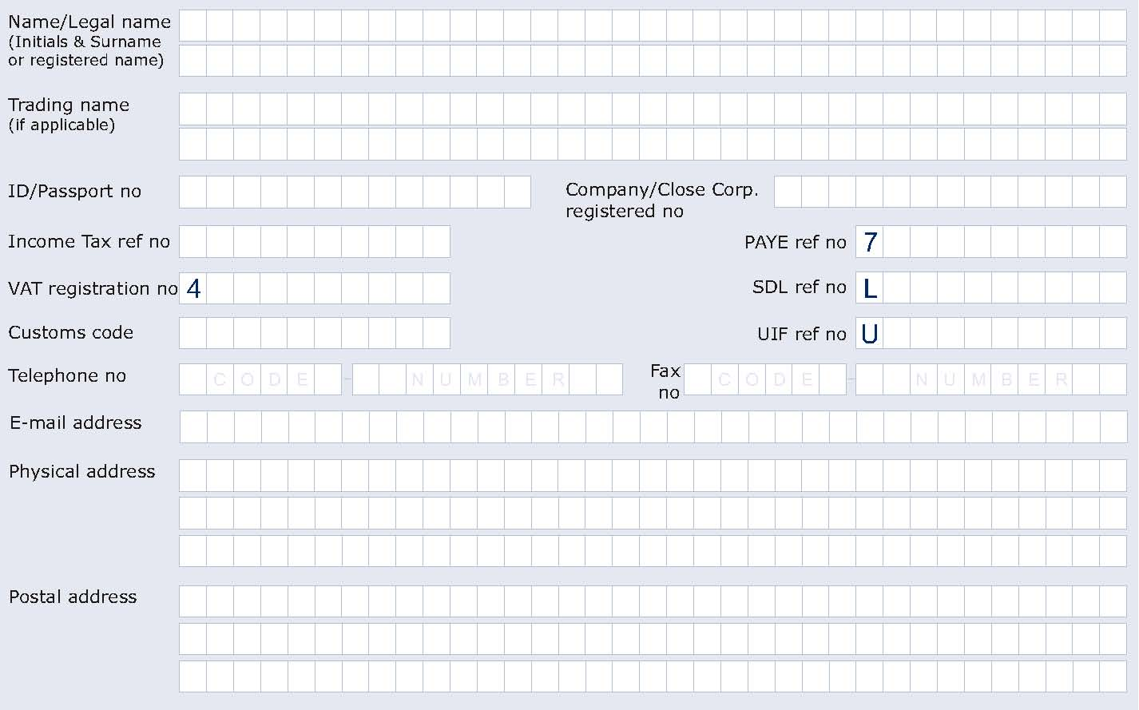
Particulars of representative (Public Officer/Trustee/Partner) 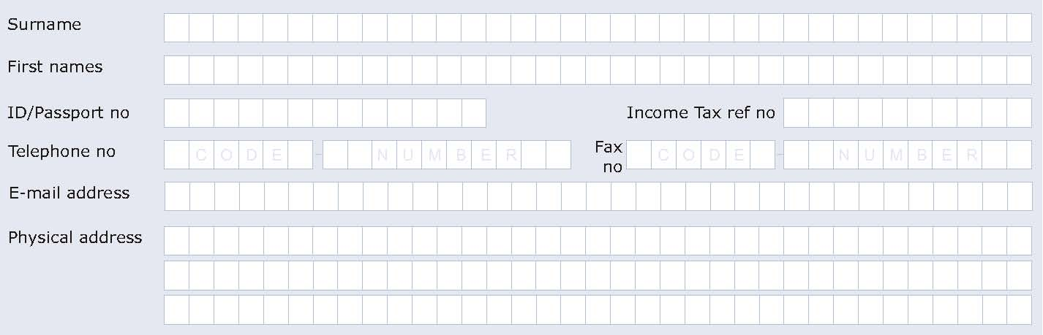
Page 1 of 2

Particulars of RFQ (If applicable)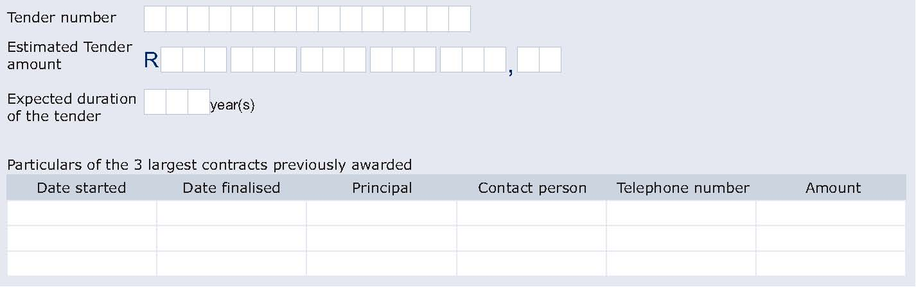
Audit
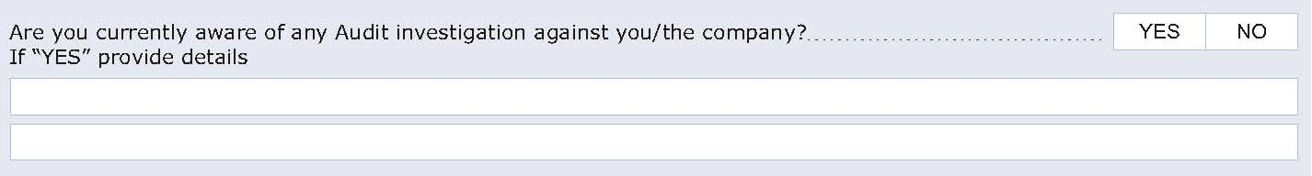
Appointment of representative/agent (Power of Attorney)
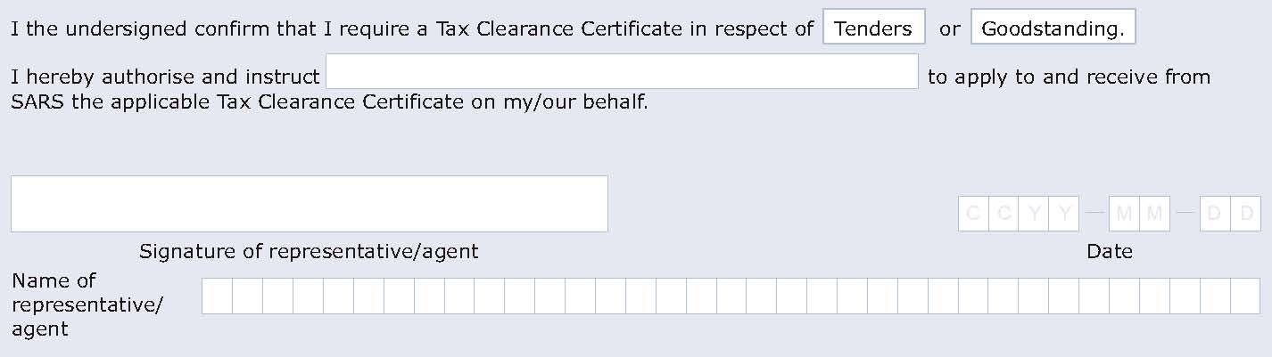
Declaration
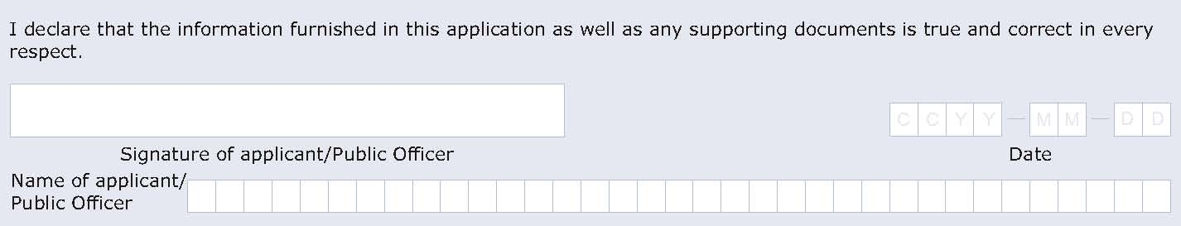

Notes:
- It is a serious offence to make a false declaration.
2. Section 75 of the Income Tax Act, 1962, states: Any person who
  - (a) fails or neglects to furnish, file or submit any return or document as and when required by or under this Act; or
  - (b) without just cause shown by him, refuses or neglects to
  - (i) furnish, produce or make available any information, documents or things;
  - (ii) reply to or answer truly and fully, any questions put to him ...
As and when required in terms of this Act ... shall be guilty of an offence ...
- SARS shall, under no circumstances, issue a Tax Clearance Certificate unless this form is completed in full.
- Your Tax Clearance Certificate shall only be issued on presentation of your South African Identity Document or Passport (Foreigners only) as applicable.

- Declaration Of Interest SBD 4
1 Declaration of interest
1.1 Any legal person, including persons employed by the state¹, or persons having a kinship with persons employed by the state, including a blood relationship, may make an offer or offers in terms of this invitation to bid (includes a price quotation, advertised competitive bid, limited bid or proposal). In view of possible allegations of favouritism, should the resulting bid, or part thereof, be awarded to persons employed by the state, or to persons connected with or related to them, it is required that the bidder or his/her authorised representative declare his/her positionin relation to the evaluating/adjudicating authority where:
1.1.1 the bidder is employed by the state; and/or
1.1.2 the legal person on whose behalf the bidding document is signed, has a relationship with persons/a person who are/is involved in the evaluation and/or adjudication of the bid(s), or where it is known that such a relationship exists between the person or persons for or on whose behalf the declarant acts and persons who are involved with the evaluation and/or adjudication of the bid.

1.2 In order to give effect to the above, the following questionnaire must be completed and submitted with the Bid.
    - Full name of bidder or his or her representative:____________________________________
1.2.2 Identity number: _________________________________________________________
1.2.3 Position occupied in the company (director, trustee, shareholder) ______________________
    - Company registration number ______________________________________________
    - Tax reference number _____________________________________________________
    - VAT registration number ___________________________________________________
      - The names of all directors / trustees / shareholders / members, their individual identity numbers, tax reference numbers and, if applicable, employee / persal numbers must be indicated in paragraph 3 below.
_______________
“State” means:
- any national or provincial department, national or provincial public entity or constitutional institution within the meaning of the Public Finance Management Act, 1999 (Act No. 1 of 1999);
- any municipality or municipal entity;
- provincial legislature;
- national Assembly or the national Council of provinces; or
- Parliament.
²”Shareholder” means a person who owns shares in the company and is actively involved in the management of the enterprise or business and exercises control over the enterprise.

1.2.6.2 Any legal person, including persons employed by the state, or persons having a kinship with persons employed by the State, including a blood relationship, may make an offer or offers in terms of this invitation to bid (includes a price quotation, advertised competitive bid, limited bid or proposal). In view of possible allegations of favouritism, should the resulting Bid, or part thereof, be awarded to persons employed by the State, or to persons connected with or related to them, it is required that the bidder or his/her authorised representative declare his/her positionin relation to the evaluating/adjudicating authority where:
1.2.6.2.1 the bidder is employed by the state; and/or
1.2.6.2.2 the legal person on whose behalf the bidding document is signed, has a relationship with persons/a person who are/is involved in the evaluation and/or adjudication of the Bid(s), or where it is known that such a relationship exists between the person or persons for or on whose behalf the declarant acts and persons who are involved with the evaluation and/or adjudication of the Bid.

2 In order to give effect to the above, the following questionnaire must be completed and submitted with the Bid.

  - Full name of the bidder or his or her representative: ………………………………………………………….
  - Identity number: ………………………………………………………………………………………………….............
  - Position occupied in the company (director, trustee, shareholder²): …………………………………
  - Company registration number: ………………………………………………………………………..…….
  - Tax Reference Number: ………………………………………………………………………………….………
2.6 VAT Registration Number: ………………………………………………………………………………....
2.6.1 The names of all directors / trustees / shareholders / members, their individual identity numbers, tax reference numbers and, if applicable, employee / perusal numbers must be indicated in paragraph 3 below.
2.7 Are you or any person connected with the bidder YES / NO
presently employed by the state?

2.7.1 If so, furnish the following particulars:

Name of person / director / trustee / shareholder/ member:
_____________________________
Name of state institution at which you or the person connected to the bidder is employed
_______________________________________________________________________
Position occupied in the state institution:____________________________________________
Any other particulars:______________________________________________________________
_______________________________________________________________________
_______________________________________________________________________

    - If you are presently employed by the state, did you obtain YES / NO
the appropriate authority to undertake remunerative
work outside employment in the public sector?

      - If yes, did you attached proof of such authority to the Bid YES / NO
document?
(NOTE Failure to submit proof of such authority, where applicable, may result in the disqualification of the bid.)

      - If not, furnish reasons for non-submission of such proof: __________________________________________________________________
__________________________________________________________________
__________________________________________________________________

  - Did you or your spouse, or any of the company’s directors / YES / NO
trustees / shareholders / members or their spouses conduct
business with the state in the previous twelve months?

2.8.1 If so, furnish other particulars:__________________________________________________
__________________________________________________________________________
__________________________________________________________________________

  - Do you, or any person connected with the bidder, have YES / NO
any relationship (family, friend, other) with a person
employed by thestate and who may be involved with
the evaluation and or adjudication of this bid?

2.9.1 If so, furnish other particulars: _______________________________________________________________________
_______________________________________________________________________
_______________________________________________________________________

2.10 Are you, or any person connected with the bidder, YES/NO
aware of any relationship (family, friend, other) between
any other bidder and any person employed by the state
who may be involved with the evaluation and/or adjudication
of this Bid?

2.10.1 If so, furnish other particulars: _______________________________________________________________________
_______________________________________________________________________
_______________________________________________________________________

2.11 Do you or any of the directors / trustees / shareholders / members YES/NO
of the company have any interest in any other related companies
whether or not they are bidding for this contract?

2.11.1 If so, furnish other particulars: __________________________________________________________________________
__________________________________________________________________________
__________________________________________________________________________
3. Full details of directors / trustees / members / shareholders
Full name | Identity number | Personal tax reference number | State employee number / Persal number

4. Declaration

I, the undersigned (name) ____________________________________________________ certify that the information furnished in paragraphs 2 and 3 above is correct.

I accept that the State may reject the bid or act against me in terms of paragraph 23 of the GCC should this declaration prove to be false.

Signature Date

Position Name of bidder

May 2011

- Government Procurement: General Conditions of Contract – July 2011
NOTES
The purpose of this document is to:
(i) Draw special attention to certain general conditions applicable to government Bids, contracts and orders; and
(ii) To ensure that clients be familiar with regard to the rights and obligations of all parties involved in doing business with government.

In this document words in the singular also mean in the plural and vice versa and words in the masculine also mean in the feminine and neuter.
• The GCC will form part of all bid documents and may not be amended.
• Special Conditions of Contract (SCC) relevant to a specific bid, should be compiled separately for every bid (if (applicable) and will supplement the GCC. Whenever there is a conflict, the provisions in the SCC shall prevail.

TABLE OF CLAUSES
1. Definitions
2. Application
3. General
4. Standards
5. Use of contract documents and information; inspection
6. Patent rights
7. Performance security
8. Inspections, tests and analysis
9. Packing
10. Delivery and documents
11. Insurance
12. Transportation
13. Incidental services
14. Spare parts
15. Warranty
16. Payment
17. Prices
18. Contract amendments
19. Assignment
20. Subcontracts
21. Delays in the supplier’s performance
22. Penalties
23. Termination for default
24. Dumping and countervailing duties
25. Force Majeure
26. Termination for insolvency
27. Settlement of disputes
28. Limitation of liability
29. Governing language
30. Applicable law
31. Notices
32. Taxes and duties
33. National Industrial Participation Programme (NIPP)
34. Prohibition of restrictive practices

General conditions of contract
1. Definitions
1 The following terms shall be interpreted as indicated:
1.1 “Closing time” means the date and hour specified in the bidding documents for the receipt of Bids.
1.2 “Contract” means the written agreement entered into between the purchaser and the supplier, as recorded in the contract form signed by the parties, including all attachments and appendices thereto and all documents incorporated by reference therein.
1.3 “Contract price” means the price payable to the supplier under the contract for the full and proper performance of his contractual obligations.
1.4 “Corrupt practice” means the offering, giving, receiving, or soliciting of anything of value to influence the action of a public official in the procurement process or in contract execution.
1.5 "Countervailing duties" are imposed in cases where an enterprise abroad is subsidized by its government and encouraged to market its products internationally.
1.6 “Country of origin” means the place where the goods were mined, grown or produced or from which the services are supplied. Goods are produced when, through manufacturing, processing or substantial and major assembly of components, a commercially recognized new product results that is substantially different in basic characteristics or in purpose or utility from its components.
1.7 “Day” means calendar day.
1.8 “Delivery” means delivery in compliance of the conditions of the contract or order.
1.9 “Delivery ex stock” means immediate delivery directly from stock actually on hand.
1.10 “Delivery into consignees store or to his site” means delivered and unloaded in the specified store or depot or on the specified site in compliance with the conditions of the contract or order, the supplier bearing all risks and charges involved until the supplies are so delivered and a valid receipt is obtained.
1.11 "Dumping" occurs when a private enterprise abroad market its goods on own initiative in the RSA at lower prices than that of the country of origin and which have the potential to harm the local industries in the RSA.
1.12 “Force majeure” means an event beyond the control of the supplier and not involving the supplier’s fault or negligence and not foreseeable. Such events may include, but is not restricted to, acts of the purchaser in its sovereign capacity, wars or revolutions, fires, floods, epidemics, quarantine restrictions and freight embargoes.
1.13 “Fraudulent practice” means a misrepresentation of facts in order to influence a procurement process or the execution of a contract to the detriment of any bidder, and includes collusive practice among bidders (prior to or after bid submission) designed to establish bid prices at artificial non-competitive levels and to deprive the bidder of the benefits of free and open competition.
1.14 “GCC” means the General Conditions of Contract.
1.15 “Goods” means all of the equipment, machinery, and/or other materials that the supplier is required to supply to the purchaser under the contract.
1.16 “Imported content” means that portion of the bidding price represented by the cost of components, parts or materials which have been or are still to be imported (whether by the supplier or his subcontractors) and which costs are inclusive of the costs abroad, plus freight and other direct importation costs such as landing costs, dock dues, import duty, sales duty or other similar tax or duty at the South African place of entry as well as transportation and handling charges to the factory in the Republic where the supplies covered by the bid will be manufactured.
1.17 “Local content” means that portion of the bidding price which is not included in the imported content provided that local manufacture does take place.
1.18 “Manufacture” means the production of products in a factory using labour, materials, components and machinery and includes other related value-adding activities.
1.19 “Order” means an official written order issued for the supply of goods or works or the rendering of a service.
1.20 “Project site,” where applicable, means the place indicated in bidding documents.
1.21 “Purchaser” means the organisation purchasing the goods.
1.22 “Republic” means the RSA.
1.23 “SCC” means the Special Conditions of Contract.
1.24 “Services” means those functional services ancillary to the supply of the goods, such as transportation and any other incidental services, such as installation, commissioning, provision of technical assistance, training, catering, gardening, security, maintenance and other such obligations of the supplier covered under the contract.
1.25 “Written” or “in writing” means handwritten in ink or any form of electronic or mechanical writing.

2 Application
2.1 These general conditions are applicable to all Bids, contracts and orders including Bids for functional and professional services, sales, hiring, letting and the granting or acquiring of rights, but excluding immovable property, unless otherwise indicated in the bidding documents.
2.2 Where applicable, SCCare also laid down to cover specific supplies, services or works.
2.3 Where such SCCare in conflict with these general conditions, the special conditions shall apply.
3 General
3.1 Unless otherwise indicated in the bidding documents, the purchaser shall not be liable for any expense incurred in the preparation and submission of a bid. Where applicable a non-refundable fee for documents may be charged.
3.2 With certain exceptions, invitations to bid are only published in the Government Tender Bulletin. The Government Tender Bulletin may be obtained directly from the Government Printer, Private Bag X85, Pretoria 0001, or accessed electronically from www.treasury.gov.za
4 Standards
4.1 The goods supplied shall conform to the standards mentioned in the bidding documents and specifications.
- Use of contract documents and information; inspection
5.1 The supplier shall not, without the purchaser’s prior written consent, disclose the contract, or any provision thereof, or any specification, plan, drawing, pattern, sample, or information furnished by or on behalf of the purchaser in connection therewith, to any person other than a person employed by the supplier in the performance of the contract. Disclosure to any such employed person shall be made in confidence and shall extend only so far as may be necessary for purposes of such performance.
5.2 The supplier shall not, without the purchaser’s prior written consent, make use of any document or information mentioned in GCC clause 5.1 except for purposes of performing the contract.
5.3 Any document, other than the contract itself mentioned in GCC clause 5.1 shall remain the property of the purchaser and shall be returned (all copies) to the purchaser on completion of the supplier’s performance under the contract if so required by the purchaser.
5.4 The supplier shall permit the purchaser to inspect the supplier’s records relating to the performance of the supplier and to have them audited by auditors appointed by the purchaser, if so required by the purchaser.
6 Patent rights
6.1 The supplier shall indemnify the purchaser against all third-party claims of infringement of patent, trademark, or industrial design rights arising from use of the goods or any part thereof by the purchaser.

- Performance security
7.1 Within thirty (30) days of receipt of the notification of contract award, the successful bidder shall furnish to the purchaser the performance security of the amount specified in SCC.
7.2 The proceeds of the performance security shall be payable to the purchaser as compensation for any loss resulting from the supplier’s failure to complete his obligations under the contract.
7.3 The performance security shall be denominated in the currency of the contract, or in a freely convertible currency acceptable to the purchaser and shall be in one of the following forms:
7.3.1 a bank guarantee or an irrevocable letter of credit issued by a reputable bank located in the purchaser’s country or abroad, acceptable to the purchaser, in the form provided in the bidding documents or another form acceptable to the purchaser; or
7.3.2 a cashier’s or certified cheque
7.4 The performance security will be discharged by the purchaser and returned to the supplier not later than thirty (30) days following the date of completion of the supplier’s performance obligations under the contract, including any warranty obligations, unless otherwise specified in SCC.
8. Inspections, tests and analyses
8.1 All pre-bidding testing will be for the account of the bidder.
8.2 If it is a bid condition that supplies to be produced or services to be rendered should at any stage during production or execution or on completion be subject to inspection, the premises of the bidder or contractor shall be open, at all reasonable hours, for inspection by a representative of the Department or an organisation acting on behalf of the Department.
8.3 If there are no inspection requirements indicated in the bidding documents and no mention is made in the contract, but during the contract period it is decided that inspections shall be carried out, the purchaser shall itself make the necessary arrangements, including payment arrangements with the testing authority concerned.
8.4 If the inspections, tests and analyses referred to in clauses 8.2 and 8.3 show the supplies to be in accordance with the contract requirements, the cost of the inspections, tests and analyses shall be defrayed by the purchaser.
8.5 Where the supplies or services referred to in clauses 8.2 and 8.3 do not comply with the contract requirements, irrespective of whether such supplies or services are accepted or not, the cost in connection with these inspections, tests or analyses shall be defrayed by the supplier.
8.6 Supplies and services which are referred to in clauses 8.2 and 8.3 and which do not comply with the contract requirements may be rejected.
8.7 Any contract supplies may on or after delivery be inspected, tested or analyzed and may be rejected if found not to comply with the requirements of the contract. Such rejected supplies shall be held at the cost and risk of the supplier who shall, when called upon, remove them immediately at his own cost and forthwith substitute them with supplies which do comply with the requirements of the contract. Failing such removal the rejected supplies shall be returned at the suppliers cost and risk. Should the supplier fail to provide the substitute supplies forthwith, the purchaser may, without giving the supplier further opportunity to substitute the rejected supplies, purchase such supplies as may be necessary at the expense of the supplier.
8.8 The provisions of clauses 8.4 to 8.7 shall not prejudice the right of the purchaser to cancel the contract on account of a breach of the conditions thereof, or to act in terms of Clause 23 of GCC.
9 Packing
9.1 The supplier shall provide such packing of the goods as is required to prevent their damage or deterioration during transit to their final destination, as indicated in the contract. The packing shall be sufficient to withstand, without limitation, rough handling during transit and exposure to extreme temperatures, salt and precipitation during transit, and open storage. Packing, case size and weights shall take into consideration, where appropriate, the remoteness of the goods’ final destination and the absence of heavy handling facilities at all points in transit.
9.2 The packing, marking, and documentation within and outside the packages shall comply strictly with such special requirements as shall be expressly provided for in the contract, including additional requirements, if any, specified in SCC, and in any subsequent instructions ordered by the purchaser.
10 Delivery and documents
10.1 Delivery of the goods shall be made by the supplier in accordance with the terms specified in the contract. The details of shipping and/or other documents to be furnished by the supplier are specified in SCC.
10.2 Documents to be submitted by the supplier are specified in SCC.
11 Insurance
11.1 The goods supplied under the contract shall be fully insured in a freely convertible currency against loss or damage incidental to manufacture or acquisition, transportation, storage and delivery in the manner specified in the SCC.
12 Transportation
12.1 Should a price other than an all-inclusive delivered price be required, this shall be specified in the SCC.
13 Incidental services
13.1 The supplier may be required to provide any or all of the following services, including additional services, if any, specified in SCC:
13.1.1 performance or supervision of on-site assembly and/or commissioning of the supplied goods;
13.1.2 furnishing of tools required for assembly and/or maintenance of the supplied goods;
13.1.3 furnishing of a detailed operations and maintenance manual for each appropriate unit of the supplied goods;
13.1.4 performance or supervision or maintenance and/or repair of the supplied goods, for a period of time agreed by the parties, provided that this service shall not relieve the supplier of any warranty obligations under this contract; and
13.1.5 training of the purchaser’s personnel, at the supplier’s plant and/or on-site, in assembly, start-up, operation, maintenance, and/or repair of the supplied goods.
13.2 Prices charged by the supplier for incidental services, if not included in the contract price for the goods, shall be agreed upon in advance by the parties and shall not exceed the prevailing rates charged to other parties by the supplier for similar services.
14 Spare parts
14.1 As specified in SCC, the supplier may be required to provide any or all of the following materials, notifications, and information pertaining to spare parts manufactured or distributed by the supplier:
14.1.1 such spare parts as the purchaser may elect to purchase from the supplier, provided that this election shall not relieve the supplier of any warranty obligations under the contract; and
14.1.2 in the event of termination of production of the spare parts:
14.1.2.1 Advance notification to the purchaser of the pending termination, in sufficient time to permit the purchaser to procure needed requirements; and
14.1.2.2 following such termination, furnishing at no cost to the purchaser, the blueprints, drawings, and specifications of the spare parts, if requested.
15 Warranty
15.1 The supplier warrants that the goods supplied under the contract are new, unused, of the most recent or current models, and that they incorporate all recent improvements in design and materials unless provided otherwise in the contract. The supplier further warrants that all goods supplied under this contract shall have no defect, arising from design, materials, or workmanship (except when the design and/or material is required by the purchaser’s specifications) or from any act or omission of the supplier, that may develop under normal use of the supplied goods in the conditions prevailing in the country of final destination.
15.2 This warranty shall remain valid for twelve (12) months after the goods, or any portion thereof as the case may be, have been delivered to and accepted at the final destination indicated in the contract, or for eighteen (18) months after the date of shipment from the port or place of loading in the source country, whichever period concludes earlier, unless specified otherwise in SCC.
15.3 The purchaser shall promptly notify the supplier in writing of any claims arising under this warranty.
15.4 Upon receipt of such notice, the supplier shall, within the period specified in SCC and with all reasonable speed, repair or replace the defective goods or parts thereof, without costs to the purchaser.
15.5 If the supplier, having been notified, fails to remedy the defect(s) within the period specified in SCC, the purchaser may proceed to take such remedial action as may be necessary, at the supplier’s risk and expense and without prejudice to any other rights which the purchaser may have against the supplier under the contract.

16 Payment
16.1 The method and conditions of payment to be made to the supplier under this contract shall be specified in SCC.
16.2 The supplier shall furnish the purchaser with an invoice accompanied by a copy of the delivery note and upon fulfilment of other obligations stipulated in the contract.
16.3 Payments shall be made promptly by the purchaser, but in no case later than thirty (30) days after submission of an invoice or claim by the supplier.
16.4 Payment will be made in rand unless otherwise stipulated in SCC.
17 Prices
17.1 Prices charged by the supplier for goods delivered and services performed under the contract shall not vary from the prices quoted by the supplier in his bid, with the exception of any price adjustments authorised in SCC or in the purchaser’s request for bid validity extension, as the case may be.
18 Contract amendments
18.1 No variation in or modification of the terms of the contract shall be made except by written amendment signed by the parties concerned.
19 Assignment
19.1 The supplier shall not assign, in whole or in part, its obligations to perform under the contract, except with the purchaser’s prior written consent.
20 Subcontracts
20.1 The supplier shall notify the purchaser in writing of all subcontracts awarded under this contract if not already specified in the bid. Such notification, in the original bid or later, shall not relieve the supplier from any liability or obligation under the contract.
21 Delays in the supplier’s performance
21.1 Delivery of the goods and performance of services shall be made by the supplier in accordance with the time schedule prescribed by the purchaser in the contract.
21.2 If at any time during performance of the contract, the supplier or its subcontractor(s) should encounter conditions impeding timely delivery of the goods and performance of services, the supplier shall promptly notify the purchaser in writing of the fact of the delay, its likely duration and its cause(s). As soon as practicable after receipt of the supplier’s notice, the purchaser shall evaluate the situation and may at his discretion extend the supplier’s time for performance, with or without the imposition of penalties, in which case the extension shall be ratified by the parties by amendment of contract.
21.3 No provision in a contract shall be deemed to prohibit the obtaining of supplies or services from a national department, provincial department, or a local authority.
21.4 The right is reserved to procure outside of the contract small quantities or to have minor essential services executed if an emergency arises, the supplier’s point of supply is not situated at or near the place where the supplies are required, or the supplier’s services are not readily available.
21.5 Except as provided under GCC Clause 25, a delay by the supplier in the performance of its delivery obligations shall render the supplier liable to the imposition of penalties, pursuant to GCC Clause 22, unless an extension of time is agreed upon pursuant to GCC Clause 21.2 without the application of penalties.
21.6 Upon any delay beyond the delivery period in the case of a supplies contract, the purchaser shall, without cancelling the contract, be entitled to purchase supplies of a similar quality and up to the same quantity in substitution of the goods not supplied in conformity with the contract and to return any goods delivered later at the supplier’s expense and risk, or to cancel the contract and buy such goods as may be required to complete the contract and without prejudice to his other rights, be entitled to claim damages from the supplier.
22 Penalties
22.1 Subject to GCC Clause 25, if the supplier fails to deliver any or all of the goods or to perform the services within the period(s) specified in the contract, the purchaser shall, without prejudice to its other remedies under the contract, deduct from the contract price, as a penalty, a sum calculated on the delivered price of the delayed goods or unperformed services using the current prime interest rate calculated for each day of the delay until actual delivery or performance. The purchaser may also consider termination of the contract pursuant to GCC Clause 23.
23 Termination for default
23.1 The purchaser, without prejudice to any other remedy for breach of contract, by written notice of default sent to the supplier, may terminate this contract in whole or in part:
23.1.1 if the supplier fails to deliver any or all of the goods within the period(s) specified in the contract, or within any extension thereof granted by the purchaser pursuant to GCC Clause 21.2;
23.1.2 if the Supplier fails to perform any other obligation(s) under the contract; or
23.1.3 if the supplier, in the judgment of the purchaser, has engaged in corrupt or fraudulent practices in competing for or in executing the contract.
23.2 In the event the purchaser terminates the contract in whole or in part, the purchaser may procure, upon such terms and in such manner as it deems appropriate, goods, works or services similar to those undelivered, and the supplier shall be liable to the purchaser for any excess costs for such similar goods, works or services. However, the supplier shall continue performance of the contract to the extent not terminated.
23.3 Where the purchaser terminates the contract in whole or in part, the purchaser may decide to impose a restriction penalty on the supplier by prohibiting such supplier from doing business with the public sector for a period not exceeding 10 years.
23.4 If a purchaser intends imposing a restriction on a supplier or any person associated with the supplier, the supplier will be allowed a time period of not more than fourteen (14) days to provide reasons why the envisaged restriction should not be imposed. Should the supplier fail to respond within the stipulated fourteen (14) days the purchaser may regard the intended penalty as not objected against and may impose it on the supplier.
23.5 Any restriction imposed on any person by the Accounting Officer / Authority will, at the discretion of the Accounting Officer / Authority, also be applicable to any other enterprise or any partner, manager, director or other person who wholly or partly exercises or exercised or may exercise control over the enterprise of the first-mentioned person, and with which enterprise or person the first-mentioned person, is or was in the opinion of the Accounting Officer / Authority actively associated.
23.6 If a restriction is imposed, the purchaser must, within five (5) working days of such imposition, furnish the National Treasury, with the following information:
23.6.1 the name and address of the supplier and / or person restricted by the purchaser;
23.6.2 the date of commencement of the restriction
23.6.3 the period of restriction; and
23.6.4 the reasons for the restriction.
23.7 These details will be loaded in the National Treasury’s central database of suppliers or persons prohibited from doing business with the public sector.
23.8 If a court of law convicts a person of an offence as contemplated in sections 12 or 13 of the Prevention and Combating of Corrupt Activities Act, No. 12 of 2004, the court may also rule that such person’s name be endorsed on the Register for Tender Defaulters. When a person’s name has been endorsed on the Register, the person will be prohibited from doing business with the public sector for a period not less than five years and not more than 10 years. The National Treasury is empowered to determine the period of restriction and each case will be dealt with on its own merits. According to section 32 of the Act the Register must be open to the public. The Register can be perused on the National Treasury website.
24 Anti-dumping and countervailing duties and rights
24.1 When, after the date of bid, provisional payments are required, or anti-dumping or countervailing duties are imposed, or the amount of a provisional payment or anti-dumping or countervailing right is increased in respect of any dumped or subsidized import, the State is not liable for any amount so required or imposed, or for the amount of any such increase. When, after the said date, such a provisional payment is no longer required or any such anti-dumping or countervailing right is abolished, or where the amount of such provisional payment or any such right is reduced, any such favourable difference shall on demand be paid forthwith by the contractor to the State or the State may deduct such amounts from moneys (if any) which may otherwise be due to the contractor in regard to supplies or services which he delivered or rendered, or is to deliver or render in terms of the contract or any other contract or any other amount which may be due to him.
25 Force majeure
25.1 Notwithstanding the provisions of GCC Clauses 22 and 23, the supplier shall not be liable for forfeiture of its performance security, damages, or termination for default if and to the extent that his delay in performance or other failure to perform his obligations under the contract is the result of an event of force majeure.
25.2 If a force majeure situation arises, the supplier shall promptly notify the purchaser in writing of such condition and the cause thereof. Unless otherwise directed by the purchaser in writing, the supplier shall continue to perform its obligations under the contract as far as is reasonably practical, and shall seek all reasonable alternative means for performance not prevented by the force majeure event.
26 Termination for insolvency
26.1 The purchaser may at any time terminate the contract by giving written notice to the supplier if the supplier becomes bankrupt or otherwise insolvent. In this event, termination will be without compensation to the supplier, provided that such termination will not prejudice or affect any right of action or remedy which has accrued or will accrue thereafter to the purchaser.
27 Settlement of disputes
27.1 If any dispute or difference of any kind whatsoever arises between the purchaser and the supplier in connection with or arising out of the contract, the parties shall make every effort to resolve amicably such dispute or difference by mutual consultation.
27.2 If, after thirty (30) days, the parties have failed to resolve their dispute or difference by such mutual consultation, then either the purchaser or the supplier may give notice to the other party of his intention to commence with mediation. No mediation in respect of this matter may be commenced unless such notice is given to the other party.
27.3 Should it not be possible to settle a dispute by means of mediation, it may be settled in a South African court of law.
27.4 Mediation proceedings shall be conducted in accordance with the rules of procedure specified in the SCC.
27.5 Notwithstanding any reference to mediation and/or court proceedings herein,
27.5.1 the parties shall continue to perform their respective obligations under the contract unless they otherwise agree; and
27.5.2 the purchaser shall pay the supplier any monies due the supplier.
28 Limitation of liability
28.1 Except in cases of criminal negligence or wilful misconduct, and in the case of infringement pursuant to Clause 6;
28.1.1 the supplier shall not be liable to the purchaser, whether in contract, tort, or otherwise, for any indirect or consequential loss or damage, loss of use, loss of production, or loss of profits or interest costs, provided that this exclusion shall not apply to any obligation of the supplier to pay penalties and/or damages to the purchaser; and
28.1.2 the aggregate liability of the supplier to the purchaser, whether under the contract, in tort or otherwise, shall not exceed the total contract price, provided that this limitation shall not apply to the cost of repairing or replacing defective equipment.
29 Governing language
29.1 The contract shall be written in English. All correspondence and other documents pertaining to the contract that is exchanged by the parties shall also be written in English.
30 Applicable law
30.1 The contract shall be interpreted in accordance with South African laws, unless otherwise specified in SCC.
31 Notices
31.1 Every written acceptance of a bid shall be posted to the supplier concerned by registered or certified mail and any other notice to him shall be posted by ordinary mail to the address furnished in his bid or to the address notified later by him in writing and such posting shall be deemed to be proper service of such notice
31.2 The time mentioned in the contract documents for performing any act after such aforesaid notice has been given, shall be reckoned from the date of posting of such notice.
32 Taxes and duties
32.1 A foreign supplier shall be entirely responsible for all taxes, stamp duties, license fees, and other such levies imposed outside the purchaser’s country.
32.2 A local supplier shall be entirely responsible for all taxes, duties, license fees, etc., incurred until delivery of the contracted goods to the purchaser.
32.3 No contract shall be concluded with any bidder whose tax matters are not in order. Prior to the award of a bid the Department must be in possession of a tax clearance certificate, submitted by the bidder. This certificate must be an original issued by the SARSs.
33 National Industrial Participation (NIP) Programme
33.1 The NIP Programme administered by the DTI shall be applicable to all contracts that are subject to the NIP obligation.
34 Prohibition of restrictive practices
34.1 In terms of section 4 (1) (b) (iii) of the Competition Act No. 89 of 1998, as amended, an agreement between, or concerted practice by, firms, or a decision by an association of firms, is prohibited if it is between parties in a horizontal relationship and if a bidder (s) is / are or a contractor(s) was / were involved in collusive bidding (or bid rigging).
34.2 If a bidder(s) or contractor(s), based on reasonable grounds or evidence obtained by the purchaser, has / have engaged in the restrictive practice referred to above, the purchaser may refer the matter to the Competition Commission for investigation and possible imposition of administrative penalties as contemplated in the Competition Act No. 89 of 1998.
34.3 If a bidder(s) or contractor(s), has / have been found guilty by the Competition Commission of the restrictive practice referred to above, the purchaser may, in addition and without prejudice to any other remedy provided for, invalidate the bid(s) for such item(s) offered, and / or terminate the contract in whole or part, and / or restrict the bidder(s) or contractor(s) from conducting business with the public sector for a period not exceeding ten (10) years and / or claim damages from the bidder(s) or contractor(s) concerned.

The above General Conditions of Contract (GCC) are accepted by:
Name:
Designation:
Bidder:
Signature:
Date:

“State” means: - any national or provincial department, national or provincial public entity or constitutional institution within the meaning of the Public Finance Management Act, 1999 (Act No. 1 of 1999); - any municipality or municipal entity; - provincial legislature; - national Assembly or the national Council of provinces; or - Parliament. ²”Shareholder” means a person who owns shares in the company and is actively involved in the management of the enterprise or business and exercises control over the enterprise.

